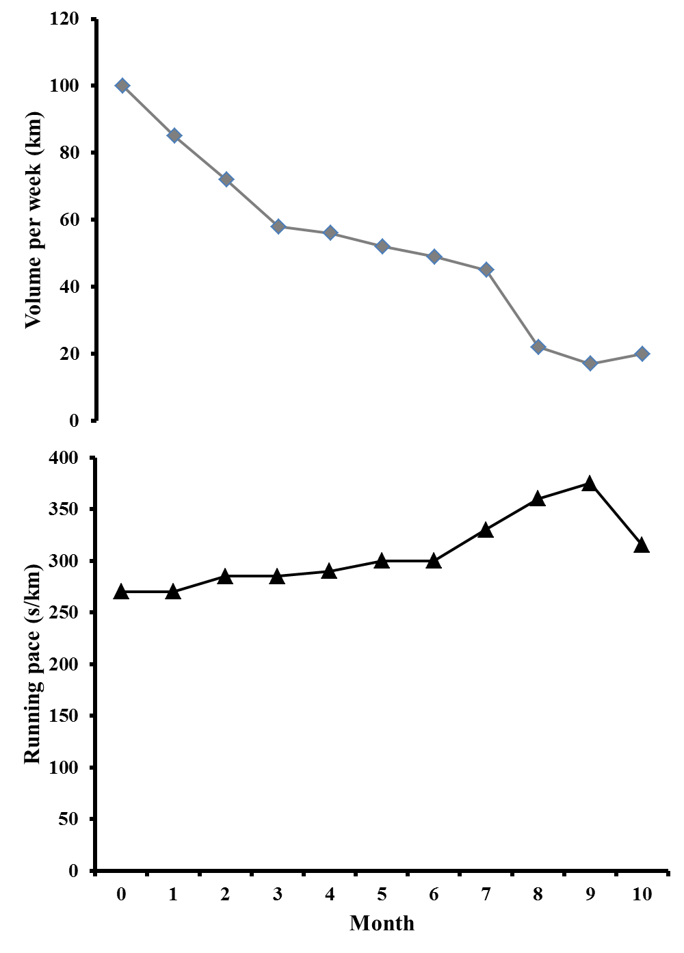
Fig. 1 – Average volume per week (upper graph) and running intensity (lower graph) during the 11-month period (0 – one month prior to pregnancy, 1-9 – during the pregnancy, 10 – one month after the pregnancy)

 |  |  |  |  | Table 1
Thyroid hormones (T4, TSH), cortisol, prolactin and glucose values (1 – at the beginning of the third trimester, 2 – at the end of the third trimester, 3 – one week after the delivery)
Measurement No. | Parameters
Measurement No. | Cortisol | Prolactin | Glucose | T4 | TSH
Reference Values | 171-536  nmol/l | 102-496  µU/ml | 4.1–6.1  mmol/l | 9.1-19.1  pmol/L | 0.35-4.94  mIU/L
1. | 1096 | 2752 | 4.4 | 11.9 | 2.73
2. | 1148 | 2798 | 4.3 | 13.1 | 3.57
3. | 837 | 4095 | 4.2 | 14.3 | 4.43

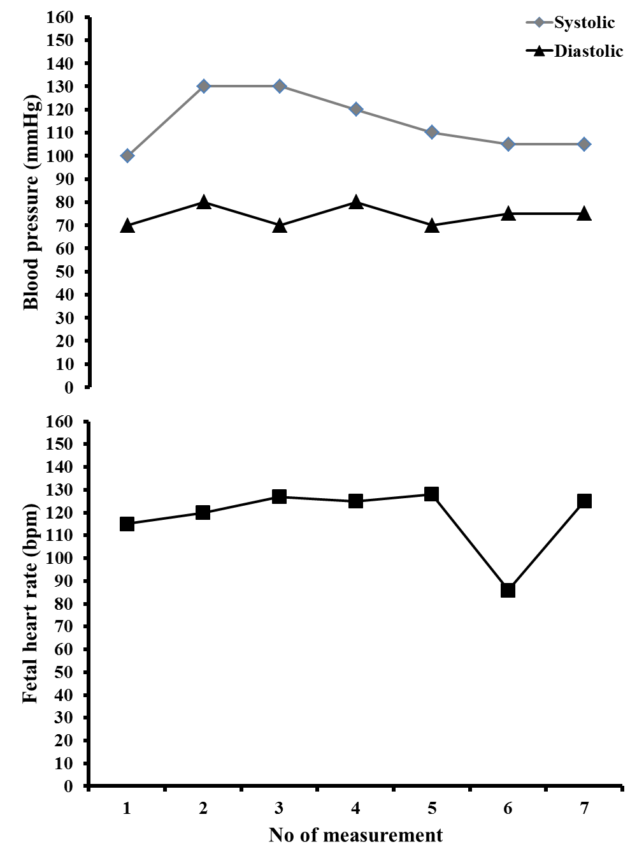
Fig. 2 – Cardiotocographic recording (CTG) of mother′s blood preasure measured before CTG (upper graph) and CTG recording of fetal heart rate (lower graph)

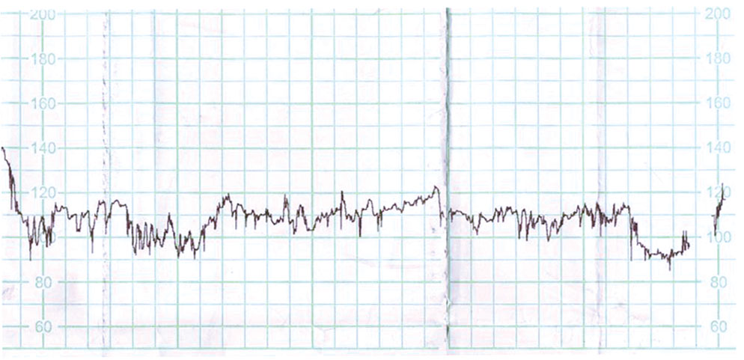
Fig. 3 – CTG recording of pulse in the foetus in the 39th week of the pregnancy

