PRILOZI

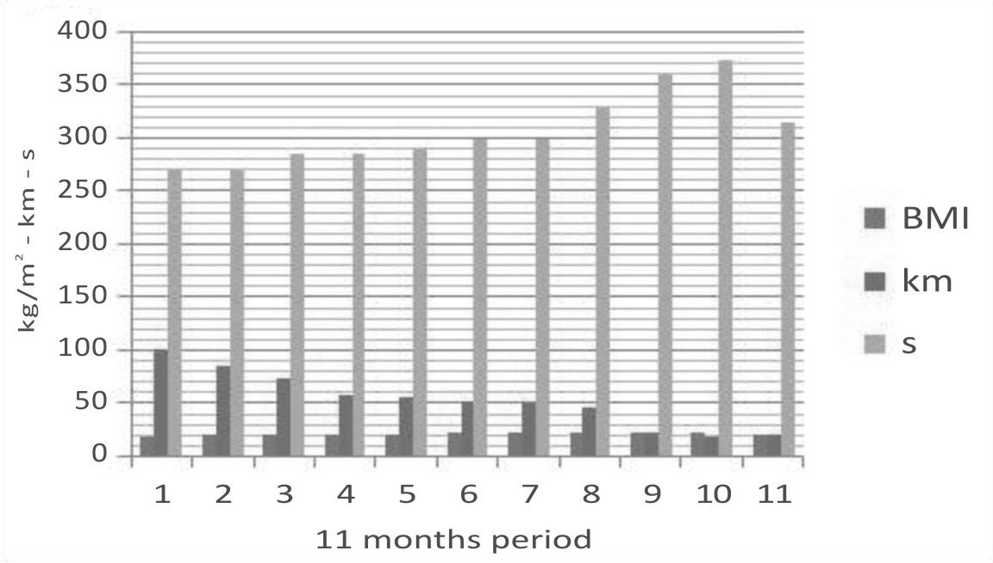
Fig. 1 – Average BMI, running length and running intensity values during the 11-month period (1 – one month prior to pregnancy, 2–10 – during the pregnancy, 11 – one month after the pregnancy)

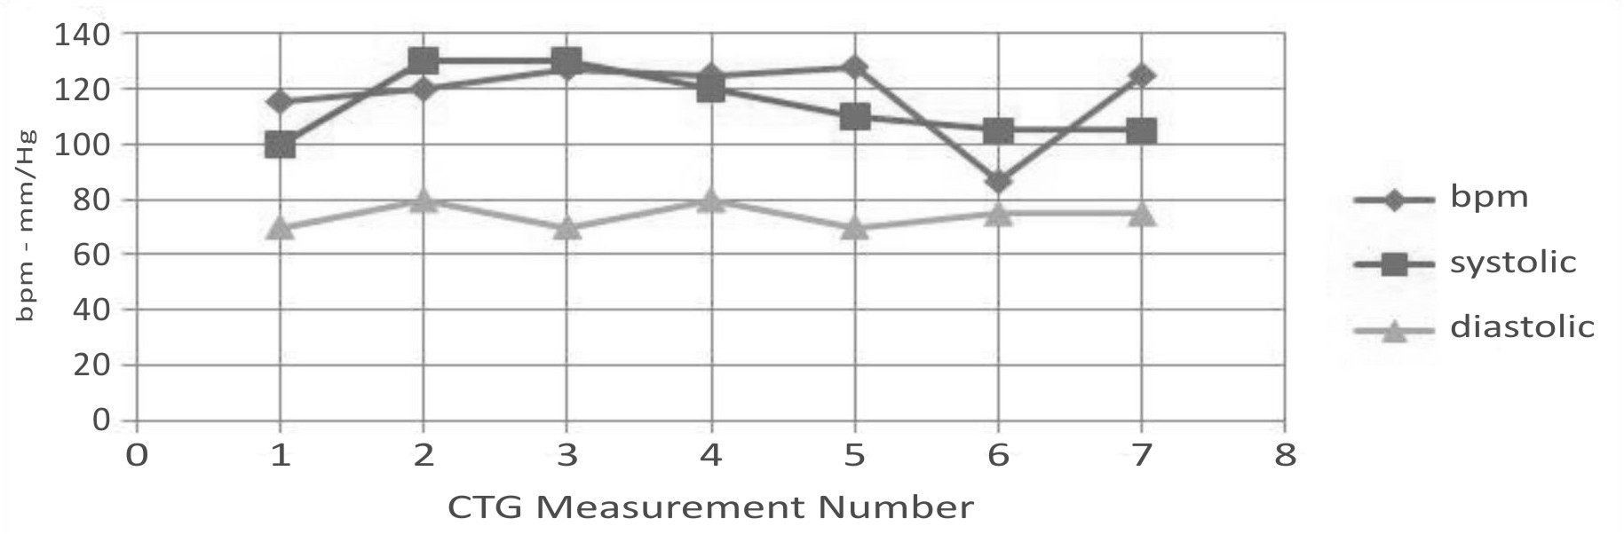
Fig. 2 – Cardiotocographic recording (CTG) of average pulse in the foetus and blood pressure (systolic, diastolic) in the mother, measured before the CTG

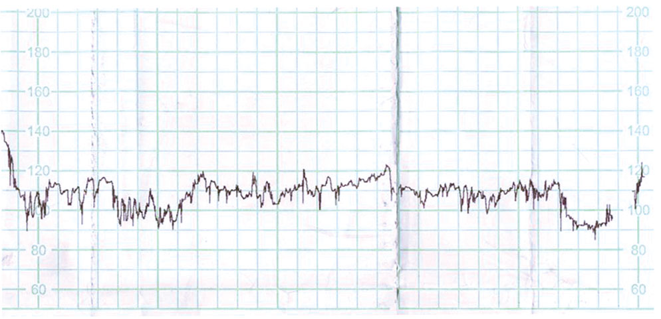
Fig. 3 – CTG recording of pulse in the foetus in the 39th week of the pregnancy

 |  |  |  |  | Table 1
Thyroid hormones (T4, TSH), cortisol, prolactin and glucose values (1 – at the beginning of the third trimester, 2 – at the end of the third trimester, 3 – one week after the delivery)
Measurement No. | Parameters
Measurement No. | Cortisol | Prolactin | Glucose | T4 | TSH
Reference Values | 171-536 nmol/l | 102-496 µU/ml | 4,1-6,1 mmol/l | 9,1-19,1 pmol/L | 0,35-4,94 mIU/L
1. | 1096 | 2752 | 4,4 | 11,9 | 2,73
2. | 1148 | 2798 | 4,3 | 13,1 | 3,57
3. | 837 | 4095 | 4,2 | 14,3 | 4,43

 |  |  |  |  | Table 2
Average blood pressure and pulse values in the third trimester
Week of Pregnancy | Blood Pressure and Pulse Measurements (Systolic/Diastolic (Pulse))
Week of Pregnancy | Before Running | During Running | 1 min After Running | 2 min After Running | 3 min After Running
27.-30. | 114/64 (57) | 168/72 (88) | 129/65 (93) | 110/62 (91) | 111/65 (82)
31.-34. | 112/59 (61) | 156/68 (94) | 150/66 (101) | 127/63 (92) | 112/65 (95)
35.-38. | 113/62 (59) | 149/72 (116) | 145/63 (112) | 124/62 (107) | 110/59 (108)
39.-40. | 118/65 (57) | 150/70 (119) | 143/62 (113 | 125/60 (110) | 107/60 (107)

