Non plug technique of bilayer patch device insertion for indirect inguinal hernia repair

Neutiskujuća tehnika ubacivanja dvolisne mrežice u reparaciji indirektne preponske kile

Miroslav Ilic∗†, Srdjan Putnik†, Ivan Kuhajda∗†, Dejan Ivanov† ‡

∗ Clinic for Thoracic Surgery, Institute for Lung Diseases of Vojvodina, Sremska Kamenica, Serbia
† Faculty of Medicine, University of Novi Sad, Novi Sad, Serbia
‡ Clinic for Abdominal, Endocrine and Transplant Surgery, Clinical Center of Vojvodina, Novi Sad, Serbia

Correspodence to :
Prof. dr Miroslav Ilic, Haed of Clinic for Thoracic Surgery, Institute for Lung Diseases of Vojvodina
Address: Put dr Goldmana 4, 21230 Sremska Kamenica
Telephone: +381 21 480 5253, + 381 63 501 301
Mail: drmiroslavilic@gmail.com

Non plug technique of bilayer patch device insertion for indirect inguinal hernia repair
Neutiskujuća tehnika ubacivanja dvolisne mrežice u reparaciji indirektne preponske kile

Abstract:

Background/ Aim: The aim of this paper is to present new technique of non plug insertion of bilayer patch device ( Prolene Hernia System®, Ethicon) and early, mid term and late results for the indirect hernia repair in male.
Methods: Retrospective study of 96 male patients and 103 indirect unilateral and bilateral inguinal hernia, operated due to primary or recurrent hernia in eleven years interval (2004-2015). In all operation an extended Prolene Hernia System® (PHS) bilayer patch device has been inserted medial of inferior epigastric vessels through small incision in Hasselbach triangle, thus avoid plug component of device connector into internal ring. Collected data has been taken from the medical records, operative protocols and telephone questionnaire.
Results: Non plug technique of insertion bileyer patch device was presented in details. Mean age in our group of male patients was 59 years. There were 3 patients with procedure related complications (2, 91%), two patients with postoperative seroma and one with scrotal ecchymosis. There were 86 patients (89.6%) who answered on questionnaire. During 11 years of following, recurrence of hernia occurred in 1 patients, one had funiculocelle and only one had chronic pain during 6 month. Satisfaction with procedure and results of hernia surgery were in almost all patients (97, 68%).

Conclusion: Non plug insertion of bylayer patch device is safe technique for solving the primary and recurrent indirect inguinal hernias. Low incidence of the recurrence and chronic pain many years after the operation justify this technique even in hospitals not specialized for the hernioplasty.

Key words: Prolen Hernia System, non plug insertion, indirect inguinal hernia.

Apstrakt:

Uvod / Cilj: Cilj rada je da predstavi novu neutiskujuću tehniku postavljanja dvolisne mrežice (Prolen Hernia Sistem®, PHS, Ethicon) u reparaciji indirektnih preponskih kila kod muškaraca i rane, srednjeročne i kasne rezultate ove tehnike.
Metode: Retrospektivna studija obuhvatila je 96 pacijenata muškog pola sa 103 jednostrane odnosno obostrane preponske kile, operisane kao primarne ili recidivne u jedanaestogodišnjem intervalu (2004-2015). U svim operacijama je korišćena proširena Prolen Hernia Sistem® (PHS) dvolisna mrežica koja je postavljana medijalno od donjih epigastričnih sudova kroz inciziju u Haselbahovom trouglu, kako bi se izbeglo ubacivanje konektora u unutrašnji ingvinalni otvor. Prikupljeni podaci su dobijeni iz medicinske dokumentacije, operativnih protokola i telefonskog upitnika.
Rezultati: Detaljno predstavljanje neutiskajuće tehnike umetanja dvolisne mrežice (PHS) u hirurgiji indirektnih hernija. Prosečna starost muških pacijenata u našoj grupi bila je 59 godina. Bilo je 3 pacijenta koje su vezane za tehniku postavljanja tokom operacije (2,91%), dva pacijenta su imali postoperativni serom, a jedan ekhimozom skrotuma. Na upitnik je odgovorilo 86 pacijenata (89,6%). Tokom 11 godina praćenja, recidiv kile razvio se kod jednog pacijenta, zabeležena je jedna funikulokela, a jedan pacijent je imao hronični bol u periodu od 6 meseci. Zadovoljstvo procedurom i rezultatima operacije kile bilo je prisutno kod gotovo svih pacijenata (97,68%).
Zaključak: Neutiskajuća tehnika postavljanja dvolisne prolenske mrežice u toku reparacije indirektne preponske kile je sigurna i bezbedna metoda kojom se mogu rešiti i primarne i recidivantne hernije. Niska stopa recidiva i hroničnog bola utvrđena na kroz dugi niz godina posle operacije, opravdavaju ovu tehniku u širokoj primeni i u centrima koji nisu usko specijalizovani za hernioplastike.

Ključne reči: Prolen Hernia Sistem, dvolisna mrežica, indirektna preponska kila.

Introduction
The evolution of inguinal hernia repair went through phase of simple reposition, tension techniques based on Bassini’s technique, then mesh technique-open or laparoscopic (TAPP, TEP) (1-4). Plug in technique were based on insertion of synthetic, no absorbable, semi absorbable or absorbable materials into internal inguinal hiatus, place where indirect inguinal hernia appear (5, 6). Although, there has been a huge success in recidive decrease of rate in mesh and plug in technique, a new problem has been shown such as chronic pain, erosive complications of intraperitoneal organs and rejection of artificial material (7-11). An ideal technique for indirect hernial repair is still not established.
Bilayer patch device (Ethicon, Prolen Hernia System® Extended) made of polypropylene is three dimensional mesh with two patch layer (underlay and onlay) attached with the connector in order to keep both patches stable. It has been in use for the last 20 years. Although, it was created as the two-layer patch (underlay and onlay) this device has a plug component, because, after a preparation of hernia sac and reposition in preperitoneal space, the conector is placed through the internal inguinal hiatus and underlay patch is placed in preperitoneal space. In original technique the spermatic cord is located close to connector and can be compressed above through internal inguinal hiatus, so the space for spermatic cord is created laterally through narrowest side of onlay mesh. Onlay mesh has to cover the space between internal obliques muscle and inguinal ligament (6, 12).
Plug component has been accused for late complications in indirect hernia repair with this technique in some papers (8, 9). That is why we applied our own modification of bilayer patch device (PHS) with insertion of connector without plug component, placing connector through separate incision in Hesselbach’s triangle, medially from epigastric inferior blood vessels. Through the small incision it was safe to create the space for the underlay patch which can cover the whole internal inguinal hiatus and spermatic cord form inside, similarly as in laparoscopic techniques and the onlay patch is placed like in Lichtenstein technique. Space for the spermatic cord was created making a Y incision on the longest diameter of the onlay patch, so the connector cannot exert the pressure on spermatic cord.
The aim of this paper is to explain the non plug bileyer patch device insertion technique, as well as early, midterm and late results for the indirect hernia repair in tertiary surgical institution not specialized for hernia surgery.

Material and methods

This was a retrospective study which included 96 male patients who has been operated due to indirect primary or recurrent inguinal hernia between November 2004 and December 2014. Among those 96 patients seven of them had bilateral inguinal hernias, in total numbers of 103 indirect hernias. All the operations has been done by one general surgeon in tertiary surgical institution specialized for thoracic and esophageal surgery. All the patients received preoperatively one dose of antibiotics. All hernioplasty procedures were done in general anesthesia. In all operation an extended PHS mesh has been used with non plug insertion technique with bilayer patch device (PHS®, Ethicon).
Collected data has been taken from the medical records and operative protocols. For late complications and quality of life of these patients, questionnaire has been made by telephone call. The focus was intolerance of patch, chronic pain, recurrent hernias or other complications on intraperitoneal organs.

Operative technique

With the skin incision of about 4 cm above the inguinal canal, the fascia of abdominal external oblique muscle has been opened from the spermatic cord to internal inguinal ring. After the identification of spermatic cord structures and nerves of inguinal region, the hernia sac was preparated, reposted without resection (Picture 1.). Medial from the inferior epigastric blood vessels in Hesselbach’s triangle (Picture 2.), a small incision of about 15mm has been made on transversal fascia, parallel with the inferior epigastric blood vessels (Picture 3.).
In preperitoneal space (space of Borgos) a place for the underlay patch has been made with moist gauze, so it can cover from internal hernia hiatus from the back side (Picture 4.). Lateral and lower end of the underlay patch is set above the femoral blood vessels. In this fashion, the connector of the bilayer patch device PHS is positioned on the spot, where the direct hernia can hypothetically appear. The underlay patch covered internal hernia ring and all the others weak points of preperitoneal space of inguino-femoral region.
The small Y incision has been made on the longest diameter of the onlay patch on about 15mm from the connector and the spermatic cord is placed through (Picture 5.). Above the spermatic cord the transected part of the onlay mesh has been approximated with Prolene 2.0 stitches except the Y incision (Picture 6.).
The onlay mesh has to cover the pubic tubercle for 2cm and sutured with Prolene 2.0 for the inguinal ligament laterally, for the internal oblique muscle medially but avoiding iliohypogastric nerve. The upper part of the onlay mesh is pushed beneath the external oblique muscle aponeurosis and sutured with usually six Prolene 2.0 stitches (Picture 7.). The operation is finished with the skin sutured.

Results
The demographic characteristic of 96 patients with 103 indirect inguinal hernias has been shown in Table 1.

Table 1
Characteristics of patients
___________________________
No of patients: 96
Sex
Male 96
Age (years)
Mean 59,26
Range 27-91

Total 103 hernias
Side of hernia
Right 49 (51,0%)
Left 40 (41,7%)
Bilateral 7 (7,3%)
Occurrence
Primary indirect
inguinal hernia 96 (93,2%)
Recurrent indirect
inguinal hernia 7 (6,8%)

Picture 8. Shows the number of operated patients per year
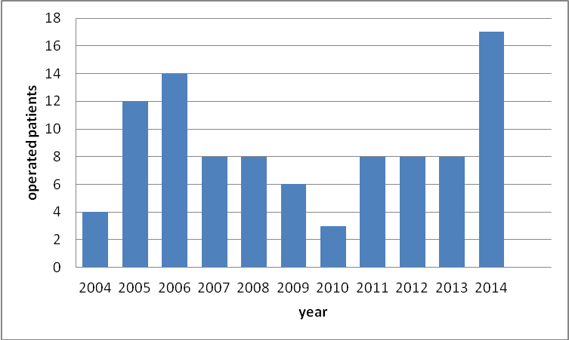

Picture 9. Shows the age structure of operated patients
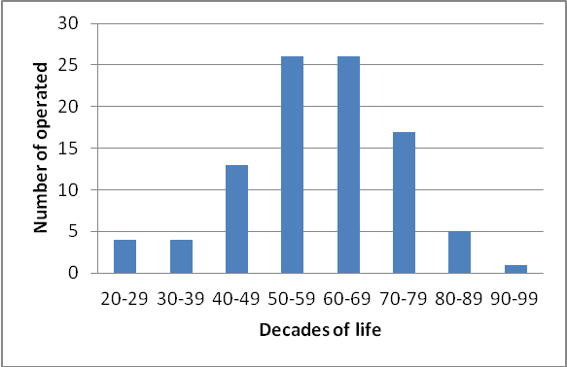

Table 2.
Total 103 hernias
Procedure relating problems

Lesions of epigastric vessels 2 (1,94%)
Accidental demage of hernia bags 1 (0,97%)

Early postoperative complications

Seroma 2 (1,94)
Scrotal wall ecchymosis 1 (0,97%)

Late postoperative complications

Chronic pain (up to 6 month) 1 (0,97%)
Funiculocele 1 (0,97%)
Reccurence 1 (0,97%)

From the 96 operated patients, 86 patients (89.6%) answered the all questions and 10 patients (10.4%) died, so the information’s has been given by their family.

The patient with recurrent hernia appeared four years after the operation, the contra lateral inguinal hernia appears and it was operated with the same technique, and the recurrent hernia is solved with additional onlay patch, without taking out the previously inserted PHS mesh. This patient had complicated pelvic fracture due to traffic accident a year before the primary operation.
The patient with the funicocoela had the other operation in other hospital, and the PHS mesh has been taken out. However, the previous operator and the other hernia surgeon expert claim that it was not the relapse.
Table 3. Satisfaction of patients with procedure and results of hernia surgery
Total number of patients 86
Satisfied with the result of the operation 84 (97,68%)
Moderately satisfied with the result of the operation 1 (1,16%)
Unhappy with the operation 1 (1,16%)

The dissatisfied patient in this study reported his displeasure with the laparoscopic appendectomy which was performed in the same act.

Picture 10. The follow up period surveyed patients from surgery
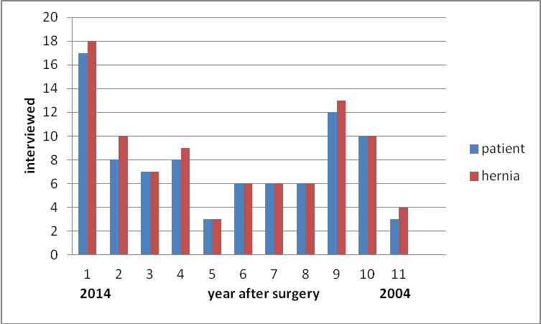

The following period of operated patients was from 1 to 11 years, with the mean interval of 5 years and 6 months. Up to 4 years of follow up there were a total of 40 patients (46. 5%) and 44 indirect inguinal hernias (47. 8%). Over 4 years of follow up, 46 patients (53. 5%) and 48 indirect hernias (52. 2%).

Discussion
In the original description about usage of PHS mesh for the indirect hernias, the connector is set as the plug in the internal inguinal ring, and the opening for the spermatic cord is set centrally or laterally, but in both cases the spermatic cord is in the contact with the connector (12). In our modification, we decided to place the connector medially of inferior epigastric blood vessels avoiding the pressure on the spermatic cord and the underlay mesh is much easier to place into preperitoneal space. In this position, the connector is not in the contact with the intraperitoneal organs, but only underlay mesh. The onlay mesh is set identically as in Lichtenstein technique (3). In this fashion, the onlay mesh fixed with the 6 Prolene 2.0 stitches prevents the migration of the underlay mesh. With this position of the connector and the both meshes, a double protection of internal inguinal hiatus has been achieved and the spermatic cord is not compressed by the connector in the internal inguinal ring.
Potentially weak spot on transversal fascia is protected with the connector and the appearance of the recurrent hernias is prevented.
Positioning of PHS meshes in this fashion is very important in cases of large indirect inguinal hernias or with accidental lesions of hernia sac (one patient in this study), due to medially position of the connector, so there is no risk of hernia sac re-damaging while creating the space for the underlay through the internal inguinal ring.
In this study, we did not have complication like migration of the mesh or damaging of intraperitoneal organs, like it is described in some newer papers about classical PHS technique (9, 10). We had only one recurrent hernia, four years after the operation, with the expansion of the internal inguinal ring over the underlay and onlay patches. This problem was solved with the additional onlay patch without need of removing the PHS mesh which was in the primary position. Funicocoela in one patient has been solved by taking out the PHS mesh in the other hospital, without any information how was the hernia resolved. Our results with this modification show low rate of the recurrences and late complications. Only one patients reported chronic pain which lasted 6 months (13).
It is well known that the beginning and the development of the indirect inguinal hernias is connected with the pain in the inguinal region. The pain is caused by nerves of ilioinguinal region, especially with the genital branch of genitofemoral nerve, ilioinguinal nerve, sympathetic nerves (testicular plexus) which are included in spermatic cord (14). The pain during the developing of indirect inguinal hernia is not proportional with the size of the internal inguinal ring defect. The classification of indirect inguinal ring size is more descriptive then need for certain type of hernioplasty. Even in recurrent indirect inguinal hernias the pain is very common (7).
We believe that the low incidence of the chronic pain in this modification technique is the result of less manipulation in the region of internal inguinal ring (15), as well as no pressure on the spermatic cord by the connector, with making the Y incision on the onlay patch (16). The low incidence of the pain is established with usage of Prolene stitches for onlay mesh fixation and obligatory identification and avoidance of the nerves with the stitches.
Although the telephone survey was very considered of the postoperative pain, as well as for the general satisfaction with the operation, the majority of the patients declared to have the same operative procedure if necessary. One dissatisfied patient reported his displeasure with the laparoscopic appendectomy which was performed in the same act and not with inguinal hernia repaired. With the all date about the satisfaction and the low incidence of postoperative pain, we conclude that this modification technique is very acceptable for the all patients who submitted the operation.
The majority of the patients in this study were the elderly patients, unlike some other studies (18), which are connected with some other co morbidities, so the antibiotics prophylaxis and general anesthesia were justified. The antibiotics prophylaxis was the reason why in this study, we did not have wound infections (19).
The absence of local or regional anesthesia in this study did not have any influence on postoperative pain.
Non plug PHS technique is safer and much easier to learn then some other open techniques, and especially laparoscopic techniques, which are more demanded with much longer learning curves (7, 20).
In this study we have two lesions of inferior epigastric blood vessels, during the transversal fascia transaction, and were solved by ligations.
With this technique, we solved primary, bilateral and recurrent hernias and showed that this technique is applicable for the all indirect inguinal hernias, despite some other studies that did not use the PHS for recurrent hernias (18, 21).
Conclusion
Non plug Prolene Hernia System hernioplasty is safe technique for solving the primary and recurrent indirect inguinal hernias. Low incidence of the recurrence and chronic pain many years after the operation justify this technique even in hospitals not specialized for the hernioplasty. Major advantages of this technique are the absence of the connector in the internal inguinal ring and his pressure on the spermatic cord, as well as with intraperitoneal organs.

References:

- Bassini E. Nuovo metodo operativo per la cura dell'ernia inguinale. Padua:
R Stabilimento Prosperini, 1889
- Rutkow, I.M, Robbins, A.W. “Tension-free” inguinal herniorrhaphy: a preliminary report on the “mesh plug” technique. Surgery. 1993;114:3–8
- Lichtenstein IL, Shulman AG, Amid PK, Montllor MM. The tension free hernioplasty. Am J Surg. 1989 ;157(2):188-93
- Schultz L, Graber J, Pietrafitta J, Hickok D. Laser laparoscopic herniorraphy: a clinical trial preliminary results. J Laparoendosc Surg. 1990. 1(1):41-5
- Robbins AW, Rutkow IM. The mesh-plug hernioplasty. Surg Clin North Am. 1993;73:501-512
- Gilbert AI, Young J, Graham MF, Divilio LT, Patel B. Combined anterior and posterior inguinal hernia repair: intermediate recurrence rates with three groups of surgeons. Hernia. 2004 Aug;8(3):203-7
- Simons MP, Aufenacker T, Bay-Nielsen M, Bouillot JL, Campanelli G, Conze J, et al. European Hernia Society guidelines on the treatment of inguinal hernia in adult patients. Hernia. 2009 August; 13(4): 343–403
- Chen MJ, Tian YF. Intraperitoneal migration of a mesh plug with a small intestinal perforation: report of a case. Surg Today. 2010 Jun;40(6):566-8
- Lo DJ, Bilimoria KY, Pugh CM. Bowel complications after prolene hernia system (PHS) repair: a case report and review of the literature. Hernia. 2008 Aug;12(4):437-40
- Zuvela M, Krivokapic Z, Galun D, Markovic V. Rare late mesh complications following inguinal prolene hernia system hernioplasty: report of three cases Surg Today. 2012 Dec;42(12):1253-8
- Yamamoto S, Kubota T, Abe T. A rare case of mechanical bowel obstruction caused by mesh plug migration. Hernia. 2014 Apr 12. [Epub ahead of print]
- Gilbert AI, Graham MF, Voigt WJ. A bilayer patch device for inguinal hernia repair. Hernia. 1999;3(3):161-6
- Campanelli G, Bertocchi V, Cavalli M, Bombini G, Biondi A, Tentorio T, et al. Surgical treatment of chronic pain after inguinal hernia repair. Hernia. 2013 Jun;17(3):347-53
- Skandalakis JE, Colborn GL, Pemberton LB, Skandalakis LJ, Gray SW. The surgical anatomy of the inguinal area — Part 2. Contemp Surg 38(2):28-38, 1991; with permission
- E. Stark, K. Oestreich, K. Wendl, B. Rumstadt, E. Hagmüller. Nerve irritation after laparoscopic hernia repair. Surg Endosc (1999) 13: 878-881
- Hsu W, Chen CS, Lee HC, Liang HH, Kuo LJ, Wei PL, et al. Preservation versus division of ilioinguinal nerve on open mesh repair of inguinal hernia: a meta-analysis of randomized controlled trials. World J Surg. 2012 Oct;36(10):2311-9
- Alfieri S, Amid PK, Campanelli G, Izard G, Kehlet H, Wijsmuller AR, et al. International guidelines for prevention and management of post-operative chronic pain following inguinal hernia surgery. Hernia. 2011;15:239–49.
- Yener O, Aksoy F, Güzel P, Bölük S, Dağ E, Atak T. Long-term quality of life after hernioplasty using a Prolene hernia system in adult inguinal hernia. Hernia. 2012 Feb;16(1):29-32
- Mazaki T, Mado K, Masuda H, Shiono M. Antibiotic prophylaxis for the prevention of surgical site infection after tension-free hernia repair: a Bayesian and frequentist meta-analysis. J Am Coll Surg. 2013;217:788-801.e1-e4
- Lovisetto F, Zonta S, Rota E, Bottero L, Faillace G, Turra G, Fantini A, Longoni M. Laparoscopic transabdominal preperitoneal (TAPP) hernia repair: surgical phases and complications. Surg Endosc. 2007 Apr;21(4):646-52
- Mottin CC, Ramos RJ, Ramos MJ. Using the Prolene Hernia System (PHS) for inguinal hernia repair. Rev Col Bras Cir. 2011 Jan-Feb;38(1):24-7

