List of figures:
Fig. 1. The ability of the TSH in discriminating between bone fracture positive and negative pre and menopausal female subjects
Fig. 2. The hip FRAX and TSH
Fig. 3 The main FRAX and FT4
Fig. 4. The hip FRAX and FT4

Fig. 1. The ability of the TSH in discriminating between bone fracture positive and negative pre and postmenopausal female subjects

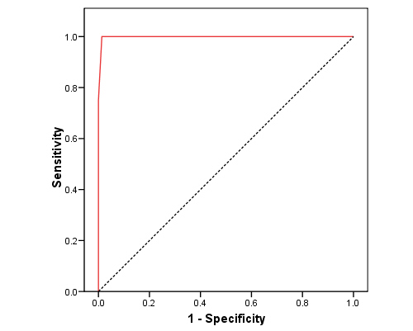

Fig. 2. The hip FRAX and TSH
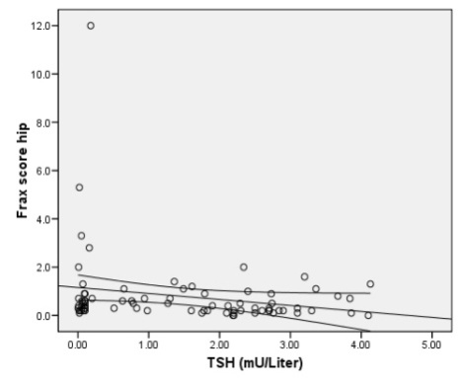

Fig. 3 The main FRAX and FT4
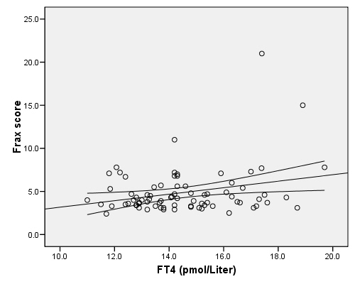

Fig. 4. The hip FRAX and FT4
