Table 1 Basic indicators of the organized screening CRC
Indicator | n (%) |  |  | Relative to issue
 | 2013. | 2014. | Total
Invited | 38 290 (15,3) | 61 302 (20,5) | 99 592 (19) | Eligable
Tested iFOBT | 23 761 (62,1) | 38 491 (62,8) | 62 252 (62,5) | Invited
Positive iFOBT | 887 ( 3,7) | 2 803 ( 7,3) | 3 690 ( 5,9) | Tested
Colonoscopied | 463 (52,2) | 1 091 (38,9) | 1 554 (42,1) | Positive iFOBT
Adenom detected | 145 ( 31,3) | 441 (40,4) | 586 (37,7) | Colonoscopy
CRC diagnosed | 41 ( 8,9) | 88 ( 8,1) | 129 ( 8,3) | Colonoscopy

Coverage by invitations and participation rate of the target population was higher in the year 2014, as is shown in the graph 1 and the graph 2
Graph.1 Graph.2
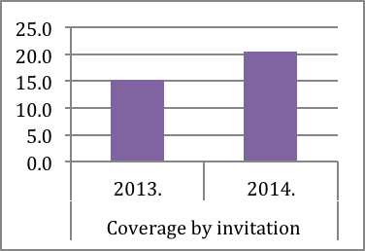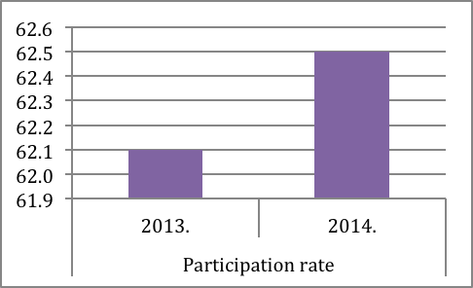

Tab. 2. Number of invited persons, participation rate, number and % of positive iFOBT, number of screening colonoscopies and number of persons with detected adenomas and CRC in municipalities in Serbia 2013-2014.
Municipality | Invited | Participation rate | Positive |  | Colonosocopy | Persons with  detected adenom. |  | Persons with detected CRC
 | n | % | n | % | n | n | % of colonoscopy | n | % of colonoscopy
Zemun | 2580 | 41,6 | 76 | 7,1 | 45 | 17 | 37,8 | 2 | 4,4
Voždovac | 6774 | 92,1 | 298 | 4,8 | 96 | 42 | 43,8 | 15 | 15,6
Čukarica | 9939 | 70,3 | 615 | 8,8 | 465 | 212 | 45,6 | 37 | 8
Barajevo | 751 | 73,8 | 114 | 20,6 | 17 | 2 | 11,8 | 0 | 0
Sopot | 2808 | 67,7 | 122 | 6,4 | 34 | 10 | 29,4 | 5 | 14,7
Novi Bečej | 1460 | 59,2 | 110 | 12,7 | 41 | 20 | 48,8 | 1 | 2,4
Sečanj | 2110 | 75 | 72 | 4,6 | 49 | 28 | 57,1 | 5 | 10,2
Pančevo | 12461 | 61,4 | 337 | 4,4 | 176 | 47 | 26,7 | 7 | 4
Kragujevac | 4637 | 51,4 | 200 | 8,4 | 52 | 21 | 40,4 | 3 | 5,8
Topola | 887 | 71,5 | 39 | 6,2 | 15 | 2 | 13,3 | 4 | 26,7
Knić | 1596 | 60,2 | 24 | 2,5 | 7 | 2 | 28,6 | 0 | 0
Niš | 22162 | 43,7 | 597 | 6,2 | 127 | 44 | 34,6 | 5 | 3,9
Dolјevac | 1478 | 89 | 45 | 3,4 | 15 | 5 | 33,3 | 5 | 33,3
Kosjerić | 1803 | 64,4 | 14 | 1,2 | 12 | 3 | 25 | 1 | 8,3
Požega | 3954 | 54,5 | 25 | 1,2 | 17 | 1 | 5,9 | 1 | 5,9
Leskovac | 3793 | 83,4 | 140 | 4,4 | 43 | 9 | 20,9 | 9 | 20,9
Vlasotince | 1589 | 65,8 | 57 | 5,5 | 31 | 11 | 35,5 | 8 | 25,8
Lebane | 1795 | 53,4 | 14 | 1,5 | 7 | 2 | 28,6 | 2 | 28,6
Medveđa | 1236 | 67,9 | 15 | 1,8 | 8 | 5 | 62,5 | 1 | 12,5
Mali Iđoš | 1083 | 57,7 | 30 | 4,8 | 15 | 7 | 46,7 | 0 | 0
Sr. Mitrovica | 2730 | 47,7 | 89 | 6,8 | 28 | 2 | 7,1 | 3 | 10,7
Lučani | 1238 | 70,4 | 16 | 1,8 | 2 | 0 | 0 | 0 | 0
Ivanjica | 854 | 46,7 | 9 | 2,3 | 3 | 1 | 33,3 | 0 | 0
Ćuprija | 1017 | 79,1 | 178 | 22,1 | 50 | 21 | 42 | 1 | 2
Valјevo | 3045 | 93,1 | 230 | 8,1 | 77 | 19 | 24,7 | 10 | 13
Sombor | 4052 | 66,8 | 76 | 2,8 | 30 | 19 | 63,3 | 2 | 6,7
Kralјevo | 1760 | 88,5 | 148 | 9,5 | 92 | 34 | 37 | 2 | 2,2
Total | 99 592 | 62,5 | 3690 | 5,9 | 1554 | 586 | 37,7 | 129 | 8,3

Graph 3: Participation rate (%)
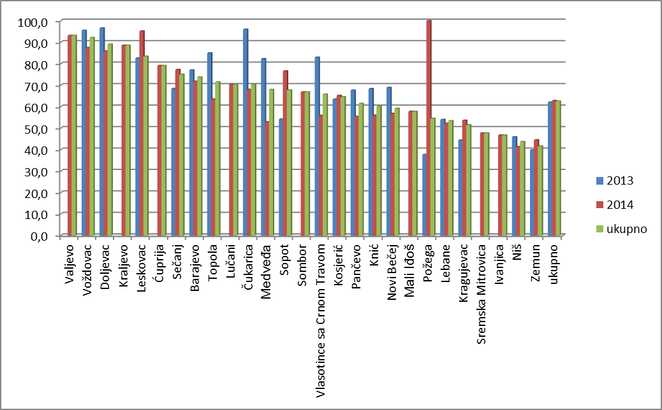
CI=95%, Sig. 0,704

Graph 4: Positive iFOBT (%)
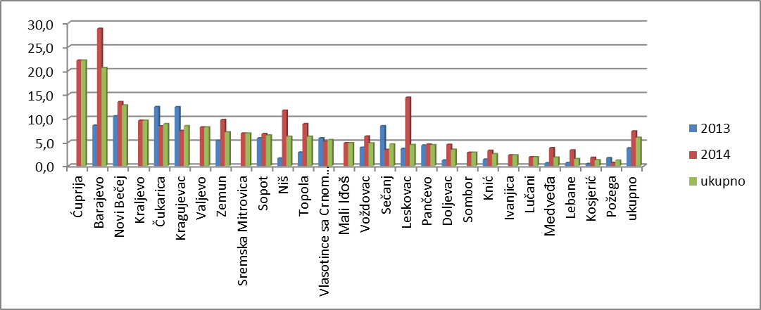
CI=95%, Sig. 0,088

Graph 5: Adenoma detection rate (‰)
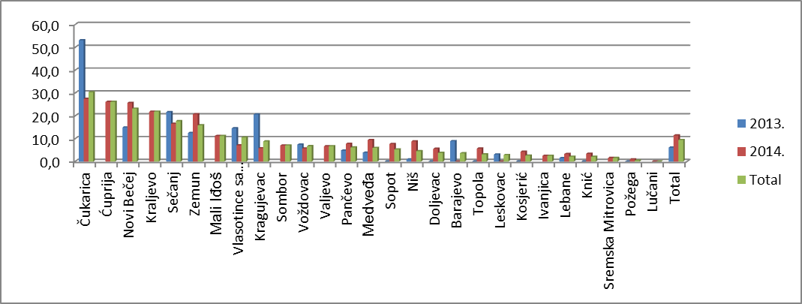
CI=95%, Sig.0,30 0,302

Graph 6: PPV for detection of adenoma (%)
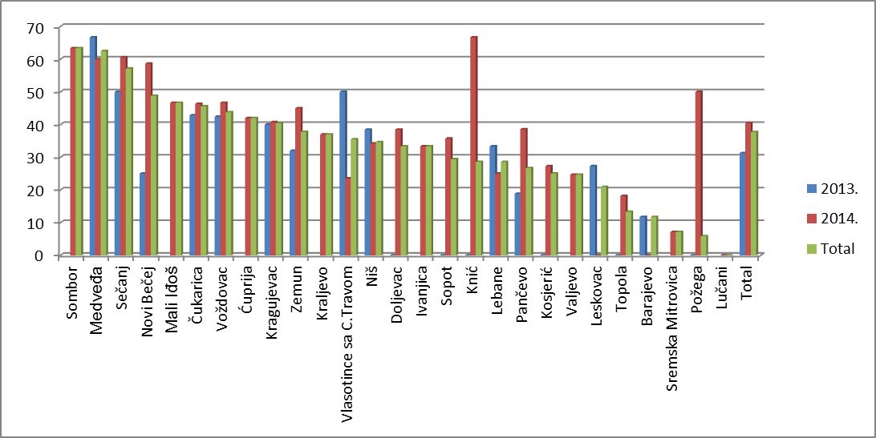
CI=95%, Sig. 0,107

Graph 7: Cancer detection rate (‰)
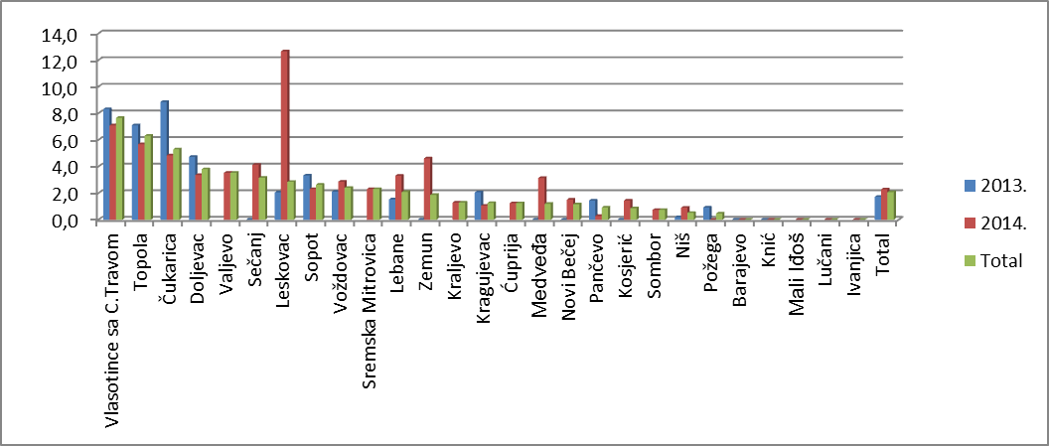
CI=95%, Sig. 0,465

Graph 8: PPV for detection of cancer (%)
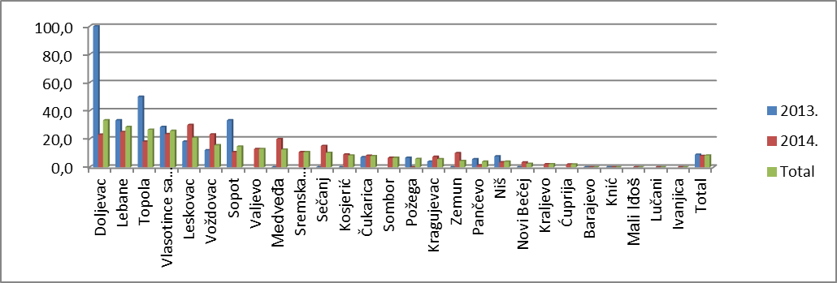
CI=95%, Sig. 0,919

Table 3 Localization of detected polyps and carcinoma
Part of colon |  | Localization of polyps | Size ≤10mm | Size ≥10mm | Localization of CRC
Part of colon |  | Percent (%) | Percent (%) | Percent (%) | Percent (%)
Left | Rectum | 11,2 | 12,9 | 10,9 | 27,3
Left | Sigmo -rectum | 5,9 | 5,7 | 6,7 | 12,1
Left | Sigmoid | 43,1 | 38,1 | 53,8 | 30,3
Left | Descending | 10,1 | 11,1 | 6,7 | 7,6
Left | Total | 70,4 | 67,8 | 78,1 | 77,3
Right | Transverse | 15,9 | 16,8 | 14,3 | 4,5
Right | Ascending | 7,2 | 9,2 | 4,2 | 16,7
Right | Cecum | 6,6 | 6,2 | 3,4 | 1,5
Right | Total | 29,6 | 32,2 | 21,9 | 22,7

