Enclosures
Prilozi

Fig 1. - Age range of all patients

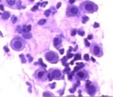
Fig. 2. Suspicious cytological findings (Papanicolaou 400x)

Fig. 3. Distribution cervical intraepithelial neoplasia in female patients with abnormal Pap test.
.
Table 1
Frequency of histopatological parameters
Histopatological variables Frequency Percentage
Suspicious findings 80/2578 3.1
CIN I 12 15
CIN II 3 3.7
CIN III 9 11.25
CERVICITIS 56 70
LGSIL 12 15
HGSIL 12 15
CIN 24 30
HPV positive cervicitis 19 33.92
HPV positive CIN 13 54.16

Koilocytosis (HPV infection)

Pathological mitosis

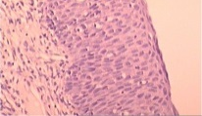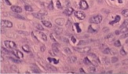
B
A

Fig. 4. Pathohistologically characteristics cervical intraepithelial neoplasm in CIN III with A) Koilocytosis (HE 200x) and B) Pathological mitosis (HE 400x)

Fig 5. The incidence of HPV infection is higher in patients with CIN (54.16%) compared to patients with cervicitis (33.92%).

Fig. 6. The presence HPV16 (61.53%) in CIN - out of he number of infected

Fig.7 The incidence of HPV infection in patients with CIN III (88.88%)

Fig.8 The frequency of HPV16 infection in infected patients with CIN III (75%)

