1 ROC ANALYSIS

ROC CURVE FOR MYOMA SIZE

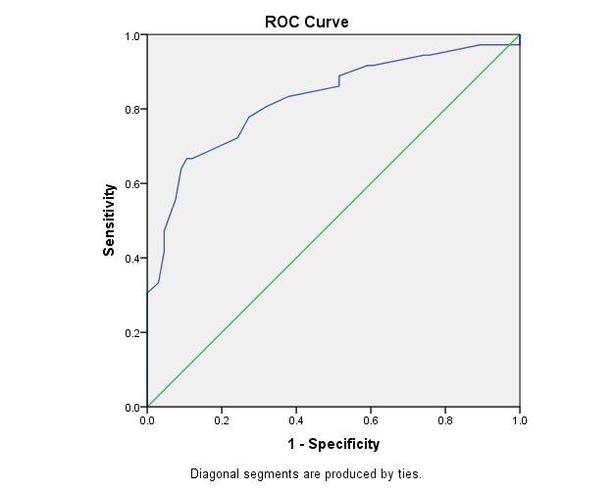

Area Under the Curve
Test Result Variable(s): Myoma size
Area | Std. Errorª | Asymptotic Sig.^{b} | Asymptotic 95% Confidence Interval
Area | Std. Errorª | Asymptotic Sig.^{b} | Lower Bound | Upper Bound
.825 | .046 | .000 | .734 | .916

Coordinates of the Curve
Test Result Variable(s): Myoma size
Positive if Greater Than or Equal Toª | Sensitivity | 1 - Specificity
9.0000 | 1.000 | 1.000
12.5000 | .972 | 1.000
16.5000 | .972 | .985
19.0000 | .972 | .970
21.5000 | .972 | .909
24.0000 | .972 | .894
26.5000 | .944 | .758
29.0000 | .944 | .742
31.0000 | .917 | .606
33.5000 | .917 | .591
36.5000 | .889 | .515
39.0000 | .861 | .515
42.5000 | .833 | .379
47.5000 | .806 | .318
52.5000 | .778 | .273
57.5000 | .722 | .242
61.5000 | .667 | .121
64.0000 | .667 | .106
67.5000 | .639 | .091
72.5000 | .556 | .076
77.5000 | .472 | .045
82.5000 | .417 | .045
87.5000 | .333 | .030
92.5000 | .306 | .000
97.5000 | .222 | .000
105.0000 | .194 | .000
115.0000 | .167 | .000
125.0000 | .139 | .000
140.0000 | .111 | .000
180.0000 | .028 | .000
211.0000 | .000 | .000

2
MYOMA TYPE ANALYSIS

Case Processing Summary
 | Cases
 | Valid |  | Missing |  | Total
 | N | Percent | N | Percent | N | Percent
Myoma type* Hemorrhage | 102 | 100.0% | 0 | 0.0% | 102 | 100.0%
Myoma localization* Hemorrhage | 102 | 100.0% | 0 | 0.0% | 102 | 100.0%

Crosstab
 |  |  | Hemorrhage |  | Total
 |  |  | no | yes | Total
Myoma type | Pedunculated | Count | 4 | 5 | 9
Myoma type | Pedunculated | % within Hemorrhage | 6.1% | 13.9% | 8.8%
Myoma type | Subserous | Count | 34 | 7 | 41
Myoma type | Subserous | % within Hemorrhage | 51.5% | 19.4% | 40.2%
Myoma type | Intramural | Count | 4 | 7 | 11
Myoma type | Intramural | % within Hemorrhage | 6.1% | 19.4% | 10.8%
Myoma type | Multiple | Count | 24 | 17 | 41
Myoma type | Multiple | % within Hemorrhage | 36.4% | 47.2% | 40.2%
Total |  | Count | 66 | 36 | 102
 |  | % within Hemorrhage | 100.0% | 100.0% | 100.0%

Chi-Square Tests
 | Value | df | Asymp. Sig. (2-sided)
Pearson Chi-Square | 12.131ª | 3 | .007
Likelihood Ratio | 12.546 | 3 | .006
Linear-by-Linear Association | 1.451 | 1 | .228
N of Valid Cases | 102
a. 2 cells (25.0%) have expected count less than 5. The minimum expected count is 3.18.

3
MYOMA LOCALISATION ANALYSIS

Crosstab
 |  |  | Hemorrhage |  | Total
 |  |  | no | yes | Total
Myoma localisation | Fundus | Count | 4 | 4 | 8
Myoma localisation | Fundus | % within Hemorrhage | 6.1% | 11.1% | 7.8%
Myoma localisation | Aterior wall | Count | 43 | 18 | 61
Myoma localisation | Aterior wall | % within Hemorrhage | 65.2% | 50.0% | 59.8%
Myoma localisation | Posterior wall | Count | 15 | 8 | 23
Myoma localisation | Posterior wall | % within Hemorrhage | 22.7% | 22.2% | 22.5%
Myoma localisation | Istmicocervical | Count | 2 | 3 | 5
Myoma localisation | Istmicocervical | % within Hemorrhage | 3.0% | 8.3% | 4.9%
Myoma localisation | Cornual | Count | 2 | 3 | 5
Myoma localisation | Cornual | % within Hemorrhage | 3.0% | 8.3% | 4.9%
Total |  | Count | 66 | 36 | 102
 |  | % within Hemorrhage | 100.0% | 100.0% | 100.0%

Chi-Square Tests
 | Value | df | Asymp. Sig. (2-sided)
Pearson Chi-Square | 4.327ª | 4 | .364
Likelihood Ratio | 4.166 | 4 | .384
Linear-by-Linear Association | 1.287 | 1 | .257
N of Valid Cases | 102
a. 5 cells (50.0%) have expected count less than 5. The minimum expected count is 1.76.

DATA FOR MYOMA SIZE-T TEST

Group Statistics
 | Hemorrhage | N | Mean | Std. Deviation | Std. Error Mean
Myoma size | no | 66 | 41.8030 | 18.23793 | 2.24493
Myoma size | yes | 36 | 80.9167 | 40.85121 | 6.80854

Independent Samples Test
 |  | Levene's Test for Equality of Variances |  | t-test for Equality of Means
 |  | F | Sig. | t | df | Sig. (2-tailed) | Mean Difference | Std. Error Difference | 95% Confidence Interval of the Difference
 |  |  |  |  |  |  |  |  | Lower | Upper
Myoma size | Equal variances assumed | 15.589 | .000 | -6.673 | 100 | .000 | -39.11364 | 5.86140 | -50.74248 | -27.48479
Myoma size | Equal variances not assumed |  |  | -5.456 | 42.752 | .000 | -39.11364 | 7.16909 | -53.57392 | -24.65336

CS INDICATIONS PERCENTAGES

CS INDICATION * Hemorrhage
 |  |  | Hemorrhage |  | Total
 |  |  | no | yes | Total
Indication | Dyspropotion | Count | 12 | 2 | 14
Indication | Dyspropotion | % within Hemorrhage | 18.2% | 5.6% | 13.7%
Indication | Previous CS | Count | 4 | 1 | 5
Indication | Previous CS | % within Hemorrhage | 6.1% | 2.8% | 4.9%
Indication | Previous myomectomy | Count | 2 | 5 | 7
Indication | Previous myomectomy | % within Hemorrhage | 3.0% | 13.9% | 6.9%
Indication | Hypertension | Count | 5 | 4 | 9
Indication | Hypertension | % within Hemorrhage | 7.6% | 11.1% | 8.8%
Indication | Fetal malpresentation | Count | 11 | 3 | 14
Indication | Fetal malpresentation | % within Hemorrhage | 16.7% | 8.3% | 13.7%
Indication | Prolonged labor | Count | 4 | 0 | 4
Indication | Prolonged labor | % within Hemorrhage | 6.1% | 0.0% | 3.9%
Indication | Myoma previa | Count | 5 | 12 | 17
Indication | Myoma previa | % within Hemorrhage | 7.6% | 33.3% | 16.7%
Indication | Fetalne indikacije | Count | 11 | 4 | 15
Indication | Fetalne indikacije | % within Hemorrhage | 16.7% | 11.1% | 14.7%
Indication | Other | Count | 12 | 5 | 17
Indication | Other | % within Hemorrhage | 18.2% | 13.9% | 16.7%
Total |  | Count | 66 | 36 | 102
 |  | % within Hemorrhage | 100.0% | 100.0% | 100.0%

