Table 1. Characteristics of 162 asthmatic subjects enrolled in the study

Characteristics | Group I ( 81) | Group II ( 81 )
Age - years | 23,98 ± 0,22 | 23,62 ± 0,30
Men/women | 81/0 | 81/0
FEV1 (l) -basal | 4,31 ± 0,87 | 4,65 ± 1,04
Hist. conc. PC20 (mg/ml) | 0,60 ± 0,07 | 1,25 ± 0,10
Data are presented as mean values ± SD

Graph 1 .Skin reactions to inhaled allergens

p< 0,005

Graph 2 . The level of total IgE in serum by groups

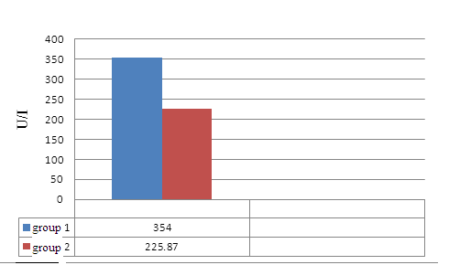 p<0,05

Graph 3 . Average concentration of histamine in groups mg / ml, which caused the decline in FEV1
of 20%

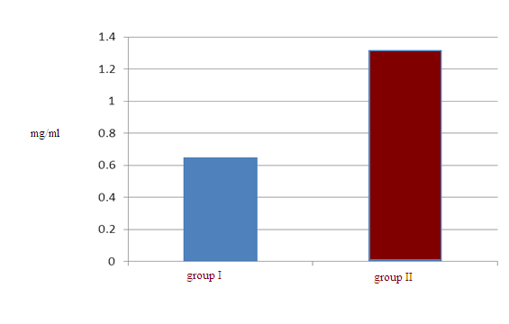p< 0.05

Graph 4 . Percentage of fall - decrease in FEV1 after histamine test by groups

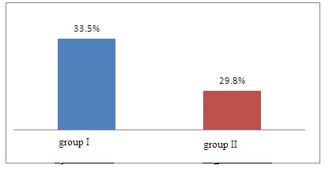p<0,05

