POSTERIOR REVERSIBLE ENCEPHALOPATHY SYNDROMA - case report

Dejan Kostić*, Biljana Brkić-Georgievski†,Aleksandar Jovanovski*, Smiljana Kostić‡, Dražen Ivetić ||, Leposava Sekulović*
*Institute of Radiology, ‡ Clinic for Neurology, || Clinic for Neurosurgery, Military Medical Academy, Belgrade, Serbia;
†Special Hospital for Cerebrovascular Diseases „ Sveti Sava“, Belgrade, Serbia

ABSTRACT

Posterior reversible encephalopathy syndrome (PRES) is characterized by the following symptoms: seizures, impaired consciousness and/or vision, vomiting, nausea, and focal neurological signs.
Diagnostic imaging includes an examination by magnetic resonance (MR) and computed tomography (CT), where brain edema is visualized bilaterally and symmetrically, predominantly posterior parietally and occipitally.
We present a 73-year-old patient, with years-long medical history of hipertension and renal problems, who developed PRES with the symptomatology of the rear of the cranium and CT and MR verified changes in the white matter involving all lobes on both sides of the brain. After two weeks of treatment the clinical improvement with no complications occurred, with complete resolution of changes in the white matter seen on CT and MR.
PRES is a reversible syndrome in which the symptoms withdraw after several days to several weeks if early diagnosis is made and appropriate treatment begins without delay.
Key words: Posterior reversible encephalopathy syndrome, PRES, MRI

Introduction

Posterior reversible encephalopathy syndrome (PRES) is characterised by the following symptoms: epileptic seizures, consciousness impairment, visual abnormalities, nausea, vomiting and focal neurological signs. It was first described by Hinchey in 1996. based on the study of 15 cases (1). Since then this syndrome has been also designated by reversible posterior leukoencephalopathy syndrome, reversible posterior cerebral edema syndrome and reversible occipital parietal encephalopathy (2,3,4).
Studies have shown that various conditions can lead to development of PRES, hypertension, autoimmune diseases, toxic agents, sepsis, preeclampsia/eclampsia, kidney diseases being among them (5). Regardless to this heterogeneity main pathophysiological mechanism which leads to development of this syndrome is cerebral vasogenic edema which occurs as a result of abnormality in blood flow through the brain (cerebral blood flow, CBF) (6).
Diagnostical imaging includes magnetic resonance imaging (MR) and, less commonly, computed tomography (CT), where cerebral edema is visualized bilaterally and symetrically predominantly posterior parietally and occipitally, but frontal and temporal lobes can also be affected, as well as basal ganglia, brainstem and cerebellum. Also, alongside with the white matter, cortical gray matter can be affected as well (7).
Diagnosis of PRES is complicated, since the CT results are often normal or non-specific, and MR scanners not available in many centres. Standard MR sequences, which include T1-weighted images (T1W), T2-weighted images (T2W), fluid attenuated inversion recovery (FLAIR) and diffusion-weighted imaging (DWI) with apparent diffusion coefficient (ADC) map, as well as contrast T1W, are sufficient for the diagnosis.
The treatment should primarily consist of correction of the underlaying causes which led to neurological symptomatology, and then symptomatic measures should be taken. Some patients may develop severe manifestations of PRES, such as coma or status epilepticus, which require ICU admission (8, 9).
PRES is a reversible syndrome, but in a small number of patients neurological deficit is permanent.
Death occurs in up to 15% of cases due to acute hemorrhage and ischemia (6, 11, 12, 13 ).

CASE REPORT:

A patient, 73 years old, was complaining of headache, instability while walking and loss of balance which lasted for a few days. This is a patient with a history of hypertension and chronic renal insufficiency. Arterial blood pressure reached 160/90 mmHg. Clinical presentation at admittance was dominated by symptomatology of posterior fossa with discreet right faciobrachial hemiparesis. Initially, CT scanning without application of contrast was performed and this scanning showed the presence of both sided hypodensic zones, frontally more prominent on the left as well as parietally right subcortically, which resemble most vasogenic edema ( figure 1 ).

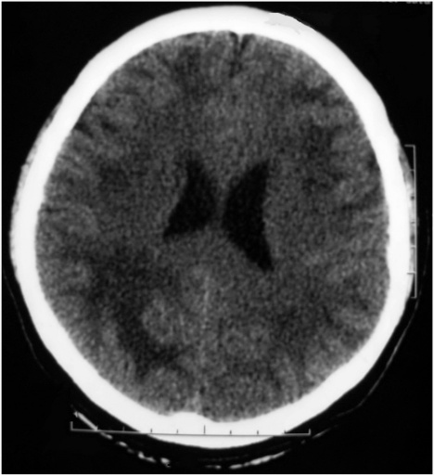
Figure 1 Native CT tomogram shows hypodense zone on both sides of the frontal and parietal lobe pronounced right.

After CT, MR scanning was also performed in T1W, T2W, FLAIR,T2*, DWI with ADC map, as well as postcontrast T1W and 3D T1 FSPGR.
MR spectroscopy using 2D multivoxel SE 144 and Single voxel SE 144 and SE 35 sequences with positioning of volume of interest occipitoparietally was also performed.
This scanning showed cortico-subcortical temporopolar both sidedly, parieto-occipital and posterior parietal both sidedly more dominant on the right, pachy, unsharply bordered, partly confluent lesions hyperintense in T2W and FLAIR sequence with mild compressive effect on occipitial horn of the right lateral lobe, without postcontrastive enhancment of signal intensity ( figure 2 ).

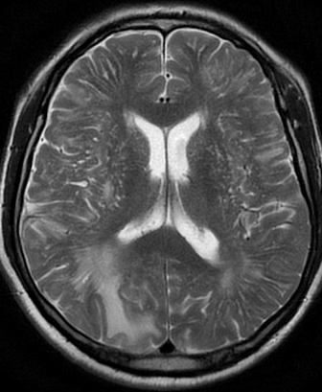
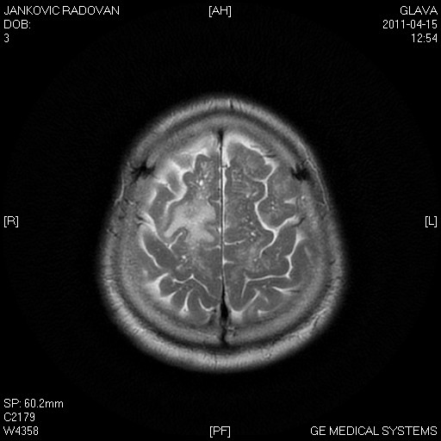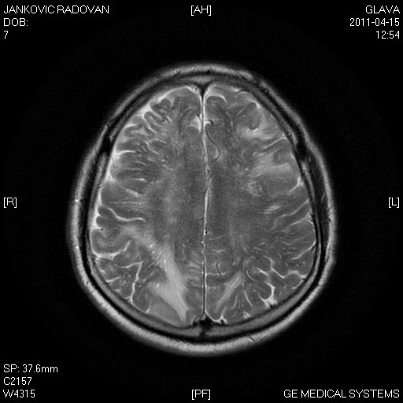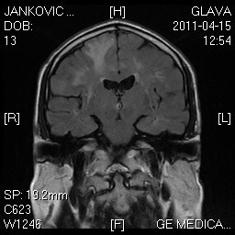

A. T2W axial tomogram shows the zone vasogenic edema cortical / subcortical localization in the parietal lobes, more pronounced on the right.
B. T2W axial tomogram shows the asymmetric changes in frontal-left, parijetalno mutual pronounced right.
C. T2W axial tomogram shows the changes frontally right.
D. Coronal T2W axial tomogram shows vazogeni edema bilaterally frontally pronounced right.

There are no signs of a diffusion restriction. In DWI sequence occipitoparietally on the right there are no changes in signal intensity, but on ADC map hypointensity of the signal is seen, which implicates the existence of vasogenic edema.
Based on the CT and MR scanning results the patient was then examined with MR spectroscopy. Using 2D Multivoxel spectroscopy the obtained spectres had normal or slightly higher values of choline for the area in question (Cho/Cr), and NAA was slightly lower. By Singlevoxel spectroscopy spectres of low apsolute concentrations were obtained, ratio Cho/Cr did not deviate significantly from normal values for the area in question. NAA was lower. Resonant lines of lipides and lactates were not noticed.
DTI: in the area of lesion occipitoparietally on the right fractional anizotrophy was lower.
After diagnosing the patient was regularly treated with antihypertensive, antilypemic and rehydration therapy and was discharged two weeks later with arterial tension 140/80 mmHg and normalized neurological findings.
Control MR scanning, performed two months after the initial MR scanning, showed complete regression of T2W and FLAIR hyperintense changes which had previously affected cortex and subcortical white matter ( figure 3 ).
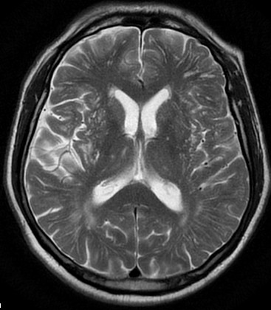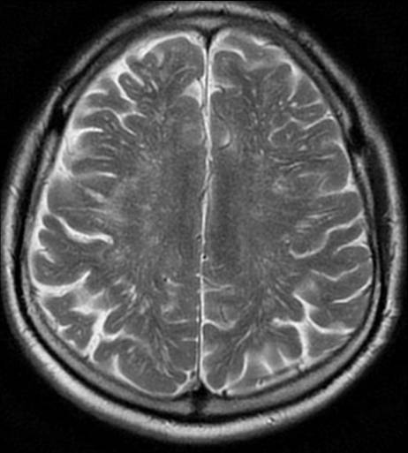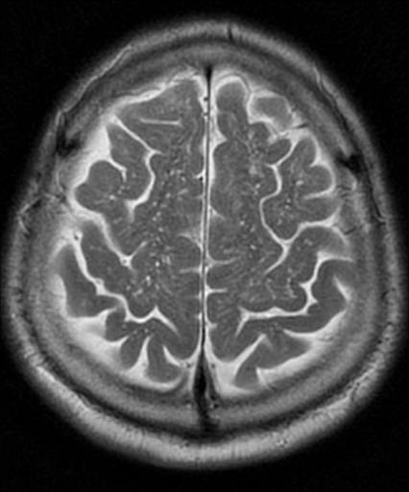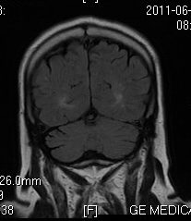
Figure 3. Control MRI after one month. T2W axial tomogram and coronal T2W tomogram showed almost complete regression of the lesion.

Discussion:

PRES has been reported in patients aged 4 to 90 years, although most cases occur in young to middle-aged adults. Mechanical ventilation is required in 35% to 40% of patients ( 11, 12 ). Average hospital length of stay is 20 days, and mortality rate is up to 15% ( 11, 12) . Numerous conditions may lead to the syndrome. Acute hypertension, renal function disorder, immunosuppressive therapies are some of them (1). Other possible causes are eclampsia, transplantation, chemotherapy (14), systemic infection, shock (15) and insect bites (16 and 17).
Until recently it was thought that PRES tipically affects the white matter, simetrically, predominantly in occipital and posterior parietal area. Sporadically, changes were described in frontal and temporal lobes, basal ganglia, brain stem and cerebellum, as well as in cortical grey matter ( 5 ).
Cohort recent studies showed that changes are asymmetric in 3-15% of cases, that occipital lobes are affected in 99%, and parietal lobes in 67 to 99% of cases. Changes are less often detected in frontal (68 to 89%) and temporal (40 to 83%) ( 12, 15,18 ,19 ) lobes of cerebral parenchyma. Brain stem is affected in 13 to 58%, cerebellum in 30 to 58%, and basal ganglia in 12 to 34% of cases ( 15, 18, 19 ). Up until now changes are least often detected in the grey matter, i.e. in 10 to 44 % of cases ( 10, 15, 18, 19). In the shown case the changes were asymmetrical and affecting frontal, temporal, parietal and occipital lobes, cortical grey matter, as well as subcortical and deep cerebellar white matter.
Main pathophysiological mechanism which leads to this syndrome is cerebral vasogenic edema. Some authors are of opinion that occurence of edema is the consequence of disorder in cerebral autoregulation of blood flow through brain. Other authors think that it is caused by a dysfunction of endothelium with cerebral hypoperfusion ( 6 ).
CTscan is often normal or non-specific, as in our case. Topographic regions suggest the diagnosis of PRES ( 19 ).
T2W sequence shows lesions of higher intensity signal, which indicates the existence of edema, and T1W low intensity signal. Changes in PRES are best seen in FLAIR sequence, as hyperintense zones cortically and/or subcortically ( 7 ).
Signal intensity on the DWI sequence is normal, but on the ADC is higher ( 20 ).
Fractional isotrophy shows zones of a decrease, which indicates mild damage of brain paths which can be reversible and it is in accordance with a mild decrease of the values of NAA obtained by MR spectroscopy. ( 21, 22 ).
MR spectroscopy is not superior to conventional MR sequences, but it helps us to rule out other etiology of changes. Increase of signal intensity after the application of contrast agents is seen in about one half of cases ( 18 ).
All those characteristics of lesions are also seen in our case.
Many conditions may resemble PRES. Differential diagnosis of findings obtained by the examination of the brain using magnetic resonance imaging in patients with abnormalities of cerebellar white matter includes the following:
-Acute disseminated encephalomyelitis (ADEM) - in which, unlike the PRES , lesions in T1 can be hypo to isointense, in DWI the signal is without changes, and on ADC map an increase of signal intensity is seen, changes being contrast uptaken ( 23 ).
-In progressive multifocal leukoencephalopathy ( PML ) in DWI new and active lesions show hyperintensity of signal, the old ones hypointensity, while in ADC map new and active lesions are hypointense and the old ones are hyperintense ( 24 ).
-In CADASIL ( cerebral autosomal dominant arteriopathy with subcortical infarcts and leukoencephalopathy ) in DWI and ADC sequences the restriction of diffusion always occurs, and the changes after i.v. application of contrast do not show signs of signal hyperintensity. Changes simetrically affect basal ganglia and white matter widening the perivascular space ( 25 ).
-In acute ischemia the restriction of diffusion does exist ( signal hyperintensity in DWI, signal hypointensity in ADC map ) without contrast increase of signal intensity ( 26 ).
-In MELAS ( Mitochondrial encephalomyopathy, lactic acidosis, and stroke-like episodes) signal hyperintensity occurs in T1 W sequence, in T1 W and T2 FLAIR it is hypointense, and in DWI iso or hypointense. In ADC it is iso or hyperintense. The increase of signal intensity may occur post-contrastivelly ( 27 ).
-In CNS vasculitis lesions show a decrease of signal intensity in T1 W, an increase of signal intensity in T1 W and FLAIR, and in DWI and ADC. Signal hyperintensity occurs post-contrastivelly ( 28 ).
-In CREUTZFELDT– JAKOB disease the changes are isointense in T1 W, hyperintense in T2 W, T2 FLAIR and DWI, and in ADC they are hypointense ( 29 ).
CONCLUSION:
PRES is an encephalopathy with non-specific clinical presentation and mortality rate in up to 15% of cases due to acute hemorrhage and ischemia. Studies show that MR scanning is crucial for diagnosing, monitoring the course and assessing the treatment effectiveness of this syndrome.
Although the name of the syndrome implicates that posterior cerebral circulation is affected, the changes are often localized in frontal and temporal lobes, as noted in our case study, as well as in the structures of brain stem and cerebellum.
Because of the complications (hemorrhage, ischemia), as well as the lethal outcome, the acronym denoting this clinicoradiological entity has been challenged.
We are of opinion that some authors` suggestion concerning the change of the term into Potentially reversible encephalopathy syndrome should be accepted.

REFERENCES:
1. Hinchey J, Chaves C, Appignani B, et al. A reversible posterior leukoencephalopathy syndrome. N Engl J Med 1996;334: 494–500.

2. Fugate J, Claassen D, Cloft H, Kallmes D, Kozak O, Rabinstein A. Posterior Reversible Encephalopathy Syndrome: Associated Clinical and Radiologic Findings. Mayo Clin Proc. 2010 May; 85(5): 427–432.

3. Bartynski WS. Posterior reversible encephalopathy syndrome, part 1: fundamental imaging and clinical features. AJNR Am J Neuroradiol 2008; 29: 1036–1042.
4. Bartynski WS. Posterior reversible encephalopathy syndrome, part 2: controversies surrounding pathophysiology of vasogenic edema. AJNR Am J Neuroradiol 2008; 29: 1043–1049.
5. Schwartz RB, Jones KM, Kalina P, et al. Hypertensive encephalopathy: findings on CT, MR imaging, and SPECT imaging in 14 cases. AJR Am J Roentgenol 1992; 159: 379–38.
6. Schwartz RB, Bravo SM, Klufas RA, et al. Cyclosporine neurotoxicity and its relationship to hypertensive encephalopathy: CT and MR findings in 16 cases. AJR Am J Roentgenol 1995; 165: 627–631.
7. Casey SO, Sampaio RC, Michel E, Truwit CL. Posterior reversible encephalopathy syndrome: utility of fluid-attenuated inversion recovery MR imaging in the detection of cortical and subcortical lesions. AJNR Am J Neuroradiol 2000; 21: 1199–1206.
8. Servillo G, Striano P, Striano S, et al. Posterior reversible encephalopathy syndrome (PRES) in critically ill obstetric patients. Intensive Care Med 2003; 29: 2323–2326.
9. Kozak OS, Wijdicks EF, Manno EM, Miley JT, Rabinstein AA. Status epilepticus as initial manifestation of posterior reversible encephalopathy syndrome. Neurology 2007; 69: 894–897.
10. Sang-Duk Yoon, Byung-Moon Cho, Sae-Moon Oh, Se-Hyuck Park, In-Bock Jang, Jong-Young Lee: Clinical and Radiological Spectrum of Posterior Reversible Encephalopathy Syndrome. J Cerebrovasc Endovasc Neurosurg. 2013 September;15(3):206-213.
11. Lee VH, Wijdicks EF, Manno EM, Rabinstein AA. Clinical spectrum of reversible posterior leukoencephalopathy syndrome. Arch Neurol 2008; 65: 205–210.
12. Burnett MM, Hess CP, Roberts JP, Bass NM, Douglas VC, Josephson SA. Presentation of reversible posterior leukoencephalopathy syndrome in patients on calcineurin inhibitors. Clin Neurol Neurosurg 2008;112: 886–889.
13. Legriel S, Schraub O, Azoulay E, Hantson P, Magalhaes E, Coquet I, et al. Determinants of recovery from severe posterior reversible encephalopathy syndrome. PLoS One. 2012;7:e44534.
14. Marrone LC, Marrone BF, Raya JP, et al. Gemcitabine monotherapy associated with posterior reversible encephalopathy syndrome. Case Rep Oncol 2011;4:82-87.
15. Bartynski WS, Boardman JF, Zeigler ZR, Shadduck RK, Lister J. Posterior reversible encephalopathy syndrome in infection, sepsis, and shock. AJNR Am J Neuroradiol 2006; 27: 2179–2190.
16. Loh HH, Tan CHH. Acute renal failure and posterior reversible encephalopathy syndrome following multiple wasp sting: a case report. Med J Malaysia 2012;67:133-135.
17. Posterior Reversible Encephalopathy Syndrome Following a Scorpion Sting Luiz Carlos Porcello Marrone J Neuroimaging 2013;23:535-536.
18. Bartynski WS, Boardman JF. Distinct imaging patterns and lesion distribution in posterior reversible encephalopathy syndrome. AJNR Am J Neuroradiol 2007; 28: 1320–132.
19. McKinney AM, Short J, Truwit CL, et al. Posterior reversible encephalopathy syndrome: incidence of atypical regions of involvement and imaging findings. AJR Am J Roentgenol 2007; 189: 904–912.
20. Covarrubias DJ, Luetmer PH, Campeau NG . Posterior reversible encephalopathy syndrome: prognostic utility of quantitative diffusion-weighted MR images. AJNR Am J Neuroradiol 2002; 23: 1038–1048.
21. Lee SY, Kim SH, Lee SH, Baek HJ, Shon HS, Kim SS. Serial MR spectroscopy in relapsing reversible posterior leukoencephalopathy syndrome. Neurologist. 2009 Nov;15(6):338-41.
22. Alexander AL, Lee JE, Lazar M, Field AS. Diffusion tensor imaging of the brain. Neurotherapeutics. 2007;4:316-329.
23. Sonneville R, Klein IF, Wolff M. Update on investigation and management of postinfectious encephalitis. Curr Opin Neurol 2010; 23: 300–304.
24. Thurnher MM, Post MJ, Rieger A, Kleibl-Popov C, Loewe C, Schindler E. Initial and follow-up MR imaging findings in AIDS-related progressive multifocal leukoencephalopathy treated with highly active antiretroviral therapy. AJNR Am J Neuroradiol 2001; 22: 977–984.
25. O’Sullivan M. Leukoaraiosis. Pract Neurol 2008; 8: 26–38.
26.Culebras A, Kase CS, Masdeu JC, et al. Practice guidelines for the use of imaging in transient ischemic attacks and acute stroke. A report of the Stroke Council, American Heart Association. Stroke 1997; 28: 1480–1497.
27.Matthews PM, Tampieri D, Berkovic SF, et al. Magnetic resonance imaging shows specific abnormalities in the MELAS syndrome. Neurology 1991; 41: 1043–1046.
28. Pomper MG, Miller TJ, Stone JH, Tidmore WC, Hellmann DB. CNS vasculitis in autoimmune disease: MR imaging findings and correlation with angiography. AJNR Am J Neuroradiol 1999; 20: 75–85.
29. Kallenberg K, Schulz-Schaeffer WJ, Jastrow U, et al. Creutzfeldt-Jakob disease: comparative analysis of MR imaging sequences. AJNR Am J Neuroradiol 2006; 27: 1459–1462.

