CHANGING BODY STRUCTURE COMPONENTS AND MOTOR SKILLS OF MILITARY HIGH SCHOOL STUDENTS WITHIN ONE YEAR
Table 1. AS differences of morphological and motor variables by grades
*p < 0.05 ** p < 0.01
2 – second grade; 3 – third grade; 4 – fourth grade; 5 – first year of the Military Academy (former fourth grade of the MHS)
A negative value in the column “Mean diff 2013 and 2012”, means that greater value was measured in 2012

Table 2. Canonical prediction

Classification Results
 |  | GROUP | Predicted Group Membership |  |  |  | Total
 |  | GROUP | 2 | 3 | 4 | 5 | Total
Original  (measured) | Count | 2 | 45 | 13 | 7 | 3 | 68
Original  (measured) | Count | 3 | 7 | 42 | 5 | 4 | 58
Original  (measured) | Count | 4 | 5 | 4 | 39 | 6 | 54
Original  (measured) | Count | 5 | 2 | 2 | 4 | 29 | 37
Original  (measured) | % | 2 | 66.2 | 19.1 | 10.3 | 4.4 | 100.0
Original  (measured) | % | 3 | 12.1 | 72.4 | 8.6 | 6.9 | 100.0
Original  (measured) | % | 4 | 9.3 | 7.4 | 72.2 | 11.1 | 100.0
Original  (measured) | % | 5 | 5.4 | 5.4 | 10.8 | 78.4 | 100.0
Cross-validated | Count | 2 | 34 | 18 | 12 | 4 | 68
Cross-validated | Count | 3 | 16 | 29 | 6 | 7 | 58
Cross-validated | Count | 4 | 8 | 9 | 22 | 15 | 54
Cross-validated | Count | 5 | 3 | 6 | 9 | 19 | 37
Cross-validated | % | 2 | 50.0 | 26.5 | 17.6 | 5.9 | 100.0
Cross-validated | % | 3 | 27.6 | 50.0 | 10.3 | 12.1 | 100.0
Cross-validated | % | 4 | 14.8 | 16.7 | 40.7 | 27.8 | 100.0
Cross-validated | % | 5 | 8.1 | 16.2 | 24.3 | 51.4 | 100.0

Table 3. Chi-square and T-test

CHI-SQUARE and T TEST
 | VARIABLES
HI ² | survey | F | df | p
GRADE (2,3,4 and 5) (N 217) | DS 20 178 9 0.017
SMOKER (N 27) | F | 15 717 | 3 | 0.001
SMOKER (N 27) | A | 5 362 | 1 | 0.021
ALCSMOKER (N 51) | MS | 11 935 | 4 | 0.018
TTEST  ALCSMOKER (N 51) | VARIABLES
TTEST  ALCSMOKER (N 51) | morphology | t | df | p
TTEST  ALCSMOKER (N 51) | SMM | 2025 | 215 | 0.044
TTEST  ALCSMOKER (N 51) | BH | 2010 | 215 | 0.046
TTEST  ALCSMOKER (N 51) | TW | 2073 | 215 | 0.039

DS - dessert; F - fruit; A - alcohol; MS - annual training exercise expressed in months; SMM – skeletal muscle mass; BH - body height; TW - total water

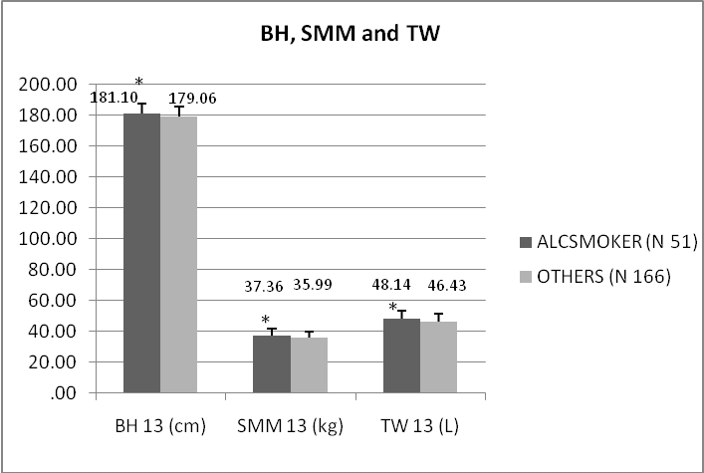

* p < 0.05
Figure 1. Morphological differences between Alcsmoker and other students

