PRILOZI
Table 1
Distribution of risk factors in melanoma patients and controls and analysis
of statistical significance
Risk factors | Groups of participants  Patients Controls |  |  |  | χ² | df | p
Risk factors | No | (%) | N | (%) | χ² | df | p
Level of education  Primary school  Secondary school  College  University degree | 59  185  16  81 | 17,3  54,3  4,7  23,8 | 22  244  15  75 | 6,2  68,5  4,2  21,1 | 24,967 | 3 | <0,0001
Professional UV exposure  Yes | 59 | 17,3 | 129 | 36,2 | 31,699 | 1 | <0,0001
Intermittent exposure  Yes | 233 | 68,3% | 206 | 57,9 | 8,179 | 1 | 0,005
Use if sunbeds  Never  Sometimes  Often | 298  35  8 | 87,4  10,3  2,3 | 336  16  4 | 94,4  4,5  1,1 | 10,371 | 2 | 0,006
Other malignant tumors  Yes | 6 | 1,8 | 3 | 0,8 | 1,149 | 1 | 0,284
Malignant tumors of the skin  Yes | 20 | 5,9 | 48 | 13,5 | 11,481 | 1 | 0,001
Melanoma in family  Yes | 2 | 0,6 | 0 | 0 | 2,094 | 1 | 0,148
Immunosuppressive therapy  Yes | 3 | 0,9 | 8 | 2,2 | 2,097 | 1 | 0,148
HCT*  Yes | 14 | 4,1 | 4 | 1,1 | 6,156 | 1 | 0,013
Sunburns  <14 years  14-19 years  >19 years | 19  32  32 | 5,6  9,4  9,4 | 99  78  72 | 27,8  21,9  20,2 | 61,240  20,560  16,123 | 1  1  1 | <0.0001  <0,0001  <0,0001
Solar damage of the skin  None  Mild  Moderate  Severe | 68  117  98  58 | 19,9  34,3  28,7  17 | 88  144  119  5 | 24,7  40,4  33,4  1,4 | 51,678 | 3 | <0,0001
Use of sunscreens  Never  Sometimes  Often  Always | 156  103  61  21 | 45,7  30,2  17,9  6,2 | 193  60  42  61 | 54,2  16,9  11,8  17,1 | 37,978 | 3 | <0,0001
Fitzpatrick phototype  Type I  Type II  Type III | 7  157  177 | 2,1  46  51,9 | 0  189  167 | 0  53,1  46,9 | 9,932 | 2 | 0,007
Hair color  Black/brown  Light brown/blond  Red | 100  230  11 | 29,3  67,4  3,2 | 163  193  0 | 45,8  54,2  0 | 29,018 | 2 | <0,0001
Eye color  Black/brown  Blue/green | 167  174 | 49  51 | 217  139 | 61  39 | 10,106 | 1 | 0,002
Freckles  Yes | 22 | 6,5 | 23 | 6,5 | 0,000 | 1 | 0,996
Number of common naevi  <50  50-100  >100 | 112  182  47 | 32,8  53,4  13,8 | 263  81  12 | 73,9  22,8  3,4 | 120,085 | 2 | <0,0001
Number of dysplastic naevi  None  1-10  >10 | 220  79  42 | 64,5  23,2  12,3 | 310  41  5 | 87,1  11,5  1,4 | 56,147 | 2 | <0,0001
Congenital naevi  None  Small  Medium  Large | 315  14  5  7 | 92,4  4,1  1,5  2,1 | 293  50  13  0 | 82,3  14  3,7  0 | 31,293 | 3 | <0,0001

*HCT- hormonal contraceptive therapy; df-degree of freedom

Table 2.
Logistic regression model of risk factors for melanoma prediction
Risk factors |  |  |  |  |  |  | 95% CI
Risk factors | β | SE |  | Wald | p | OR | 95% CI
Level of education  Primary school*  Secondary school  College  University degree | -  -1.309  -1.295  -1.351 | -  0.350  0.564  0.398 |  | -  13.973  5.270  11.534 | -  <0.0001  0.022  0.001 | -  0.270  0.274  0.259 | -  0.136-0.536  0.091-0.829  0.119-0.565
Intermittent exposure  Yes | -0.065 | 0.204 |  | 0.102 | 0.749 | 0.937 | 0.627-1.398
Use if sunbeds  Never*  Sometimes  Often | -  1.391  0.957 | -  0.432  0.808 |  | -  10.378  1.403 | -  0.001  0.236 | -  4.018  2.603 | -  1.724-9.366  0.535-12.680
HCT*  Yes | 0.987 | 0.708 |  | 1.946 | 0.163 | 2.683 | 0.670-10.739
Solar damage of the skin  None*  Mild  Moderate  Severe | -  0.104  -0.319  2.113 | -  0.255  0.275  0.579 |  | -  0.168  1.342  13.325 | -  0.682  0.247  <0.0001 | -  1.110  0.727  8.274 | -  0.674-1.830  0.424-1.246  2.661-25.730
Fitzpatrick phototype  Type I  Type II  Type III* | 18.096  -1.248  - | 1.3x10⁴  0.251  - |  | 0.000  24.652  - | 1  <0.0001  - | 7.2x10⁷  0.287  - | 0.000  0.175-0.470  -
Hair color  Black/brown*  Light brown/blond  Red | -  1.170  21.271 | -  0.247  10.2x10³ |  | -  22.380  0.000 | -  <0.0001  1 | -  3.222  1.73x10⁹ | -  1.984-5.231  0.000
Eye color  Black/brown*  Blue/green | -  0.165 | -  0.234 |  | -  0.495 | -  0.482 | -  1.179 | -  0.745-1.866
Number of common naevi  <50*  50-100  >100 | -  1.668  1.273 | -  0.213  0.468 |  | -  61.373  7.399 | -  <0.0001  0.007 | -  5.301  3.570 | -  3.493-8.047  1.427-8.931
Number of dysplastic naevi  None*  1-10  >10 | -  0.983  1.870 | -  0.271  0.602 |  | -  13.197  9.641 | -  <0.0001  0.002 | -  2.672  6.487 | -  1.572-4.540  1.993-21.119
Congenital naevi  None*  Small  Medium  Large | -  -1.148  -2.191  20.501 | -  0.378  0.708  1.36x10⁴ |  | -  9.215  9.586  0.000 | -  0.002  0.002  1 | -  0.317  0.112  8x10⁸ | -  0.151-0.666  0.028-0.448  0.000
*Reference category; β-coefficient of regression; SE-standard error; OR-odds ratio; 95%CI- confidence interval

Fig.1 Distribution of probabilities in controls

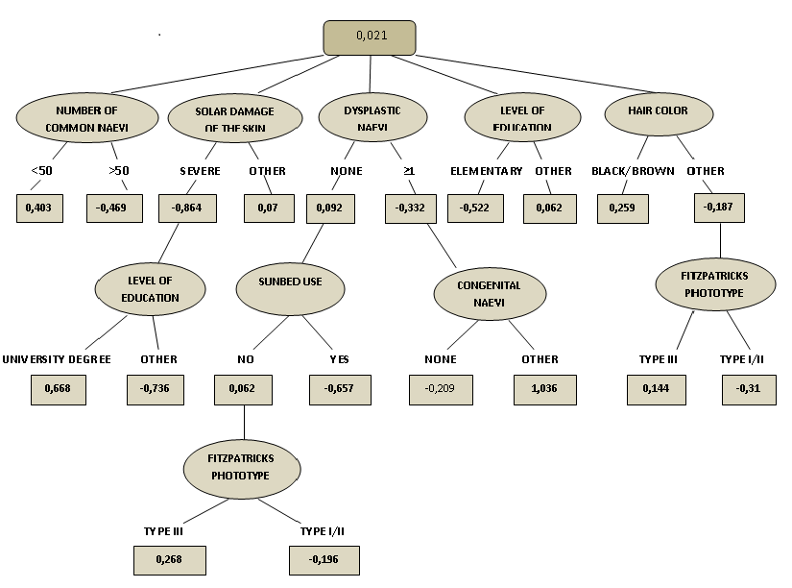
Fig.2 Alternating decision tree

