Dear Editor;

We are submitting an original case report titled “Identification Of Clostridium Septicum In A Tuboovarian Abscess : A Rare Case And Review Of The Literature” to the Journal. It is not a duplicate publication and is not submitted to any other journal. There is no financial or other relationships that might lead to a conflict of interest. The manuscript has been read and approved by all the authors.
Sincerely Yours.
06.04.2013
Ali YAVUZCAN, Gynecologist and Obstetrician

Address: Duzce University Faculty of Medicine , Gynecology and Obstetrics Department.
81000 Konuralp/DUZCE-TURKEY
Tel: 0090 380 5421390
Mobile : 00905326345431
e-mail: draliyavuzcan@yahoo.com

IDENTIFICATION OF CLOSTRIDIUM SEPTICUM IN A TUBOOVARIAN ABSCESS : A RARE CASE AND REVIEW OF THE LITERATURE
(CLOSTRIDIUM SEPTICUM AND TUBOOVARIAN ABSCESS)
Ali Yavuzcan* , Mete Çağlar* , Serdar Dilbaz * , Selahattin Kumru * , Fatma Avcıoğlu ** ,Yusuf Üstün *
* M.D., Department of Obstetrics and Gynecology, Düzce University Faculty of Medicine, Düzce
** M.D., Department of Microbiology, Düzce University Faculty of Medicine, Düzce
Correpondence to: Ali YAVUZCAN , M.D., Department of Obstetrics and Gynecology, Duzce University Faculty of Medicine, 81000 Konuralp/DUZCE-TURKEY
Tel: 0090 380 5421390
Mobile : 00905326345431
e-mail: draliyavuzcan@yahoo.com
Mete Çağlar,M.D., Department of Obstetrics and Gynecology, Duzce University Faculty of Medicine, Düzce
e-mail: drmete96@gmail.com
Serdar Dilbaz, M.D., Department of Obstetrics and Gynecology, Duzce University Faculty of Medicine, Düzce
e-mail: sdilbaz@gmail.com
Selahattin Kumru, M.D., Department of Obstetrics and Gynecology, Duzce University Faculty of Medicine, Düzce
e-mail: selahattinkumru@gmail.com
Fatma Avcıoğlu, M.D., Department of Microbiology, Duzce University Faculty of Medicine, Düzce
e-mail: fatmaavcioglu@yahoo.com.tr
Yusuf Üstün, M.D., Department of Obstetrics and Gynecology, Duzce University Faculty of Medicine, Düzce
e-mail: ustunyusuf@gmail.com

The authors have nothing to disclose.

Identification Of Clostridium Septicum In A Tuboovarian Abscess : A Rare Case And Review Of The Literature
Abstract
Background: A tuboovarian abscess ( TOA) is a conglomerated mass of pelvic organs including tube, ovary, and bowel.The most commonly isolated organisms from TOAs are Escherichia coli(E.coli) and Bacteroides species. Case Report: We reported a case of Clostridium Septicum(C. Septicum) infection from a ruptured TOA disease that had atypical clinical features. Culture of intraabdominal free fluid obtained during surgery yielded C. septicum.VITEK II (bioMérieux, France) automated system was used for advanced identification of the bacteria. Conclusions : The infected tissues with C.septicum can become necrotic. Combination of early , adequate antibiotic therapy and surgery is the key point of treatment.
Keywords: abscess ; Clostridium septicum ; tuboovarian.
Aпстрактан
Позадина: тубоовариан апсцес (ТОА) је мешовиту маса карличних органа, укључујући цеви, јајника, и бовел.Тхе најчешће изолованих организама са тоас су Есцхерицхиа цоли (Е. цоли) и Бацтероидес врста. Случаја: Ми смо пријавили случај Цлостридиум Септицум (Ц. Септицум) инфекције из покиданих ТОА болести која је имала атипичне клиничке карактеристике. Култура интраабдоминалног слободне течности добијене током операције дала Ц. септицум.ВИТЕК ИИ (биоМериеук, Француска) аутоматизовани систем је коришћен за напредне идентификацију бактерија. Закључак: инфицираних ткива са Ц.септицум може да постане некротичног. Комбинација ране, адекватне антибиотске терапије и операције је кључна тачка лечења.
Кључне речи: апсцес, Цлостридиум септицум; тубоовариан.

Identification Of Clostridium Septicum In A Tuboovarian Abscess : A Rare Case And Review Of The Literature

INTRODUCTION
Pelvic inflammatory disease(PID), which is characterized by containing a polymicrobial infection in the upper genital tract inflammation, can include endometritis, salpingitis, and tubaovarian abscess(TOA).It is generally caused by sexually transmitted infections(STIs) such as Chlamydia trachomatis and Neisseria gonorrhoeae that spread upward from the lower genital tract, infecting and causing inflammation of the uterus, fallopian tubes, and ovaries(1). Anaerobic bacteria, and facultative bacteria are the other microorganisms in the pathogenesis of PID(2). PID is one of the most common causes of hospitalization for gynecologic disorders among reproductive age. In the United States ,770,000 cases of PID are diagnosed every year (3) . The annual cost of PID and its consequences is estimated to be $4.2 billion (4). PID is usually sexually active women's disease. It may be the cause of sepsis and mortality in untreated cases. A TOA can be detected in about 15% of women with PID. TOA develops in up to 34% of patients hospitalized for PID(5).
An end-stage process of acute PID is a TOA. It is a conglomerated mass of pelvic organs including tube, ovary, and bowel . Severe acute PID usually generates this disease. TOA could be defined in 18–34% of patients with PID (5). Risk factors for TOA are similar to that of PID and include multiple sexual partners, intrauterine device, and low socioeconomic status (6). Since the disease commonly is caused by the STIs, intercourse with a partner having infection is the most important risk factor in TOA formation. However, gynecologic surgery, genital malignancy, in vitro fertilization treatment, and perforated appendicitis have also been shown to cause TOA (7).
The association of Clostridium species ,which are gram positive, anaerobic, spore former , usually found in the soil and gastrointestinal tract, with post-traumatic and surgical wound complications is well known. 80-90% of all Clostridial infections occur due to C.perfrigens. C.septicum is isolated at 4-20% of clostridial infections(8). Spontaneous C.septicum infections are rare and associated with cyclical neutropenia, diabetes mellitus and immunosupression.A strong association of spontaneous C.septicum infection with haematological and colorectal malignancies is known.Cerebral abscess and aortic-ring abscess due to C.septicum have been also reported before (9,10). A survival rate of only 35% of patients who were infected with C. septicum regardless of the presence of an occult malignancy versus a clinically evident malignancy. It is mandatory to carry out a systematic and aggressive approach to the treatment of these patients (11).A ruptured TOA and septic shock with Clostridium perfringens in a postmenopausal woman was reported(12). Clostridium sordellii and Clostridium perfringens are responsible for toxic shock after medical and spontaneous abortions (13).
We reported a rare case of C.septicum infection from a ruptured TOA disease that had atypical clinical features.

CASE
A 38 year-old Caucasian woman, para II, gravida II was referred to our department with a pelvic mass. She presented with 10-day history of nausea , vomiting and right lower abdominal pain. She had a regular menstrual cycle, her history revealed two unremarkable cesarean sections. She had a total thyroidectomy. The patient did not have a personal and familial history of gastrointestinal disorders. She was not receiving immunosuppressive therapy. She had not received treatment for cancer. She had her IUD removed two months ago after having it for several years.
On physical examination, there was right lower quadrant tenderness.There was guarding of muscle. She had white vaginal discharge. A large, immobile, 12×10-cm semisolid mass at the right adnexal region was palpated via bimanual pelvic exam. There was a fixed retroverted uterus. The uterosacral ligaments and parametrium were not tender.The patient was afebrile.Vital signs were in normal ranges.Laboratory investigations revealed a high white blood cell count of 32900/μl , 90% of which comprised segmented neutrophils and a high trombosit count of 722000/μl. Serum CRP level was found to be high.It was 48.1 mg/dl. Blood urea nitrogen (BUN), was 29 mg/dl; serum creatinine was 2.88 mgidl; and uric acid was 8.6 mg/dl.Our sonographic examination showed a 125×72-mm semisolid , heterogenous mass at the right adnexal region(Figure 1). There was fluid in the pouch of Douglas.
Fig. 1. Preoperative transvaginal view of pelvis.
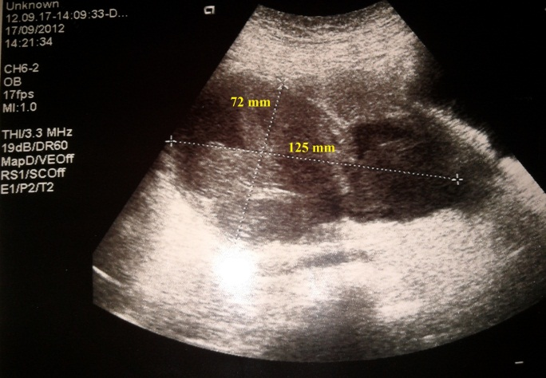

The serum levels of CA-125 , CA-19-9 ,CEA and AFP were 15.11 , 14.30 , 1.63 and 1.61 U/mL, respectively. The patient’s serum Beta-human chorionic gonadotropin (hCG) level was 0.1 IU/L. She was negative for hepatitis B surface antigen. Antibody testing for HIV and HCV was done on serum specimens. Tests were negative. Clindamycin was used in combination with an aminoglycoside by the parenteral route. The patient underwent laparotomy with a preoperative diagnosis of pelvic abscess. Mid-line laparotomy was performed. About 2000 cc. of infected fluid and pus located inside the abdominal cavity. After draining , it was seen that the right tubo-ovarian abscess had already ruptured and adhered to the ileum,sigmoid colon and rectum. Sample of the peritoneal free fluid was taken. Dense adhesions between the mass and other pelvic structures were seen. Right tuboovarian complex was removed. Right salphingooferectomy was performed. Samples of free fluid were were cultured onto chocolate agar, blood agar, and Eosin Methylene-blue Lactose Agar.Two preparats were prepared and evaluated with gram staining at the same time. Anaerobic culture media was putted in a jar and oxygen-free environment was provided with using dry process gas packet (AnaeroGen - Oxoid, Basingstoke, UK veya GENbox-bioMérieux, Lyon, France) . Then chocolate agar was placed in the waxy jar. All of the media had been incubated at 35-37°C for 48 hours. There was not bacterial overgrowth in blood culture. Bacteria that did not live or grow in the presence of oxygen was accepted as anaerobic bacteria. The structure of the colony was analyzed.Gram stain was performed to help identify colonies isolated from cultures.Also VITEK II (bioMérieux, France) automated system was used for advanced identification of the bacteria. Large gram positive, spore forming, obligate anaerobic, rod-shaped and motile bacteria(C. septicum) were obtained from intraabdominal free fluid (Figure 2).
Fig. 2. C. septicum obtained from intarabdominal free fluid.
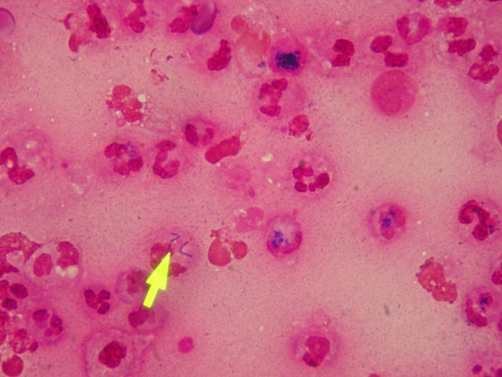
Combined upper and lower gastrointestinal endoscopy performed after detection of C. septicum in order to eliminate a potential neoplasm of the gastrointestinal tract. The Computed tomography(CT) scan of chest, abdomen and pelvis was done. No tumor was visualized. Postoperative CT scans also showed contrast enhancement in the previous operation site (Figure 3). The patient was discharged 19 days after surgery. She was clinically asymptomatic 6 months after surgery.

Fig. 3. Postoperative CT scan of the operation site.
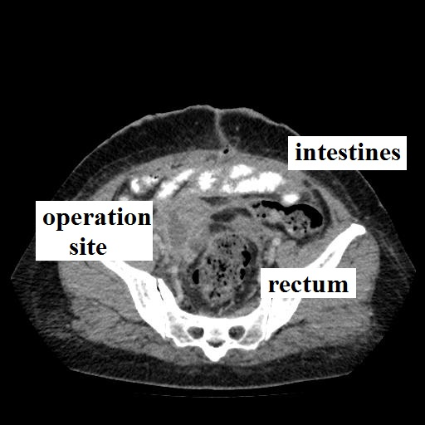

DISCUSSION
Various gynecological and non-gynecological pathologies can be presented as pelvic masses. Infectious diseases should be considered in differential diagnosis .Following an acute salpingitis, fallopian tubes become distended with purulent material creating a TOA. PID can lead to tubal scarring and stenosis which become distended as the tubal secretions accumulate within the tubal lumen. This process leads to the formation of hydrosalpinx and presents as a tubular pelvic mass. Both of these conditions can be chronic or acute and should be always suspected in any woman with a history of malodorous cervical discharge, pelvic pain and fever (14). A purely clinical approach using the findings of lower genital tract inflammation (leukorrhea) associated with pelvic organ tenderness will identify the vast majority of women with PID(15).The uterosacral ligaments and parametrium of our patient were not tender.There was no fever ,malodorous cervical discharge or no history of PID .It was quite difficult to diagnose preoperatively.
Infections due to Neisseria gonorrhoeae, like those resulting from Chlamydia trachomatis, are a major cause of PID in the United States(16). But Neisseria gonorrhoeae and chlamydia are rarely recovered from an abscess . The most commonly isolated organisms from TOAs are E. coli and Bacteroides species (17). There is an association between the presence of the vaginal flora bacteria and/or actinomycetes and TOA in women who use IUDs.There is an increased risk of ascending infection. IUD tails facilitate the transfer of bacteria from of the vagina/cervix to the upper genital tract(18). Our patient used to have IUD but she had her IUD removed 2 months ago. No vaginal bacteria or actinomycetes in the specimens could be detected.
C.septicum causes myonecrosis through the release of exotoxins such as the alpha toxin, lethal toxin, and hemolytic toxin. They were initially believed to be non- pathogenic. On the other hand; alpha toxin of C.septicum is necrotic and lethal. Bacteremic infections with C.septicum are associated with a mortality of 68% and should be treated as a medical emergency (19). Owing to its’ anaerobic nature , C.septicum can be detected in areas of decreased blood flow. C. septicum infections are often detected in individuals with a recent history of trauma, surgery, peripheral vascular disease, diabetes, colon cancer, skin infections or burns and septic abortions (20). The diagnosis of C. septicum-associated large bowel malignancy may be delayed or missed. Clinical manifestations are commonly nonspecific, mimicking more common disorders. At times, no clinical clue to a colon malignancy is present. Some clinicians may be unaware of the association. Bacterial sepsis may be the initial feature of previously undiagnosed and unsuspected large bowel carcinoma(21). There are some atypical presentations of C.septicum infections have been reported in recent years. The possible mechanism of these unusual presentations is generally hematogenous seeding of microorganism and defective circulation. Halak et al. reported a C. septicum infection at aortic graft.The patient had an abdominal aortic aneurysm reducing blood flow in the affected areas (22). It was reported that myonecrosis caused by C. septicum in an immunosuppressed patient who did not have colon cancer, but rather colonic mucosal inflammation produced by C. difficile (23). C. septicum infection may be detected in the orbita,brain,aorta and lower limp (24-28). E. coli may be a concomitant or predisposing factor (25). A rare mechanism is direct extension of infection, such as from incarcerated internal hernia (29). In 2009 Wagner et al. reported a ruptured tuboovarian abscess and septic shock with Clostridium perfringens in a postmenopausal woman. The hysterectomy specimen of that patient revealed endometrial carcinoma(12). A fatal case of Clostridium sordellii septic shock syndrome associated with medical abortion(31). Endomyometritis and toxic shock associated with Clostridium sordellii and Clostridium perfringens after medical and spontaneous abortion is well known (13). Necrotising endomyometritis due to C. Sordellii infection may be notable for lack of fever, hemoconcentration, and a profound leukocytosis (32). These properties remarkably similar to those of ruptured TOA due to C. Septicum. Ruptured TOA due to C. Septicum due to is an extremely rare phenomenon.After her evaluation , malignancy could be definitively ruled out in our patient. She, however, was not treated with immunosuppressive drugs.There was no evidence of immunosuppression.
Table 1. Recent cases of atypical presentations
References | Localization | Predisposing disease | Concominant infection
Halak et al. (22) | Aortic graft | abdominal aortic aneurysm | none
Gnerlich et al. (23) | colon | end-stage renal disease and immunodeficiency syndrome | C. difficile colitis
Fejes et al. (24) | orbita | colon tumour and lymphatic malignancy | none
Williams et al. (25) | Brain abscess | haemolytic uraemic syndrome | E. coli 0157
Annapureddy et al. (26) | aorta | atheromatous disease of the aorta | none
Rewa and Smith (27) | Lower limp compartment syndrome | non-Hodgkin's lymphoma | none
Ge and de Virgilio (28) | aorta | sigmoid colon adenocarcinoma. | none
Granok et al.(29) | lung pleura | incarcerated internal hernia | none
Burnell et al. (30) | prosthetic joint of knee | colonic malignancy | none

There are few large randomized trials guiding appropriate clinical management of TOA, including antibiotic selection and timing of surgical management and drainage (33). Radiographic size, leukocyte count, age, and parity are associated with operative or procedural treatment of tuboovarian abscess (34). Originally, treatment of TOA was thought to perform bilateral oophorectomy and hysterectomy. Medical management with broad spectrum antibiotics is nowadays generally considered as the initial management for unruptured TOAs(2). Center for Disease Control and Prevention Sexually Transmitted Diseases Treatment Guidelines recommended inpatient intravenous antibiotics for at least 24 hours. No specific inpatient antibiotic regimen was suggested. Upon discontinuation of parenteral therapy, the CDC recommended that clindamycin or metronidazole be used with doxycycline for a total of 14 days of treatment (35). The best treatment alternative for ruptured TOA is surgery. Parenteral antibiotic therapy can not be adequate for complete healing. Patients with larger abscesses usually need surgery (34,36). DeWitt et al. reported a 60% failure rate of antibiotic treatment for abscesses with diamension of ≥10 cm (34). After intravenous antibiotics terapy , we performed a salphingooferectomy(36).
C.septicum may cause PID and TOA in patients without any predisposing factor. Diagnosis of TOA due to C.septicum is very hard. Lack of fever and malodorous cervical discharge , no history of PID , no pain on movement of cervix are diffuculties. The infected issues with C.septicum can become necrotic. Combination of early , adequate antibiotic therapy and surgery is the key point of treatment. Although there was not any malignancy in our patient , malignancy should be kept in mind for all kinds of infecions due to C.septicum.
* The authors have nothing to disclose.

References
- Susan M. Pelvic inflammatory disease and tubo-ovarian abscess. Infect Dis Clin N Am 2008; 22:693-708.
- Sweet RL. Pelvic Inflammatory Disease. Tubo-ovarian abscess. London, UK: Taylor & Francis ; 2006 . p. 101–124.
- Sutton MY, Sternberg M, Zaidi A, Louis MES, Markowitz LE. Trends in pelvic inflammatory disease hospital discharges and ambulatory visits, United States, 1985–2001. Sexually Transmitted Diseases 2005; 32:778–784.
- Quan M. Pelvic inflamamatory disease: diagnosis and management. J Am Board Fam Pract 1994; 7:110-123.
- Beigi RH, Wiesenfeld HC. Pelvic inflammatory disease: new diagnostic criteria and treatment. Obstet Gynecol Clin North Am 2003; 30:777-93.
- Washington AE, Aral SO, Wølner-Hanssen P, Grimes DA, Holmes KK.Assessing risk for pelvic inflammatory disease and its sequelae. JAMA 1991 ;13: 2581-2586.
- Protopapas AG, Diakomanolis ES, Milingos SD, Rodolakis AJ, Markaki SN, Vlachos GD, et al.Tubo-ovarian abscesses in postmenopausal women: gynecological malignancy until proven otherwise? European Journal of Obstetrics Gynecology and Reproductive Biology 2004;114:203–209.
- Mayer G, Kang R. Gas gangrene, diabetes, and cholecystitis. Am J Emerg Med 1985;3:42–45.
- Marangou AG, Joske RA, Kaard AO, Thomas W. Cerebral abscess due to Clostridium septicum. J R Soc Med 1992;85:641.
- Cohen CA, Almeder LM, Israni A, Maslow JN. Clostridium septicum endocarditis complicated by aortic-ring abscess and aortitis. Clin Infect Dis 1998 ; 26 :495-496.
- Kornbluth A, Danzig J, Bernstein L. Clostridium septicum infection and associated malignancy. Medicine 1989;68:30–37.
- Wagner A, Russell C, Ponterio JM, Pessolano JC. Ruptured tuboovarian abscess and septic shock with Clostridium perfringens in a postmenopausal woman: a case report.J Reprod Med 2009 ;54:652-654.
- Cohen AL, Bhatnagar J, Reagan S, Zane SB, D'Angeli MA, Fischer M, et al. Toxic shock associated with Clostridium sordellii and Clostridium perfringens after medical and spontaneous abortion. Obstet Gynecol 2007;110(5):1027-1033.
- Stenchever MA, Droegenmueller W, Hebrst AL.Differential diagnosis of major gynecological problems by age group. In: Comprehensive gynecology.Harcourt Health Sciences Company; 2001. p. 137-155.
- Jaiyeoba O, Soper DE. A practical approach to the diagnosis of pelvic inflammatory disease.Infect Dis Obstet Gynecol 2011;2011:753037.
- Centers for Disease Control and Prevention. 2011 Sexually Transmitted Diseases Surveillance. 2012;December 13.
- Landers DV, Sweet RL.Tubo-ovarian abscess: contemporary approach to management.Rev Infect Dis 1983 ; 5 :876-884.
- Toglia MR, Schaffer JI. Tubo-ovarian abscess formation in users of intrauterine devices remote from insertion: a report of three cases. Infect Dis Obstet Gynecol 1996 ;4 :85-88.
- Johnson S, Driks MR, Tweten RK, Ballard J, Stevens DL, Anderson DJ, et al. Clinical courses of seven survivors of Clostridium septicum infection and their immunologic responses to alpha toxin. Clin Infect Dis 1994;19:761-764.
- Smith-Slatas CL, Bourque M , Salazar JC. Clostridium septicum infections in children: a case report and review of the literature. Pediatrics 2006 ; 117 : 796-805.
- Mao E, Clements A, Feller E. Clostridium septicum Sepsis and Colon Carcinoma: Report of 4 Cases. Case Rep Med 2011;2011:248453.
- Halak M, Heldenberg E, Silverberg D, Schneiderman J. Clostridium septicum post-endovascular aneurysm repair stent-graft infection. Vascular 2012;20:104-106.
- Gnerlich JL, Ritter JH, Kirby JP, Mazuski JE. Simultaneous necrotizing soft tissue infection and colonic necrosis caused by Clostridium septicum. Surg Infect (Larchmt) 2011;12:501-506.
- Fejes I, Dégi R, Végh M. Clostridium septicum gas gangrene in the orbit: a case report. Infection 2013 0;41:267-270.
- Williams EJ, Mitchell P, Mitra D, Clark JE. A microbiological hazard of rural living: Clostridium septicum brain abscess in a child with E coli 0157 associated haemolytic uraemic syndrome. BMJ Case Rep 2012; 25;2012.
- Annapureddy N, Agarwal SK, Kanakadandi V, Sabharwal MS, Ammakkanavar N, Simoes P, et al. Clostridium septicum aortitis in a patient with extensive atheromatous disease of the aorta. J Infect Chemother 2012;18:948-950.
- Rewa O, Smith CA. Medical cause of compartment syndrome: a fatal case of Clostridium septicum. BMJ Case Rep 2012;2012: pii: bcr1220115434.
- Ge PS, de Virgilio C. Clostridium septicum aortitis with associated sigmoid colon adenocarcinoma. Ann Vasc Surg 2012;26:280.
- Granok AB, Mahon PA, Biesek GW. Clostridium septicum Empyema in an Immunocompetent Woman. Case Rep Med 2010;2010:231738.
- Burnell CD, Turgeon TR, Hedden DR, Bohm ER. Paraneoplastic Clostridium septicum infection of a total knee arthroplasty. J Arthroplasty 2011 ;26:666.
- Wiebe E, Guilbert E, Jacot F, Shannon C, Winikoff B. A fatal case of Clostridium sordellii septic shock syndrome associated with medical abortion.Obstet Gynecol 2004;104:1142-1144.
- Centers for Disease Control and Prevention (CDC). Clostridium sordellii toxic shock syndrome after medical abortion with mifepristone and intravaginal misoprostol--United States and Canada, 2001-2005. MMWR Morb Mortal Wkly Rep 2005;54(29):724.
- Chappell CA, Wiesenfeld HC. Pathogenesis, diagnosis, and management of severe pelvic inflammatory disease and tuboovarian abscess.Clin Obstet Gynecol 2012;55:893-903.
- Greenstein Y, Shah AJ, Vragovic O, Cabral H, Soto-Wright V, Borgatta L, et al. Tuboovarian abscess. Factors associated with operative intervention after failed antibiotic therapy. J Reprod Med 2013;58:101-106.
- Center for Disease Control and Prevention. Sexually Transmitted Diseases Treatment Guidelines 2006.
- Dewitt J, Reining A, Allsworth JE, Peipert JF. Tuboovarian abscesses: is size associated with duration of hospitalization & complications? Obstet Gynecol Int 2010;2010:847041.

Table 1. Recent cases of atypical presentations
References | Localization | Predisposing disease | Concominant infection
Halak et al. (22) | Aortic graft | abdominal aortic aneurysm | none
Gnerlich et al. (23) | colon | end-stage renal disease and immunodeficiency syndrome | C. difficile colitis
Fejes et al. (24) | orbita | colon tumour and lymphatic malignancy | none
Williams et al. (25) | Brain abscess | haemolytic uraemic syndrome | E. coli 0157
Annapureddy et al. (26) | aorta | atheromatous disease of the aorta | none
Rewa and Smith (27) | Lower limp compartment syndrome | non-Hodgkin's lymphoma | none
Ge and de Virgilio (28) | aorta | sigmoid colon adenocarcinoma. | none
Granok et al.(29) | lung pleura | incarcerated internal hernia | none
Burnell et al. (30) | prosthetic joint of knee | colonic malignancy | none

Fig. 1. Preoperative transvaginal pelvic ultrasonography view

Fig. 2. Clostridium septicum obtained from intarabdominal free fluid.

Fig. 3. Postoperative view of operation site

