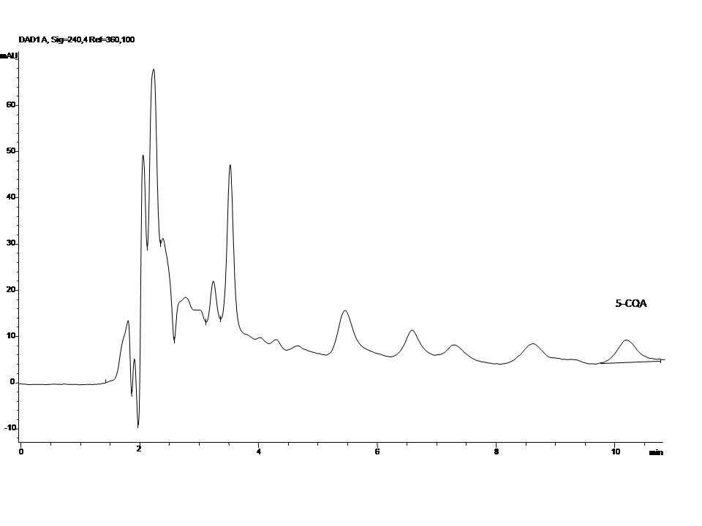
Figure 1. HPLC-DAD chromatogram of analyzed commercial tea sample (sample number 6)

