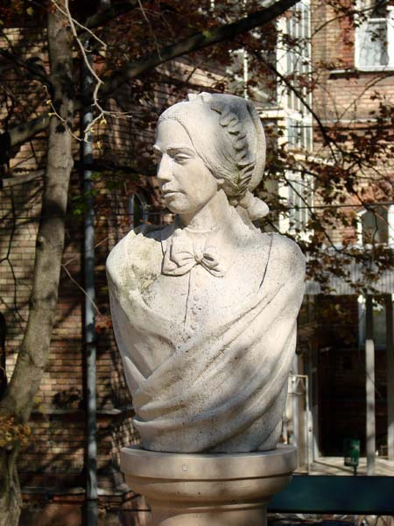
Figure 7. The sculpture of Zsuzsanna Kossuth in Budapest

