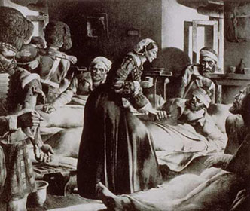
Figure 3. Helping to wounded

