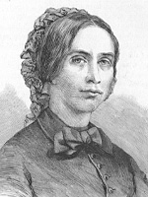
Figure 1. Zsuzsanna Kossuth (1817-1854)

