Figure 1.

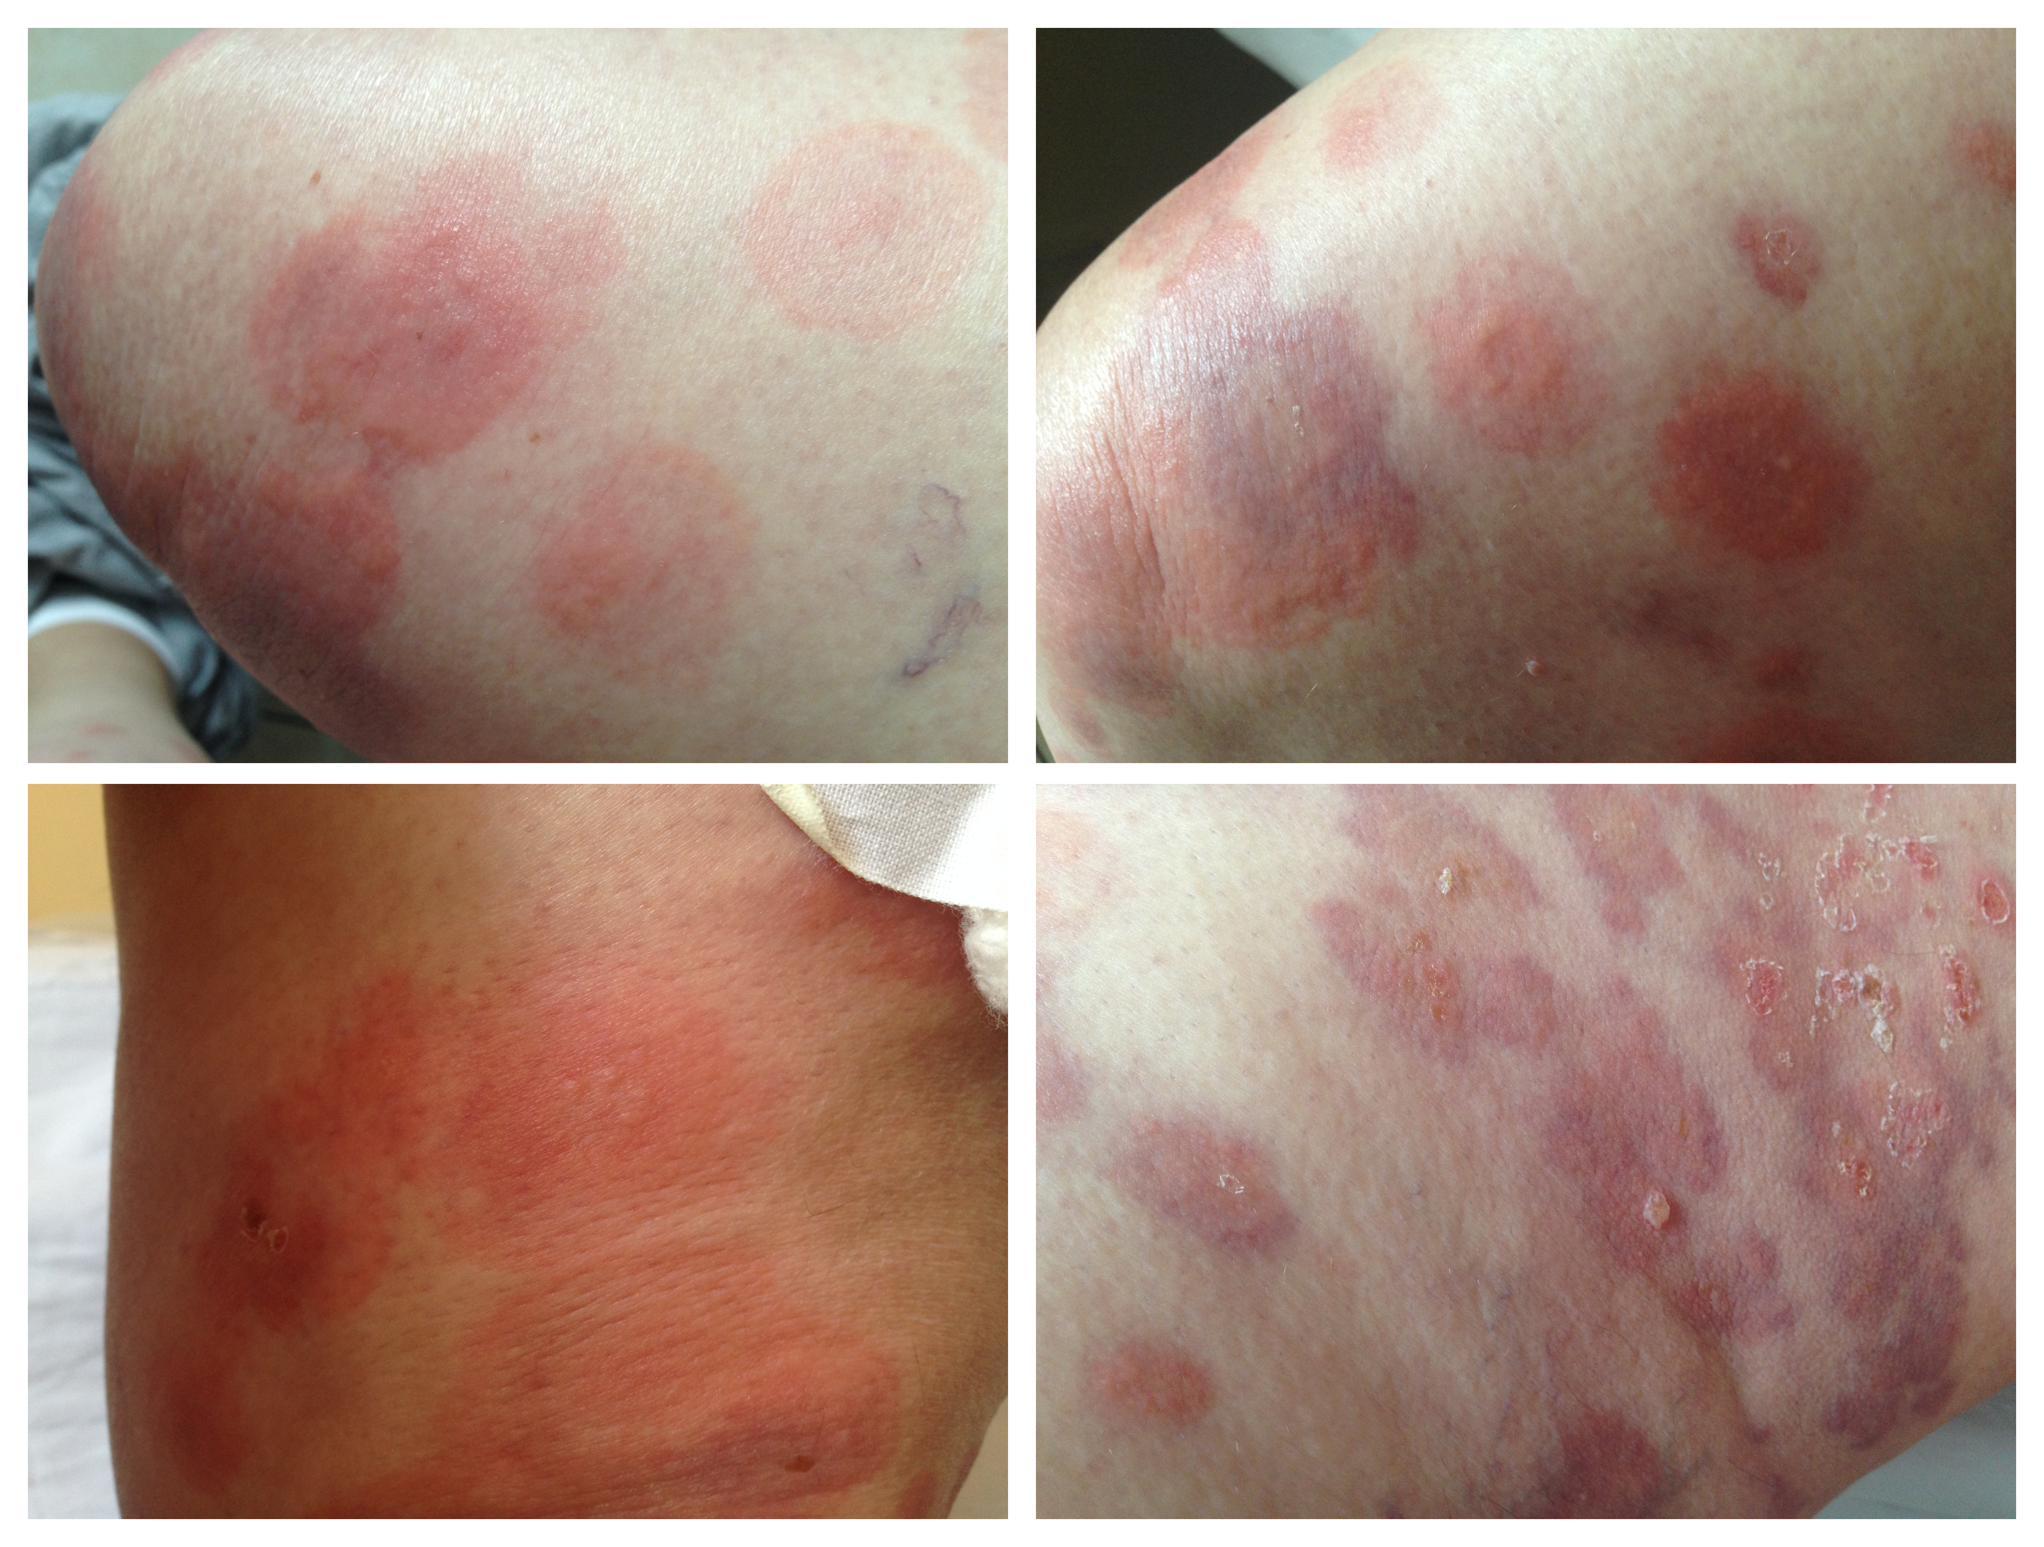

Figure 2.

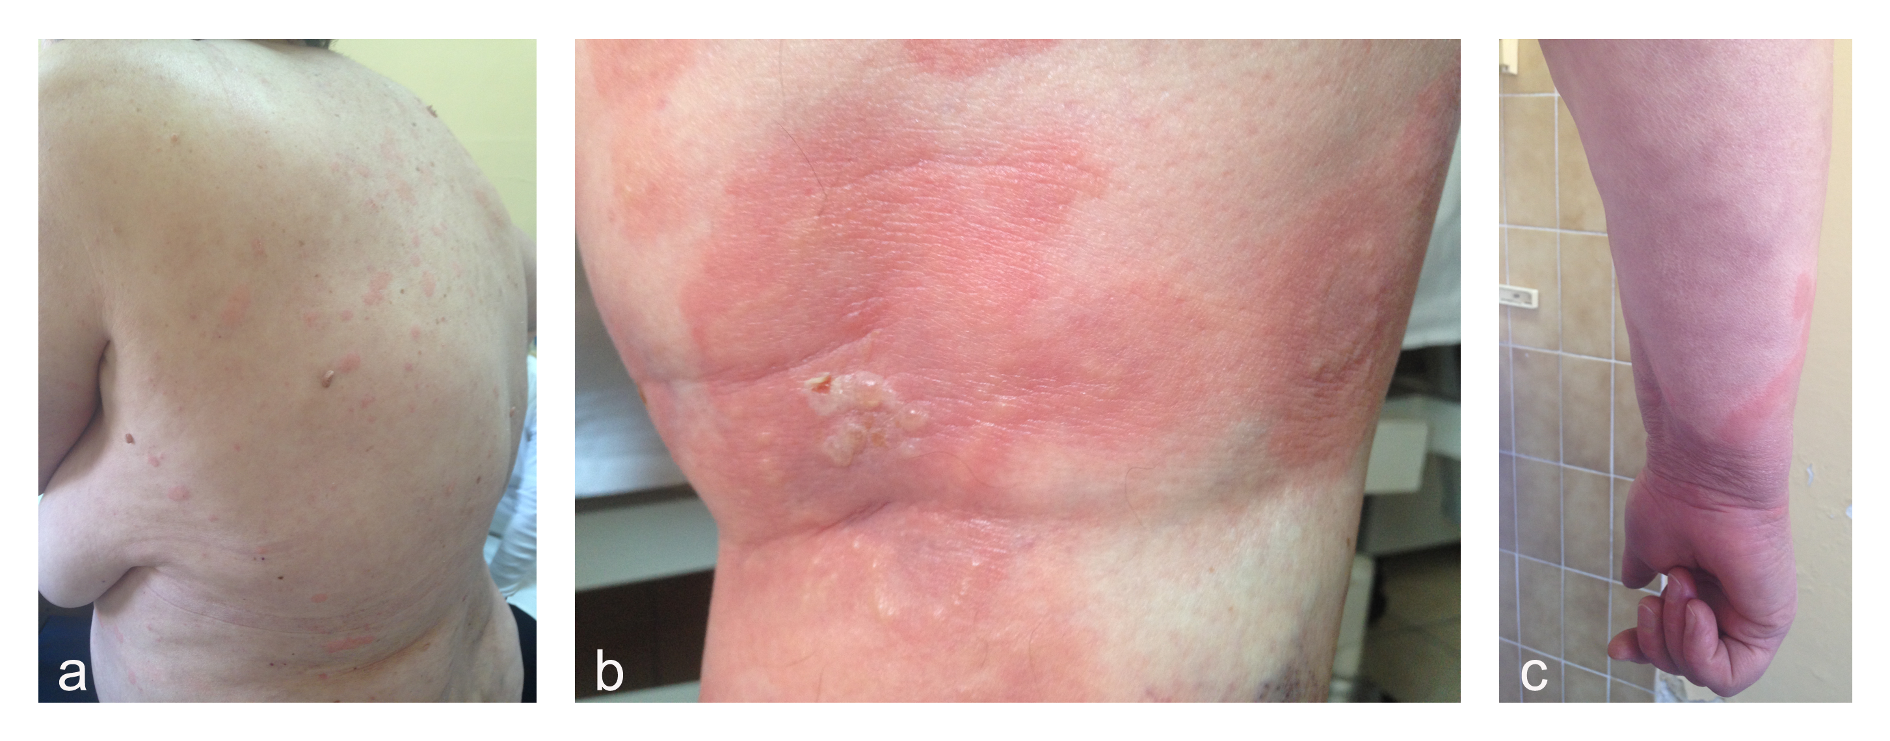

Figure 3.

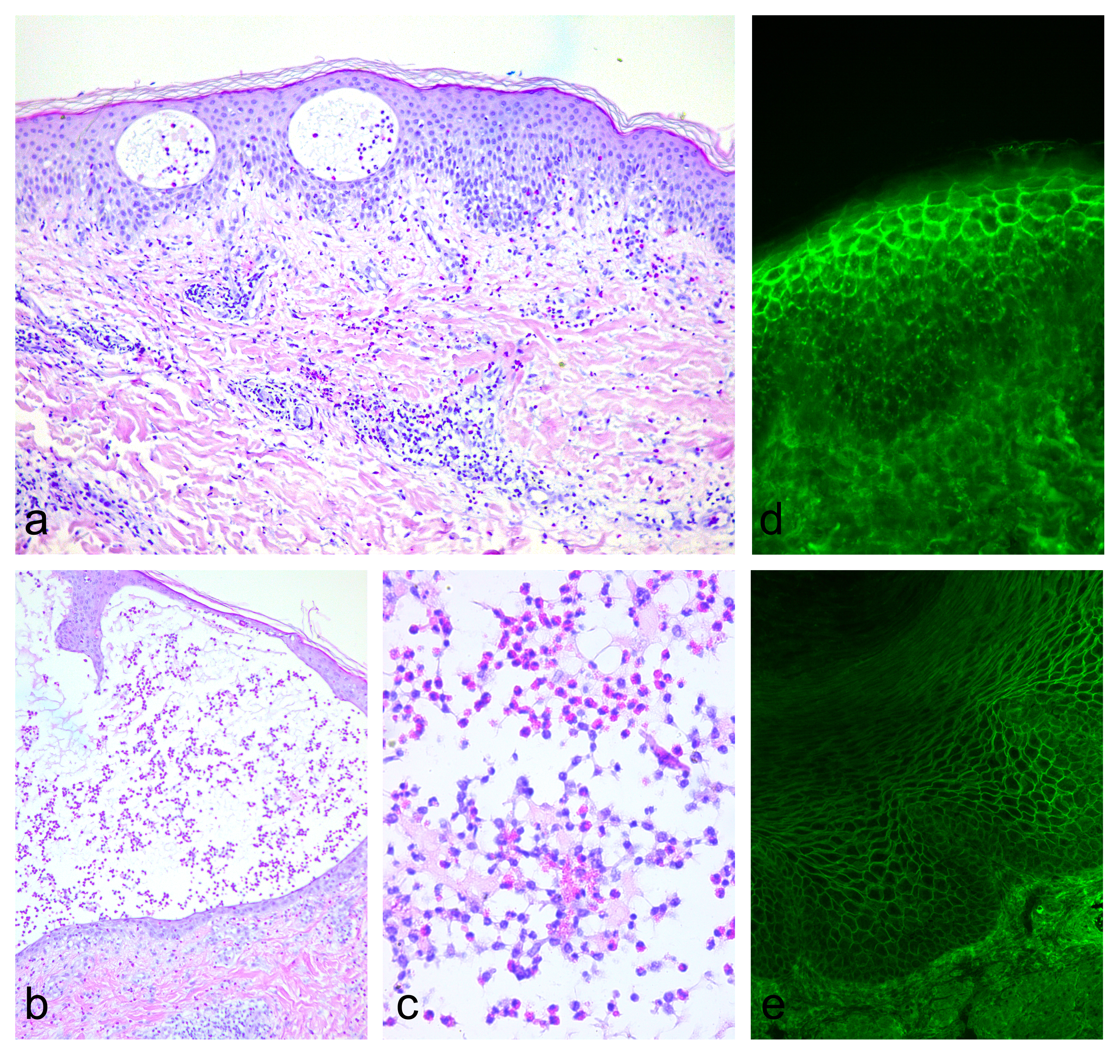

Figure 1. Pemphigus herpetiformis. Groups of small and abortive vesicles, in herpetiform pattern, on erythematous plaques.

Figure 2. Pemphigus herpetiformis. (a) Erythematous, urticarial plaques on the trunk. (b) Tense, vesicles on erythematous base on the leg. (c) Annular erythematous, edematous plaques on the distal arm.

Figure 3. Pemphigus herpetiformis. (a) Spongiosis and intraepidermal vesicles with eosinophils (HE 40x) (b) Spongiotic vesicle containing numerous eosinophils and neutrophils (HE200x) (c) Numerous eosinophils within vesicle (HE400x) (d) Direct immunofluorescence of perilesional skin showing intercellular deposits of IgG, more prominent in the upper layers of the epidermis. (e) Indirect immunofluorescence on monkey esophagus demonstrating intercellular distribution of anti-IgG antibodies in the patienst’s sera (1:320).

