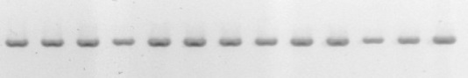
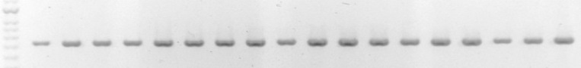
M P1 P4 P5 P7 P9 P10 P13 P14 P18 P21 P22 P27 P28 P29 P37 P40 P42 P43 P44 P45 P46 P47 P48 P51 P52 P53 P54 P56 P57 P58 R
533 bp

Fig. 1 B. cereus group specific PCR. Line M: 100 bp DNA ladder; Lines P1-Z58: B. cereus isolates; Line R: reference strain B. cereus ATTC 11778

