Figure 1. Preoperative appearance of the patient. A. an face. B. right halfprofile. C. left halfprofile
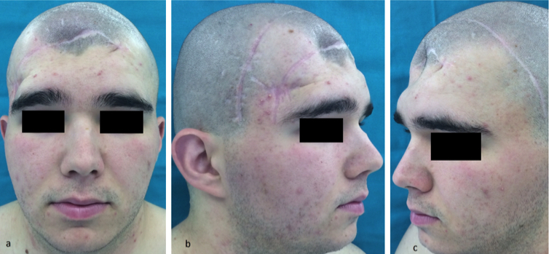
Figure 2. Preoperative multislice computerized tomography showing the complex defect of the skull.
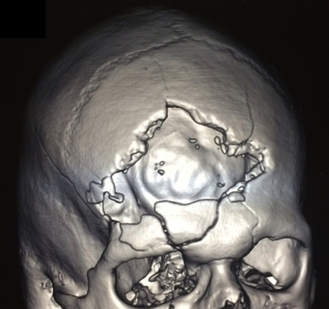
Figure 3. PEEK OPTIMA implant fixed with titanium screws and stars.
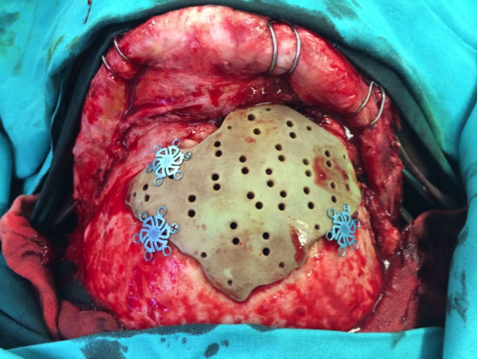
Figure 4. Multislice computerized tomography (3D reconstruction) on the first postoperative day showing the fixed PEEK OPTIMA implant.
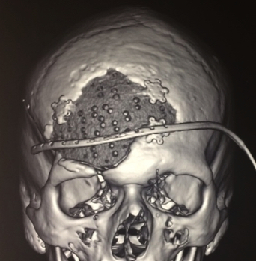
Figure 5. Postoperative appearance of the patient A. an face. B. right halfprofile. C. left halfprofile

