CONSERVATIVE TREATMENT OF BRONCHOBILIARY FISTULA EVALUATED

WITH MAGNETIC RESONANCE IMAGING

Tatjana N.Adžić-Vukičević ^{1,2}, Ana Z.Blanka², Aleksandra M.Ilić ^{1,2}, Snežana V.Raljević ^{1,2}, Ružica M.Maksimović ³, Srđan P.Đuranović ⁴

¹ School of Medicine, University of Belgrade , Belgrade
² Clinic for pulmonology,Clinical Centre of Serbia, Belgrade
³ Centre for radiology and magnetic resonance imaging,Clinical Centre of Serbia, Belgrade
⁴ Clinic for gastroenterology, Clinical Centre of Serbia, Belgrade

E-mail addresses:
adzic_tatjana@yahoo.com, ana_blanka@yahoo.com, sanjadudvarski@yahoo.com,sneza.raljevic@gmail.com,
ruzica.maksimovic@med.bg.rs,gastroendo@beotel.rs

*Corresponding author: Tatjana N.Adžić-Vukičević,School of Medicine, University of Belgrade, Clinic for pulmonology, Clinical Centre of Serbia,11000 Belgrade, Višegradska 26/20, Serbia, Tel./fax+381113663961,adzic_tatjana@yahoo.com

Abstract
Introduction
Bronchobiliary fistula (BBF) is an abnormal communication between the bronchial system and biliary tree, presents with bilioptysis. Many conditions can cause its development. There is still no optimal therapy for BBF. Conservative treatment is rarely indicated, as was published before in a few cases.

Case presentation
We present a 71-year-old Caucasian Serbin woman with bronchobiliary fistula secondary to previous laparotomy due to multiple echinococcus liver cysts. Diagnosis was established by presence of bilirubin and bile acids in sputum and MRCP (Magnetic Resonance Cholangiopancreatography). Repeat MRCP performed after conservative procedure, did not reveal fistulous communication.

Conclusion
We suggest that in cases of small and less severe fistulas between biliary and bronchial tracts, conservative treatment may be used with successful result, and invasive treatment methods are not needed in all patients.

Key words: bilioptysis,fistula,treatment

Introduction

BBF is defined as the passage of bile in the bronchi and presence of bile in the sputum (bilioptysis). The most common causes are trauma, bile duct obstruction, and liver infections such are hydatid cysts, echinococcosis, or amebic abscess [1]. It can occur, rarely, in the congenital form [2].Therapeutic options include surgical repair or minimal invasive teatment such are nasobiliary drainage, ERCP (endoscopic sphincterotomy and biliary stenting) and percutaneous drainage. Herein, we describe a case of BBF after liver echinococcosis treated conservatively.

Case presentation

A 71-year-old Caucasian Serbian woman was admitted to our hospital with a 2-month history of bilioptysis. The patient had history of laparotomy one year previously because of multiple echinococcus liver cysts. Pericystectomy was done with omentoplasty and cholecystectomy. Eight months after operation an abdominal ultrasound revealed fluid collection in liver. Percutaneus ultrasound guided drainage was performed with daily drainage between 150-200 ml of green-yellowish content. Intravenous antibiotic therapy was applied in a few days followed with oral therapy. Two months after catheter dropped, the patient noticed green-yellowish sputum similiar to previously drained content. Physical examination revealed fever (38°C), and decreased breath sound over the right basal lung fields. Sputum output ranged between 50-75 ml/day. Laboratory tests findings showed elevated sedimentation rate 70 mm/1h, increased levels of AST 39 U/L (norm.<37), Alkaline phosphatase 370 U/L (norm.40-120) and gamma GT 736 U/L (norm.<55). A chest radiograph showed a right pleural effusion (Figure1). Fiberopticbronchoscopy was normal. Sputum samples detected presence of bilirubin and bile acids in concentration of 14 µmol/L (norm.serum total bilirubin <17,1, direct<5, bile acids<12) (Figure 2), while sputum and blood cultures were negative. Endoscopic retrograde cholangiopancreatography (ERCP) was not successful in selective canulation of common bile duct, so we could not visualize biliary system. Magnetic resonance cholangiopancreatography (MRCP) showed micro-fistula between intrahepatic bile ducts and the right pleural space (Figure 3). Patient was treated with antibiotics (cephalosporin of the third generation with metronidazole) and saline solutions intravenosly in seven days. Bilioptysis disappeared after 5 days and she was discharged from our hospital in a good clinical condition. Followup MRCP performed nine months later did not reveal any fistulous communication (Figure 4). Control chest radiograph made two years after was normal (Figure 5).

Discussion

This case is interesting to clinicians as has shown that conservative antibiotic treatment after percutaneus drainage could be successful in the treatment of BBF, alleviating the need for more invasive management.
Bronchobiliary fistula represents an abnormal communication between the biliary system and bronchial tree. The most common causes for BBF in the Western countries are bile duct obstruction due to choledocholithiasis, malignancy, trauma or postoperative complications of hepatobiliary surgery [3,4,5]. In developing countries, echinococcal cysts, amebiasis, pancreatitis and tuberculosis are the most prevalent causes [6,7]. Bronchobiliary fistula can be iatrogenic after radiofrequency ablation for liver metastases or congenital [8,2]. Pathogenesis of BBF, include two mechanisms, biliary obstruction that produces an inflammatory process in the subdiaphragmatic space and rupture towards bronchial tree [9]. Diagnosis of BBF is established by the presence of bile in sputum. Bilioptysis is pathognomonic of BBF. The radiographic finding includes pleural effusion with pneumonic consolidation as in our patient. Different diagnostic imaging investigations are useful in visualization of the fistula such are percutaneous transhepatc cholangiography (PTC), ERCP, MRCP, T-tube cholangiography, fistulography, bronchoscopy or bronchography, HIDA scyntigraphy [10,11]. The main aim of BBF is to reduce an inreased intrabiliary pressure in order to facilitate bile flow to the duodenum. Conservative, minimal invasive and surgical methods are used in the treatment of BBF. Conservative treatment can be used in small, not complicated cases. It includes antibiotic therapy and somatostatin or its analogues. Somatostatin or analogues, reducing the pancreatic and bile secretion, are the most commonly used in the treatment of acute or chronic pancreatitis complicated by the pancreatic-pleural fistula. The use of octreotide in BBF management has been described in the literature [12]. Biliary decompression may be obtained by the following methods of the minimal invasive treatment such as nasobiliary and percutaneous transhepatic drainage [13,14]. In our patient after liver collection occured, we decided to use ultrasound guided percutaneus drainage. Percutaneus drainage was successful with daily drainage 150-200 ml of green-yellowish content. Two months after catheter dropped and a new one was not replace. Until the presence of biloptysis, patient did not visit her doctor. On the other hand, in cases of large, persistent fistulas and non-effective non-invasive treatment, surgery is needed. The type of surgical procedure depends on etiology, location and complications of the BBF. The following surgical procedures such as drainage of right subphrenic or hepatic abscess, closure of the fistula, resection of hydatid cyst, biliary drainage using T-tube and bilioenteric anastomoses are performed in BBF [3,5,8]. In cases of diaphragmatic, pleural, bronchial or pulmonary damage, closure of the diaphragm, pleural drainage, decortication or different pulmonary resections are used [15].
In our patients case ERCP was performed without successful selective canulation of biliary tree therefore we decided to treat our patient conservatively. Reduced biliary pressure after bilioptysis associated with antibiotic therapy could facilitate healing and closing of BBF. It is probably, because the described fistula was small. Somatostatin was not used in our patient case, as was published before [12].
The clinical course of our patient improved. MRCP performed nine months later was without fistulous communication. Early diagnosis is mandatory because of serious complications such are chemical pneumonitis, pneumonia or necrotizing bronchitis [16].

Conclusion

We suggest that in cases of small and less severe fistulas between biliary and bronchial tracts, conservative treatment may be used with successful result, and invasive treatment methods are not needed in all patients. Accurate therapeutic approach should be a key factor of management.

Abbreviations

BBF-bronchobiliary fistula
ERCP- endoscopic retrograde cholangiopancreatography
MRCP- Magnetic resonance cholangiopancreatography
HIDA- hepatic iminodiacetic acid scan
PTC- percutaneous transhepatic cholangiography

References

- Gugenheim J, Ciardullo M, Traynor O, Bismuth H. Bronchobiliary fistula in adults. Ann Surg 1988; 207:90-94.
- Tommasoni N, Gamba P, Midrio P.et al. Congenital tracheobiliary fistula. Pediatr Pulmonol 2000; 30:149-152.
- Eryigit H, Oztas S, Urek S. Et al. Management of acquired bronchobiliary fistula: 3 case reports and literature review. J Cardiothorac Surg. 2007:2:52.
- Baudet J, Medina A, Moreno A et al. Bronchobiliary fistula secondary to ruptured hepatocelluar carcinoma into the bile duct. J of Hepatol 2004; 41:1066-1067.
- Chua K, Allen S, Deschamps C et al. Broncho-biliary fistula: principle of management. Ann Thorac Surg 2000; 70: 1392-1324.
- Tocchi A, Mazzoni G, Miccini M et al. Treatment of hydatid bronchobiliary fistula:
30 years of experience. Liver Int 2007; 27:209-14.
- Hansen M, Höier-Madsen K. A bronchobiliary fistula probably due to exacerbation of chronic pancreatitis. A short review of the literature. Ann Chir Gynecol 1985; 74:36-9.
- Senturk H, Mert A, Ersavasti D et al. Bronchobiliary fistula due to alveolar hydatid disease-report of three cases. Am J Gastroenterol 1998; 93:2248-2253.
- Tran T, Hampel H, Qureshi W et al. Successful endoscopic management of bronchobiliary fistula due to radiofrequency ablation. Dig Dis Sci 2007; 52: 3178-3180.
- Gerazounis M, Athanassiadi K, Metaxas E et al. Bronchobiliary fistulae due to echinoccosis. Eur J Cardiothorac Surg 2002; 22: 306-8.
- Ragozzino A, De Rosa R, Galdiero R et al. Bronchobiliary fistula evaluated with magnetic resonance imaging. Acta Radiol 2005; 46:452-4.
- Ong M, Moozar K, Cohen LB. Octreotide in bronchobiliary fistula management. Ann Thorac Surg 2004; 78(4): 1512-3.
13. Aydin U, Yazici P, Tekin F et al. Minimally invasive treatment of patients with broncobiliary fistula: a case series. J Med Case Reports 2009; 3:23.
14. Partrinou V, Dougenis D, Kritikos N, et al. Treatment of postoperative bronchobiliary fistula by nasobiliary drainage. Surg Endosc 2001; 15(7): 758.
15. Chong F, Chong Hm Jalihal A et al. Bronchobiliary fistula successfully treated surgically.Singapore Med J 2008;49(8):208-11.
16. Singh B, Moodley J,Sheik- Gafoor MH, Dhoma N, Reddi A.Conservative management of thoracobiliary fistula. Ann Thorac Surg.2002:73:1088-91.

Figure legends:

Figure 1. Theright pleural effusion
Figure 2. Sputum sample
Figure 3. MRCP finding shows fistula between intrahepatic bile ducts and the right pleural space
Figure 4. MRCP finding without fistulous communicat

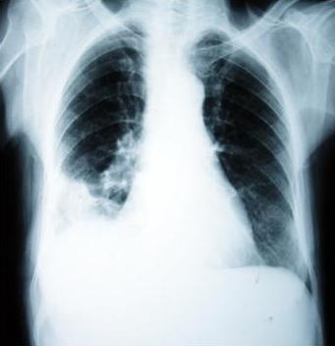

Figure 1. Theright pleural effusion

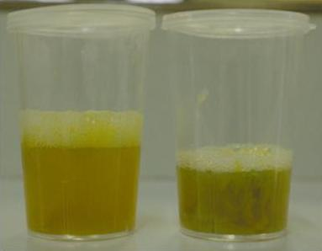

Figure 2. Sputum sample

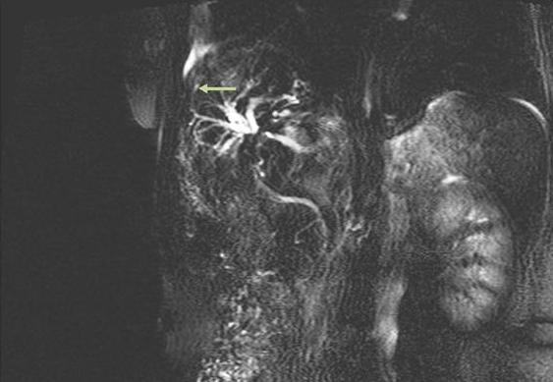

Figure 3. MRCP finding shows fistula between intrahepatic bile ducts and the right pleural space

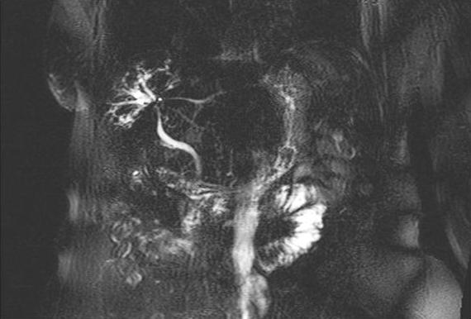

Figure 4. MRCP finding without fistulous communicat

