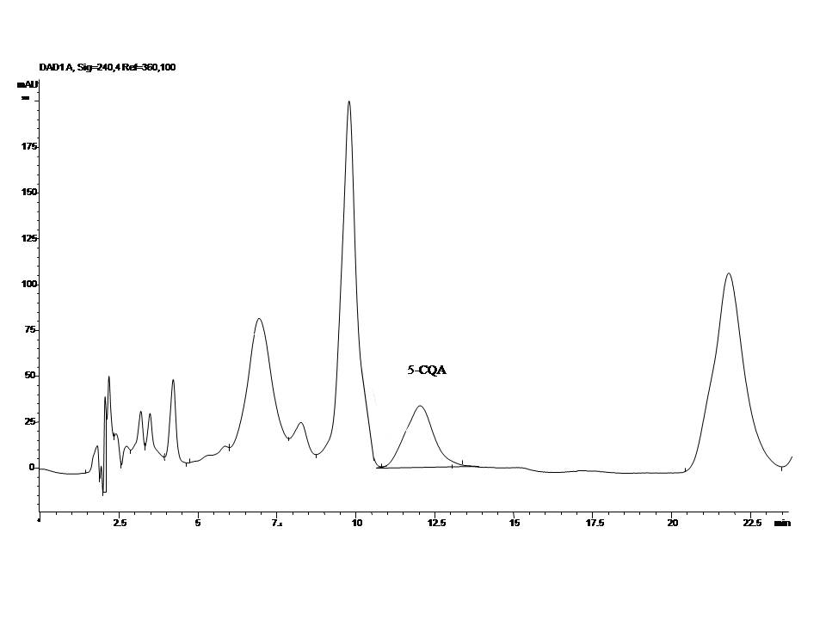
Figure 2. Representative HPLC-DAD chromatogram of analyzed commercial coffee sample (sample number 2)

