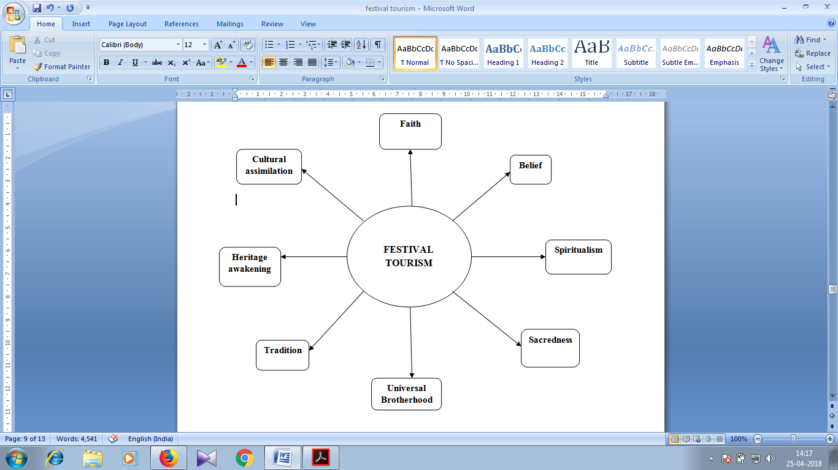
Figure 3(Attributes of Festival Tourism)
Source (Author’s own design)

