Figure 2( Typology of festivals)
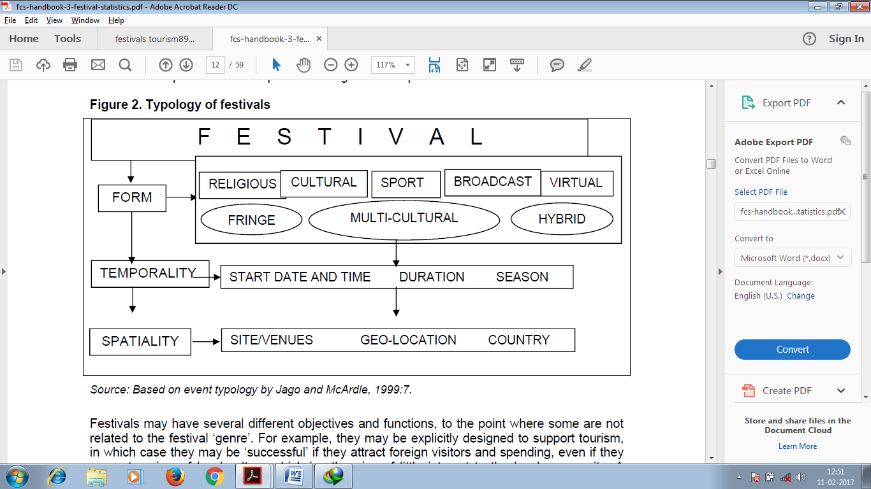

Source: (Based on event typology by Jago and McArdle, 1999:7)

