Figure 1(Map of Odisha)

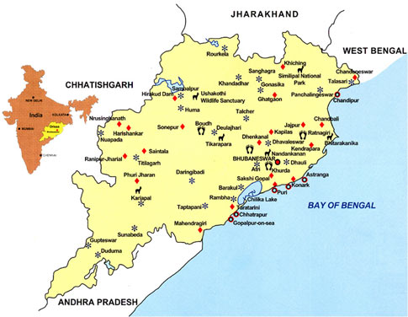
Source (Google map)

