FIGURES:
- A-C
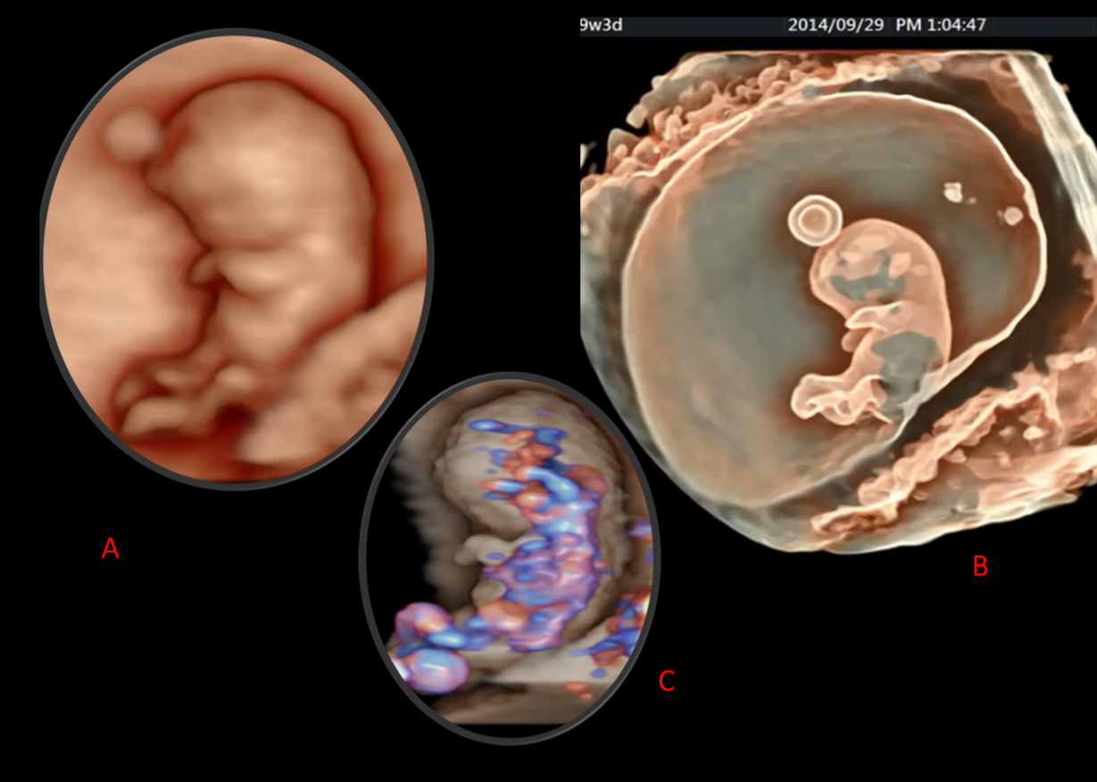
1A, B: 3D HDlive Silhuette fetal presentation at 9 + 3 gestational weeks. With the different intensity of Silhouette mode, we get more or less transparent picture in "see through fashion".
1A: The surface details.
1B: See differences in the details of the previous picture (A), see the details of the internal organs filled with fluid, such as a ventricular system in the brain, an egg yolk, etc.
1C: 3D HDlive Silhuette and Flow showing the same fetus as above. Facing the details of early fetal circulation in the brain, heart and umbilical cord.¹⁶

- A-D
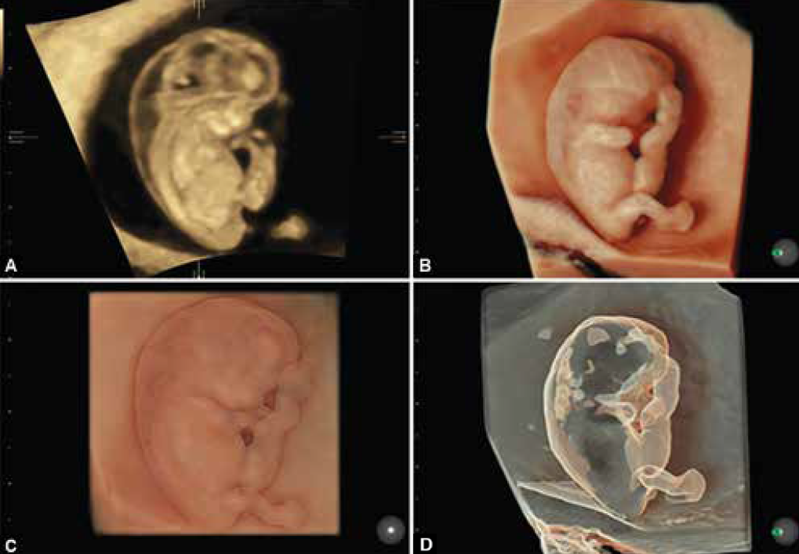
A-D: The same fetus at 9 weeks of gestation. Note the diference in imaging details.
A: VCI mode- sagittal image of the fetus- increased nucal translucency (NT)
B-D: 3D HDlive Silhouette images with the increasing silhouette mode from B to D. Ending up with the transparent view. Notice the increased accumulation of the fluid in the neck area and the cystic structures whithin: Cystic hygroma coli.¹⁶

- A-C
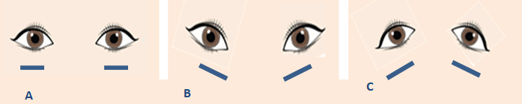
A: normal position of the eyes
B: mongoloid inclination of the eyes ( e.g.Trisomy 21)
C: antimongoloid inclination of the eyes ( e.g. Treacher–Collins syndrome)
4.
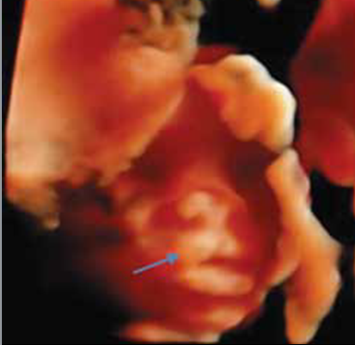
3D HDlive surface rendering, US imaging of the fetus at 14 weeks of gestation. Notice: suptile and small paramedian cleft lip only.¹⁶
5.
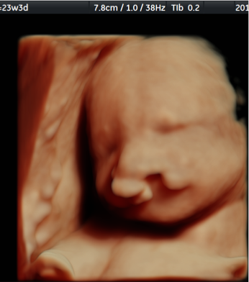
3D HDlive surface rendering of the fetal face at 23+3 weeks of gestation. Notice: bilateral cleft lip and palate (CLP). Because of the protrusion of inner maxillary segment under the nose, anomaly is easily detected.¹⁶
6.
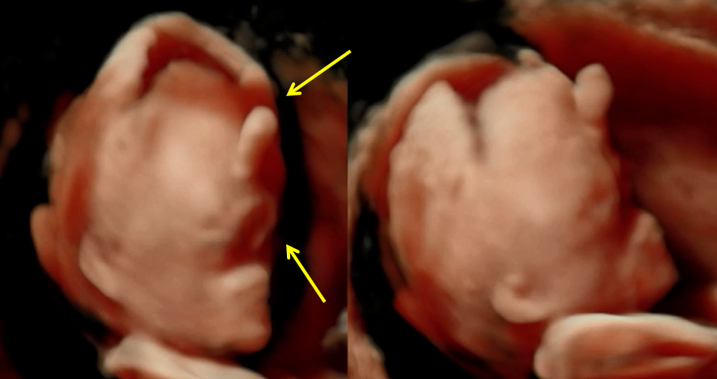
3D HDlive surface rendering, the same fetus from the front and profile. Notice. Abnormal shape of the head, wide open sutures of the skull, anomalies of the midline of the fetal face: cyclopia (lower arrow), proboscis (upper arow) and holoprosencephaly and low set ears are seen. All features of trisomy 13- Patau syndrom. ¹⁶

7.

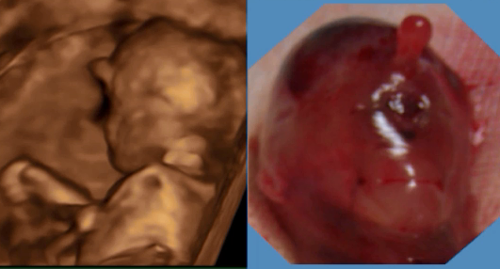
Image on the left: 3Dsurface rendering, profile: notice: proboscis!
Image on the right: the same fetus after miscarage:notice similarities with the prenatal imaging (proboscis, cyclopia)

8.
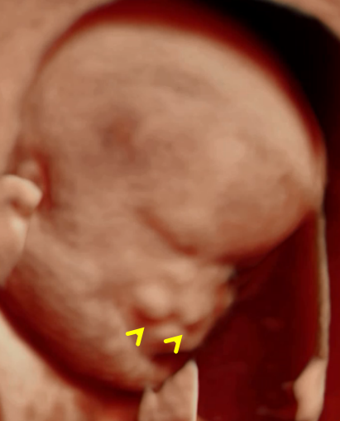
3D HDlive surface rendering of the fetus at 13 weeks of gestation. Notice abnormal shape of the head, holoprosencephaly, bilateral CLP, microphtalmia, low set ears. But NORMAL karyotype !

9.
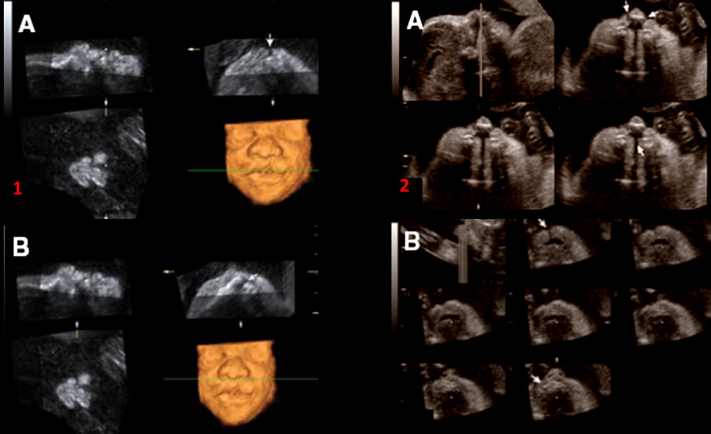
9: 1A: 3D Muliplanar imaging, small, only suptile paramedian cleft lip seen on this image but, 1B: movement of the green dot across the mandible, small alveolar defekt becomes evident.
9: 2A, 2B: A: Bilateral CLP; detected by tomographyc ultrasound imaging technique (TUI)
B: Isolated cleft lip Izolirani – integrity of the fetal palte can be obtained by TUI imaging method

10.

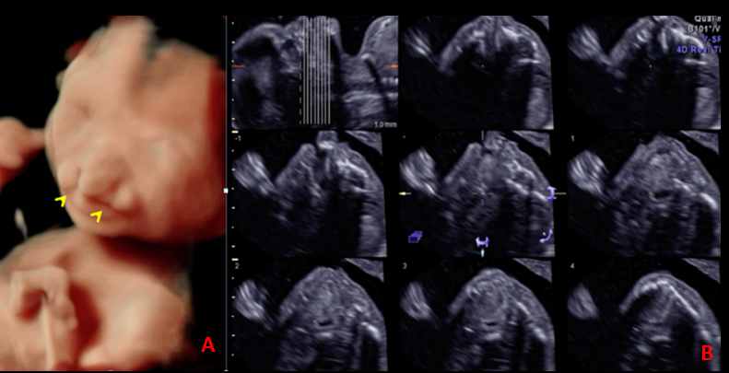
10.: 3D HDlive surface imaging: bilateral CLP; fetus with multiple anomalies but: NORMAL KARYOTYPE! B: TUI display –notice: the extent of the cleft !¹⁶

11.
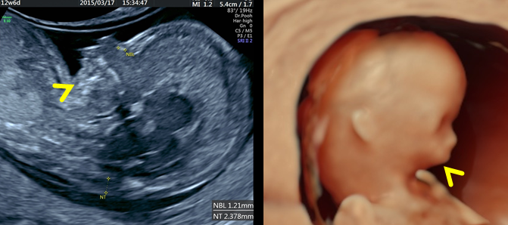
A: left image: 2D midsagittal view of the fetus, notice: abnormal fetal profile and shape of the head, increased NT and prominent micrognathia (arow).
B: right image: the same fetus as in the left image, 3D HDlive surface rendering modality. uz notice: all mention above and detail of the low set ears,¹⁶

12.

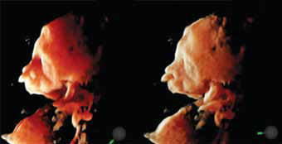
3D HDlive surface rendering: notice: cleft lip and palate (CLP) and hypoplysia of the mandible. Case of Trisomy 13 (Patau syndrome at 21 gestational weeks)

13.
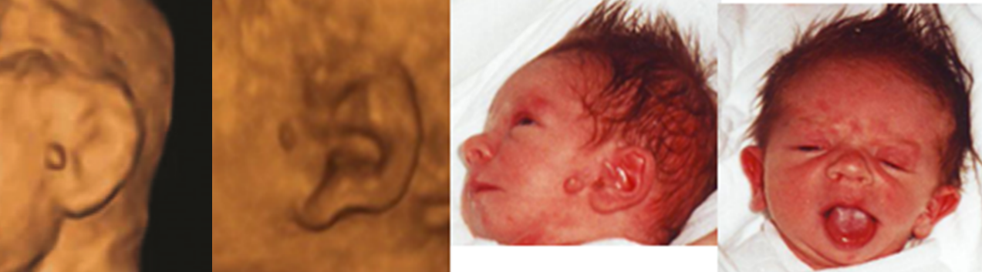
First two images- prenatal (left): 3D surface rendering. Notice preauricular tag. Second two images- postnatal (right): postnatal images of the baby with Goldenhar syndrome: notice hemifacial hypoplasia and microophtalmia.⁴

14.
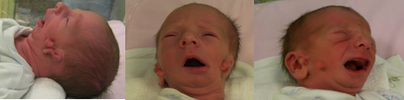
Pstnatal images of the baby with Goldenhar syndrome. Notice Hemifacial hypoplasia with microophtalmia, periauricular tags and sinuses, external ear deformity hemi hypoplasia of the mandible.⁴

15.
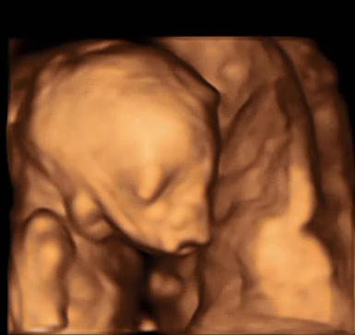
3D surface rendering of the fetus with. Treacher Collins syndrom. Notice: typical facial dysmorphism: bilateral symetric otomandibular dysplasia with the hyperplasia of the soft tissue of the face. Low set ears.⁴

16.

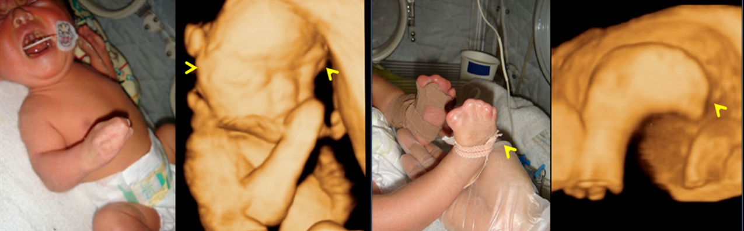
Combination of prenatal and postnatal images of the same baby with the Apert syndrome. Prenatal images with 3D surface mode imaging. Notice the similarities of the images: prenatal and postnatal facial dysmorphism, abnormal shape of the scul, frontal bossing hyperthelorism and „mitten like hands/ feet“.⁴

17.
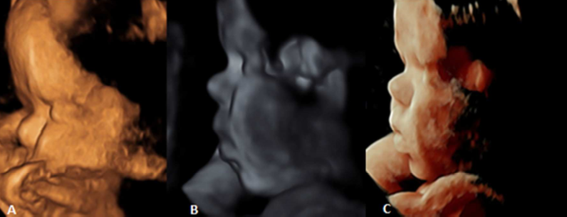
17. A-C: 3D surface rendering of the 34 gestational week fetus, face- profile. Achondroplasia was suspected. Notice diferent methods of surface rendering. Frontal bosing and depressed nasal bridge.

18.

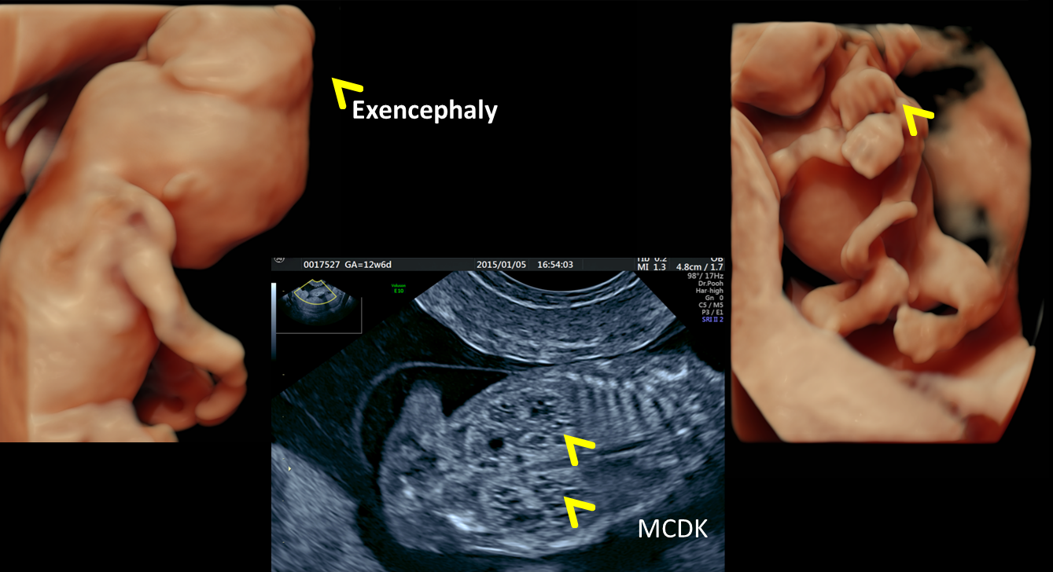
Typical triade of findings: Encephalocele( 80%), Renal cystic dysplasia-bilateral MCDK (95%): , Polydactyly( 75%):Lethal syndrome : Meckel Gruber Syndrom !¹⁶

19.
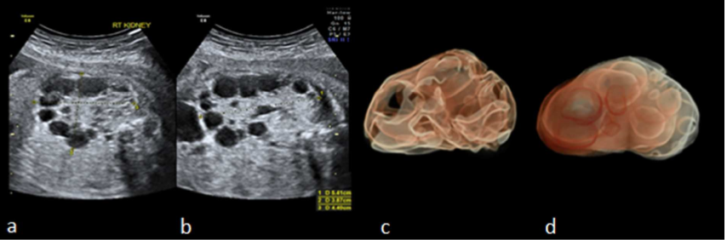
A, b: Multicystic Dysplastic Kidneys: (MCDK) in a fetus of 26 gestational weeks.
C,d: 3D HDlive Silhouette imaging: extraction of the volume of the MCDK kidney^{16,4}

20.
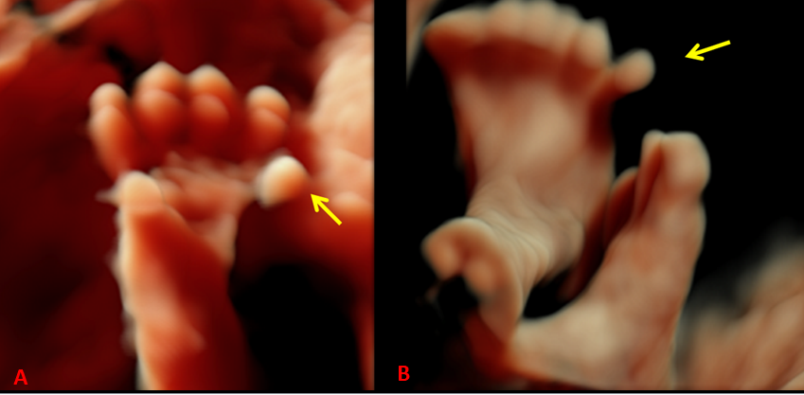
3D HDlive surface rendering of the fetal hand and the feet. Notice the polydactily in both cases! Fetus with Meckel Gruber Syndrome.

21.
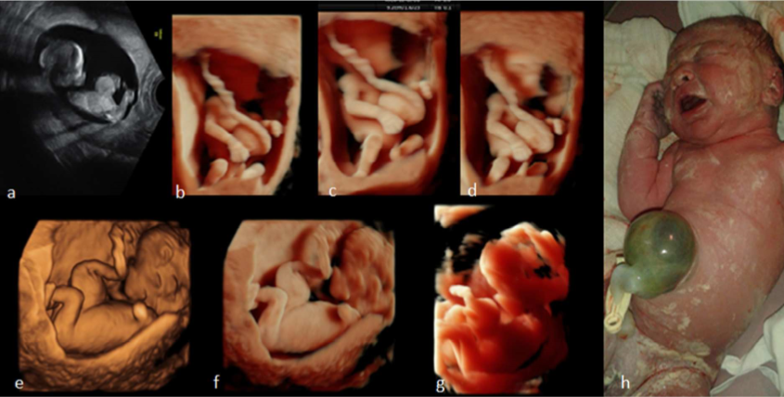
Sequence of images with a: 2D US: fetusawith the omphalocele in the second trimester, b-g: 3D HDlive modality in the assessment of the fetus. Notice the diference in image ilumination and angle of imaging. Notice the similarities of imaging with postpartum image.⁴

22.
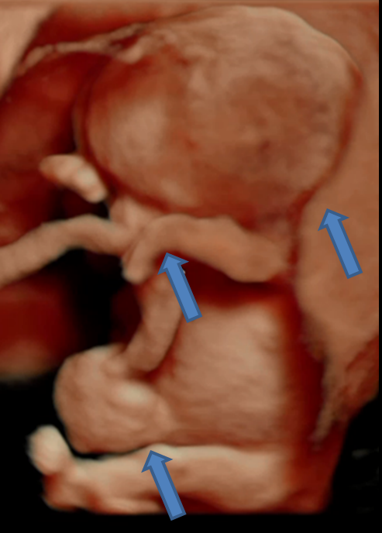
3D HDlive surface image of the fetus with Trisomy 18. Notice the triade of the anomalies: omphalocele, contracted wrists/hands and hygroma colli (arows)1⁶

23.
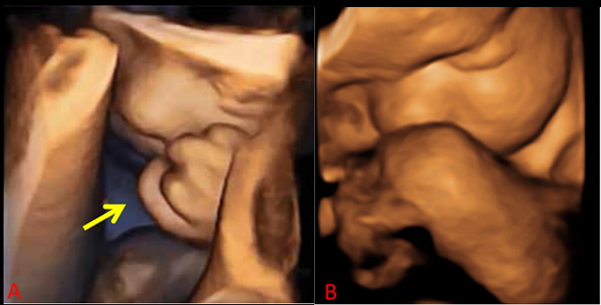 3D surface rendering; trisomy 18 (Edwards syndrome) in 2 cases. Notice the clenched haand (arow) and overlapping fingers in both.
24.
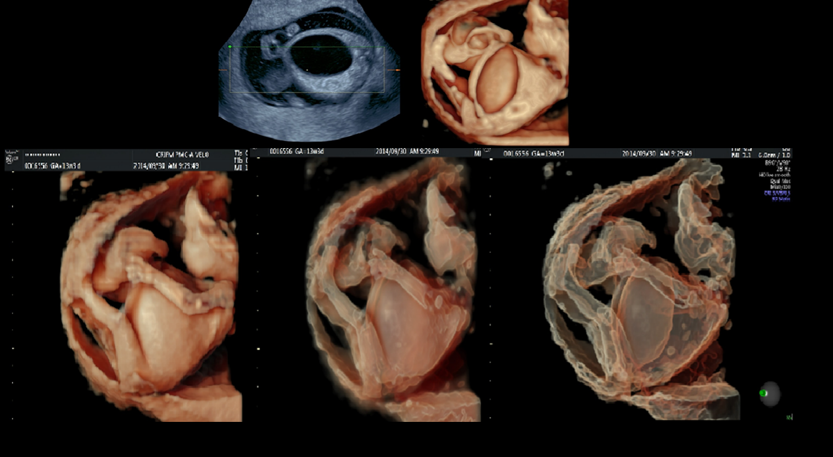
Sequence of images. From 2D to 3D surface and Silhouette display with increasing Silhouette intensity. Notice: Megacystic blader in the fetus with Prune Belly syndrome.^{16,2}

25.
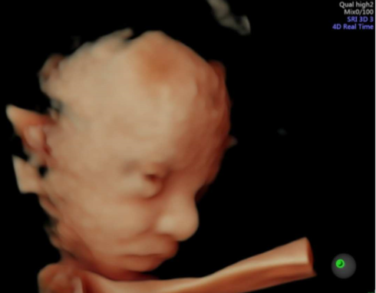
3D/ 4D HDlive fetal assessment by KANET test: Notice open eyes of the fetus at 28 gestational weeks.⁴

TABLE: 1.
ANATOMY  (3 ortogonal PLANES) | SECTION
3D SURFACE rendering | Sagittal view | - PROFILE:forehead, nose, lips, chin
3D TRANSPARENT rendering | Parasagittal view | - Nasal bone yes/no  Image angle 45ᵒ
3D Maximum mode imaging | Coronal view | - Forehead, orbits, both nasal bones, maxilla and mandible
 | Transverse view | - Forehead, orbits, both nasal bones, maxilla and mandible
BIOMETRY | Sagittal view | - FMF angle (>85ᵒ)
STORED IMAGES |  | - Face profile wih the nasal bone  - FMF if needed
Ultrasoundassessment of fetal face by 3D US in the 1st trimester of pregnancy (modified) according to Merzu et al.⁵⁹

TABLE 2.
ANATOMY  (3 ortogonal planes) | SECTION
3D Surface rendering | Sagittal view | - PROFILE: forehead, nose, lips, chin,  - Nasal bone yes/no
3D Transparent rendering  3D Maximum mode | Coronal view | - – forehead with metopic (= frontal) suture – orbits with lenses (symmetry) – lips – palate (3 D surface rendered image and transparent (= maximum intensity) image
 | Transverse view | - Orbits with the lenses  - palate (transparent)  - maxila  - mandible
BIOMETRY | Sagittal view | - nasal bone  - FMF angle  - inferior facial angle (IFA)
 | Coronal view | - orbital diameter –  - inner orbital distance  - outer orbital distance
 | Transverse view | - orbital diameter –  - inner orbital distance  outer orbital distance  maxilla width – mandible width or Jaw index
STORED IMAGES |  | - profile with nasal bone coronal or transverse view with orbits – coronal view
Assessment of the fetal face by 3 D US in the second and third trimesters. (modified) according to Merzu et al.⁵⁹

TABLE 3.
GOLDENHAR SYNDROM: | GS
Asymetric (unilateral) hypoplasia of the face | 70-85%
Mandibular hypoplasia- PRS
“Skin tags” around the ear
Hypoplasia of the ear
Malformation/ microophtalmia of the eye
Unilateral cleft lip/ palate
Anomaly of vertebrae (hemivertebrae)
CHD
CNS anomalies- Corpus Callosum Lipoma
Malformations of gastrointestinal system

