Table 1
Socio-demographic and clinical characteristics of kidney transplant recipients
Gender:
male | 21 (70.0%)
female | 9 (30.0%)
Age (years); mean ± standard deviation | 34.43 ± 8.67
Dialysis before transplant:
hemodialysis | 23 (76.7%)
peritoneal dialysis | 4 (13.3%)
preemptive transplant | 3 (10.0%)
Cause of the ESRD:
glomerulonephritis | 18 (60.0%)
hypertension | 6 (20.0%)
bilateral kidney angiomyolipoma | 1 (3.3%)
chronic pyelonephritis | 1 (3.3%)
unknown | 4 (13.3%)
Donor:
Living-related | 29 (96.7%)
Living-unrelated | 1 (3.3%)
Induction therapy:
yes | 23 (76.7%)
no | 7 (23.3%)

Table 2
Post-operative complications in kidney transplant recipients
Surgical complications | 10 (33.3%)
Medical complications | 9 (30.0%)
Urinary tract infections | 12 (40.0%)
Graft rejection | 5 (16.7%)
Cytomegalovirus infection | 1 (3.3%)
Electrolyte imbalance | 6 (20.0%)

Table 3
The most important outcomes of renal function in kidney transplant recipients
Returned ESRD | 4 (13.3%)
Death of patients | 2 (6.7%)
Current glomerular filtration rate (mL/min/1.73 m²);  mean ± standard deviation | 81.80 ± 30.34

Figure 1
Overall survival in the patients with renal transplantation; means with 95% confidence interval (CI): 2919.53 (2668.06-3171.00) days
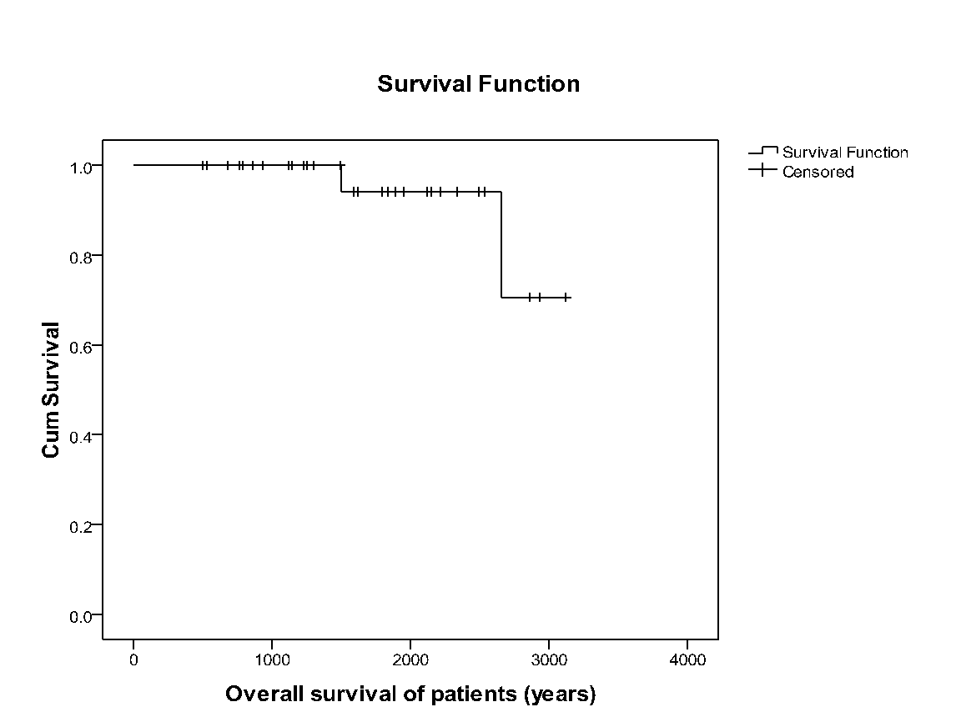
One-, 3-, 5- and 8-year overall patient survival were 100%, 100%, 96.67% and 93.33%, respectively

Figure 2
Cumulative graft survival rates in the transplanted patients; means with 95%CI: 2,729.99 (2,392.54-3,067.44) days;
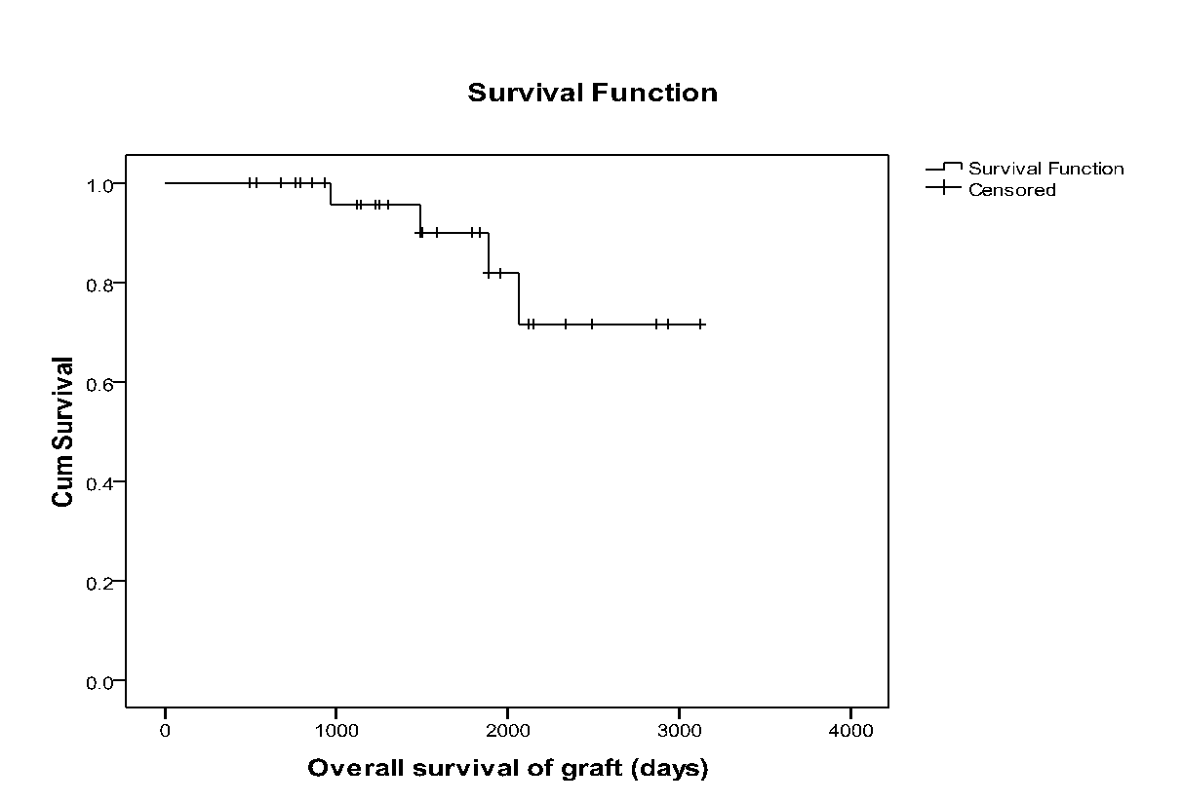
One-, 3-, 5- and 8-year cumulative graft survival rates were 100%, 96.67%, 93.33% and 86.67%, respectively; There was a statistically significant difference in the graft survival rates between the group of patients who had UTIs and group of patients who did not have UTIs

Figure 3
Cumulative graft survival rates in the transplanted patients according to the incidence of post-operative UTIs; Log Rank test, p=0.004
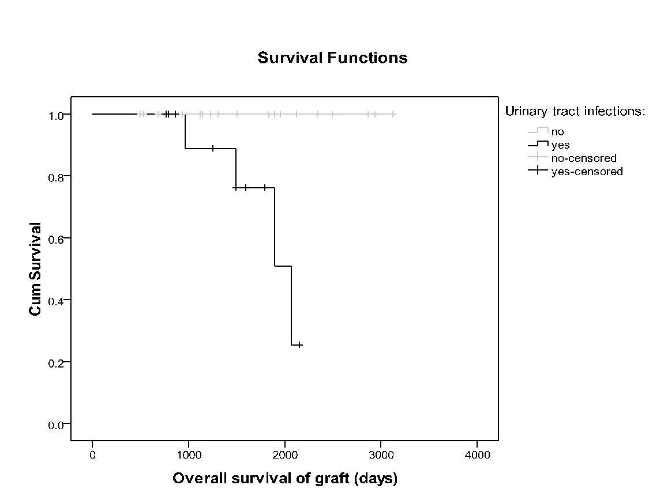
There was also a statistically significant difference in the graft survival rates between the group of patients with no graft rejection (25 patients) and the group of patients with graft rejection

Figure 4
Cumulative graft survival rate in the transplanted patients according to the incidence of post-operative graft rejection; Log Rank test, p=0.040
