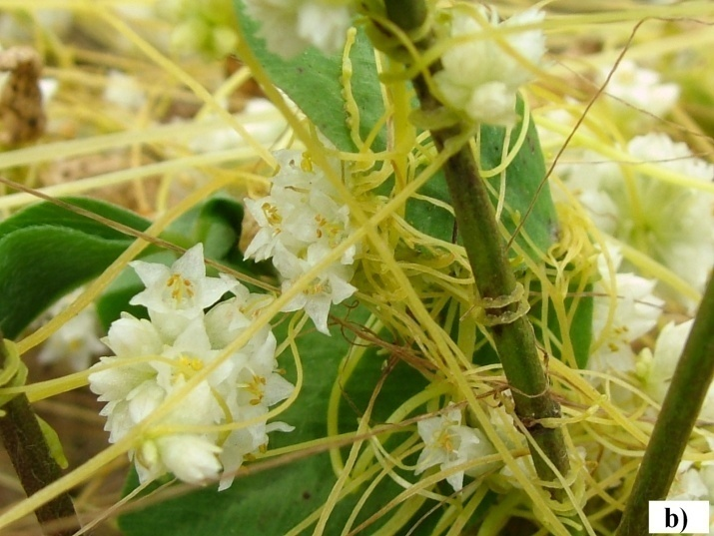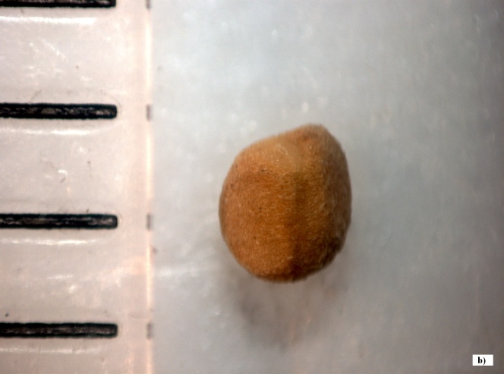
a)
b)
Figure 1. (a) Coiling stems and flowers of field dodder (Cuscuta campestris Yunk)
(S. Vrbničanin); (b) seed of field dodder (C. campestris Yunk.)(Sarić-Krsmanović, 2013)

