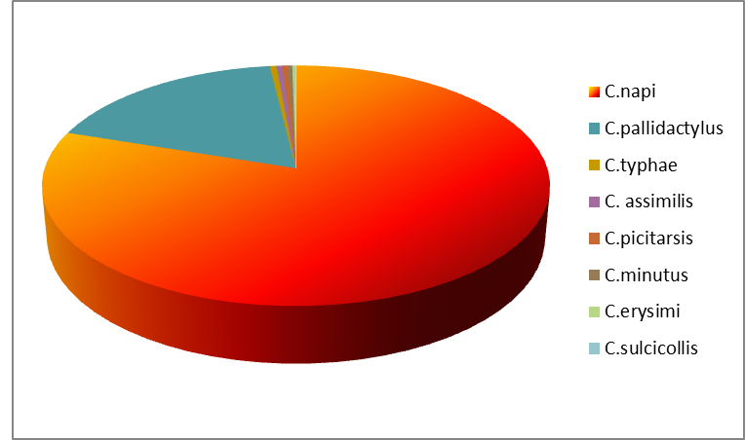

Figure 1 Species of genus Ceutorhynchus associated with oilseed rape

