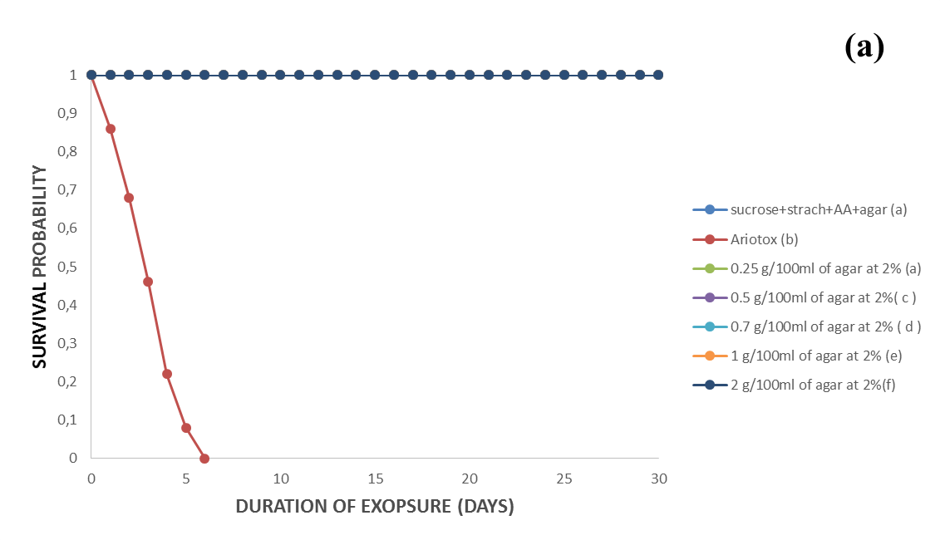
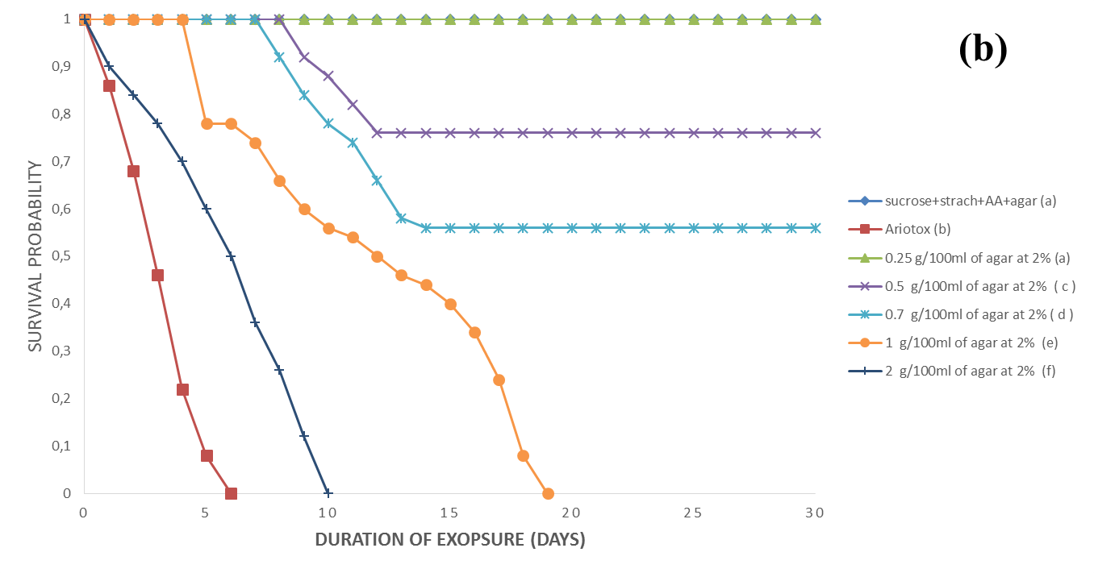
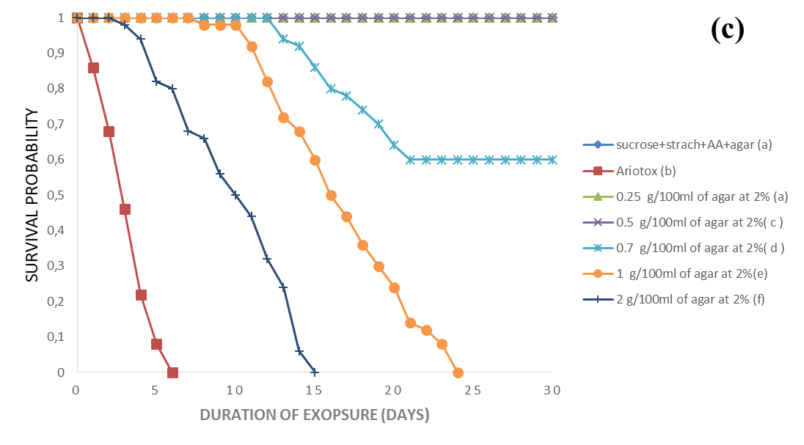

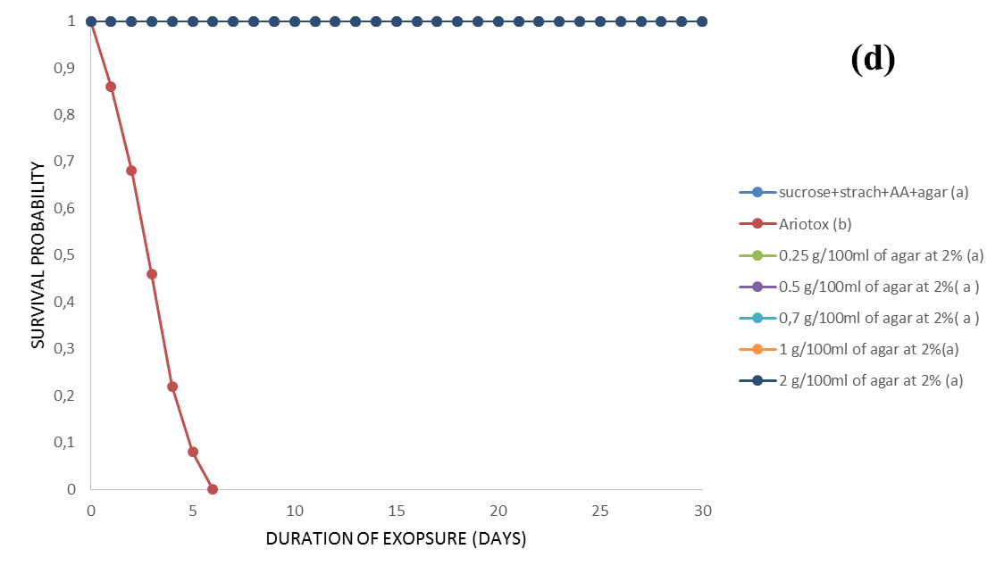

Figure 1: Survival curves of treated Theba pisana’s adults with pellets containing roots stems, leaves and flowers of Euphorbia helioscopia. (Concentrations with the same letter, are not statistically different (Logrank test at 5%; χ²> χ² _{(0.05; 1)} = 3.84)), a: E. helioscopia's roots against T. pisana’s adults, b: E. helioscopia's stems against T. pisana’s adults, c: E. helioscopia's leaves against T. pisana's adults, d: E. helioscopia's flowers against T. pisana's adults.

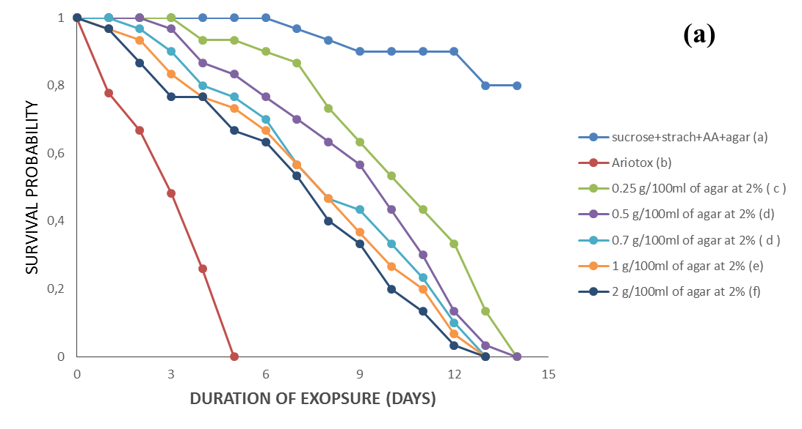

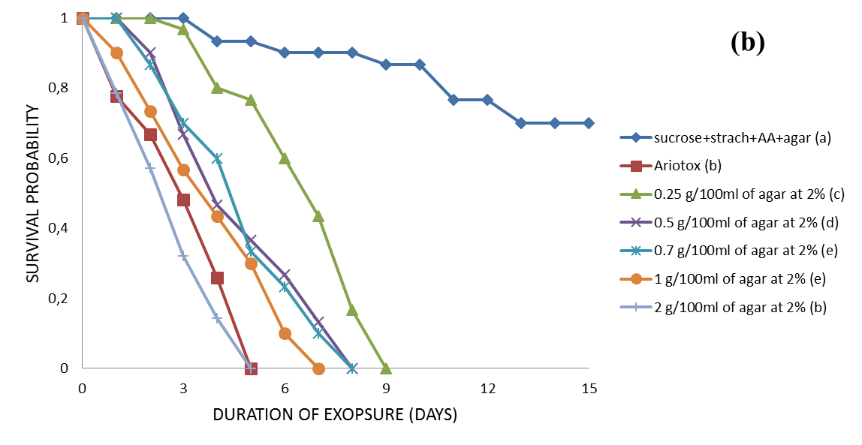
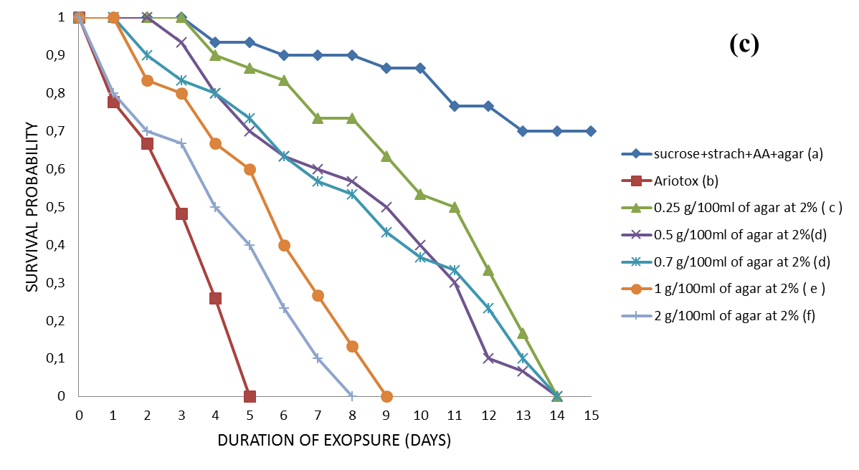

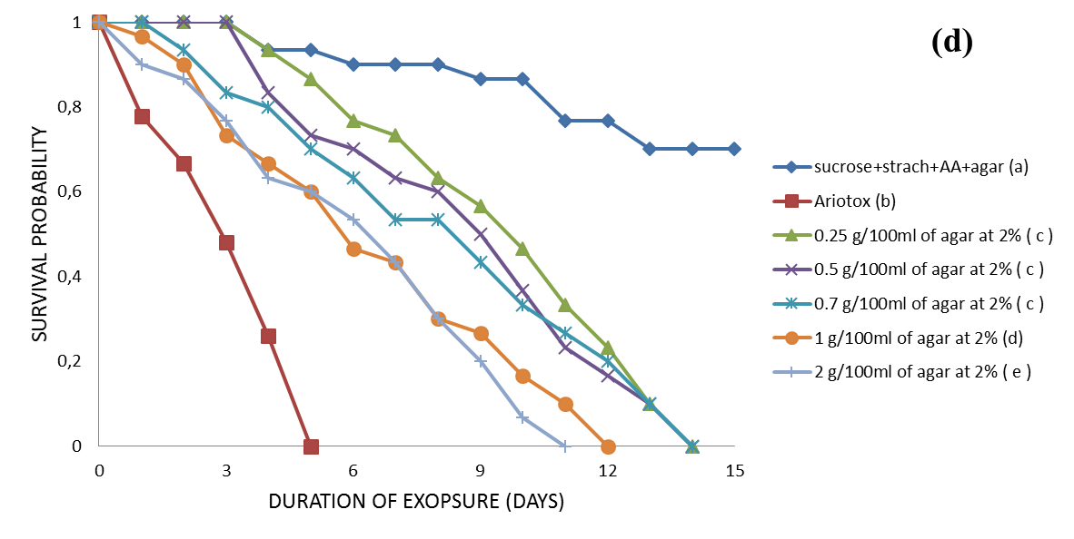

Figure 2: Survival curves of Arion hortensis’s adults treated with pellets containing roots, leaves, stems or flowers of Euphorbia helioscopia. (Concentrations affected by the same letter, are not statistically different (test Logrank at P ≤ 0.05; χ²> χ² _{(0.05 ; 1)} = 3.84)), a: E. helioscopia's roots against A. hortensis's adults, b: E. helioscopia 's stems against A. hortensis's adults, c: E. helioscopia 's leaves against A. hortensis's adults, d: E. helioscopia 's flowers against against A. hortensis's adults.

