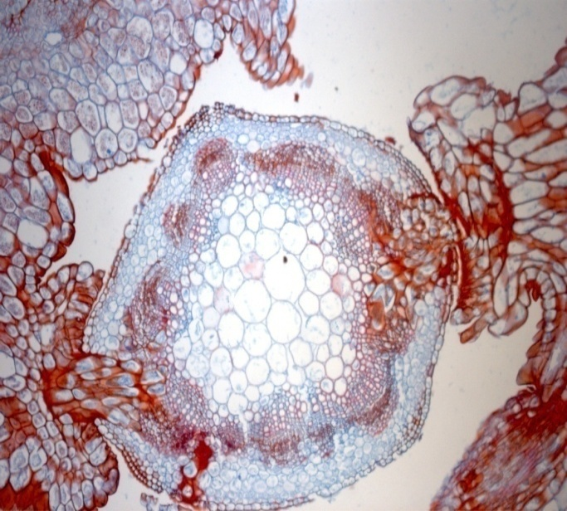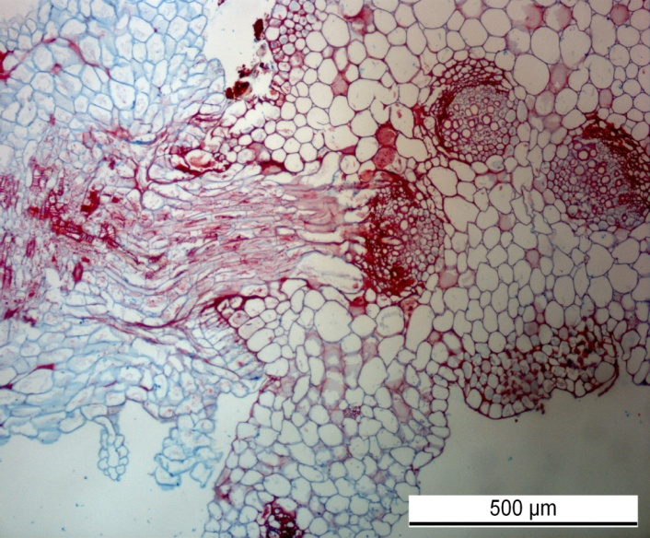
b)
a)
Figure 3. Haustorium “searching hyphae” of field dodder establishing a connection with both phloem and xylem tissues of alfalfa stem (a) and sugar beet petiole (b) (Sarić-Krsmanović, 2013)

