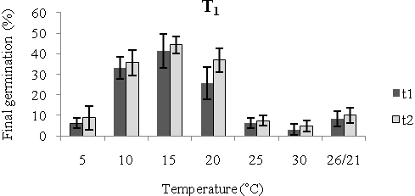
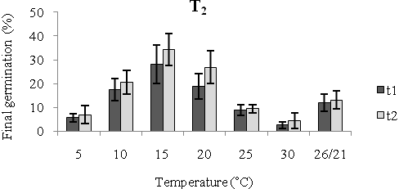
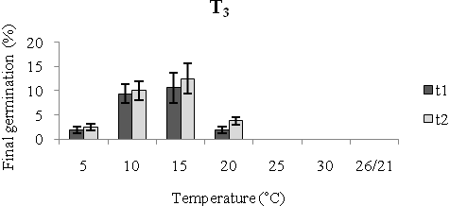
Figure 1. Final percentage of seed germination (%) of A. fatua at different temperatures; a, b – differences between treatments (LSD test, p < 0.05); T₁ - seeds were stored in a climate room under following conditions: temperature 24±1°C, humidity 40-50%; T₂ - seeds were stored in a climate room under following conditions: temperature 26±1°C, humidity 70-80%, and T₃ - seeds were stored at 4°C; t₁- after being stored for three months; t₂- after being stored for 12 months.

