Fig. 3. Virulence of vacuma, transposa, boty, and flipper isolates of Botrytis cinerea towards detached vine, sunflower and raspberry leaves
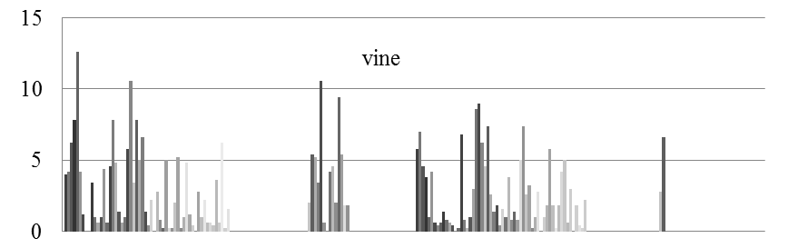
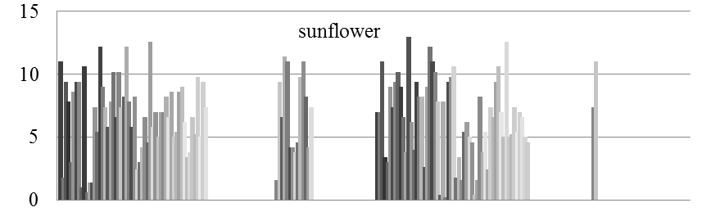
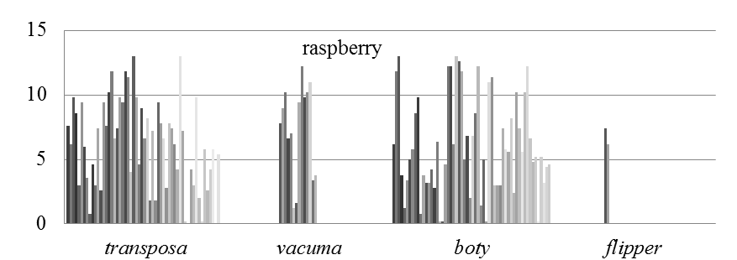
Isolates
Mean disease severity index

