Fig. 2. Growth rate of Botrytis cinerea isolates belonging to different genetic, morphological and sporulation ability groups
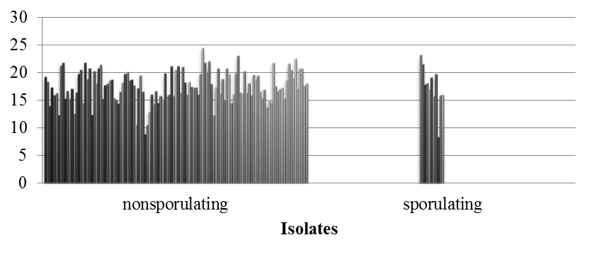
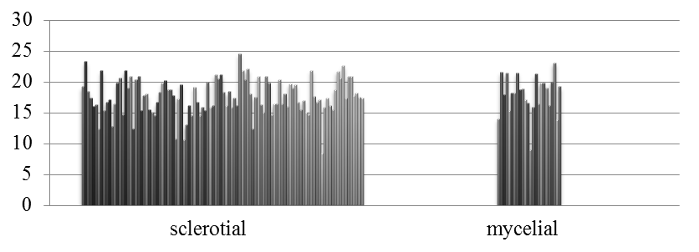
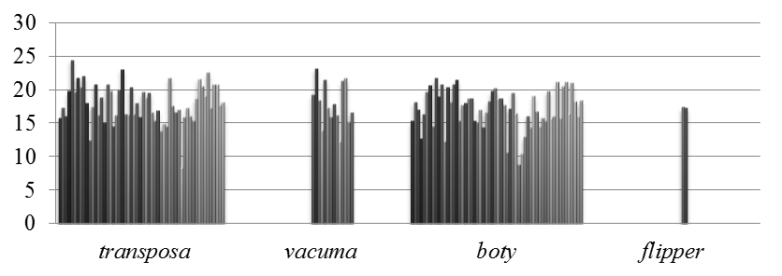
Daily growth rate (mm/day)

