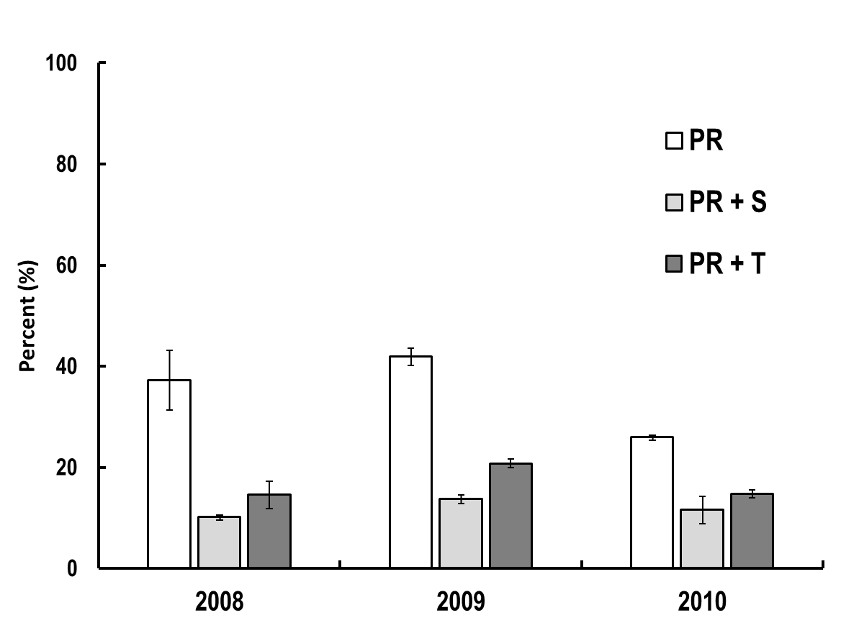
ba
ba
a
ba
ca
a
ba
a
ba

Fig. 1 Relative abundance of A. pomi (Ms ± SE) at the end of the trials (PR = predator activity (Coccinela septempunctata); PR + b = predator activity (C. septempunctata) + selective treatment with NeemAzal T/S; PR + B = predator activity (C. septempunctata) + total treatment with NeemAzal T/S)

The means followed by the same letter are not significantly different (Duncan test, α = 0.05)

