Table 1: Results of the endoscopic and the open surgical management in all patients

Treatment results | Number of patients
Treatment results | Endoscopic correction of the VUR |  | Surgical treatment of the  VUR
Treatment results | N | % | N | %
Resolved reflux | 281 | 93.67 | 290 | 96.67
Downgraded reflux | 10 | 3.33 | 8 | 2.67
Unresolved reflux | 9 | 3 | 2 | 0.66
Total | 300 | 100 | 300 | 100

Table 2: Results of the endoscopic and open surgical management per ureteral units

Treatment results | Number of ureters
Treatment results | Endoscopic correction of the VUR |  | Surgical treatment of the  VUR
Treatment results | N | % | N | %
Resolved reflux | 402 | 93.49 | 463 | 96.46
Downgraded reflux | 10 | 2.33 | 13 | 2.71
Unresolved reflux | 18 | 4.65 | 4 | 0.83
Total | 430 | 100 | 480 | 100
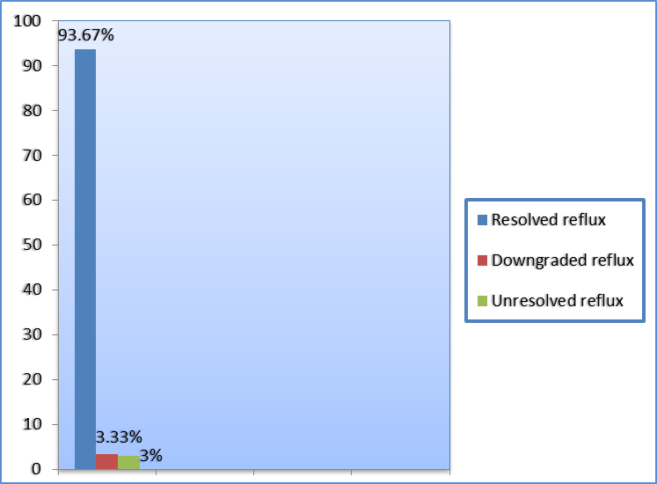

Graphic 1: Results of endoscopic treatment of all patients.

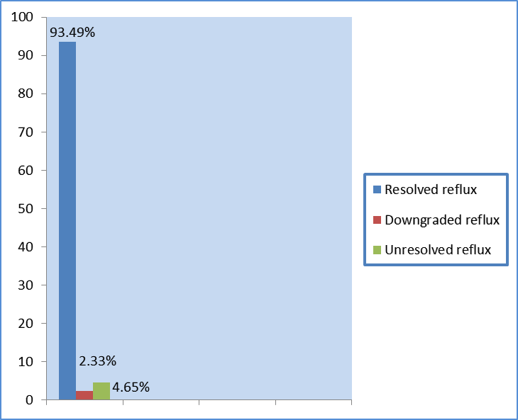

Graphic 2: Results of endoscopic treatment per ureteral units.

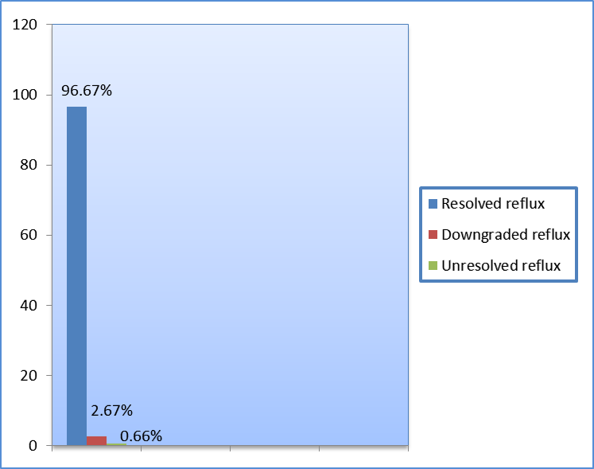

Graphic 3 : Resuts of surgical correction of the VUR in all patients.

Graphic 4: Results of surgical treatment of the VUR per ureteral units.

