EFFECT OF HYPERBARIC OXYGEN THERAPY ON PERIPHERAL VASCULAR DISEASES

EFEKAT HIPERBARIČNE OKSIGENOTERAPIJE KOD PERIFERNIH VASKULARNIH BOLESTI

Abstract
Introduction
Peripheral vascular disease (PVD) is a common and concerning symptom of several habits and illnesses and occurs most often in the lower extremities. PVD manifests itself by decreasing blood flow to tissues and therefore causing a lack of oxygenation, which, if not treated, can ultimately progress to ulcer formation. It is suggested that Hyperbaric oxygen therapy (HBOT) may lead to revascularization of affected tissue.
Aim
This study was performed in order to determine whether HBOT aids wound and ulcer healing, that were caused by PVD.
Material and Methods
20 participants (14 male, 6 female and age ranging from 45 to 89) took part in this case study. All of them suffered from PVD symptoms, such as developed ulcers, open wounds and pain. At 2.2 atmospheres (ATM) with 100% oxygen, the patients fulfilled 15 sessions, each lasting 60 minutes of which the decompression and compression phases lasted each 10 minutes. Treatment took place in the Center for Hyperbaric Medicine in Belgrade. Existing ulcers and their changes were classified. The subjective feeling of pain was being routinely evaluated. The data were analysed with the student t-test and ANOVA.
Results
Outcome presented itself with a clear commenced healing of ulcers, wound and pain reduction. Additional improvements in elongation of intermittent claudication distance and peripheral sensation could also be observed. Ten patients partook in 5 or 10 further sessions before noteworthy progress could be observed.
Conclusion
According to this study, HBOT can facilitate the healing of existing ulcers and wounds caused by PVD if used as a preventative method. However, a larger amount of participants with control groups should be used for a definitive conclusion.
Keywords:
Peripheral vascular disease, hyperbaric oxygen therapy, ulcer

Apstrakt
Uvod
Periferna vaskularna bolest (PVB) je čest i zabrinjavajući simptom određenih navika i bolesti, te se najčešće pojavljuje u donjim ekstremitetima. PVB se manifestuje kroz smanjenu vaskularizaciju tkiva i stoga izaziva smanjenu oksigenaciju. Netretirana, može da dovede do formiranja ulcera. Smatra se da tererapija hiperbaričnom oksigenacijom može da dovede do revaskularizacije i obnove oboljelog tkiva.
Cilj
Ovo istraživanje je sprovedeno kako bi se utvrdila efektivnost HBOT u oporavku rana i tkiva oboljelih od periferne vaskularne bolesti.
Materijali and Metode
20 pacijenata (14 muškaraca, 6 žena, 45 - 89 godina) su učestvovali u ovoj studiji slučaja. Svi pacijenti su imali simptome PVB, kao što je razvoj ulcera, otvorene rane i bol. Tokom 15 seansi, pacijenti su izloženi pritisku od 2.2 atmosfere (ATM), primjenom 100% kiseonika. Svaka seansa je trajala 60 minuta, od čega su faze kompresije i dekompresije trajale po 10 minuta. Tretmani su sprovedeni u Centru za Hiperbaričnu Medicinu u Beogradu. Posotjeći ulceri i njihove promjene su klasifikovane. Subjektivni osjećaj bola je redovno praćen. Podaci su analizirani uz pomoć studentskog t-testa i ANOVA testa.
Rezultati
Ishod istraživanja je početak zarastanja ulcera, umanjenje perifernih senzornih tegoba, kao i smanjenje bola. Produženje klaudikacione distance je takođe registrovano. Deset pacijenata je učestvovalo u dodatnih 5 ili 10 sesija, prije nego što se značajno poboljšanje moglo ustanoviti.
Zaključak
Prema ovom istraživanju, HBOT može da doprinese zarastanju postojećih ulcera i rana izazvanih perifernom vaskularnom bolesti, ako se korsiti kao preventivna metoda. Ipak, veći broj učesnika sa kontrolisanim grupama bi doprinio definitivnom zaključku.
Ključne reči:
Periferna vaskularna bolest, hiperbarična oksigenoterapia, ulcer

Introduction
It is a fact that the global number of people with peripheral vascular diseases (PVD) is increasing due to a rise in the elderly population (1). Additional illnesses and habits such as smoking, poor physical activity or diabetes mellitus also contribute to the development of the disease. This and several other factors lead to the formation of atherosclerosis, which is important in understanding the serious consequences of PVD.
A peripheral vascular disease is a slow and progressive circulation disorder caused by a narrowing, blockage, or spasms in a blood vessel. It can occur in any blood vessel outside the coronary system, most often it is seen in the ones leading to the lower extremities. This leads to diminished blood, and therefore oxygen and nutrient supply of the surrounding tissue. Since the supply is decreased, necrosis and formation of cutaneous wounds can occur.
Hyperbaric oxygenation (HBO) or hyperbaric oxygen therapy (HBOT) is the therapeutic modality in which a patient breathes 100% oxygen intermittently, while the pressure of the treatment chamber is increased to more than one atmospheric pressure (2). Successful use of hyperbaric oxygen has been noted for treatment for a variety of conditions (3). It has been suggested by several studies that hyperbaric oxygen therapy (HBOT) might improve revascularization, and therefore wound healing. However, two large scale studies contradict each other in their findings. While M.Löndahl MD and his colleagues (4) claim that HBOT treatment with HBOT facilitates healing of chronic foot ulcers in selected patients with diabetes, L.Fedorko and his colleagues (5) study follows the conclusion, that HBOT does not reduce indications for amputation in patients with diabetes with non-healing ulcers of lower limbs.
Since the overall results are contradictory to one another, this study has been conducted in order to contribute and hopefully shed some light on the possible outcome with HBOT and peripheral vascular disease.
Research Design and Methods
This study is a case series study that was conducted on 20 patients that were admitted to the Center for Hyperbaric Medicine, Belgrade, due to a previous diagnosis of peripheral vascular disease.
The participants in the study were informed about research protocol and written approval for participation in the study was obtained from each patient. Our research was approved by the Ethical Committee of the Center for Hyperbaric Medicine (EC 9/20016).
The patients from both groups were exposed to 100% oxygen in the multi-measuring hyperbaric chamber (Model: Haux Starmed, Haux Life Support GmbH, Karlsbad-Ittersbach, Germany)
The first part of the treatment was the compression phase, which lasted for 10 minutes and was followed by a period with an atmospheres absolute of 2.2 (ATA) for 60 minutes. The last part, the decompression phase lasted for another 10 minutes. Every session was performed once per day. There were 15 treatment sessions in total, which were held during work days without the weekends.
During the study, all of the patients continued with their regular therapy, noted glycaemia was followed and cutaneous wounds were regularly checked, measured and bandages changed. The wounds and ulcers on the lower extremities were classified by the widely accepted and universally used grading system, Wagner – Meggitt’s classification (6).
Some patients were suffering from muscle cramps and discomfort in their lower extremities while walking. These symptoms are also called intermittent claudication and it is due to the poor vascularization of tissues in PVD. It was suggested that revascularization of wounds can improve symptoms (7). Since about a third to a half of patients with PVD have this symptom (8), the changes were regularly followed. A common nominator of all patients was lower limb pain. The importance of this lies in that continuous, unrelieved pain can not only affect the physical but also psychological state of the patient (9). In order to measure such an unpleasant sensory and emotional experience associated with tissue damage (10), the “Verbal Scale of Pain” was used. The scale was constructed with four options, each of which stood for a short description of momentary pain feeling such as “without pain, slight feeling of pain, moderate feeling of pain and strong pain” (11). Patients were daily inquired about their subjective pain feeling and they responded by choosing one of the options mentioned above.
Statistical analysis
For the evaluation of non numerical parameters, the descriptive statistics were used. All numerical parameters were depicted as the middle value with the corresponding standard deviation. In order to test the significant difference for independent and related causes, analysis of variance (ANOVA) and the Student's-t test were used. All the results obtained during the study were processed with the statistical computer programme SPSS 12.0 for Windows. In all the tests, the defined statistical significance value was p < 0.05 and p <0.01.
Results
A total of 20 eligible patients, 14 of which were men and 6 women participated in the study. The sex distribution depends on the incidence of disease in the population. All patients who were treated in our centre during a six month period (October 1st 2016 to February 1st 2017) were included.
4 (20%) patients completed 25 sessions, 6 (30%) completed 20 sessions and 10 (50%) completed 15 sessions (Table 1). There were no withdrawals or early treatment cancellations.
There were 14 (100%) men and 4 (66.7%) women with diabetes mellitus type 2 and 2 (33.3%) women with diabetes type 1. Both diseases have been present in all patients for >30 years (Table 2). Ulcer appearance was identified in 13 (93%) men and 6 (100%) women. The majority of both groups was affected by multiple ulcers (Table 3). Claudication was present in 2 (14.3%) men and 2 (33%) women. The intensity of the verbal scale of pain in the lower extremities belonged mostly to numbers 3 and 4. 9 (64.3%) men and 2 (33.3%) women experienced peripheral edema (Table 4) and 12 (85%) men and 3 (50%) women had reduced sensibility of the affected limbs (Table 5). All results in summery are listed in (Table 6).

Table no. 1. Number of HBOT treatments
Female sex | 20.83
Male sex | 17.5

Table no. 2. Baseline patient characteristics
 | Male sex | Female sex
n (20) | 14 | 6
Age (years) | 65 (45-81) | 69 (49-89)
BMI (kg/m²) | 26 (22-32) | 23 (18.8-26)
Type I diabetes | 0 (0%) | 2 (33.3%)
Type II diabetes | 14 (100%) | 4 (66.7%)
Glycaemia (mol/L) | 11.4 (6-19.6) | 8.8 (5.5-15.9)
Diabetes duration (years) | 30 > | 35 >
Smoking habits  Current (%)  Previous (%) | 14.3%  78.6% | 33.3%  0%
Hypertension | 10 | 4
Previous peripheral artery revascularization | 7 | 1
Previous amputation | 6 | 2

Table no. 3. Peripheral complications
 | Male sex | Female sex
Ulcer (%)  Multiple (%)  Single (%) | 93%  54%  46% | 100%  67%  33%
No. of days/months with ulcer | 4.9 months (3-6)  *no data, n=6 | 4.4 months (3-5)  *no data, n=1
Wagner grade
0 | 6 | 1
1 | 0 | 0
2 | 1 | 3
3 | 3 | 1
4 | 4 | 1
5 | 0 | 0

Table no. 4. Mobility
 | Male sex | Female sex
Walking without support (%) | 9 | 5
Walking with support (%) | 5 | 1
Wheelchair | 1 | 0
Claudication presence (%) | 14.3% | 33%
Presence of pain in lower extremities (Verbal scale of pain)
1 | 0 | 0
2 | 1 | 1
3 | 8 | 3
4 | 5 | 2
Presence of edema | 9 (64.3%) | 2 (33.3%)

Table no. 5. Peripheral sensibility
 | Male sex | Female sex
Reduced sensibility (%) | 85.7% | 50%
Cramps (%) | 29% | 0%
Numb (%) | 7% | 0%
Tingling (%) | 86% | 50%

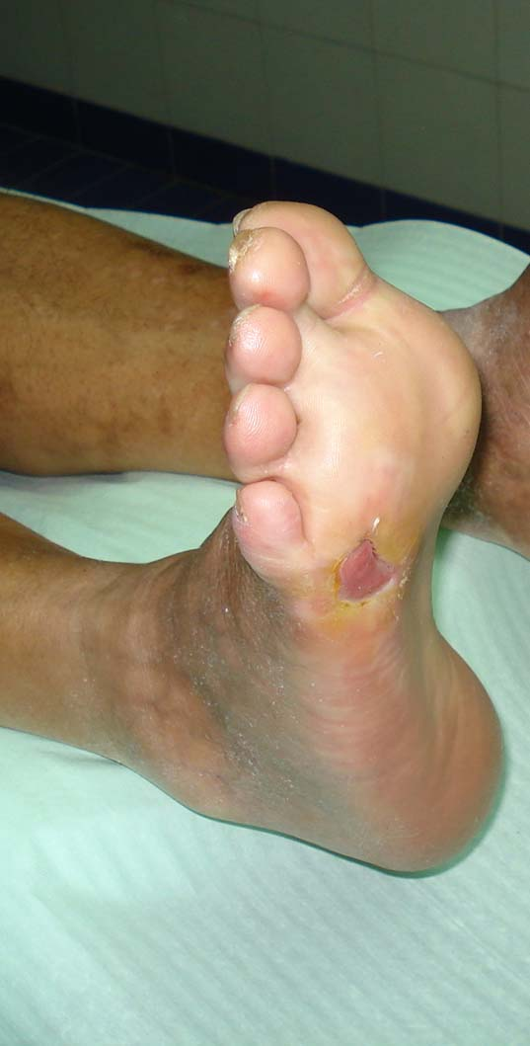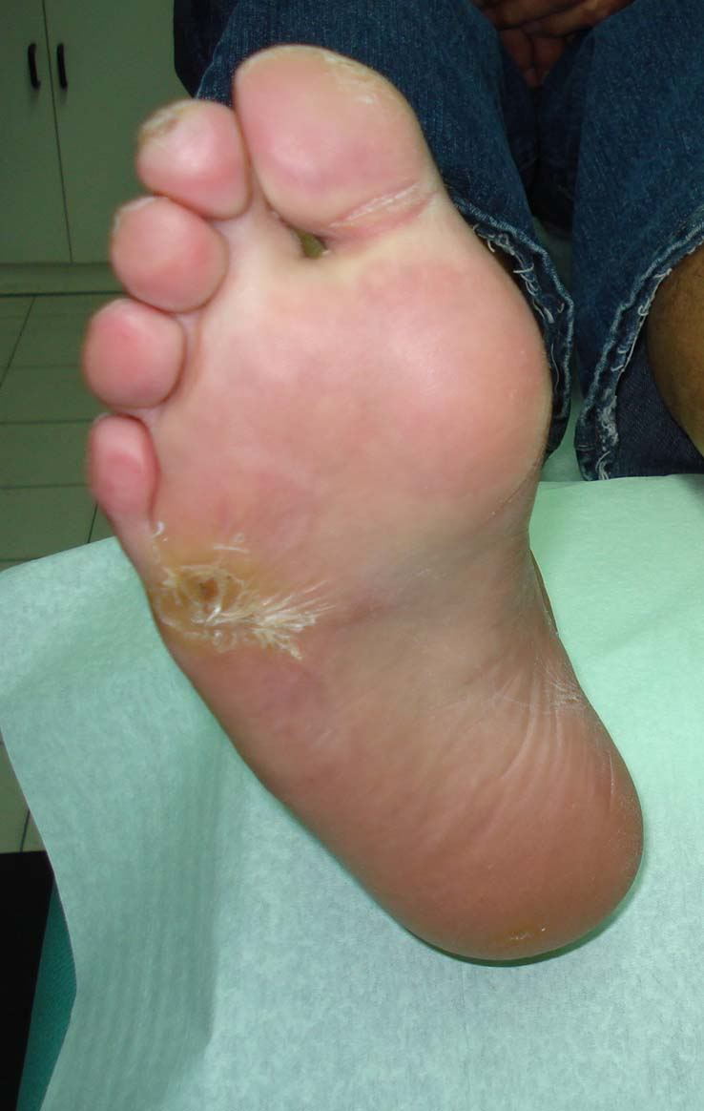
Figure 1. Foot wound before and after HBOT treatment

Table no. 6. Outcome
 | Male sex | Female sex
Elongation of Claudication distance (%) | 93% | 50%
Presence of pain in lower extremities (Verbal scale of pain)
0 (no pain) | 1 | 1
1 | 9 | 4
2 | 4 | 1
3 | 0 | 0
4 | 0 | 0
Reduction of edema (%) | 9 out of 9 (100%) | 2 out of 2 (100%)
Improvements in sensibility (%) | 85.7% | 76.8%
Reduction of Cramps (%) | 3 out of 3 (100%) | 1 out of 2 (50%)
Reduction of Numbness (%) | 83.9% | 86%
Reduced Tingling (%) | 10 out 11 (90%) | 2 out of 6 (30%)

Discussion

The claudication distance was elongated in 13 (93%) men and 3 (50%) women. The proportion of women receiving HBOT was significantly lower comparing to the male group, which is in accordance with other studies (12,13).
The verbal scale of pain intensity went down to being most prominent on numbers 1 and 2. Edema was reduced in 9 out of 9 (100%) men and 2 out of 2 (100%) women. In 10 out of 12 (83%) men and 2 out of 3 (66%) women an improvement in peripheral sensibility was observed. The reduction of cramps and numbness was seen in 3 out of 3 (100%) men and in 1 out of 2 (50%) men and no women since none of them were affected by these two symptoms. An additional reduction of tingling occurred in 10 out of 11 (90%) men and 2 out of 3 (66%) women.
Distinct positive trophic changes were seen, such as a loss in depth of deep and superficial layers of wounds, which ultimately started to close up (Figure 1). A clear improvement in coloration, increase in temperature and vascularization of the lower limbs was noted in more than half of the male and female patients that weren’t categorised in Wagner grade 0.

A previous randomised double blinded study by Löndahl et al. (5) suggests similar conclusions. In this study a therapy duration over 10 weeks with a total of 94 patients was exercised (5 fig1). 'An HBOT session included a period of compression in air for 5 min, followed by a treatment period at 2.5 atmospheres absolute (ATA) for 85min, and then a decompression period of 5 min' (5 p999). The participants used gas masks in which either gas or air was administered. Therefore a control group could be followed at the same time. A majority of the patients completed the full 40 sessions (5 p1000). Löhndal et al. formed an index ulcer, that belonged to Wagner’s grade 3 and 4 (5 p1000). The healing process could be observed after two months. 'Complete healing of the index ulcer was achieved in 37 patients at 1-year of follow-up in 25/48 (52%) in the HBOT group and 12/42 (29%) in the placebo group (P=0.03)' (5 p1000). Even though the study by Löndahl et al. differed in having more participants, longer duration and a higher number of treatment sessions. The results obtained, such as the significant change in ulcer reduction in patients, align with the direction of the study discussed in this paper.

Another double blinded, placebo-controlled study by Fedorko et al. 'aimed to assess the efficacy of HBOT in reducing the need for major amputation and improving wound healing in patients with diabetes and chronic DFUs' (6 p1). Over a period of 6 weeks, a total of 103 patients underwent treatment and a majority of both groups completed all of the sessions. The 30 HBOT sessions lasted 5 days per week and consisted of 'breathing oxygen for 90 min at 244 kPa of pressure, with 5-min intervals of breathing air for every 30 min of oxygen' (6 p2). The control group sessions breathed air of about 125 kPa of pressure (6 p2). The outcomes stated that there was a 'lack of significant progress in wound healing over the follow-up period, which indicated ongoing risk of severe systemic infection related to the wound. Persistent deep infections involving the bone and tendons and the inability to bear weight on the affected limb' (6 p2) were also part of the results.
A nonsignificant difference was found for HBOT, with 11 (22.5%) HBOT group participants and 13 (24.1%) sham group participants meeting the criteria for major amputation (odds ratio [OR] 0.91 [95% Cl 0.37, 2.28], P=0.846) at the end of the 12-week study period. The hypothesised benefit of HBOT was a reduction in indication for amputation of 28%, and the results indicated a difference of <3 percentage points (6 p5).
Even though there was a larger group of participants and an additional control group in the study designed by. Fedorkos et al., as opposed to the one in this article, the results are contrary to it and the above mentioned one by Löhndal et. al. Although the number of HBOT sessions was slightly higher than in the study of this paper, wound complications rather than improvement through healing was noted.
Conclusion
The results of our study are in agreement with the ones published in the earlier mentioned one by Löndahl et al. (5) in which they stated that HBOT helps the healing process of ulcers of diabetic patients. In contrast to the above mentioned study, our research was limited in the way that we didn't have a control group.
An additional constraint in reaching other conclusions was that our group of participants wasn't large enough in order to determine other factors and differences that might play a role in HBOT. For instance, a clear distinction of whether the treatment worked better in women or in men isn't possible because there wasn't an equal amount of either involved. However, HBOT was seen to have evident curative effect on already present PVD symptoms but a greater benefit was found if used as a preventative treatment. We observed that Hyperbaric Oxygen Therapy is a useful preventative measure for growth and development of ulcers, as it supports the revascularization and healing process of PVD wounds. A vast majority of patients regained health benefits as a cause of this therapy. In addition, this treatment increases the patients life quality by decreasing the amount of possible surgical interventions, such as amputations and medical costs.

References
- Criqui MH, Aboyans V. Epidemiology of peripheral artery disease. Circ Res. 2015; 116(9):1509-26. Available from: https://www.ncbi.nlm.nih.gov/pubmed/25908725 [Accessed 11 Dec. 2016].
- Tibbles PM, Edelsberg JS. Hyperbaric oxygen therapy. N Engl J Med 1996; 334:1642–1648.
- Kindwall EP. Uses of hyperbaric oxygen therapy in the 1990s. Cleve Clin J Med 1992; 59:517-528. Available from: https://www.ncbi.nlm.nih.gov/pubmed/1468134 [Accessed 11 Dec. 2016].
- Löndahl M, Katzman P, Nilsson A, Hammarlund C. Hyperbaric oxygen therapy facilitates healing of chronic foot ulcers in patients with diabetes. Diabetes Care. 2010 May; 33(5):998-1003. Available from: https://www.ncbi.nlm.nih.gov/pubmed/20427683 [Accessed 11 Dec. 2016].
- Fedorko L, Bowen JM, Jones W. Hyperbaric Oxygen Therapy Does Not Reduce Indications for Amputation in Patients With Diabetes With Nonhealing Ulcers of the Lower Limb: A Prospective, Double-Blind, Randomized Controlled Clinical Trial. Diabetes Care. 2016 Mar; 39(3):392-9. Available from: https://www.ncbi.nlm.nih.gov/pubmed/26740639 [Accessed 11 Dec. 2016].
- Jain A. K. A New Classification of Diabetic Foot Complications: A Simple and Effective Teaching Tool. The Journal of Diabetic Foot Complications, 2012; Volume 4, Issue 1, No. 1, Pages 1-5.
- En.wikipedia.org. (2016). Intermittent claudication. [online] Available at: https://en.wikipedia.org/wiki/Intermittent_claudication#Treatment [Accessed 11 Dec. 2016].
- University of Maryland Medical Center. (2016). Peripheral artery disease and intermittent claudication. [online] Available at: http://umm.edu/health/medical/reports/articles/peripheral-artery-disease-and-intermittent-claudication [Accessed 11 Dec. 2016].
- Wells N, Pasero C, McCaffery M. Improving the Quality of Care through Pain Assessment and Management. Hughes RG, editor. Rockville (MD): Agency for Healthcare Research and Quality (US); 2008 Apr. Chapter 17.
- En.wikipedia.org. (2016). International Association for the Study of Pain. [online] Available at: https://en.wikipedia.org/wiki/International_Association_for_the_Study_of_Pain [Accessed 11 Dec. 2016].
- Pjević M, Bol Kratke činjenice o hroničnom nekancerskom i kancerskom bolu. ACTAVIS. Oktobar 2013. [online] Available at: http://www.uitbs.org.rs/materijal/publikacije/bol_brosura.pdf [Accessed 11 Dec. 2016].
- Feldman-Idov Y, Melamed Y, Ore L. Improvement of ischemic non-healing wounds following hyperoxygenation: the experience at Rambam-Elisha Hyperbaric Center in Israel, 1998-2007. Isr Med Assoc J. 2011 Sep:13(9):524-9.
- Fife CE Buyukcakir C, Otto GH, et al. The predictive value of transcutaneous oxygen tension measurement in diabetic lower extremity ulcers treated with hyperbaric oxygen therapy: a retrospective analysis of 1,144 patients. Wound Repair Regen 2002; 10: 198-207

