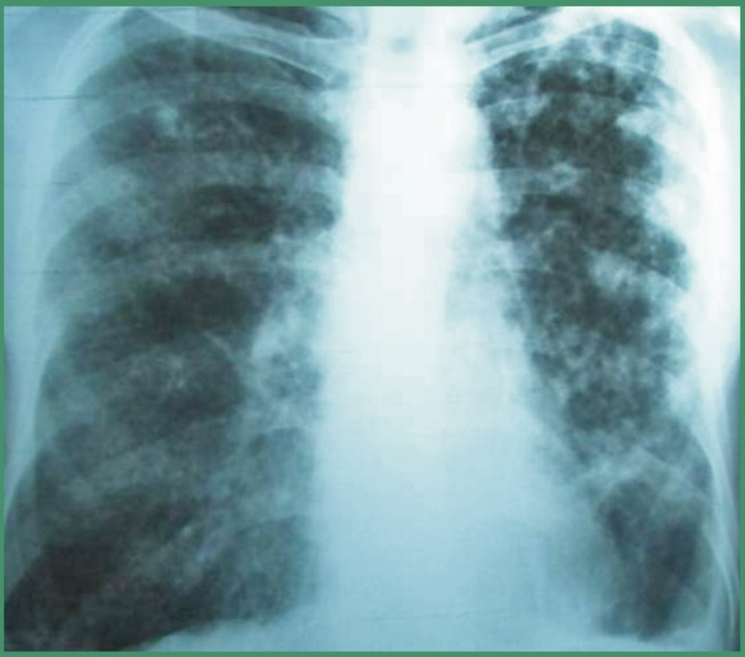
Figure 1. Chest radiography on admission
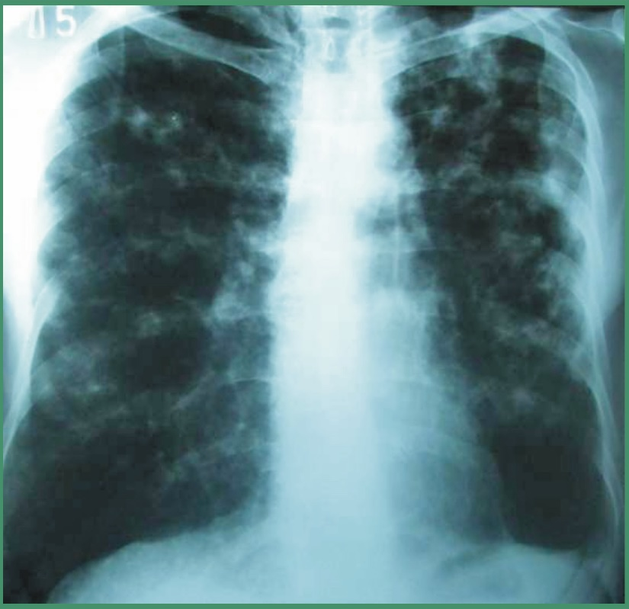
Figure 2. Chest radiography after initial treatment of 3 months

