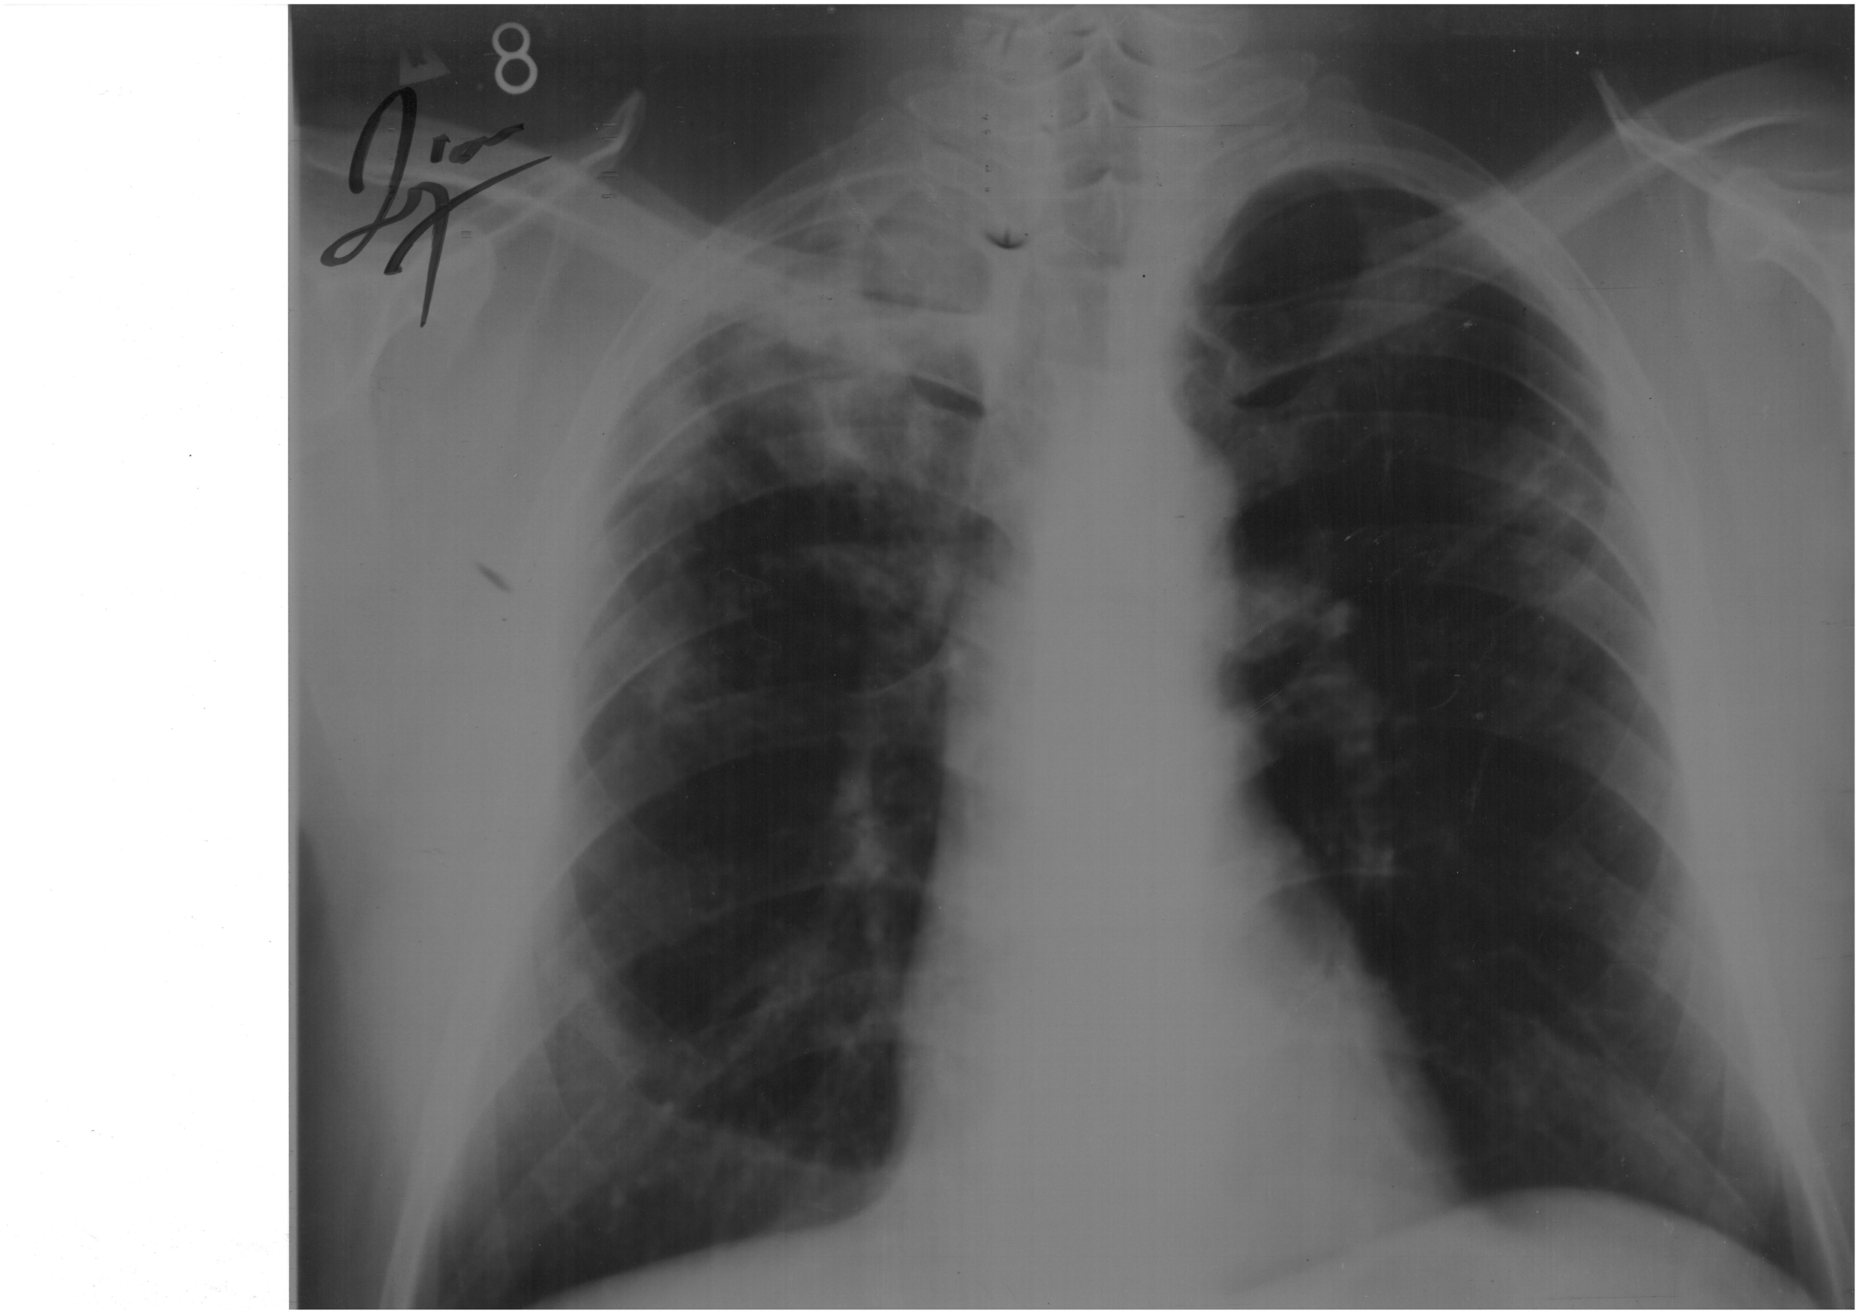
Figure 1. Chest radiography made in 2002 showed consolidations in right upper and mid lung lobe and left mid lobe.

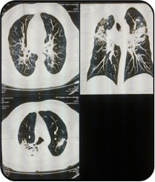

Figure 2. CT scan of thorax, made in 2010. It showed progression of lung lesions with mediastinal lymphadenopathy which suggested chronic sarcoidosis

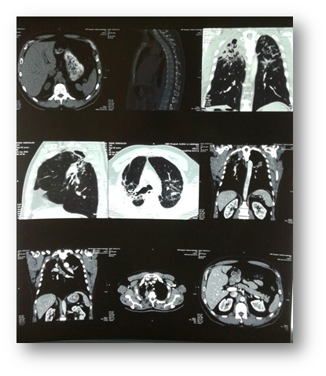

Figure 3. CT scan of thorax and abdomen from 2016. It showed cystic bronchiectasis with fibrosis in right upper lung which shifted trachea into right side. In both lower lobes fibrous changes of lower degree were seen. Mediastinal lymph nodes were enlarged, the biggest was right paratracheal node (26 mm) and infracarineal (20 mm).

skener 6 8
grafija 3

