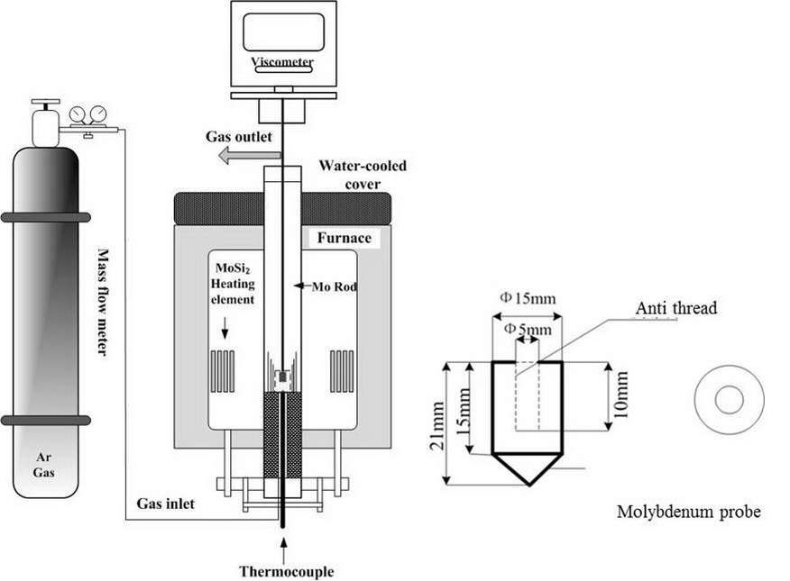

Figure.1. The schematic diagram of viscosity measurement system

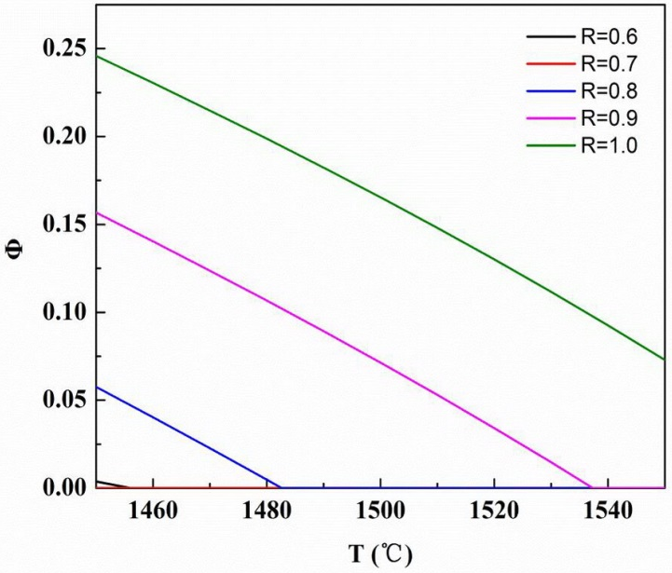

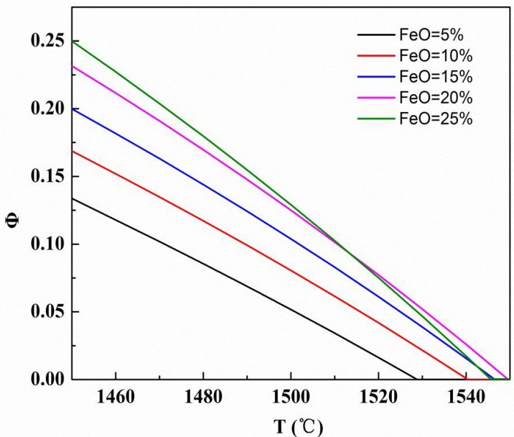

Figure.2. Relationship between temperature and solid volume percent

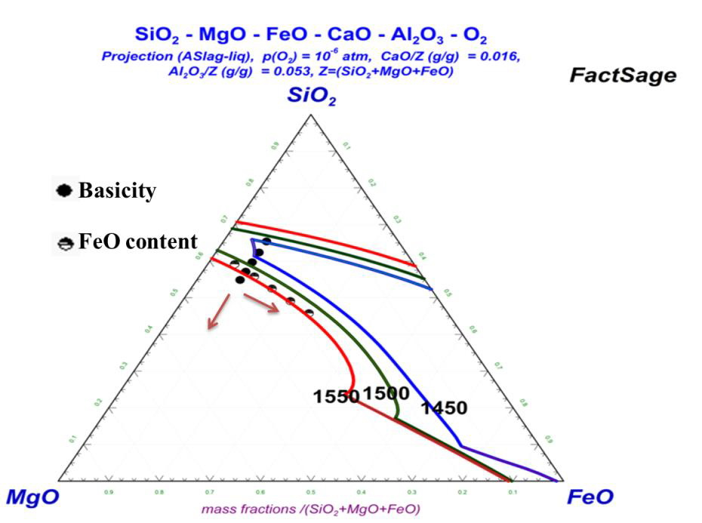

Figure.3. Phase diagram of SiO₂-MgO-FeO-CaO-Al₂O₃

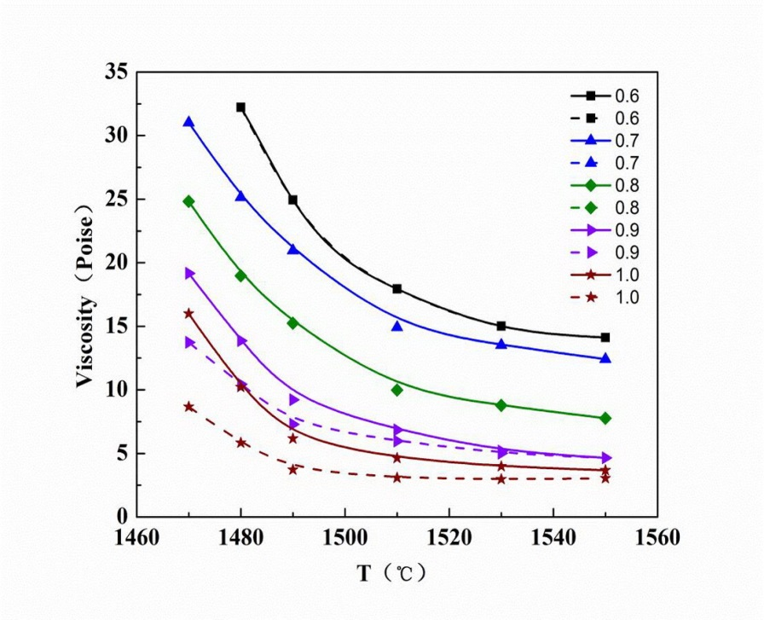

Figure.4. Relationship between basicity and viscosity

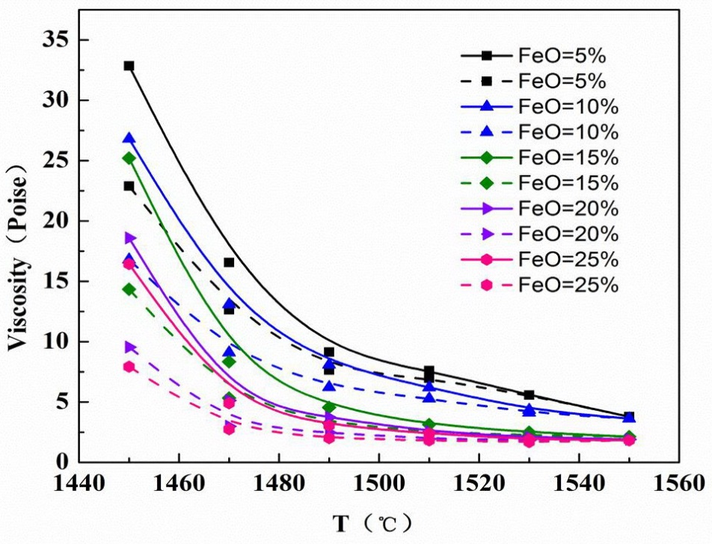

Figure.5. Relationship between FeO and apparent viscosity

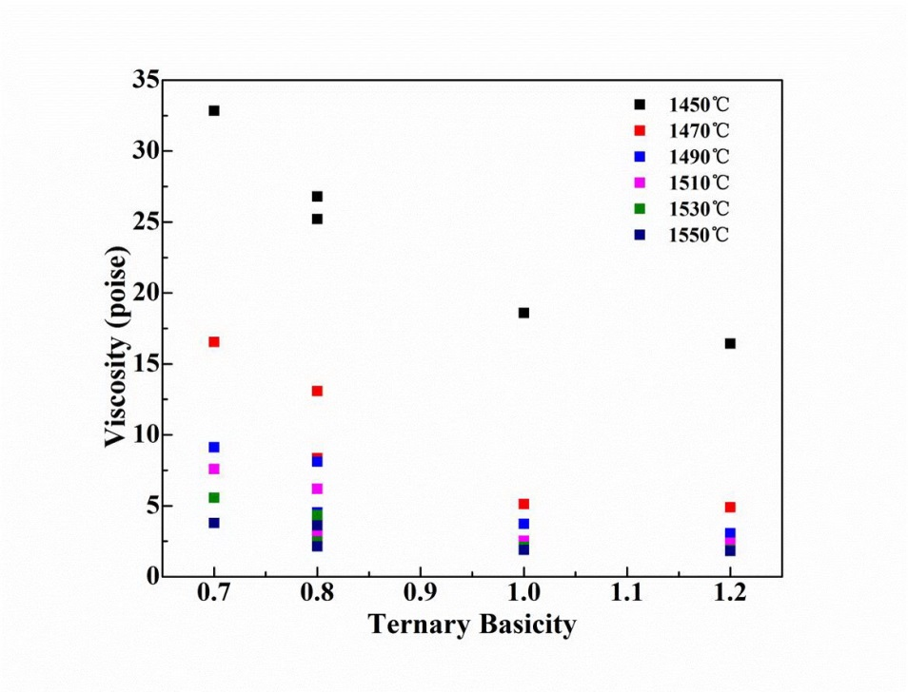

Figure.6. Relationship between ternary basicity and viscosity

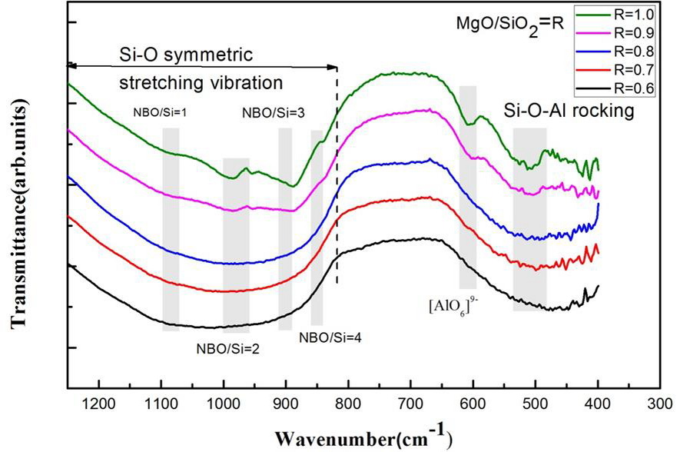

Figure.7. The effects of basicity on Infrared spectra of slag

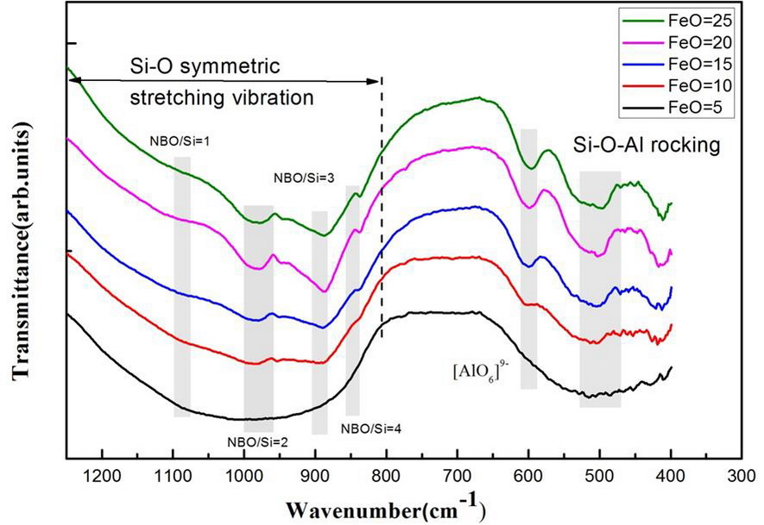

Figure.8. The effects of FeO on Infrared spectra of slag

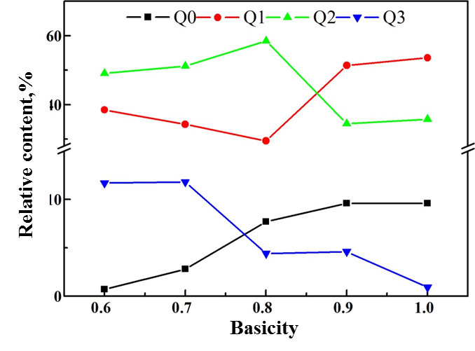

Figure.9.Abundance of structural units of slag as a function of basicity ratio by Raman analysis.

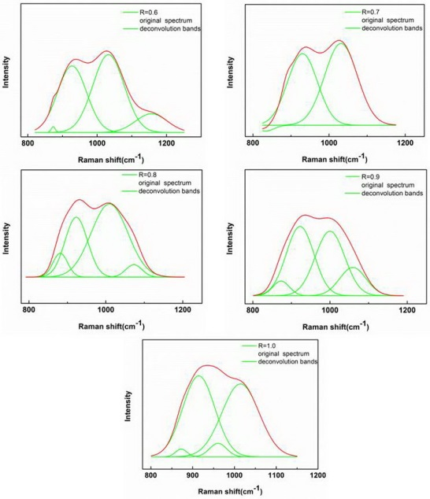
Figure.10.Deconvoluted results of the Raman spectral curves for basicity influence

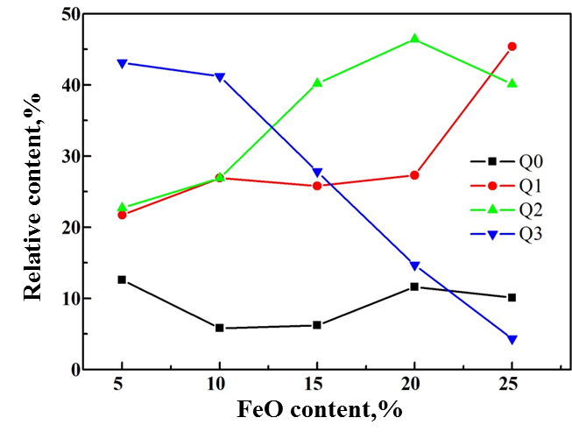

Figure.11.Abundance of structural units of slag as a function of FeO by Raman analysis

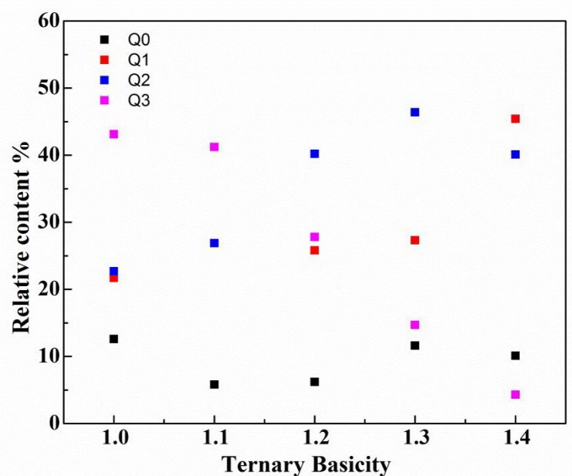

Figure.12.Abundance of structural units of slag as a function of ternary basicity by Raman analysis

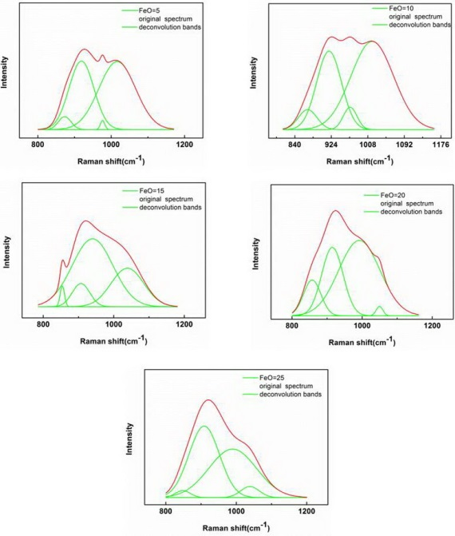
Figure.13.Deconvoluted results of the Raman spectral curves for FeO influence

