Supplementary Data for

Comparison of the mineralogy and microstructure of EAF stainless steel slags with reference to the cooling path
*Mojca Loncnar, Ana Mladenovič, Marija Zupančič, and Peter Bukovec

Table S1. Chemical composition of sampled EAF S slags. Results for the characterization of EAF S slags (samples Sa, Sw, E3041, E3042, E31, E32, EM1 and EM2) are taken from article Loncnar M., Zupančič M., Bukovec P., Jaklič A., 2009. The effect of water cooling on the leaching behaviour of EAF slag from stainless steel production. Mater. Tech. 43, 315– 321).
 | CaO | SiO₂ | Cr₂O₃ | MgO | Fe | Al₂O₃ | MnO
 |  |  | w/%
Sa | 37.5±0.1 | 20.24±0.06 | 12.0±0.1 | 8.690±0.002 | 6.7±0.2 | 6.59±0.06 | 3.54±0.04
Sw | 35.4±0.4 | 19.5±0.2 | 12.7±0.3 | 9.10±0.04 | 7.3±0.5 | 6.65±0.04 | 3.63±0.02
SaT | 35.4±0.1 | 19.4±0.1 | 11.93±0.03 | 8.28±0.01 | 8.0±0.2 | 6.22±0.01 | 3.55±0.01
SwT | 35.74±0.02 | 19.34±0.04 | 11.5±0.2 | 8.79±0.01 | 7.1±0.4 | 6.38±0.02 | 3.55±0.03
E3041 | 41.425±0.002 | 18.82±0.04 | 9.18±0.04 | 9.55±0.04 | 4.4±0.1 | 8.856±0.001 | 3.03±0.01
E3042 | 38.2±0.2 | 18.52±0.05 | 10.61±0.01 | 9.59±0.02 | 5.2±0.1 | 8.08±0.03 | 3.60±0.01
E31 | 36.4±0.1 | 22.4±0.2 | 5.91±0.06 | 13.8±0.1 | 8.0±0.2 | 7.47±0.09 | 3.29±0.01
E32 | 37.34±0.01 | 22.95±0.02 | 5.24±0.06 | 13.6±0.1 | 6.0±0.2 | 7.845±0.004 | 3.23±0.01
EM1 | 43.6±0.1 | 10.78±0.03 | 1.540±0.002 | 10.73±0.04 | 10.g±0.2 | 15.55±0.07 | 1.45±0.03
EM2 | 35.4±0.2 | 18.83±0.04 | 3.04±0.03 | 8.70±0.03 | 10.5±0.1 | 11.13±0.08 | 1.76±0.01
CSa | 43.8±0.4 | 21.3±0.3 | 4.6±0.1 | 10.1±0.1 | 4.9±0.4 | 7.10±0.02 | 1.61±0.01
CSw1 | 40.3±0.1 | 18.9±0.1 | 6.1±0.1 | 9.26±0.01 | 8.1±0.1 | 7.3±0.1 | 1.82±0.01
CSw2 | 40.1±0.7 | 19.7±0.3 | 5.7±0.2 | 9.1±0.1 | 9.3±0.9 | 6.6±0.1 | 1.60±0.01
SSa | 35±0.1 | 19.94±0.03 | 15.2±0.1 | 8.18±0.01 | 6.5±0.3 | 4.33±0.01 | 3.56±0.01
SSw1 | 34.5±0.2 | 19.5±0.1 | 16.4±0.2 | 7.39±0.06 | 6.4±0.1 | 3.73±0.01 | 3.67±0.01
SSw2 | 35.6±0.1 | 18.91±0.02 | 14.38±0.03 | 7.96±0.02 | 6.7±0.1 | 4.40±0.02 | 3.45±0.01
SSSa | 39.7±0.2 | 20.20±0.04 | 12.04±0.04 | 8.15±0.05 | 4.06±0.02 | 6.21±0.03 | 4.31±0.01
SSSw1I | 38.7±0.1 | 20.4±0.1 | 12.2±0.1 | 8.1±0.1 | 4.3±0.1 | 6.01±0.01 | 4.34±0.01
SSSw1II | 38.2±0.1 | 20.7±0.2 | 12.0±0.1 | 9.19±0.02 | 3.47±0.01 | 6.40±0.03 | 4.66±0.03
SSSw2I | 39.21±0.01 | 20.4±0.1 | 12.90±0.02 | 7.75±0.02 | 3.74±0.01 | 5.86±0.03 | 4.57±0.02
SSSw2II | 37.14±0.01 | 22.83±0.02 | 12.15±0.04 | 8.09±0.01 | 3.12±0.03 | 5.12±0.02 | 5.32±0.01
Cooling mode: a = air cooling; w1 = immersion; w2 = quenching
 | F– | TiO₂ | V₂O₅ | Ni | C | S | TOC
 |  |  | w/%
Sa | 0.64±0.01 | 0.99±0.01 | 0.283±0.001 | 0.71±0.06 | 0.16±0.01 | 0.166±0.003 | <0.2
Sw | 0.50±0.01 | 1.03±0.02 | 0.285±0.003 | 0.65±0.09 | 0.23±0.01 | 0.150±0.001 | <0.2
SaT | n.a. | 0.99±0.01 | 0.273±0.001 | 0.59±0.02 | 0.22±0.01 | 0.140±0.001 | <0.2
SwT | n.a. | 1.02±0.01 | 0.275±0.002 | 0.37±0.04 | 0.26±0.01 | 0.140±0.001 | <0.2
E3041 | 1.19±0.02 | 1.01±0.01 | 0.243±0.005 | 0.30±0.03 | 0.17±0.01 | 0.296±0.003 | n.a.
E3042 | 0.81±0.01 | 0.842±0.001 | 0.266±0.006 | 0.43±0.04 | 0.18±0.01 | 0.256±0.004 | n.a.
E31 | 0.122±0.005 | 0.78±0.01 | 0.139±0.001 | 0.76±0.09 | 0.15±0.01 | 0.095±0.001 | n.a.
E32 | 0.129±0.002 | 0.755±0.003 | 0.137±0.002 | 0.76±0.06 | 0.21±0.01 | 0.112±0.003 | n.a.
EM1 | 0.83±0.01 | 0.327±0.003 | 0.042±0.001 | 0.11±0.01 | 0.13±0.01 | 0.593±0.005 | n.a.
EM2 | 0.84±0.02 | 0.473±0.004 | 0.074±0.001 | 0.18±0.03 | 0.37±0.01 | 0.417±0.003 | n.a.
CSa | 0.51±0.01 | 1.22±0.01 | 0.257±0.002 | 0.39±0.03 | 0.065±0.005 | 0.134±0.001 | n.a.
CSw1 | 0.53±0.01 | 1.137±0.002 | 0.243±0.001 | 0.60±0.01 | 0.150±0.001 | 0.165±0.001 | n.a.
CSw2 | 0.44±0.01 | 1.13±0.01 | 0.255±0.003 | 0.72±0.06 | 0.125±0.005 | 0.126±0.001 | n.a.
SSa | 0.45±0.02 | 1.060±0.01 | 0.395±0.001 | 0.46±0.02 | 0.025±0.001 | 0.140±0.001 | n.a.
SSw1 | 0.52±0.02 | 1.09±0.01 | 0.377±0.003 | 0.502±0.002 | 0.077±0.001 | 0.140±0.001 | n.a.
SSw2 | 0.734±0.001 | 1.12±0.01 | 0.369±0.008 | 0.48±0.01 | 0.086±0.001 | 0.190±0.001 | n.a.
SSSa | 0.830±0.001 | 0.984±0.004 | 0.345±0.03 | 0.37±0.06 | 0.065±0.01 | 0.182±0.006 | <0.2
SSSw1I | 0.760±0.001 | 1.02±0.01 | 0.352±0.001 | 0.43±0.02 | 0.115±0.005 | 0.190±0.002 | <0.2
SSSw1II | 0.595±0.005 | 1.14±0.01 | 0.362±0.002 | 0.36±0.05 | 0.110±0.001 | 0.190±0.003 | <0.2
SSSw2I | 0.905±0.005 | 1.01±0.01 | 0.372±0.003 | 0.391±0.003 | 0.095±0.005 | 0.216±0.001 | <0.2
SSSw2II | 0.37±0.01 | 1.314±0.003 | 0.401±0.005 | 0.32±0.01 | 0.115±0.005 | 0.123±0.001 | <0.2
Cooling mode: a = air cooling; w1 = immersion; w2 = quenching
< LOQ = below limit of quantification
n.a. = not analysed

 | P | Mo | Ba | Sr | Na | K | Cu
c/mg kg^{–1}
Sa | 137±2 | 470±20 | 251±5 | 514±2 | 480±10 | 193±3 | 412±30
Sw | 164±2 | 440±40 | 270±2 | 492±2 | 440±20 | 142±9 | 450±40
SaT | n.a. | 450±50 | 180±20 | 495±1 | 480±30 | 111±2 | 400±20
SwT | n.a. | 260±20 | 269±11 | 495±7 | 390±10 | 87±4 | 250±10
E3041 | 137±2 | 250±30 | 259±1 | 474±5 | 1320±10 | 157±8 | 145±8
E3042 | 120±7 | 320±10 | 248±1 | 438.0±0.1 | 1200±90 | 160±30 | 200±1
E31 | 161±1 | 2100±200 | 560±10 | 485±6 | 1110±30 | 158±5 | 290±40
E32 | 127±4 | 2100±100 | 548±1 | 482±3 | 1100±100 | 170±40 | 310±60
EM1 | 648±7 | 158±7 | 309±1 | 627±2 | 1513±5 | 290±20 | 113±1
EM2 | 630±20 | 290±60 | 314±6 | 501±1 | 1240±40 | 230±20 | 150±10
CSa | 57±4 | 240±20 | 820±1 | 263±3 | 260±10 | <25 | 356±4
CSw1 | 116±2 | 330±40 | 771±6 | 261±1 | 258±3 | <25 | 490±80
CSw2 | 85±7 | 360±50 | 811±1 | 255±3 | 270±40 | <25 | 570±70
SSa | 107±2 | 350±4 | 209±1 | 176±1 | 218±4 | <25 | 283±2
SSw1 | 103±2 | 420±30 | 174±2 | 165±1 | 204±5 | <25 | 310±20
SSw2 | 130±10 | 440±40 | 198±1 | 177±1 | 188±5 | <25 | 300±20
SSSa | 120±10 | 410±20 | 222±1 | 380±1 | 392±11 | 103±5 | 279±5
SSSw1I | 96±9 | 440±20 | 178±3 | 386±3 | 301±9 | 77±1 | 276±2
SSSw1II | 91.6±0.1 | 280±30 | 245±3 | 393±3 | 276±4 | 81±1 | 210±20
SSSw2I | 96±4 | 450±10 | 252±4 | 397±1 | 345±1 | 111±1 | 280±10
SSSw2II | 87±4 | 2500±300 | 297±5 | 370±10 | 312±8 | 43±1 | 229±3
Cooling mode: a = air cooling; w1 = immersion; w2 = quenching
< LOQ = below limit of quantification
n.a. = not analysed

 | Co | Zn | Pb | As | Cd | Se
c/mg kg^{–1}
Sa | 114±8 | 226±5 | <5 | 4.2±0.2 | <1 | <5
Sw | 120±30 | 87±4 | <5 | 7±1 | <1 | <5
SaT | 110±4 | 90±1 | 5.1±0.2 | 7.9±0.1 | <1 | <5
SwT | 67±1 | 83±1 | 5.9±0.1 | 3.6±0.1 | <1 | <5
E3041 | 43±2 | 150±20 | <5 | 6±1 | <1 | <5
E3042 | 60±1 | 58±4 | <5 | 6.6±0.3 | <1 | 6±1
E31 | 140±7 | 30±2 | <5 | 8.3±0.4 | <1 | 7±1
E32 | 150±8 | 38±6 | <5 | 9±1 | <1 | 6±1
EM1 | 23±2 | 270±40 | <5 | 8.5±0.5 | <1 | <5
EM2 | 35±1 | 246±5 | <5 | 9.8±0.2 | <1 | <5
CSa | 128±1 | 15±2 | <5 | 4,2±0,2 | <1 | <5
CSw1 | 160±30 | 23±1 | <5 | 7±1 | <1 | <5
CSw2 | 210±20 | 19±1 | <5 | 6±1 | <1 | <5
SSa | 94±1 | 19±1 | <5 | 6.6±0,3 | <1 | 6±1
SSw1 | 106±7 | 20±1 | <5 | 8.3±0,4 | <1 | 7±1
SSw2 | 98±8 | 40±1 | <5 | 9±1 | <1 | 6±1
SSSa | 91±2 | 61±4 | <5 | 8.5±0,5 | <1 | <5
SSSw1I | 90±1 | 57,8±0,1 | <5 | 9.8±0,2 | <1 | <5
SSSw1II | 64±5 | 55±2 | <5 | 6.7±0,6 | <1 | <5
SSSw2I | 85±3 | 82±1 | <5 | 8.8±0,4 | <1 | <5
SSSw2II | 66±5 | 440±70 | <5 | 5.8±0,3 | <1 | <5
Cooling mode: a = air cooling; w1 = immersion; w2 = quenching
< LOQ = below limit of quantification
n.a. = not analysed

Table S2. Basicity of investigated slags expressed as B and M_{b}.
Sample | B = $\frac{w(CaO)}{w ({SiO}_{2})}$ | M_{b} = $\frac{w\left(CaO\right)+w(MgO)}{w\left(SiO_{2}\right)+w({Al}_{2}O_{3})}$
Sa | 1.85 | 1.72
Sw | 1.81 | 1.70
SaT | 1.82 | 1.70
SwT | 1.85 | 1.73
E3041 | 2.20 | 1.89
E3042 | 2.06 | 1.95
E31 | 1.62 | 1.68
E32 | 1.63 | 1.65
EM1 | 4.04 | 2.06
EM2 | 1.88 | 1.47
CSa | 2.06 | 1.90
CSw1 | 2.13 | 1.89
CSw2 | 2.04 | 1.87
SSa | 1.76 | 1.78
SSw1 | 1.77 | 1.80
SSw2 | 1.88 | 1.87
SSSa | 1.97 | 1.81
SSSw1I | 1.90 | 1.77
SSSw1II | 1.85 | 1.75
SSSw2I | 1.92 | 1.79
SSSw2II | 1.63 | 1.62

Table S3. BET surface and average pore diameter of the investigated EAF S slags. The average pore diameter (4V/A) was calculated from the desorption part of the curve.
Sample | fraction/  mm | m/  g | BET/  m² g^{–1} | Average pore diameter /nm*
CSa | 0–1 | 8.7434 | 0.0980 | 15.088
 | 1–4 | 13.8383 | 0.0172 | 16.151
CSw1 | 0–1 | 14.3889 | 0.2865 | 18.088
 | 1–4 | 10.4928 | 0.1255 | 13.376
CSw2 | 0–1 | 2.6127 | 0.1310 | 17.271
 | 1–4 | 8.1260 | 0.0610 | 10.460
SSa | 0–1 | 9.7337 | 0.3625 | 18.446
 | 1–4 | 11.3925 | 0.0865 | 23.071
SSw1 | 0–1 | 10.8135 | 0.4187 | 17.904
 | 1–4 | 8.5893 | 0.1264 | 18.97
SSw2 | 0–1 | 8.2863 | 0.4534 | 18.414
 | 1–4 | 9.6351 | 0.1297 | 15.927
Cooling mode: a = air cooling; w1 = immersion; w2 = quenching

Figure S1. The presence of γ-Ca₂SiO₄ in the powdered samples.
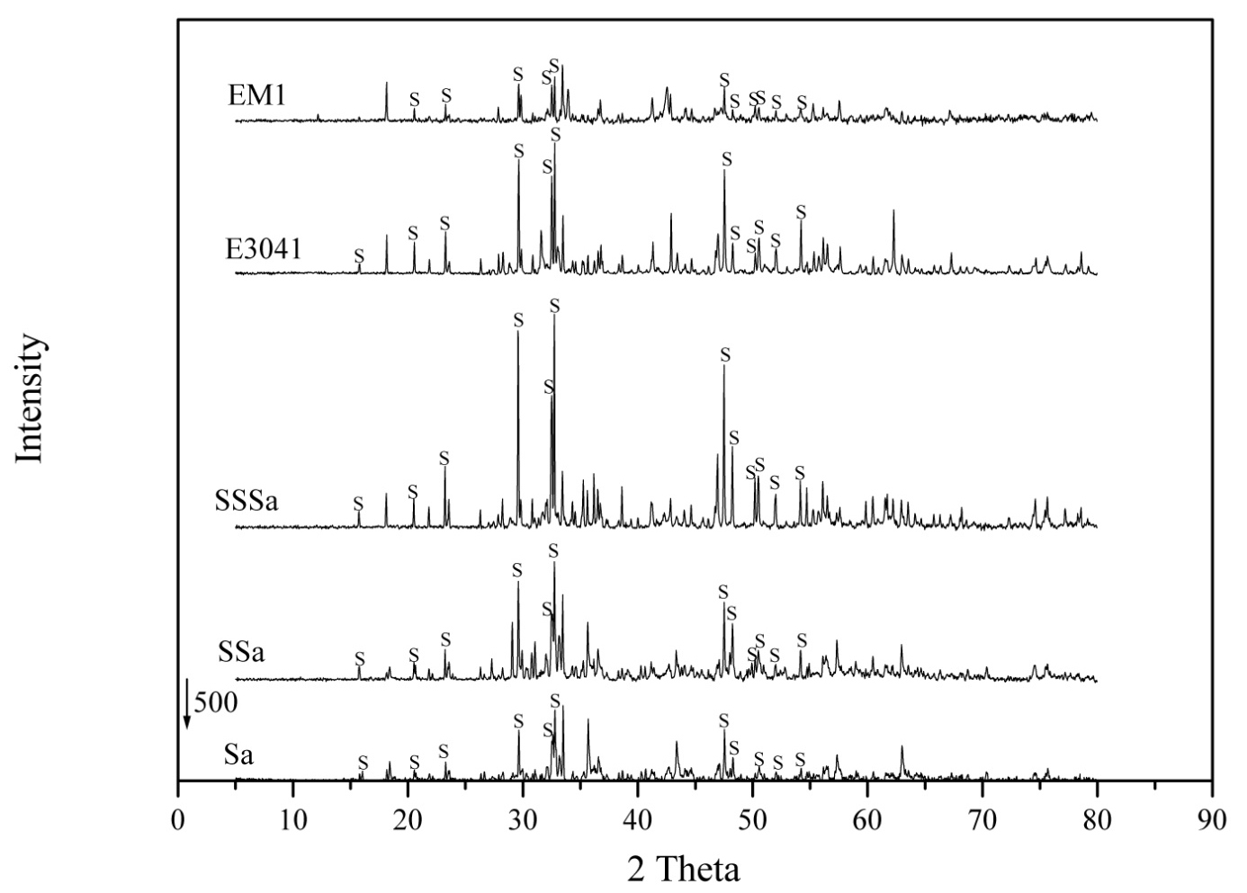

Figure S2. Particle size distribution of samples CSa, CSw1 and CSw2 ,and of samples SSa, SSw1 and SSw2
Figure S3. Particle size distribution of samples SSSa, SSSw1I, SSSw1II, SSSw2I and SSSw2II.

Figure S4. Particle size distribution of samples E3041, E3042, E31, E32, EM1 and EM2.

