Figures Extracted

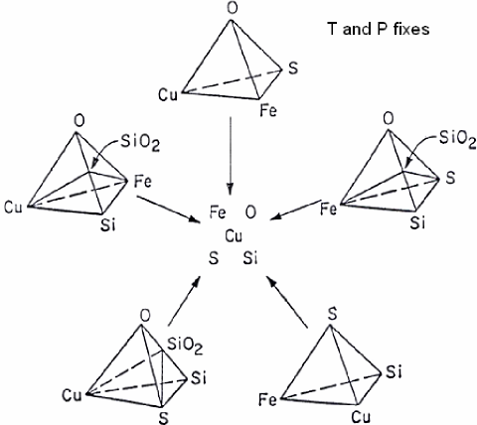
Figure 1. Quinary system Cu-Fe-S-O-SiO2, T and P fixes

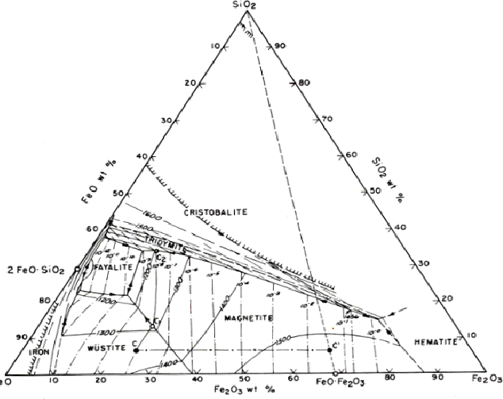
Figure 2. FeO-Fe2O3-SiO2 ternary system.

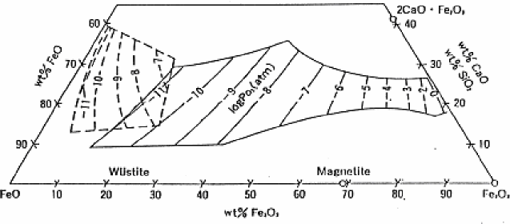
Figure 3. Isotherm at 1300 °C and isobars of oxygen potentials for ternary systems
FeO–Fe2O3–SiO2 and FeO–Fe2O3–CaO.

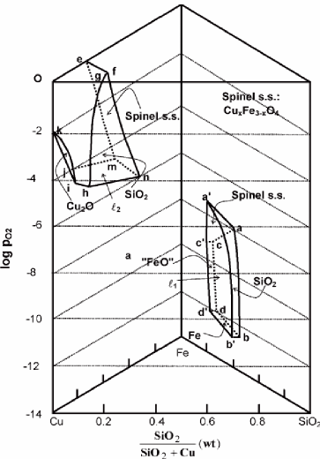
Figure 4. Stability diagrams of quaternary system Cu–Fe–O–SiO2: stability areas at 1200°C.

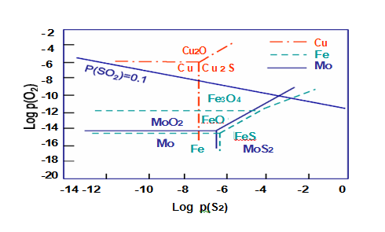
Figure 5. Stability diagram for copper and molybdenum in Cu-Mo-Fe system, 1300ºC.

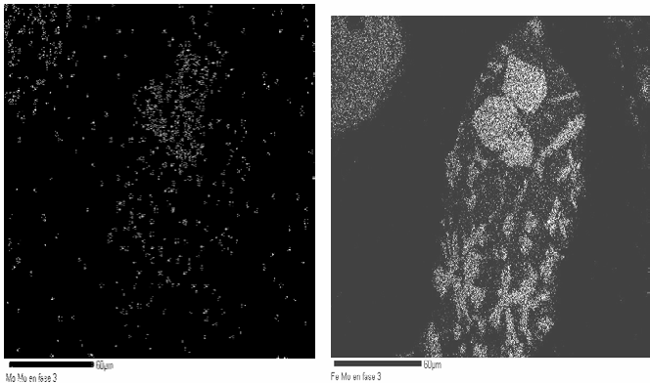
(a) (b)
Figure 6. SEM analysis for molybdenum (a) and iron (b) distribution in slag.

Phase 3
% Cu =0.1824
% Fe = 11.28
% Si = 31.76
% S = 0.2495
% Mo= 0.1034
% 2FeO·SiO2= 20.57
% SiO2= 67.95
Phase 2:
% Cu = 0.037
% Fe = 63.37
% Si = 0.394
% S = 0
% Mo= 1.245
% 2FeO∙SiO2= 2.85
% SiO2= 0.84
Phase 4
% Cu = 0.027
% Fe = 52.03
% Si = 7.12
% S = 0
% Mo= 4.36
% 2FeO∙SiO2=51.67
% SiO2=1 5.23
Phase 1
% Cu =0.032
% Fe = 52.17
% Si= 3.08
% S = 0
% Mo= 6.35
% 2FeO·SiO2=22.35 % SiO2=6.59

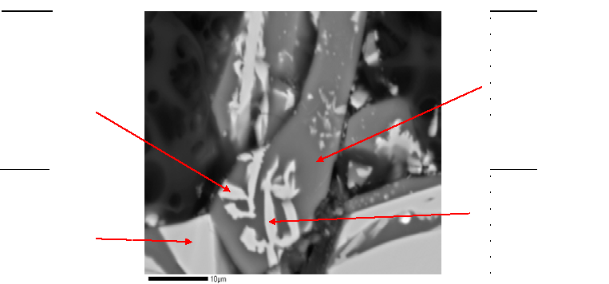

Figure 7. SEM characterization of a copper slag.

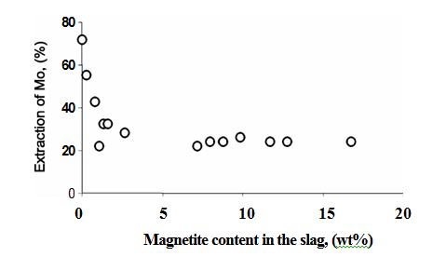

Figure 8. Extraction of molybdenum related to magnetite content.

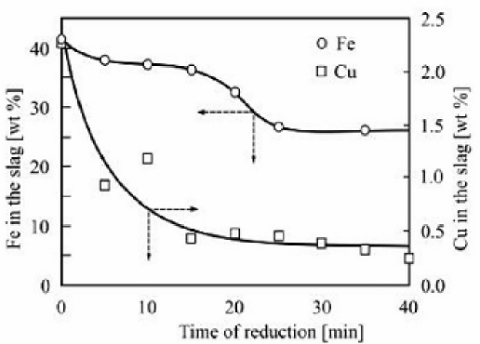
Figure 9. Concentration of copper and iron as function of time.

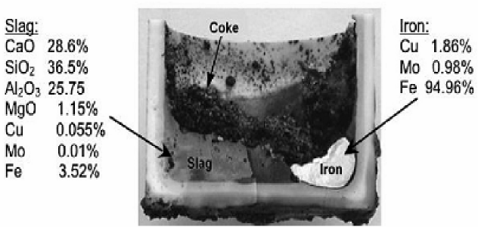
Figure 10. Slag and iron-rich alloy obtained at 1460ºC in an alumina crucible.

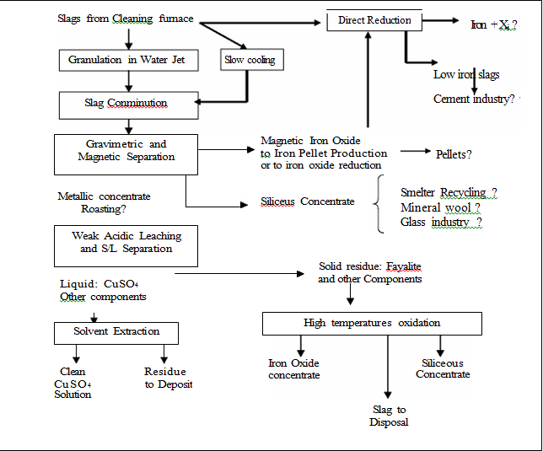
Figure 11. Flowsheet proposed for metal/material extraction from non ferrous slags.

Tables Extracted

Table 1. Estimates of Global Smelter Slag Tonnage

Smelter  Type | Metal via  Smelter kt | Recovery  Factor  % | Smelter Metal  Input kt | Smelter Feed  Grade % | Smelter Input  kt | Factor  Slag/Feed  Wt Ratio | Slag Tonnage  kt
Copper | 12,000 | 95 | 12,600 | 27 | 47,000 | 0.8 | 37,000
Nickel | 450 | 95 | 470 | 10 | 4,700 | 1 | 4,700
Fe-Ni | 300 | 95 | 320 | 2 | 16,000 | 1 | 16,000
PGM | 0.3 | 85 | 0.35 | 0.015 | 2,300 | 1 | 2,300
Iron¹ | 860,000 | - | - | - | 860,000 | 0.3 | 260,000
Steel¹ | 860,000 | - | - | - | 860,000 | 0.2 | 170,000
Cement |  |  |  |  |  |  | 2,700,000
¹ Metal Output

Table 2. Smelting Industry Product Value and Slag Cleaning Targets

Industrial Sector | Metal Prod’n kt/y | Price $/t Metal | Metal Revenue  Million $/y | Slag kt/y | Slag Cleaning Targets
Copper | 12,000 | 10,000 | 120,000 | 37,000 | Cu & Au
Nickel | 450 | 20,000 | 9,000 | 4,700 | Ni & Co
Ferro-nickel | 300 | 20,000 | 6,000 | 16,000 | -
PGM | 0.3 | 50,000,000 | 15,000 | 2,300 | Ni-Cu PGM,Cr
Blast Fce Iron | 860,000 | 500 | 430,000 | 260,000 | -
Steel (via pig) ¹ | 860,000 | 200 added | 172,000 | 170,000 | -
Notes:
Steel1(Total) | 1,100,000 | 700 | 770,000 | - | -
Cement | 2,700,000 | 100 | 270,000 | 2,700,000 | -
¹Includes scrap recycling and DRI

