ENVIRONMENTAL ASSESSMENT OF THE GREENHOUSE GASES EMISSION FROM POULTRY PRODUCTION IN
RUSSIA’S CENTRAL REGION

Miljan ?. Samardžić*, Jovica ?. Vasin¹, Igor ?. Jajić², Irina V. Andreeva³,
Dragana ?. Latković² and Ivan I. Vasenev³

¹Institute for Field and Vegetable Crops,
Maksima Gorkog 30, Novi Sad, Serbia
²University of Novi Sad, Faculty of Agriculture,
Trg Dositeja Obradovića 8, Novi Sad, Serbia
³Russian Timiryazev State Agrarian University, Moscow, Russian Federation

Abstract: With an estimated rise in poultry production and consumption of chicken meat in Russia by 9% up to 2022, as well as development of self-sustainable poultry production, the need has arisen for environmental assessment of this production, and within it especially greenhouse gases (GHGs) emission assessment. The goal of this work is to show a calculation procedure for obtaining estimations for the carbon footprint of the 1 kg of live chicken at the farm gate, taking into account regional typological features of agricultural production in agro-ecosystems. The methodology of carbon footprint (CF) calculation is based on the life cycle assessment (LCA) methodology, and on IAGRICO2 calculator, developed for agriculture products. Results have shown that in modern technology of poultry farming, 5.79 kg CO₂ е was emitted on average per kg of body mass, and that about 47% of emission was from manure, around 27,5% from crop production (fuel and fertiliser) and 25,5% from fuel and energy needed for heating, sanitation and feeding of chickens. The main distinction of Central Russia is low efficiency of the fertiliser application on crop fields and manure management, storage and utilisation, which has as a result high emissions of the nitrous oxide. This is the field where the implementation of the intensive technologies of precise farming, manure handling, utilisation and management will significantly decrease GHG emission, with preserving yield of crops and quantity and quality of chicken meat.
Key words: environmental assessment, greenhouse gases, poultry, manure, energy, fertilisers, agro-ecosystems, carbon footprin.

Introduction

Ever-increasing human population represents a major challenge for modern society, and anthropogenic pressure on ever decreasing natural resources is one of the major problems of environmental science, and anthropogenic greenhouse gases (GHGs) emission is one of the most prominent ecological issues within it. In addition, this population boom is setting the task to the agriculture: production of sufficient quantities of safe food for the constantly growing number of humans, with the efficient use of the limited quantity of natural resources (IPCC 2007, 2013). To fulfil this task, agriculture increased both intensity of production as well as arable land area, which increased the GHG emission from land use change and agricultural procedures, and resulted in modern agriculture participating in the global GHG emission with 16%, which could be compared to other sectors of human activity (energy generation – 26%, industry – 19%, transport – 13%)(IPCC 2007).
Not all agricultural products are of the same biological value for human nutrition, because humans are in need of high quality proteins in the diet for normal growth, development and sustenance of life. Basically, the main source of these proteins is the meat, which is produced from domestic animals, and because of that livestock sector is producing more GHGs than other sectors of food production, mainly methane and nitrous oxide (IPCC 2007; Popp et al., 2010).
For the purpose of providing needed quantity of meat for human consumption, the more intensive technologies in animal production are becoming increasingly interesting because resources are more efficiently used in more intensified system, which results in the cheapest unit price of the final product. Poultry raising is the most intensive branch of the animal husbandry, and the chicken meat is the most widely distributed and accessible type of meat both in quantity and in price, not only in Russia but also in the world (Figure 1).
FAO is predicting that in Russian Federation consumption of meat in 2022 will increase total meat consumption by 11.8 kg per capita, comparing to 2012, with the poultry meat share of 56.8% in this increase (Figure 2). Because of its livestock development program and increase in the production of meat, Russia should have a clear idea about the allocation of greenhouse gas emissions at each phase of the poultry production.
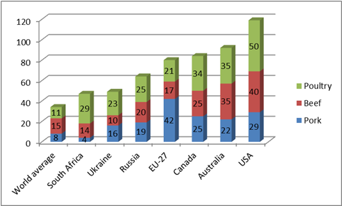

Figure 1. Meat consumption in 2009 (kg per capita). (http://www.fao.org/faostat/en/#data)

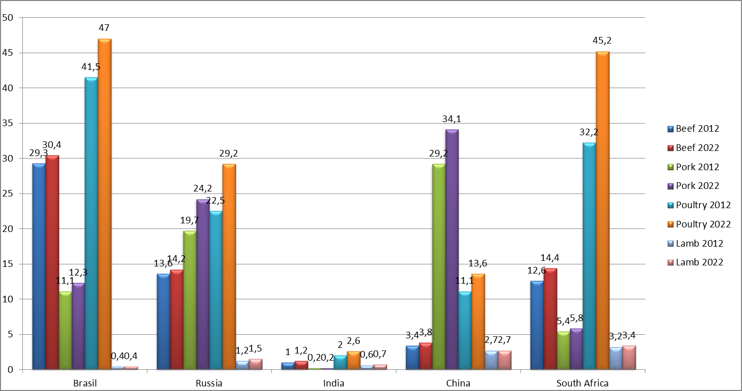

Figure 2. Estimation of the meat consumption in BRICS countries in 2012 and 2022 (kg per capita). (http://www.fao.org/faostat/en/#data)
The goal of this work is to show a calculation procedure for obtaining estimations for the carbon footprint of an agricultural product, namely 1 kg of live chicken at the farm gate, taking into account regional typological features of agricultural production in agro-ecosystems. The carbon footprint (CF) represents the amount of GHGs released during production of unit of some goods or services, represented in the kg CO₂ equivalent (kg CO₂ e), and it is calculated by multiplying the amount of specific gas with corresponding global warming potential of a given gas (1 for CO₂, 23 for CН₄ и 296 for N₂O) (FAO, 2006).

Materials and Methods

Data used in this paper were obtained through research on experimental training farms “Mummovskoe” (Saratov region, Russian Federation) and “Druzhba” (Yaroslavl’ region, Russian Federation), in the period from 2011 to 2014. In addition, complex data were obtained through LAMP field experiments in the Kursk region as well as data obtained through LISSOZ software application.
The methodology of a carbon footprint (CF) calculation is based on the life cycle assessment (LCA) methodology, i.e. the calculation of emissions that take place throughout the life cycle of a product from the production of the raw materials up to the disposal (from cradle to grave). The calculation takes account of each stage and includes the transport within the production chain from the first step up to the defined border of the system (the end of the chain or the end of the chain segment)(Samardžić et al., 2014).
LCA in poultry and chicken meat production can be divided into 5 principal phases:
- Phase 1: Feed and crop production;
- Phase 2: Poultry production;
- Phase 3: Meat processing;
- Phase 4: Chicken meat retail;
- Phase 5: Consumption and waste management.
This paper will focus on the first two phases. The methodology described in this article is based on IAGRICO₂ (Castaldi, 2013).

Results and Discussion

There are two main technologies of poultry production in Russian Federation, based on the length of the growth period: the first technology with the growth period of 42 days, and with a medium terminal weight of 1900 g and the second technology with the growth period of 56 days, and with a medium terminal weight of 3300 g. The first technology is more intensive one, which can be measured by feed conversion (the amount of feed needed for 1 kg of body mass gain), because of more efficient nutrient usage in the earlier stage of life and balanced mix of feed inputs (Table 1). In the following text, the focus will be on the more intensive technology.

Table 1. Differences of the feed conversion in two main technologies of poultry production in Russia.

Type of technology | Bodyweight at the end of  growth (kg) | Feed conversion  (kg feed/kg growth)
42 days | 1.9 | 1.76
56 days | 3.3 | 2.1

Calculation of CF in the phase of feed production: GHG emissions in this phase are dominated by CO₂ from fuel consumption, and N₂O emissions as a result of the fertiliser production and application as well as transformation of the ammonia from the applied manure to nitrates followed by processes of denitrification (Figure 3).

Feed
C footprint of the transport
Poultry
C footprint of the fertilisers
C footprint of the fuel and energy
C footprint of the manure

Figure 3. Diagram of the greenhouse gas emissions in the feed and
crop production phase.

Individual components of complex concentrated feed have different CFs, and birds are not consuming an equal amount of each component. To calculate CF of feed, it is necessary to determine quantities of consumed components throughout lifetime (Table 2) and the amount of fuel and fertiliser used in the specific crop production process and their representative CF (Table 3) (Hillier et al., 2009), as well as the amount of N₂O of fertiliser origin emitted from soil (FAO, 2001, 2006; IPCC, 2006, 2013).
Table 2. Quantities of feed components needed for the growth of the birds to the slaughtering weight.

Crops | Quantity (kg)
Maize | 1.5
Wheat | 0.7
Barley | 0.4
Soya | 0.8

Table 3. Carbon footprint of specific feed components.

Crops | Yield  (t ha⁻¹) | Applied per hectare |  | GHG emissions per hectare |  | GHG emissions per kg of crop yield |  | Carbon footprint of feed component  (kg CO₂ е)
Crops | Yield  (t ha⁻¹) | Nitrogen (kg) | Fuel (litres) | Nitrogen  (kg CO₂ е) | Fuel  (kg CO₂ е) | Nitrogen  (kg CO₂ е) | Fuel  (kg CO₂ е) | Carbon footprint of feed component  (kg CO₂ е)
Maize | 5 | 130 | 120 | 1,269 | 316.2 | 0.32 | 0.06 | 0.38
Wheat | 6 | 120 | 73.52 | 1,756 | 194.1 | 0.29 | 0.03 | 0.32
Barley | 6 | 220 | 69.05 | 2,147 | 182.3 | 0.36 | 0.03 | 0.39
Soya | 3 | 228 | 65 | 2,225 | 171.6 | 0.74 | 0.06 | 0.8

Carbon footprint of feed and crop production can be calculated by the following equation:
1.5×0.38+0.7×0.32+0.4×0.39+0.8×0.8=1.59 kg CO₂ e.

Calculation of CF in the phase of poultry production: Concerning poultry as a source of the GHG emission, the main sources at this phase are energy consumption for feeding and accommodation of the animals and manure management (Figure 4).

Birds
CF of the fuel and energy

Processing
CF of the transport
CF of the manure
Manure in the feed production
CH₄ and N₂O losses
Figure 4. Diagram of the greenhouse gas emissions in the poultry production phase.
Fuel consumption for feeding, manure handling and internal farm transport for the poultry was 0.005 litres of diesel per bird, which is equal to the 0.0132 kg CO₂ е; the energy needed for ventilation and heating had CF of 1.46 kg CO₂ е, which resulted in CF of energy equal to 1.47 kg CO₂ е. One bird produced approximately 3.9 kg of manure during lifetime, with N content of 0.195 kg. Losses of N as a consequence of bad manure managing practices were 40% and the amount of lost N transformed to N₂O was 7.5%.
To calculate CF from manure, we needed to multiply the amount of N₂O with its global warming potential (296 for N2O):
0.195×0.4×0.075×296=1.73 kg CO₂ е.
CF of the poultry production phase was:
1.47+1.73=4.2 kg CO₂ е.
Carbon footprint of poultry production at the farm gate was equal to:
1.59+4.2=5.79 kg CO₂ е.

From the given results, it is evident that the GHG emissions in the phase of feed production amounted to 27.46% of total emissions from poultry production. In this phase, dominant greenhouse gases were CO₂ from fuel consumption, and N₂O emissions as a result of the fertiliser production and application, as well as transformation of the ammonia from the applied manure to nitrates followed by processes of denitrification ( calculation of fertiliser production CF [6.8 kg CO₂ e kg-1 N in fertiliser] (Cederberg et al., 2009) and the amount of N₂O of fertiliser origin emitted from soil ). From Table 3, it is evident that around 75% of all GHG emissions in the feed and crop production phase were emitted as a consequence of fertiliser application. Using precision farming methods there could be achieved a reduction in the quantity of applied fertiliser (and consequently GHG emission) up to 40% without a decrease in crop yield.
In Russia’s conditions, the poultry sector has reached production intensity equal to the production level of developed regions in the world (EU, USA), but manure handling practices are not developed enough, which results in high losses of ammonia and consequently, in the greater GHG emission from manure. Moreover, 35% of GHG emissions from poultry production phase are a consequence of fuel and energy use, and 65% from manure management, which gives a possibility of GHG emission mitigation through improved manure storage and handling practices.

Conclusion

According to the performed analysis of the basic sources of GHG emissions in the life cycle of the poultry meat, it is concluded that the most efficient means for the greenhouse gases emission evaluation and assessment was an integral algorithm of GHG emission calculation, which was divided into 5 phases of the LCA: (1) feed and crop production, (2) poultry production, (3) meat processing, (4) chicken meat retail, (5) consumption. Every phase was characterised by specific emission factors. Regulation of those emission factors can provide means for a reduction of this specific anthropogenic impact on the environment.
The first phase was connected with analysis of the applied fodder technologies in the concrete soil, climate and agroecological conditions. Those conditions were defined by maximum essential spatial variability and temporal changes, which determined priorities of their research in the conditions of the central regions of European part of Russia (CRER). Differences between traditional and modern ways of the tillage and their corresponding GHG emission must be taken into consideration.
The second phase was characterised by a high level of unification of applied zootechnologies, with dominating contrast variants of high intensity poultry business (imported bird varieties and hybrids as well as housing and feeding technology) with ever reducing segment of extensive technologies of poultry business in the conditions of CRER. Conducted analyses show intensive lowering of the CF with the replacement of the older technologies with modern ones, chiefly by decreasing growth time and improvement of the feed conversion (42 days vs. 56 days of growing, 1.76 kg of feed vs. 2.1 of feed per 1 kg of weight), which should be included in the efficiency assessment of the modernisation projects of the poultry farms.
The main distinction of CRER is low efficiency of the manure utilisation, which has as a result high emissions of the nitrous oxide. This is the field where the implementation of the intensive technologies of manure handling, utilisation and management will significantly decrease GHG emissions.

Acknowledgements

Data used in this paper were obtained under the auspices of the project “Agroecology, Climate Changes, Carbon Cycles, Soil Ecology, System Analysis and Ecosystem Modeling” with support from the Government of Russian Federation’s Megagrant No. 11.G34.31.0079.

References

Castaldi, S. (2013). IAGRICO₂ Italian Agriculture CF calculator. Second University of Napoli.
Cederberg, C., Flysjö, A., Sonesson, U., Sund, V., & Davis, J. (2009). Greenhouse gas emissions from Swedish consumption of meat, milk and eggs 1990 and 2005. Swedish Institute for Food and Biotechnology pp. 32-36.
FAO & International Fertiliser Industry Association, (2009). Global Estimates of Gaseous Emissions of NH₃, NO and N₂O from Agricultural Land. Rome: Published by FAO and IFA.
FAO (2006). Livestock's Long Shadow: Environmental Issues and Options pp. 50-55, 80-90.
The Statistics Division of the FAO (2018). http://www.fao.org/faostat/en/#data, accessed at June 10th, 2018.
Hillier, J., Hawes, C., Squire, G., Hilton, A., Wale, S., & Smith, P. (2009). The carbon footprints of food crop production. International Journal of Agricultural Sustainability, 7 (2), 107-118.
IPCC, (2006). Emissions from Livestock and Manure Management 2006 Guidelines for National Greenhouse Gas Inventories. Volume 4, chapter 10: Agriculture, Forestry and Other Land Use. Land Use Change and Forestry.
Stocker, T.F., Qin, D., Plattner, G.K., Tignor, M., Allen, S.K., Boschung, J., & Midgley, P.M. (2013). IPCC: Climate Change: The Physical Science Basis, Working Group I Contribution to the Fifth Assessment Report of the Intergovernmental Panel on Climate Change. Cambridge, United Kingdom - New York, NY: Cambridge University Press pp. 867-869.
Popp, A., Lotze-Campen, H., & Bodirsky, B. (2010). Food consumption, diet shifts and associated non-CO₂ greenhouse gases from agricultural production. Global Environmental Change, 20 (3), 451-462.
Samardžić, M., Castaldi, S., Valentini, R., & Vasenev, I.I. (2014). Calculation of Carbon Emission Resulting from Poultry Production under the Conditions of the Central Region in European Russia. Izvestiya TSHA, 2, 35-49.

Received: June 19, 2018
Accepted: September 10, 2018

EKOLOŠKA OCENA EMISIJE GASOVA STAKLENE BAŠTE IZ PROIZVODNJE BROJLERA U CENTRALNOM REGIONU RUSIJE

Miljan ?. Samardžić*, Jovica ?. Vasin¹, Igor ?. Jajić², Irina V. Andreeva³,
Dragana ?. Latković² i Ivan I. Vasenev³

¹Institut za ratarstvo i povrtarstvo,
Maksima Gorkog 30, Novi Sad, Srbija
²Univerzitet u Novom Sadu, Poljoprivredni fakultet,
Trg Dositeja Obradovića 8, Novi Sad, Srbija
³Russian Timiryazev State Agrarian University, Moscow, Russian Federation

R e z i m e

Sa očekivanim porastom proizvodnje u živinarstvu i povećanjem korišćenja pilećeg mesa u Rusiji od 9% do 2022. godine, kao i sa razvojem domaće proizvodnje, koja će u potpunosti isključiti potrebu za uvozom živine, nastala je potreba za ocenom uticaja živinarstva na životnu sredinu, a posebno emisiju gasova staklene bašte. Cilj ovog rada je prikazati proceduru izračunavanja ugljenikovog otiska (engl. Carbon footprint) Carbon footprint–a za 1 kg žive mase na kraju tova brojlera, uzimajući u obzir regionalne tipološke osobine poljoprivredne proizvodnje u agroekosistemima. Metodologija proračuna ugljenikovog otiska bazirana je na metodologiji ocene životnog ciklusa (engl. Life Cycle Analysis – LCA), i na kalkulatoru IAGRICO₂, prilagođenom poljoprivrednim proizvodima. Rezultati su pokazali da se u modernoj tehnologiji živinarstva, u proseku emituje 5,79 kg CO₂ ekvivalenta po kg telesne mase, te da je oko 47% emisije poreklom iz stajnjaka, oko 27,5% od proizvodnje useva (upotreba goriva i đubriva) i 25,5% od goriva i energije potrebne za grejanje, čišćenje i hranjenje pilića. Glavna odlika centralnog regiona evropske Rusije je niska efikasnost primene azotnih đubriva na poljima, kao i upravljanje skladištenjem i primenom stajnjaka, što ima za posledicu velike količine emitovanog azot-suboksida. Ovo predstavlja polje u kojem bi implementacija intenzivnih tehnologija precizne poljoprivrede i skladištenja i primene stajnjaka mogla značajno smanjiti emisiju gasova staklene bašte, sa očuvanjem prinosa poljoprivrednih kultura i količine i kvaliteta pilećeg mesa.
Ključne reči: ekološka ocena, gasovi staklene bašte, živina, stajnjak, energija, đubriva, ugljenikov otisak.

Primljeno: 19. juna 2018.
Odobreno: 10. septembra 2018.

*Corresponding author: e-mail: miljan.samardzic@gmail.com
*Autor za kontakt: e-mail: miljan.samardzic@gmail.com

