QUANTITATIVE RELATIONSHIPS BETWEEN INVESTMENTS IN FARMS AND ENVIRONMENTAL EFFECTS IN SOME EUROPEAN COUNTRIES

Nicola Galluzzo

Association of Economic and Geographical Studies of Rural Areas (ASGEAR)
Via Salaria per L’Aquila, 76 scala A, 02100 Rieti, Italy

Abstract: Since the early 1970s, in many European Union member countries, there has been a significant improvement in their own agricultural economic growth due to the Common Agricultural Policy. The increasing levels of investment in land and in machinery have been one of the pivotal pillars in improvement levels of food self-sufficiency. However, a growth in investments has increased pollutant emission in terms of carbon dioxide, nitrogenous compounds and a deterioration of an environment. The purpose of this paper was to investigate the impact of investments on agricultural and arable land in improving agricultural production towards environmental quality. The quantitative methods have used a neural relation analysis through the Kohonen’s maps or self-organizing maps (SOMs). Findings of Kohonen’s maps have pointed out a good ability to classify the time series data and the spatial evolution of data over the time; furthermore, SOMs have been useful in describing the impact of investment on production specialization, levels of pollution and food self-sufficiency in the European countries. To sum up, an improvement of food self-sufficient levels has been tightly linked to an increase of pollution in terms of carbon dioxide emissions.
Key words: Kohonen’s maps, Common Agricultural Policy, rural development, investments, productive specialization, multifunctionality.

Introduction

In the European Union, from 1955 to 1990, there was a significant implementation of economic conditions in the countryside due to a growth of levels of food self-sufficiency with positive consequences on the farmers’ income through the Common Agricultural Policy (CAP) by a direct price support of ag-commodities and through a protection of the domestic market by customs barriers (Vieri, 1994). In fact, the first and foremost purpose of the CAP was to ensure a decent level of income in the countryside by an allocation of specific actions able to protect the domestic European market, which in the nineties was one of the predominant reasons of a radical structural change in the Common Agricultural Policy towards a post-productivist model of production (Shucksmith, 1993; Marsden 1995; Ilbery, 1998). It is impossible to fail to mention that the CAP has been one of the key pillars for getting better living conditions in the primary sector by ensuring an adequate socio-economic welfare in the countryside as well (XXXX, 2013a; XXXX 2013b) with a meaningful positive change in relationships among agriculture and environment throughout the multifunctionality (Van der Ploeg et al., 2002; Van der Ploeg, 2006, 2009).
Focusing the attention on the enlargement of the European Union in 2004 and in 2007 and on the changes imposed by the international agreements such as GATT and WTO, there has been a cut-off in direct payments to farmers, or rather there has been a radical political turning point in the first pillar of the Common Agricultural Policy. The direct consequence has been the development of a new agricultural common policy aimed at supporting diversified measures in order to promote a holistic rural development by multifunctionality and by a diversification of activities in the countryside through a surge of pluriactivity farms financed by the second pillar of the CAP (Vieri, 1994, 2001, 2012; Belletti, 2003; Henke, 2004; Cooper et al., 2009; Hassink et al., 2013; Dufour et al., 2007; XXXX, 2015).
The improvement in the levels of food self-sufficiency has implied the levels of technical efficiency in terms of investments in agrarian land, in zootechnic productions and in machinery used in agriculture which, however, have increased the emission of pollutants into the atmosphere such as carbon dioxide, nitrogenous compounds, etc. (Nguyen et al., 2010, Olesen and Bindi, 2002). Multifunctionality has been a direct consequence of a new vision of the European Union agriculture in protecting the environment by a production of positive externalities in particular in the upland rural areas at risk of socio-economic marginalization as a consequence of the liberalization processes (Dibden et al., 2009). Excessive specialization and intensification of agricultural production have had some effects on ecological, environmental, economic-financial management and governance in all European Union member states (Vieri, 2001; Cunha and Swinbank, 2011) in order to render the environment more sustainable in the countryside. All this has led many European citizens to a greater awareness towards the second pillar of the Common Agricultural Policy towards the rural development by awarding and recognition of the role of agriculture as a public good with effects on territorial specialization, landscape and ability to produce positive externalities (Belletti, 2003; Henke, 2004; Cooper et al., 2009). Agriculture is given a multifunctional role in terms of protecting the environment and promoting the development of rural cohesion and protection of rural territories through multifunctionality (Hassink et al., 2013; Dufour et al., 2007).
The purpose of this research was to evaluate, through the use of a quantitative method based on the self-organizing maps (SOMs), the impact of investments in land capital and machinery with the goal to improve agricultural production of commodities and the level of food self-sufficiency in the European Union countries from 1990 to 2012, and the environmental quality in terms of effects on agricultural and arable land. In order to assess these relationships, the FAO statistics database published on its website has been used.

Materials and Methods

The methodology has employed a quantitative approach as the self-organizing maps (SOMs) proposed by Kohonen (Kohonen, 1995), using the open source software Spice-Som version 2.1 for the estimation of the parameters. The main goal of the paper was aimed at assessing if there was a unique winner neuron (black hexagons in the SOMs) in terms in the European countries able to produce the highest level of carbon dioxide emission with a nexus to the highest levels of investments and agrarian production.
In general, self-organizing maps are particularly useful to estimate, in time series, the structure and the evolution of several variables, such as poverty, lifestyle, health situation, development and welfare features in different countries in order to obtain a unique parameter and a visualization of different clusters of states or rather groups of hexagons with lots of analogies to the principal component analysis (Kasky and Kohonen, 1996; Mehmood et al., 2011). The self-organizing map (SOM) is a particular quantitative model of an artificial neural network able to produce a low two-dimensional representation of inputs in some maps (Kohonen, 1995). Self-organizing maps are different from other artificial neural networks because they use a neighborhood function in order to preserve the topological properties of the input space considered in the model of analysis (Meraviglia, 2001).
The self-organizing maps are useful to visualize low dimensional views of high dimensional data and they consist of components called nodes or neurons. Each node is a weight vector of the same dimension as the input data vectors and also as a specific position in the map space. The usual arrangement of nodes is a two-dimensional regular spacing made by a hexagonal grid or rectangular box. The self-organizing map describes a mapping from a higher dimensional input space to a lower dimensional map space. The procedure for placing a vector in the map is to find out a node located nearest to the winner neuron considering that each vector in the map is linked with every neuron in the used dataset (Kohonen, 1995). The network in the SOM is characterized by a pattern in two different layers, one layer is made up by input and the other layer, commonly called the Kohonen’s layer, is constituted by output (Kohonen, 2001). The neurons of the two layers are completely connected to each other, while neurons of the output layer are linked to different output neurons (Kohonen, 1984).
The purpose of the learning process in the SOM is to define different parts in the network made by the SOM able to match with patterns of different inputs. The weights of the neurons are initialized either to small random numbers or values sampled from a subspace crossed by the two larger eigenvalues able to increase the training because initial weights are a good approximation of weights in the SOM (Kohonen, 1995). When a training sample input is put in the network, its Euclidean distance is calculated from all vectors of weights. The neuron with the weight vector most similar to the input is called the best matching unit (BMU). Weights of the BMU and neurons close to it in the SOM lattice made by hexagons or component planes are closer to the input vector and the intensity of the approach decreases over time and in function of the distance of the neurons by the BMU (Kohonen, 1984).
The formula used for updating the weights of a neuron is Wv (Lucchini, 2007):
Wv ( t + 1) = Wv (t ) + Θ ( v, t) α (t ) [D (t) - Wv (t)] (1)

where α(t) is a monotone decreasing learning coefficient and D(t) is the input vector. The function that defines the neighborhood Θ (v, t) depends on the distance in the lattice between the BMU and the neuron v. In a simplified form of the competitive network, the value is equal to 1 for all neurons close to the BMU and 0 for others, even if the most common choice is similar to a Gaussian function; hence, the winner neuron is in a central position and the losers are distant. In general, regardless of the kind of used function, the neighborhood function decreases over time; initially, when the neighborhood is broad, the self-organizing map takes place on a global scale and when the neighborhood is reduced to only a few neurons, weights converge to a local estimate called a tuning phase. This process is repeated for each input vector and it is also reiterated for a variable large number of cycles.

Results and Discussion

Findings in some analyzed variables such as arable land and permanent crops over time of investigation have pointed out on average a significant and sharp growth of arable land and by contrast a steady development of permanent crops lower than 5 million of hectares (Figure 1). Considering different European nations, the rural population on average seems to fluctuate significantly in all countries even if the highest diffusion of rural population has affected Germany, Italy, the United Kingdom and France where scattered small villages marked rural territories (Figure 2).
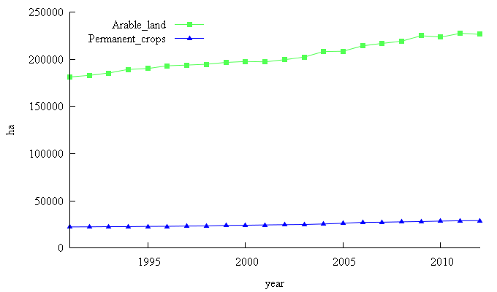

Figure 1. Evolution of arable land and permanent crops in thousands of hectares
in all European countries.
Source: Author’s elaboration on data http://faostat3.fao.org/faostat-gateway/go/to/home/E with the software GRETL 1.9.

Figure 2. Average of rural population in investigated European countries
from 1991 to 2012.
Source: Author’s elaboration on data http://faostat3.fao.org/faostat-gateway/go/to/home/E.
In more than 20 years of investigation, the average value in the time series of protein and energy consumed every day by European citizens has highlighted a significant and consistent level of ingestion of food even if findings in some newcomer states of the European Union, such as Bulgaria, Latvia and Slovakia, have pointed out the lowest level of protein per day (Figure 3).

Figure 3. Daily average levels of protein and energy in European
countries from 1991 to 2012.
Source: Author’s elaboration on data http://faostat3.fao.org/faostat-gateway/go/to/home/E.

The rural population and also the urban population have been positively influenced by the level of intake protein (Table 1). In general, a growth of arable land has implemented the level of energy and protein consumed by the European citizens even if an increase of this latter has affected the use of fertilizers and CO₂ emissions. Investments in machinery and in land capital have acted directly to the rising level of protein per day and they did not act on the level of consumption of food in terms of energy.
Focusing the attention on all analyzed variables, such as protein and energy per day, arable land, agricultural areas, rural and urban population, investments in land capital and machinery, CO₂ emissions, the Kohonen’s map has pointed out a meaningful level of horizontal variability with low level of interactions, as shown in white hexagons, in Italy and in some newcomer member states of the European Union such as Slovakia and Lithuania (Figure 4). Malta, Poland and Germany have been three countries characterized by the highest level of investigated variables such as arable land, level of investments, rural and urban population and food ingestions.
Table 1. Correlation among different investigated variables over time in all European countries.

 | Arable land | CO₂ emission | Energy (kcal/day) | Forest | Land capital investments | Machinery investments | Meadows | Protein per day | Rural population | Urban population
Arable land | 1.00 | 0.8820 | 0.3109* | 0.4810 | 0.8092 | 0.8142 | 0.7810 | 0.2686* | 0.8132 | 0.8040
CO₂ emission | 0.8820 | 1.00 | 0.4810 | 0.3885 | 0.5291 | 0.8617 | 0.8096 | 0.3145* | 0.8126 | 0.9275
Energy (kcal/day) | 0.3109* | 0.3919 | 1.00 | 0.0263* | 0.2479* | 0.3892 | 0.3772* | 0.8004 | 0.3893 | 0.3848
Forest | 0.4810 | 0.3885 | 0.0263* | 1.00 | 0.3239* | 0.4218 | 0.2934* | 0.2257* | 0.3008* | 0.3535*
Land capital investments | 0.8092 | 0.5291 | 0.2479* | 0.3239* | 1.00 | 0.4874 | 0.6542 | 0.2656* | 0.6641 | 0.5156
Machinery investments | 0.8142 | 0.8617 | 0.3892 | 0.4218 | 0.4874 | 1.00 | 0.5940 | 0.2663* | 0.9182 | 0.8936
Meadows | 0.7810 | 0.8096 | 0.3772* | 0.2934* | 0.6542 | 0.5940 | 1.00 | 0.3657* | 0.6931 | 0.7965
Protein per day | 0.2686* | 0.3145* | 0.8004 | 0.2257* | 0.2656* | 0.2663* | 0.3657* | 1.00 | 0.2339* | 0.2588*
Rural population | 0.8132 | 0.8126 | 0.3893 | 0.3008* | 0.6641 | 0.9182 | 0.6931 | 0.2339* | 1.00 | 0.9159
Urban population | 0.8040 | 0.9275 | 0.3848 | 0.3535* | 0.5156 | 0.8936 | 0.7965 | 0.2588* | 0.9159 | 1.00
* denotes significance at 5%.
Source: Author’s elaboration on data http://faostat3.fao.org/faostat-gateway/go/to/home/E with the software GRETL 1.9.

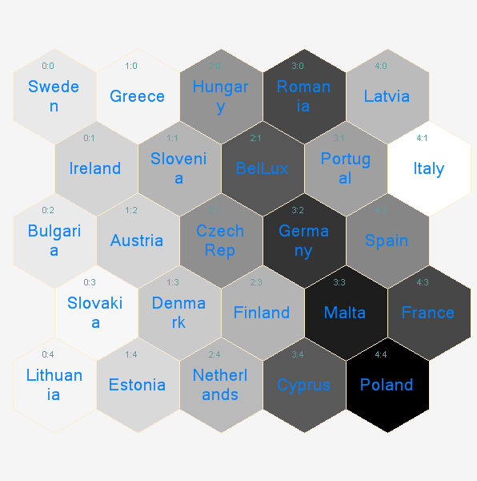

Figure 4. Component planes of all analysed variables.
Source: Author’s elaboration on data http://faostat3.fao.org/faostat-gateway/go/to/home/E.
The Kohonen’s maps comparing the level of intake protein and energy have pointed out that Bulgaria and newcomers of the European Union such as Cyprus, Hungary and Slovenia have been characterized by black hexagons, which have implied the highest levels of these variables (Figure 5). Component planes of nutrition levels, in terms of kilocalories and protein per day, which are a useful tool to understand over time the level of food self-sufficiency as a result of improving in the level of wellbeing and personal income, have showed a fairly homogeneous situation in all different European countries with the exception of some nations located in the European peripheral areas. In general, the level of intake protein per day has not underscored a great diversity among member countries of the EU. The heterogeneity in nodes, due to a greater allocation of agricultural areas, has concerned northern European countries such as France and Ireland, where there are extensive farming systems and large-sized farms.

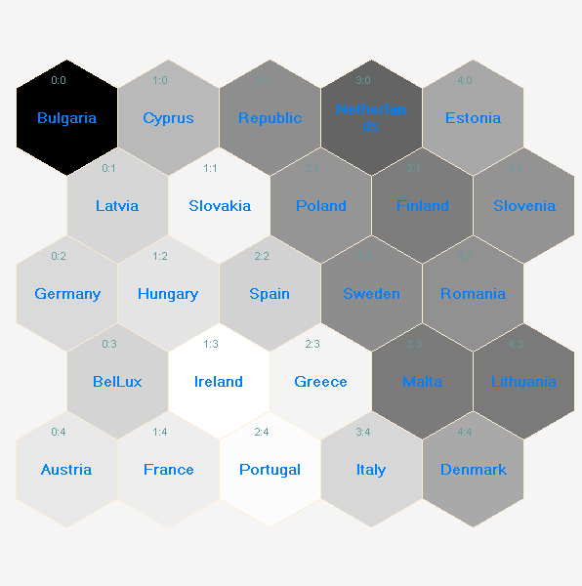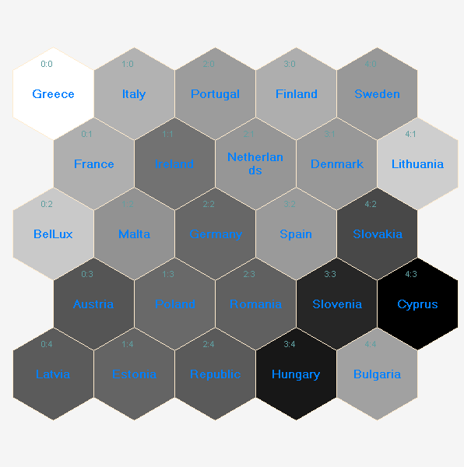
(A) (B)

Figure 5. Component planes of some inputs such as kilocalories per day (A) and level of protein per day (B).
Source: Author’s elaboration on data http://faostat3.fao.org/faostat-gateway/go/to/home/E.

Findings in component planes of the variables such as agricultural areas and arable land have highlighted that there has been the highest level of this latter variable in France (black hexagon); newcomer states of the EU such as Romania, Lithuania, Belgium and Luxemburg have also pointed out the highest level of arable land. In contrast, Italy, Germany and Malta, on one hand, and the Netherlands, Austria, Greece and Slovenia (white and grayish scale), on the other hand, have shown the lowest levels of arable land (Figure 6). The analysis of the component planes for the arable land variable has pointed out a higher homogeneity in nodes among all EU countries, even if newcomer states have demonstrated a greater endowment of arable land compared to small countries of the Mediterranean basin (Cyprus and Malta) or in other nations, where the orography does not allow cultivating of wide agrarian areas. Summing up, different component planes of self-organizing maps have highlighted a different intensity of connections. The analysis revealed a considerable horizontal variability in the agricultural areas, focusing the attention on the case of the arable land in all member states of the European Union.
It is interesting that the analysis of component planes refers to the variables such as the rural population and the urban population as well, concentrated predominately in Germany (Figure 7); the SOMs have showed that in countries, with higher agricultural areas with scattered rural villages, there is a high concentration of citizens unlike Slovakia and other countries, which have been members of the European Union since 2004, and where the population is predominantly concentrated in few urban areas.
Findings in SOMs investigating the level of investments in machinery and in land capital have pointed out that Latvia has invested more than Slovakia and Finland in machinery (Figure 8); in contrast, Denmark and France (black hexagons) have invested more in agrarian capital than newcomer states of the EU such as Bulgaria and Cyprus. Outcomes in European countries have pointed out that the higher is the rate of agricultural employment the higher is the level of agricultural population living in rural spaces. Addressing the research on the variable level of investments in countries that became members of the EU during the enlargement in 2004, findings have underlined that the most important financial resources have been used on investments in intensifying the endowment in agricultural machinery and equipment. By contrast, investments in increasing the endowment of land capital have involved predominately the old member states of the European Union, with the exception of Italy, and only few newcomer nations such as Poland.

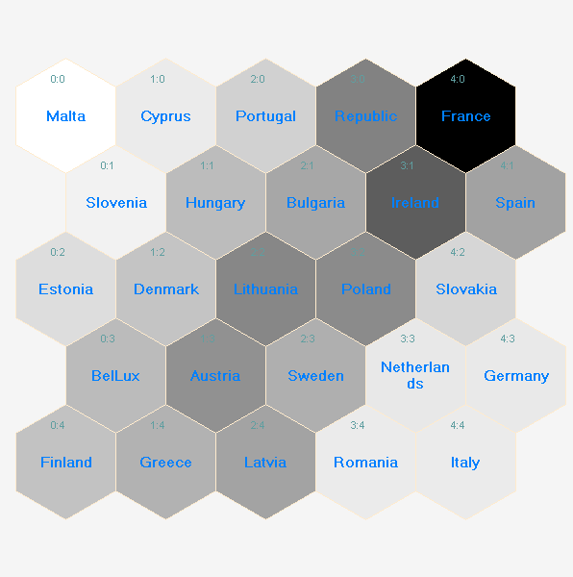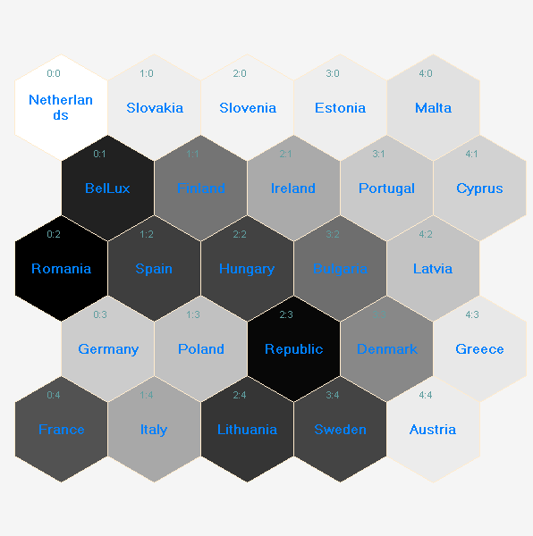
(A) (B)

Figure 6. Component planes of some inputs such as agricultural areas in
hectares (A) and arable land (B).
Source: Author’s elaboration on data http://faostat3.fao.org/faostat-gateway/go/to/home/E.

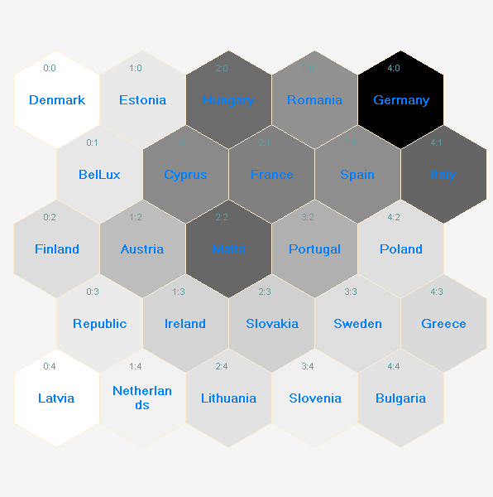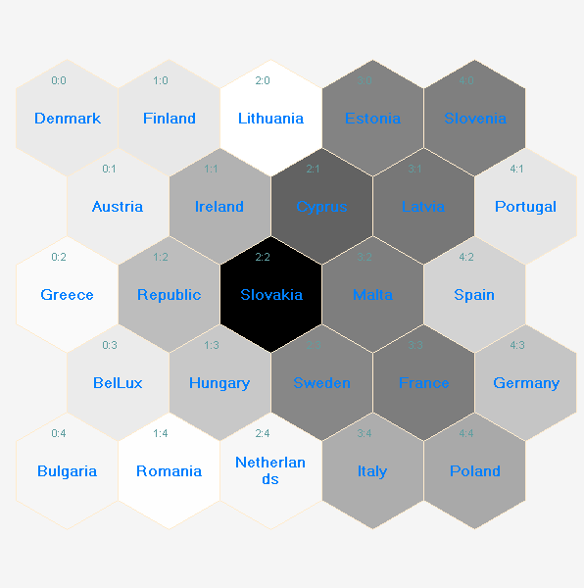
(A) (B)

Figure 7. Component planes of some inputs such as the rural population (A) and the urban population (B).
Source: Author’s elaboration on data http://faostat3.fao.org/faostat-gateway/go/to/home/E.

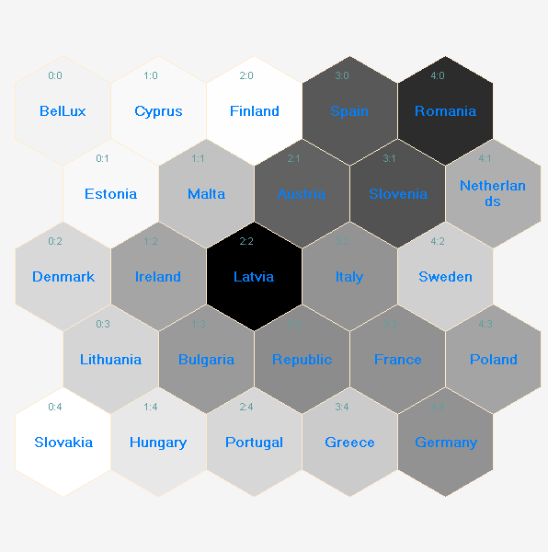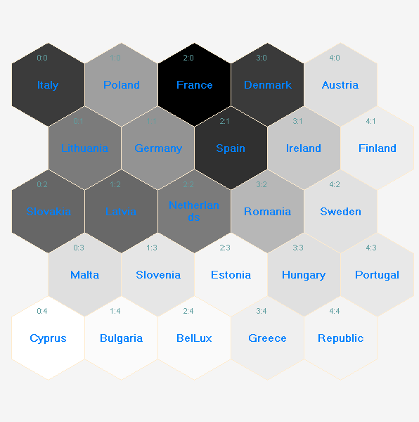
(A) (B)

Figure 8. Component planes of investments in machinery (A) and
land capital (B) in different European countries.
Source: Author’s elaboration on data http://faostat3.fao.org/faostat-gateway/go/to/home/E.

The Kohonen’s maps assessing the endowment of agricultural areas in terms of meadows and pastures have pointed out a greater level of homogeneity among all European Union countries (Figure 9).

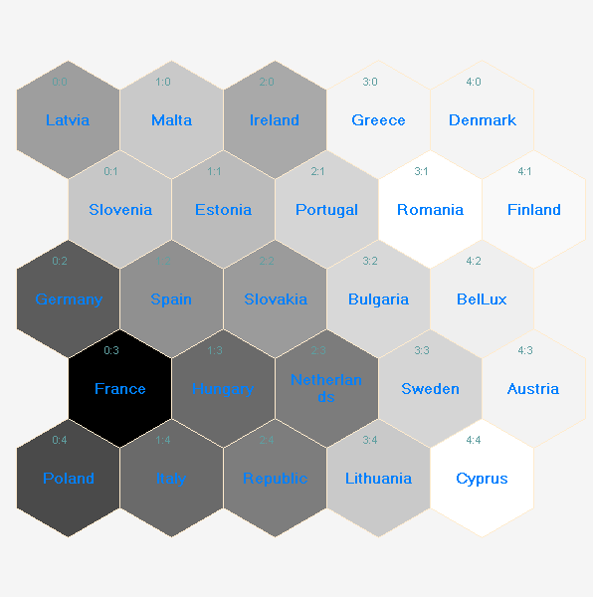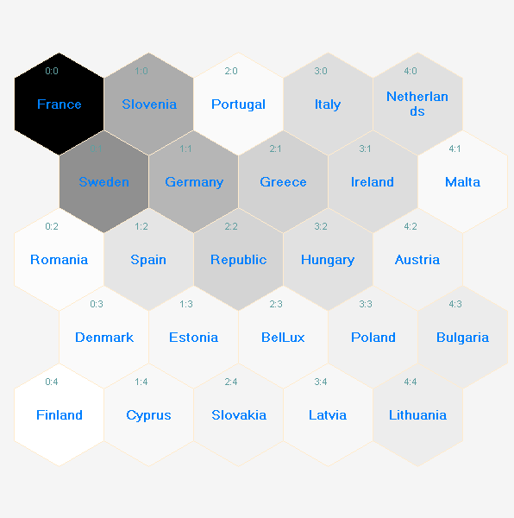
(A) (B)

Figure 9. Component planes of the carbon dioxide emission (A) and
meadows and pastures (B) in all analysed European countries.
Source: Author’s elaboration on data http://faostat3.fao.org/faostat-gateway/go/to/home/E.
The emission of carbon dioxide, as a consequence of a greater use of fertilizers and investment in the primary sector, has been homogeneous in all European countries. The level of emissions of carbon dioxide and other greenhouse gases, such as NO₂ from fertilizers and soil, has underlined that there has been a growth of the level of discharge due to an increase of the agricultural productions in all European countries over 20 years of study. Findings have indicated that since 2007 there has been a significant drop in CO₂ emissions as a consequence of several new actions carried out by the Common Agricultural Policy aimed at implementing the level of set-aside and not cultivated areas or afforested areas and at reducing the chemical negative impact on the environment through lots of actions correlated to the multifunctionality (Figure 10).

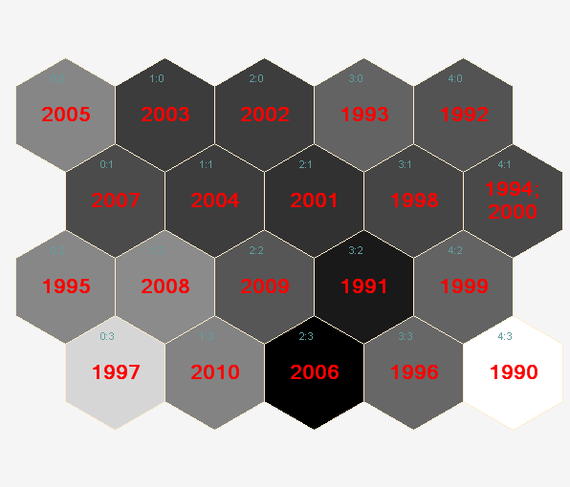

Figure 10. Self-organizing maps about the level of carbon dioxide emissions in
all analysed countries.
Source: Author’s elaboration on data http://faostat3.fao.org/faostat-gateway/go/to/home/E.

Conclusion

The Kohonen’s maps have pointed out a good ability of this quantitative approach in order to investigate and classify time series data and its spatial evolution. Roughly speaking, this method has been useful in describing the impact of investment on production specialization, levels of pollution and food self-sufficiency.
The level of food self-sufficiency has increased since 2004, despite the accession of new member states of Eastern Europe in the EU, which came from the conditions of extreme structural productive weakness and economic disadvantage; hence, the role of pre-accession funds have been pivotal to stimulate farmers to improve their factors of production and land capital by investments able to improve both economic and also food self-sufficiency reducing, on the other hand, the ecological impact of emissions of pollutants such as carbon dioxide by new ecological strategies proposed by the Common Agricultural Policy focused on protecting the environment and on reducing chemical use of pesticides and fertilizers through financial subsidies towards organic farms.
Results have underscored that countries with wide arable land areas have produced a high level of emissions in terms of CO2 from the fertilizers. In general, farmers with poorer areas than other European countries are able to put a lower level of carbon dioxide in the atmosphere, hence, this has implied that small farmers are able to produce a multifunctional effect compared to very large areas.
To sum up, the analysis has underlined that an improvement of the food self-sufficient level has been tightly linked to an increase of pollution in terms of carbon dioxide emissions; therefore some proposals of the European Union Commission about the greening approach or as an alternative reforestation seem to be the first and foremost strategies in reducing this ecological problem. It is important that policy makers take into account specificities of the different typologies of European agricultures, with the aim to disburse financial subsidies by the CAP in favor of quality agrarian productions such as certified quality food and traditional food.

References

Belletti, G. (2003). Le denominazioni geografiche nel supporto all’agricoltura multifunzionale. Politica Agricola Internazionale, 4, 1-21.
Cooper, T., Hart, K., & Baldock, D. (2009). The Provision of Public Goods Through Agriculture in the European Union. Report for DG Agriculture and Rural Development. Institute for European Environmental Policy. Retrieved November 18, 2016, from http://ec.europa.eu/agriculture/analysis/external/public-goods/index_en.htm.
Cunha, A., & Swinbank, A. (2011). An inside view of the CAP reform process. Exploring the MacSharry, Agenda 2000 and Fishler Reforms. Oxford: Oxford University Press.
Dibden, J., Potter, C., & Cocklin, C. (2009). Contesting the neoliberal project for agriculture: Productivist and multifunctional trajectories in the European Union and Australia. Journal of Rural Studies, 25(3), 299-308.
Dufour, A., Mauz, I., Rémy, J., Bernard, C., Dobremez, L., Havet, A., Pauthenet, Y., Pluvinage, J., & Tchakérian, E. (2007). Multifunctionality in Agriculture and its Agents: Regional Comparisons. Sociologia Ruralis, 47(4), 316-342.
XXXXX, XX. (2013a). ….....XXXXXXX.........
XXXXX, XX. (2013b). ….....XXXXXXX.........
XXXXX, XX. (2015). . ….....XXXXXXX.........
Hassink, J., Grin, J., & Hulsink, W. (2013). Multifunctional agriculture meets health care: applying the multi-level transition sciences perspective to care farming in the Netherlands. Sociologia Ruralis, 53(2), 223-245.
Henke, R. (2004). Verso il riconoscimento di un’agricoltura multifunzionale. Teorie, politiche e strumenti. Roma: Inea (Istituto Nazionale di Economia Agraria).
Ilbery, B. (ed) (1998). The geography of rural change. Harlow: Pearson Education Limited.
Kaski, S., & Kohonen, T. (1996). Exploratory data analysis by the self-organizing map: structures of welfare and poverty in the world. In A.P. Refenes, A.M. Yaser & A. Weigend (Eds), Proceedings of the third international conference on neural networks in the capital markets, World Scientific, (pp. 498-507). London, England.
Kohonen, T. (1984). Organization and associative memory. Berlin: Springer-Verlag.
Kohonen, T. (2001). Self-Organizing Maps. Third extended edition. Berlin Heidelberg: Springer-Verlag.
Kohonen, T. (1995). Self-organizing maps. Heidelberg: Springer Verlag.
Lucchini, M. (2007). L’analisi dei gruppi. In de Lillo, A., Argentini, G., Lucchini, M., Sarti, S. & Terranno, M. (Eds), Analisi multivariata per le scienze sociali, (pp. 197-245). Milano: Pearson Education Limited.
Marsden, T. (1995). Beyond agriculture? Regulating the new rural space. Journal of rural studies, 11, 285-296.
Mehmood, Y., Abbas, M., Chen, X., & Honkela, T. (2011). Self-organizing maps of nutrition, lifestyle and health situation in the world. In Laaksonen, J. & Honkela, T. (Eds), Advances in Self-Organizing Maps, 8th International Workshop WSOM 2011, Espoo, Finland. Berlin Heidelberg: Sperling-Verlag.
Meraviglia, C. (2001). Le reti neurali nella ricerca sociale. Milano: Francoangeli.
Nguyen, T.L.T., Hermansen, J.E., & Mogensen, L. (2010). Environmental consequences of different beef production systems in the EU. Journal of Cleaner Production, 18(8), 756-766.
Olesen, J.E., & Bindi, M. (2002). Consequences of climate change for European agricultural productivity, land use and policy. European Journal of Agronomy, 16(4), 239-262.
Shucksmith, M. (1993). Farm household behaviour and the transition to post-productivism. Journal of Agricultural Economics, 44(3), 466-478.
Van der Ploeg, J.D., Long, A., & Banks, J. (2002). Living Countrysides: Rural Development Processes in Europe: the State of the Art. Amsterdam: Elsevier, EBI.
Van der Ploeg, J.D. (2006). Oltre la modernizzazione. Processi di sviluppo rurale in Europa. Soveria Mannelli: Rubettino.
Van der Ploeg, J.D. (2009). The new peasantries. Struggles for autonomy and sustainability in an era of empire and globalization. London: Earthscan.
Vieri, S. (1994). La politica agricola comune, dal Trattato di Roma alla riforma Mac Sharry. Bologna: Edagricole.
Vieri, S. (2001). Politica agraria comunitaria, nazionale e regionale. Bologna: Edagricole.
Vieri, S. (2012). Agricoltura: settore multifunzionale allo sviluppo. Milano: Edagricole-Il Sole 24 ore.

Received: February 27, 2017
Accepted: May 17, 2017

KVANTITATIVNI ODNOSI IZMEĐU ULAGANJA U GAZDINSTVA I UTICAJA NA ŽIVOTNU SREDINU U NEKIM EVROPSKIM ZEMLJAMA

Nicola Galluzzo*

Asocijacija ekonomskih i geografskih studija ruralnih područja (ASGEAR)
Via Salaria per L’Aquila, 76 scala A, 02100 Rieti, Italija

R e z i m e

Od ranih sedamdesetih godina dvadesetog veka, u mnogim zemljama članicama Evropske unije, došlo je do značajnog poboljšanja njihovog poljoprivrednog ekonomskog rasta usled Zajedničke poljoprivredne politike (engl. Common Agricultural Policy). Sve veća ulaganja u poljoprivredno zemljište i mehanizaciju bila su ključni stubovi u nivoima poboljšanja prehrambene samodovoljnosti. Međutim, rast ulaganja povećao je emisiju zagađujućih supstanci u pogledu ugljen-dioksida, azotnih jedinjenja i pogoršanja životne sredine. Cilj ovog rada bio je da se ispita uticaj ulaganja na poljoprivredno i obradivo zemljište prema kvalitetu životne sredine. Kvantitativne metode su obuhvatale analizu nervnih/neuronskih odnosa putem Kohonenovih mapa ili samoorganizujućih mapa (engl. Kohonen’s maps / self-organizing maps – SOMs). Rezultati Kohonenovih mapa ukazali su na dobru sposobnost da se klasifikuju podaci vremenskih serija i prostorna evaluacija podataka tokom vremena; pored toga, ove mape su se pokazale korisnim u opisivanju uticaja ulaganja na specijalizaciju proizvodnje, nivoe zagađenja i prehrambenu samodovoljnost u evropskim zemljama. Da rezimiramo, poboljšanje nivoa prehrambene samodovoljnosti blisko je povezano sa povećanjem zagađenja u pogledu emisija ugljen-dioksida.
Ključne reči: Kohonenove mape, Zajednička poljoprivredna politika, ruralni razvoj, ulaganja, proizvodna specijalizacija, multifunkcionalnost.

Primljeno: 27. februara 2017.
Odobreno: 17. maja 2017.

Corresponding author: e-mail: asgear@libero.it
*Autor za kontakt: e-mail: asgear@libero.it

