A FIRST REPORT OF A NEW CHEMOTYPE OF THYMUS MIGRICUS (KLOKOV&DESJ-SHOST) FROM EAST AZARBAIJAN PROVINCE OF IRAN

Yousef Imani Dizajeyekan, Ahmad Razban Haghighi and
Rasoul Rangavaran

East-Azarbaijan Research Center for Agriculture & Natural Resources Tabriz, Iran

Abstract: In order to determine Thymus migricus volatile compounds, sampling from two regions of East Azerbaijan province located in Northwestern Iran was performed. After drying the samples at room temperature, the essential oils were taken by the hydrodistillation method for 2.5 hours. The essential oils were dehydrated over anhydrous sodium sulfate. Compositions of the oils were identified by GC and GC-MS analyses. The eleven and nine identified compounds from Mishoo and Espiran regions represent 94.62% and 86.08% total oil compositions, respectively. In Mishoo, the percentages of main compounds included linalool (65.57%), citronellol (15.63%) and geraniol (2.79%) and in Espiran, there were linalool (46.36%), geraniol (26.74%), and geranyl acetate (6.17%). The present chemotype of this species is reported for the first time in East Azarbaijan, Iran.
Key words: Iran, East Azarbaijan, linalool, hydrodistillation, oil, Thymus migricus.

Introduction

Thymus genus has almost 350 different species distributed worldwide. There have been 14 species identified in Iran, of which only four species T. trautvetteri, T. persicus, T. carmanicus and T. daenensis are understood to be endemic in that region (Mozaffarian, 1996). Avishane Azerbaijani is a Persian name of T. migricus which is one of the species dispersed in East and West Azerbaijan provinces of Iran. In addition to the current distribution in Iran, it is distributed in Turkey, Nakhchivan and Armenia (Jamzad, 2012). The essential oil existing in the Thymus genus has several active compounds such as thymol and carvacrol which have several effects such as wound healing, disinfectants, appetizing, anti-inflammatory and anti-coughing properties (Zargari, 1995). T. migricus is a perennial plant with a height of 25 cm and very split and crack roughly triangular, oval to ovate leaves and flowers of pink to pink white (Rechinger, 1982). Yavari et al. (2010) showed that essential oils in T. migricus harbored three main compounds such as thymol (46.6–72.5 %), γ–terpinene (6.2–16.7%) and p cymene (4–6.5%). Another study was conducted on T. migricus oil and it was found that carvacrol, thymol and linalool were the main compounds as well (Baȿer et al., 2002). Alizadeh et al. (2009) found that the essential oil of T. migricus had antifungal properties and this effect was due to different compounds such as thymol (44.9%), geraniol (10.8%), γ terpinene (10.3%), citronellol (8.5%) and pcymene (7.2%). Takaloo et al. (2012) showed that the composition of T. migricus essential oil had the highest yields in the flowering stage belonging to the lowest altitude. In the latter study, α terpineol (3.4–21.8 %), thymol (3.4 –19.4 %), 1,8-cineole (1.9–14.5 %) and carvacrol (2.5–16.1 % ) were the main components of essential oils. According to the ancient uses of Thymus essential oil in pharmaceutical, health and food industries, we aimed to characterize the essential compounds of the essential oil of T. migricus distributed in East Azarbaijan, Iran.

Material and Methods

Sampling: Samples of T. migricus were collected from Espiran and Mishoo in mid-spring in 2014 from its natural habitats in North and Northwestern of East Azarbaijan province, Iran. The sampling information is depicted in Table 1 and Figure 1. Sampling of the flowering shoot took place in the middle of the flowering stage and the plants were dried and then powdered by grinding. Identification of samples was performed at the Herbarium of the Research Institute of Forests and Rangelands of Iran (Figure 2).

Table1. Natural habitat profile.

Area name | Longitude | Latitude | Altitude (m) | Slope side
Mishoo | 45° 46′ 29.4″ | 38° 20′ 26.1″ | 1874 | North
Espiran | 46° 26′ 54″ | 38° 25′ 17″ | 2300 | West

Oil extraction: Extraction of the bulk sample (100 g) was performed using hydrodistillation (Clevenger apparatus) for 2.5 hours (Clevenger, 1928). The essential oils were dried over anhydrous sodium sulfate. Species essence percentage was calculated based on the percentage of dry matter.
Gas chromatography (GC): GC: Gas Chromatography Thermo-UF (Ultra Fast Model) was performed by chromatograph using the Chrom-Card A/D data system with capillary columns Ph-5 (Thermo id: 1.0 mm, length: 10 meters), coated with stationary phase thickness: 4/0 µm, of Dimethyl siloxane phenyl, 5%, respectively. Column temperature (60–285 °C with added 80°C per minute and fixed at this temperature for 3 minutes and then stopped. Detector type: FID and helium as the carrier gas with an inlet pressure of 5.0 kg/cm². Temperature detector chamber: 290 °C and injection chamber: 280 °C).
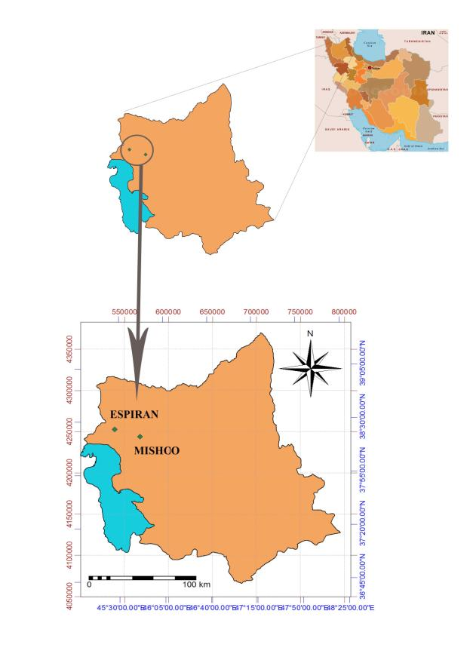Figure 1. Study areas for Thymus migricus of East Azerbaijan
province in Iran map.

GC-MS: We used varian 3,400, coupled by Saturn II with ion trap system 70eV ionization energy, DB-5 column (30m length, 0.25 mm ID, 0.25µm cover thickness) for GC-MS analysis. Apparatus was programmed as follows: 35 pounds/inch² gas pressure, 40–250°C column temperature with the speed increase of 3°C per minute, injection chamber temperature of 260°C and transfer line temperature of 270°C. Constituents in the essential oil were determined by RI (Retention Index), library references, GC/MS lab data and standard Mass spectrums (Adams, 1997; Davies, 1990; Shibamoto, 1987).

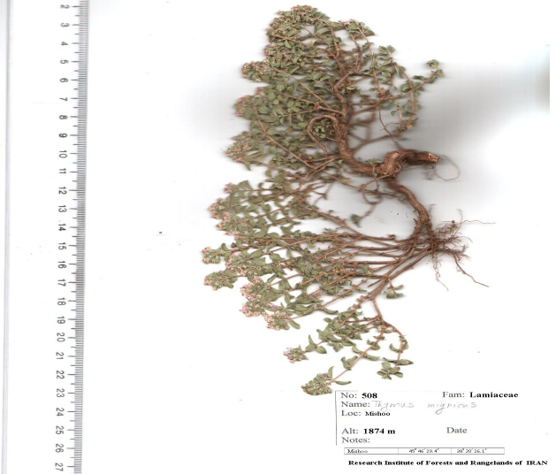

Figure 2. Herbarium specimen of Thymus migricus.

Results and Discussion

The results of this study showed that the yields of Mishoo and Espiran samples of essential oil were 0.93% and 0.38%, respectively. The linalool (65.57%) and citronellol (15.63%) were present in Mishoo habitat, whereas linalool (46.36%) and geraniol (26.74%) were present in Espiran habitat as major compounds (Table 2). T. migricus oil study was conducted for the first time in this province. According to our results, the essential oil of T. migricus collected from the Mishoo and Espiran regions included/comprised monoterpene hydrocarbons (1.38% and 0%), oxygenated monoterpenes (91.61 and 84.94%) and sesquiterpen hydrocarbons (1.63% and 1.14%). In our study, linalool was the main compound of essential oil (65.57‒46.36%). According to research conducted by Yavari et al. (2010), the essential oil mixture found in T. migricus from three districts of West Azerbaijan was the same as recognized in other species belonging to this genus. A major component was thymol. Linalool (8.1%) was detected only in essential oil of a single region. Oxygenated monoterpene compounds in these areas often contain components of essential oils. Baȿer et al. (2002) found that the oil of T. migricus in Turkey contained thymol and carvacrol as the main components. According to the study by the Takaloo et al. (2012) in the essential oil of West Azerbaijan, the alpha-terpineol and thymol were main compounds. Alizadeh et al. (2009), in another study, reported thymol and geraniol as the main compounds.

Table 2. Percentage of compositions for Thymus migricus essential oils.

Compounds | RI | Mishoo (%) | Espiran (%)
Limonene | 1056 | 1.38 | -
1,8-Cineole | 1066 | 1.12 | 1.55
Linalool | 1113 | 65.57 | 46.36
Citronellal | 1127 | 1.36 | -
Borneol | 1211 | - | 0.38
α-Terpineol | 1228 | 0.72 | -
Citronellol | 1239 | 15.63 | -
Geraniol | 1267 | 2.79 | 26.74
Geranial | 1289 | 0.46 | 2.04
Thymol | 1305 | - | 1.41
Carvacrol | 1321 | - | 0.29
Citronellyl acetate | 1351 | 1.13 | -
Geranyl acetate | 1377 | 2.83 | 6.17
E-Caryophyllene | 1488 | 1.63 | 1.14
Monoterpene hydrocarbon | - | 1.38 | -
Oxygenated monoterpenes | - | 91.61 | 84.94
Sesquiterpen hydrocarbons | - | 1.63 | 1.14
Total | - | 94.62 | 86.08
Essential Oil % | - | 0.93 | 0.38

Conclusion

The results of previous researches show that thymol and phenolic compounds are main compounds in thymus genus. In the present study, linalool composition with a high percentage of samples belonging to the East Azarbaijan province was introduced as a new chemotype. During our studies, the major compounds were monoterpenes and oxygenated compounds. According to the high application of linaloolin, we suggest that T. migricus essential oil belongs to this area and it can be used in the perfume industry.
Acknowledgements

We would like to express our appreciation to the Research Institute of Forests and Rangelands of Iran for laboratory and technical supports during experiments.

References

Adams, R.P. (1997). Identification of Essential Oil Components by Gas chromatography/Mass Spectroscopy. Journal of the American Society for Mass Spectrometry, 6(8), 671-672.
Alizadeh, A., Sharaifi, R., Javan-Nikkhah, M. & Sedaghat, N. (2009). Survey of Thymus migricus essential oil on aflatoxin inhibition in Aspergillus flavus. Communications in agricultural and applied biological sciences, 75(4), 769-776.
Başer, K., Demirci, B., Kirimer, N.E., Satil, F. & Tümen, G. (2002). The essential oils of Thymus migricus and T. fedtschenkoi var. handelii from Turkey. Flavour and fragrance journal, 17(1), 41-45.
Clevenger, J.F. (1928). Apparatus for the determination of volatile oil. Journal of the American Pharmaceutical Association, 17(4), 345-349.
Davies, N.W. (1990). Gas chromatographic retention indices of monoterpenes and sesquiterpenes on methyl silicon and Carbowax 20M phases. Journal of Chromatography A, 503, 1-24.
Jamzad, Z. (2012). Flora of Iran: Lamiaceae. Tehran:Research Institute of Forests and Rangelands.
Mozaffarian, V. (1996). A dictionary of Iranian plant names: Latin, English, Persian. Farhang Mo'aser.
Rechinger,K.H. (1982). Flora Iranica.Graz:AkademischeDruck- und Verlagsanstalt.
Shibamoto, T. (1987). Retention indices in essential oil analysis (Vol. 259). Huethig Verlag, New York.
Takaloo, S.G., Hassani, A., Hassanpouraghdam, M.B., Meshkatalsadat, M.H., Pirzad, A. & Heidari, M. (2012). Essential oil content and composition of Thymus migricus Klokov & Desj-Shost. affected by plant growth stage and wild habitat altitude. Romanian Biotechnological Letters, 17(1), 6983-6988.
Yavari, A., Nazeri, V., Sefidkon, F. & Hassani, M.E. (2010). Influence of some environmental factors on the essential oil variability of Thymus migricus. Natural Product Communications, 5(6), 943-948.
Zargari, A. (1995). Medicinal plants (Vol.1050400844). Tehrari University Publications.

Received: March 17, 2016
Accepted: June 3, 2016

PRVI OPIS NOVOG HEMOTIPA BILJKE THYMUS MIGRICUS (KLOKOV&DESJ-SHOST) IZ POKRAJINE ISTOČNI
AZERBEJDŽAN U IRANU

Yousef Imani Dizajeyekan, Ahmad Razban Haghighi* i Rasoul Rangavaran

Istraživački centar za poljoprivredu i prirodne resurse u Istočnom Azerbejdžanu, Tabriz, Iran

R e z i m e

Kako bi se utvrdila isparljiva jedinjenja biljke Thymus migricus, sprovedeno je uzorkovanje iz dva područja pokrajine Istočni Azerbejdžan koja se nalazi na severozapadu Irana. Nakon sušenja uzoraka na sobnoj temperaturi, esencijalna ulja su ekstrahovana metodom hidrodestilacije u trajanju od 2,5 sata. Esencijalna ulja su dehidrirana preko bezvodnog natrijum-sulfata. Sastojci ulja su utvrđeni analizama GC i GC-MS. Jedanaest odnosno devet identifikovanih jedinjenja iz regiona Mišu i Espiran predstavljaju 94,62% odnosno 86,08% sastava ukupnih ulja. U regionu Mišu, procenti glavnih jedinjenja su uključivali linalool (65,57%), citronelol (15,63%) i geraniol (2,79%), a u području Espiran, uočeni su linalool (46,36%), geraniol (26,74%), i geranil acetat (6,17%). Dati hemotip ove vrste je po prvi put opisan u Istočnom Azerbejdžanu u Iranu.
Ključne reči: Iran, Istočni Azerbejdžan, linalool, hidrodestilacija, ulje, Thymus migricus.

Primljeno: 17. marta 2016.
Odobreno: 3. juna 2016.

Corresponding author: e-mail: a_razban_h@yahoo.com
*Autor za kontakt: e-mail: a_razban_h@yahoo.com

