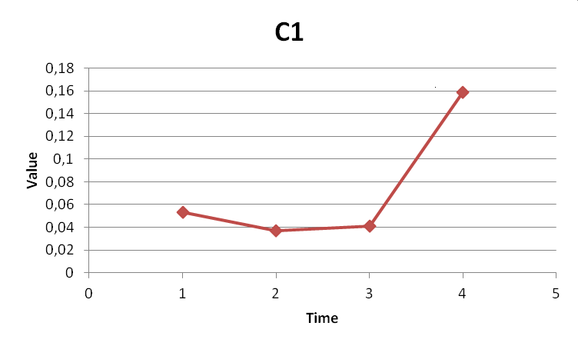
Fig. 1 The weighted normalized values of on the time delivery (c=1) during the time period
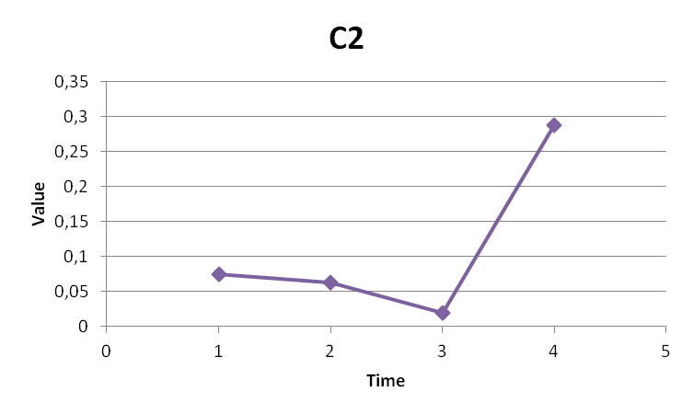
Fig. 2 The weighted normalized values of initial demands fulfillment of project (c=2) during the time period
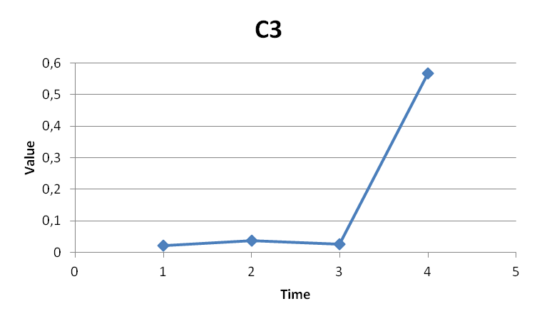
Fig. 3 The weighted normalized values of engagement of employees (c=3) during the time period

