PROCESS IMPROVEMENT TO REDUCE WASTE IN THE BIGGEST INSTANT NOODLE MANUFACTURING COMPANY IN SOUTH EAST ASIA

Hendy Tannady, Edy Gunawan, Filscha Nurprihatin, Fuji Rahayu Wilujeng

Industrial Engineering Department, Universitas Bunda Mulia, Indonesia
*htannady@bundamulia.ac.id

ABSTRACT

This research was conducted at the biggest instant noodle manufacturing company in South East Asia. In the process of producing instant noodle, there is inability to reach the target number of production, this is due to quality factor and waste in the use of raw material. Research uses lean six sigma method. In the define phase, the process of identification of waste is carried out by making VSM and WAM to find out the dominant waste. At the measure phase, the CTQ is decided and calculates the sigma level. In the analyze phase, analysis is done by using VALSAT, determining the type of dominant defect through the Pareto diagram and knowing the causes of defects with fishbone diagram. In the improve phase, improvement is made based on the highest RPN value that is known through the FMEA method. At the control phase, the handle process is carried out so that repairs are carried out continuously. The research finds the highest waste weight is due to defective products of 25.03%, sigma value of 4.75, and activities that gives value added (VA) had the highest percentage of 71.31%. The conclusion of this research is the improvement recommendations that is given to reduce the cause of failure of cutter of label machine cuts body label on the type of failure of the label sealer cutting process is not suitable with standard. The improvement step is to close the distance up between the conveyor and the conveyor table in the wrapping area.

Keyword: lean six sigma, quality, waste, instant noodle, manufacture

- Introduction
Based on data from the Central Bureau of Statistics regarding the production growth in the fourth quarter of the manufacturing industry in 2017 which is released on February 1, 2018, the growth of the large manufacturing industry is experiencing an increase of 5.15%. This growth increases if it is compared to the growth of the manufacturing industry in the fourth quarter of 2016. The increase in the growth of the medium large manufacturing industry was contributed by the food industry by 15.28%, and the transportation industry by 14.44%. The high percentage of manufacturing industry production growth contributed by the food industry illustrates the very tight competition conditions among food producers. The way to survive in this competition is to increase the productivity and quality of products produced, and reduce production cost (Gupta, 2013). The effort that needs to be done is to reduce waste in the production process. Reduced waste can give a good impact on the production process, namely the production process can run more effectively and efficiently. The process of improvement in the production process is needed to reduce waste (Grzelczak & Lewandowska, 2016). Waste can be interpreted as all activities that do not provide non-value added activities to the course of a production process. The impact appeared if a production process is wasteful, namely the value of the product offered by the company to customers will decrease (Gaspersz & Fontana, 2017). Therefore, an improvement is needed to reduce waste due to activities that do not give value added so that the resources managed by the company run optimally.

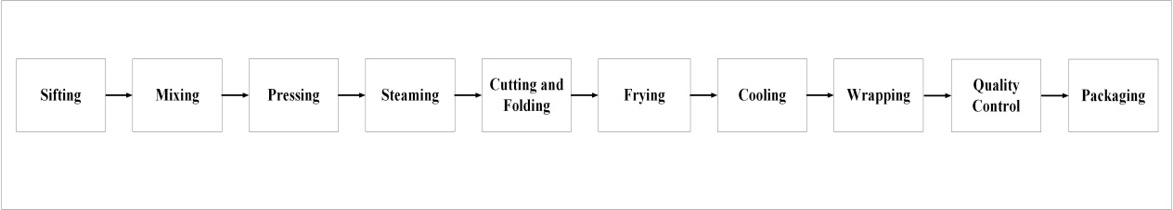
Figure 1 The process of producing instant noodles

Figure 1 is the 10 stages of the production process of making instant noodles. If the entire process is implemented properly, it can produce instant noodle products in accordance with quality standards. Based on the existing reality, there is still production line that produce instant noodle products that are not in accordance with quality standards. The non-fulfillment of quality standards makes the company unable to reach the target set.

Table 1 Number of Actual Data that does not Match Target
Production Line- | 1 | 2 | 3 | 4 | 5 | 6 | 7 | 8 | 9 | 10
Number of Failure in Reaching Target Output  (July 2018) | 8 | 10 | 9 | 4 | 6 | 7 | 11 | 9 | 13 | 17

In Table 1 it can be seen if the production output on line 10 has the highest failure rate to reach the target set. The thing that causes the line is not able to reach the production target is that the product produced is not in accordance with quality standards and the emergence of waste.
Table 2 contains the total cost of using raw materials for July 2018. Table 2 shows that the company suffered a loss of IDR 210,084,322 due to the addition of raw material usage.

Table 2 Raw Material Usage Cost Data July 2018
Total Cost of Using Raw Materials | IDR 4,078,760,222
Total Standard Cost for Using Raw Materials | IDR 3,868,675,900
Cost Difference | IDR 210,084,322

To reduce the two causes of not achieving production targets, lean methods are used to reduce waste or any activities that do not give non-value added activities and the Six Sigma method is used to improve the quality of products. Lean Six Sigma is a methodology for improving quality and minimizing waste (Hassan, 2013).
Research regarding improvements in the production process to reduce waste by using the lean manufacturing approach has been carried out by Rekha et al. (2017). In their research, Rekha et al. (2017) are able to reduce idle time and lead time due to bottlenecks and the impact of reduced cycle time is an increase in customer demand from 3,560 units / month to 4,320 units / month.
Previous research regarding quality improvement in the production process with the six-sigma method, has been carried out by Kumar et al. (2014) which examines effort to reduce defects and increase the level of sigma. The result of the research was an increase in the sigma level from 3.80 to 5.03 sigma.
Indrawati & Ridwansyah (2015) ever combined the lean and six sigma approaches. In their research in the iron ore company, Indrawati & Ridwansyah (2015) are able to map the causes of waste and defect. Bassed on the research, it was obtained some proposals, such as redesign the dust collector chute, create standard operating procedures for the process of weighing and install vibrometer and nitrogen.
The formulation of the problem in this study is to determine the weight of waste that occurs in line 10, determine the level of sigma, determine the dominant factors that cause the emergence of waste, and give recommendations for improvements to reduce waste and increase the level of sigma.

- LITERATURE REVIEW
  - Lean Manufacturing
Lean Manufacturing is a useful approach to reduce waste and activities that do not give value added to the product (Neha et al., 2013). Lean provides a way for the company to maximize the value received by customers and reduce waste in the production process through radical continuous improvement by flowing products (material, production process, output) and information by using a pull system (Gaspersz & Fontana, 2017). The lean approach has an advantage, namely it can identify activities in the production process within the company, such as Value Added (VA), Non Value Added (NVA), and Necessary Non Value Added (NNVA). The following is a description of VA, NVA, and NNVA (Hines & Taylor, 2000). VA includes activities that are able to provide value added to products, such as the process of folding, sewing, steaming and others. NVA includes activities that need to be reduced, activities do not provide value added to the product, such as waiting activities. NNVA includes activities that are not able to provide value added, but are very necessary in carrying out production processes, such as inspection, taking equipment to carry out the operation process, and moving products.

2.2. Six Sigma
The six sigma concept was introduced by Bill Smith in 1986 (Supriyanto & Maftuhah, 2017). Six sigma is a method of improving quality and has a goal to produce products and services that approximate a perfection (Uluskan, 2016). In Six Sigma, there is a strategy that is useful to increase the number of customers, the strategy is carried out by reducing product defects, minimizing variations and increasing capability in the manufacturing process (Kabir et al. 2013). By implementing Six Sigma, the best companies in the United States can increase the effectiveness of all production equipment used significantly from 40% to 85% (Sujova et al. 2016).

2.3. Lean Six Sigma
Lean Six Sigma method is a combination of Lean and Six Sigma methods. The lean six sigma method is defined as a business philosophy, systematic and systemic approach that aims to identify and reduce waste or all activities that do not provide non-value added through continuous improvement to achieve six sigma performance level, by flowing products (material, work-in-process, output) and information by using pull systems from internal and external customers to achieve superiority and perfection, by producing only 3.4 defects in every one million opportunities or operations (Gaspersz & Fontana, 2017). Lean Six Sigma methodology focuses on controlling the performance of a process to stay at the best level by following five stages, namely DMAIC (Define-Measure-Analyze-Improvement-Control) (Singh & Lal, 2016).

2.4. Waste
Waste is all activities in the production process that do not provide value added (non-value added) to the product. Basically, waste is divided into two main categories of waste. The first type of waste is all activities that do not produce value added in the initial process to the end of production along the value stream. For example, inspection activities and supervision of workers. The second type of waste is an activity that does not provide value added and needs to be eliminated immediately, for example the finished product has a defect or there is a procedural error in the production process (Gaspersz & Fontana, 2017). Generally, there are seven wastes that arise in the production process, namely overproduction, defect, unnecessary inventory, inappropriate processing, excessive transportation, waiting, and unnecessary motion (Hines & Taylor, 2000).

2.5. DMAIC
In the define phase, defining problem that emerges is done by making a SIPOC diagram (supplier-input-process-output-customer), which is made an illustration of the flow of raw materials and information using VSM (Value Stream Mapping), and identifying the waste that emerges in the production process by using WAM (Waste Assessment Model). In the measure phase, the determination of critical to quality (CTQ), making a control chart and searching the value of the defect per million opportunity (DPMO) and the conversion of DPMO value to the sigma level (Kumar et al., 2014). In the analyze phase, the root cause of the problem is identified. The tools used at this stage are VALSAT (Value Stream Mapping Tools), pareto diagrams and fishbone diagrams (Sujova et al., 2016). The improvement phase aims to formulate improvement recommendations for the problems that have been identified. The thing that is done at this stage is to make FMEA (Failure Mode and Effect Analysis) (Nandakumar et al., 2014). The control phase aims to maintain improvements based on recommendations for improvements that have been given at the improvement phase and implement preventive action against failure or production process error that can lead to defect (Kaid et al., 2016).

- RESEARCH METHODOLOGY
The focus of the research is directed on the line 10 that produce instant noodles for IDM product GS flavour. Primary data is collected by conducting interviews, giving questionnaires, and observing. The interview aims to know the changeover time, material flow and information in the production process. The questionnaire was distributed to nine sections of production supervisors and a PPIC employee. Secondary data is collected by recording data and information from company reports, the data collected is data on the number of operators, the amount of production during July 2018, the number of daily raw material usage and the number of defective products.
Observations are carried out for six weeks, where the purpose of observation is to know the course of the production process, to find the cause of the emergence of defect and waste during the production process. There are two types of questionnaires given to respondents, namely a questionnaire that has a function to identify the relationship each waste on the production floor and a questionnaire that aims to obtain the weight of each waste (waste assessment questionnaire). To identify the relationship each waste (first type questionnaire), a questionnaire is given to four sections of the production line supervisor and a PPIC employee, while the questionnaire on the waste assessment questionnaire (second type questionnaire) is given to the five sections of the production supervisor. To find out the changeover time, material flow, and various information in the production process, an unstructured interview is conducted with the production supervisor and PPIC department employees. Data regarding the number of production operators, the amount of production, total daily use of raw materials and the number of defective products obtained through company reports.

- DATA ANALYSIS AND RESULT
  - Define Phase
The things carried out by the author at this stage are to make a SIPOC diagram, value stream mapping and the concept of waste assessment model. SIPOC diagrams are used to emphasis the physical flow coverage illustrated in value stream mapping. Tables 3 and 4 show the flow from suppliers to customers both external and internal.

Table 3 External SIPOC Diagram
Party | Supplier | Input | Process | Output | Customer
External | Wheat flour and tapioca flour | Wheat flour and tapioca flour | Making instant noodles | Instant noodles that have been packed with label and passed the process  quality control | Instant noodles for IDM product GS flavour inside a sealed box and there is a production code
External | Cooking oil | Cooking oil | Making instant noodles
External | Seasoning wrap, seasoning oil and crackers; Lye | Seasoning wrap, seasoning oil and crackers; Lye | Making instant noodles
External | Label | Label | Making instant noodles
External | Clean water | Clean water | Making instant noodles
External | Duct tape, ink and carton | Duct tape, ink and carton | Making instant noodles

Table 4 Internal SIPOC Diagram
Party | Supplier | Input | Process | Output | Customer
Internal | Mixing Process | Flour dough | - Emphasis  - Steaming  - Cutting and folding  - Frying  - Cooling  - Wrapping  - Quality control | Instant noodles that have been packed with label and passed the process  quality control | Packaging process

    - Value Stream Mapping
Table 5 contains each operation in the production process and the results of processing data used for data boxes in VSM. In the table, the biggest uptime is 100%, this is caused by the changeover time of 0 seconds.

Table 5 Data Processing Results for Value Stream Mapping
No. | Operation | Cycle Time (s) | Changeover Time (s) | Uptime (%)
1 | Making of bottom flour dough sheet | 38,89 | 240 | 99,05
2 | Making of top flour dough sheet | 38,21 | 240 | 99,05
3 | Union of top and bottom flour dough sheet | 53,79 | 240 | 99,05
4 | Making of noodle strands | 3,50 | 240 | 99,05
5 | Wave forming on noodle strands | 3,31 | 240 | 99,05
6 | Steaming noodle strands | 150,10 | 600 | 97,62
7 | Cutting and folding noodle strands | 11,24 | 240 | 99,05
8 | Frying noodle | 166,97 | 600 | 97,62
9 | Cooling noodle | 31,33 | 240 | 99,05
10 | Placing seasoning wrapper | 5,03 | 240 | 99,05
11 | Placing seasoning oil and cracker wrapper | 4,65 | 240 | 99,05
12 | Wrapping noodle with label | 10,48 | 180 | 99,29
13 | Quality Control | 22,39 | 0 | 100,00

Based on Figure 2, the time obtained for non value added activities is 211.14 seconds and the value added activities time is 539.89 seconds, while the total time from the waiting activity for the flour mixture to enter until the quality control process is 751.03 seconds.

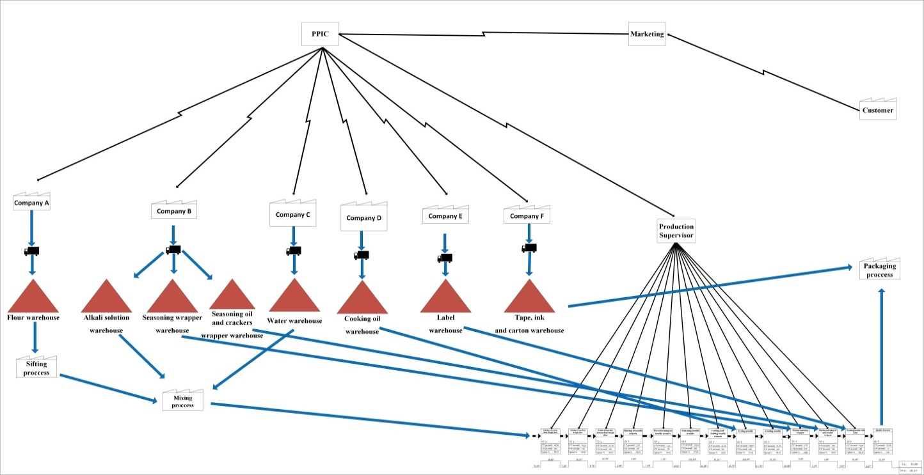
Figure 2 Value Stream Mapping

    - Identification of Waste with Waste Relationship Matrix (WRM)
The initial stage of the waste identification process is started by distributing questionnaires to five respondents, namely four sections of the production line supervisor and a PPIC employee. Respondent's answer (in letter form) then proceed to the weighting process. The answer is entered into the WRM table. The letters in the WRM table are converted to numbers (A = 10, E = 8, I = 6, O = 4, U = 2 and X = 0), then the conversion result is put in the Waste Relationship Value table.

Table 6 Waste Relationship Value (WRV)
F/T | O | I | D | M | T | P | W | Score | %
O | 10 | 4 | 4 | 2 | 4 | 0 | 4 | 28 | 12,61
I | 4 | 10 | 2 | 2 | 2 | 0 | 0 | 20 | 9,01
D | 4 | 8 | 10 | 10 | 6 | 0 | 4 | 42 | 18,92
M | 0 | 4 | 10 | 10 | 0 | 4 | 4 | 32 | 14,41
T | 2 | 2 | 6 | 4 | 10 | 0 | 4 | 28 | 12,61
P | 4 | 2 | 4 | 8 | 0 | 10 | 10 | 38 | 17,12
W | 4 | 10 | 10 | 0 | 0 | 0 | 10 | 34 | 15,32
Score | 28 | 40 | 46 | 36 | 22 | 14 | 36 | 222 | 100
% | 12,61 | 18,02 | 20,72 | 16,22 | 9,91 | 6,31 | 16,22 | 100

In Table 6, it can be seen that the largest percentage is from defect and to defect, where the percentage is 18.92% and 20.72%. The amount of these two percentages shows that the waste due to product defects can be expressed as waste caused by other waste.

    - Identification of Waste with a Waste Assessment Questionnaire (WAQ)
There are 68 different questions in the WAQ questionnaire. Table 7 shows that the biggest waste percentage is waste due to product defects (25.03%).

Table 7 Final Result of WAQ Calculation
 | O | I | D | M | T | P | W
Score (Yj) | 0,21 | 0,18 | 0,18 | 0,21 | 0,17 | 0,28 | 0,19
Pj factor | 159,08 | 162,32 | 392,01 | 233,75 | 124,99 | 107,95 | 248,36
Final result (Yj final) | 33,90 | 29,47 | 70,65 | 49,19 | 21,03 | 30,28 | 47,69
Final result (%) | 12,01 | 10,44 | 25,03 | 17,43 | 7,45 | 10,73 | 16,90
Rank | 4 | 6 | 1 | 2 | 7 | 5 | 3

  - Measure Phase
This stage is started by setting the quality criteria (critical to quality) according to the company, then calculating the DPMO value and sigma level. Table 8 is a quality criterion (CTQ) which is done by recording the factors that affect the product defects listed in the company's production report.

Tabel 8 Critical To Quality
No. | Target | CTQ
1 | Instant noodle is suitable with quality standard that has been decided | Noodle is cook
2 |  | Noodle is not contaminated with foreign object
3 |  | Strands of noodle are cut
4 |  | Noodle doesn’t break
5 |  | Noodle doesn’t burn
6 |  | Size of noodle is suitable with standard
7 |  | Noodle angle is suitable with standard
8 |  | Light yellow noodle
9 |  | Noodle doesn’t hollow
10 |  | Noodle doesn’t shrink
11 |  | Label sealer cutting process is suitable with standard

    - Control Chart
P control chart (P-Chart) is used in this research, Figure 3 shows that the production process has been controlled and the process capability can be calculated to obtain the sigma level. The value of $\overline{P}$ is 0.006281, the UCL value is 0.007069, and the LCL value is 0.005493.

Figure 3 Result of P Control Chart

    - Sigma Level Calculation
After the data is controlled, the total production for July 2018 is 1,322,341 units, there are 11 quality criteria chosen as the cause of the emergence of product failure. The number of product defects in July 2018 was 8,306 units. For obtaining sigma value, data on the number of production, criteria for defects and the number of defects are used. Hence, the sigma value obtained in this study is 4.75.

  - Analyze Phase
At this stage, analysis is conducted to the tools used and looking for the root causes of the emergence of defects in the process of making instant noodles. There are several steps in the process carried out at this stage, namely analyzing using value stream mapping tools, pareto diagram and fishbone diagram.

    - Value Stream Mapping Tools (VALSAT)
Table 9 shows the results of VALSAT calculation obtained through multiplication between weight values with VALSAT matrix. Table 9 shows that PAM has the highest value, which is equal to 540.96.

Table 9 VALSAT Selection Results
Waste Type | Weight | Mapping Tool
Waste Type | Weight | Process Activity Mapping | Supply Chain Response Matrix | Production Variety Funnel | Quality Filter Mapping | Demand Amplification Mapping | Decision Point Analysis | Physical Structure (a) volume (b) value
Overproduction | 12,01 | 12,01 | 36,04 | 0 | 12,01 | 36,04 | 36,04 | 0
Unnecessary Inventory | 10,44 | 31,33 | 93,99 | 31,33 | 0 | 93,99 | 31,33 | 10,44
Defects | 25,03 | 25,03 | 0 | 0 | 225,31 | 0 | 0 | 0
Unnecessary Motion | 17,43 | 156,89 | 17,43 | 0 | 0 | 0 | 0 | 0
Transportation | 7,45 | 67,05 | 0 | 0 | 0 | 0 | 0 | 7,45
Inappropriate Processing | 10,73 | 96,55 | 0 | 32,18 | 10,73 | 0 | 10,73 | 0
Waiting | 16,90 | 152,09 | 152,09 | 16,90 | 0 | 50,70 | 50,70 | 0
Total |  | 540,96 | 299,55 | 80,41 | 248,06 | 180,72 | 128,79 | 17,89

Table 10 shows the sequence of activities based on VA, NVA and NNVA. In the summary, it can be seen that activities are very dominating during the production process of making instant noodles.

Table 10 Recapitulation of Calculation of Process Activity Mapping
Activity | Total | Time (s) | Percentage (%)
Operation | 15 | 534,88 | 72,43
Transportation | 14 | 129,6 | 17,55
Inspection | 0 | 0 | 0
Storage | 0 | 0 | 0
Delay | 1 | 73,97 | 10,02
Total | 30 | 738,45 | 100
Classification | Total | Time (s) | Percentage (%)
Value Added | 13 | 526,58 | 71,31
Non Value Added | 1 | 73,97 | 10,02
Necessary Non Value Added | 16 | 137,9 | 18,67
Total | 30 | 738,45 | 100

    - Analysis of Dominant Defect Products with Pareto Diagrams

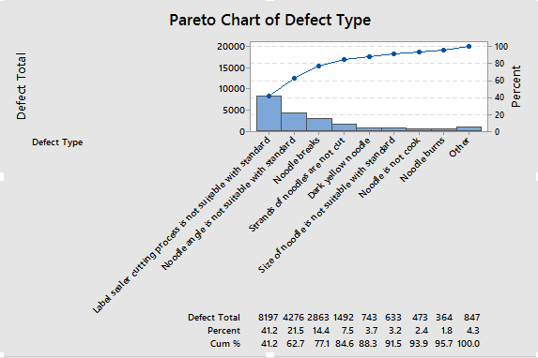
Figure 4 Pareto Diagram Number of Defective Products

Figure 4 shows the types of defects that are selected to be studied in depth, namely the label sealer cutting process is not suitable with standard, noodle angle is not suitable with standard, noodles break, and strands of noodle are not cut.

    - Analysis of the Causes of Product Defects with Fishbone Diagram

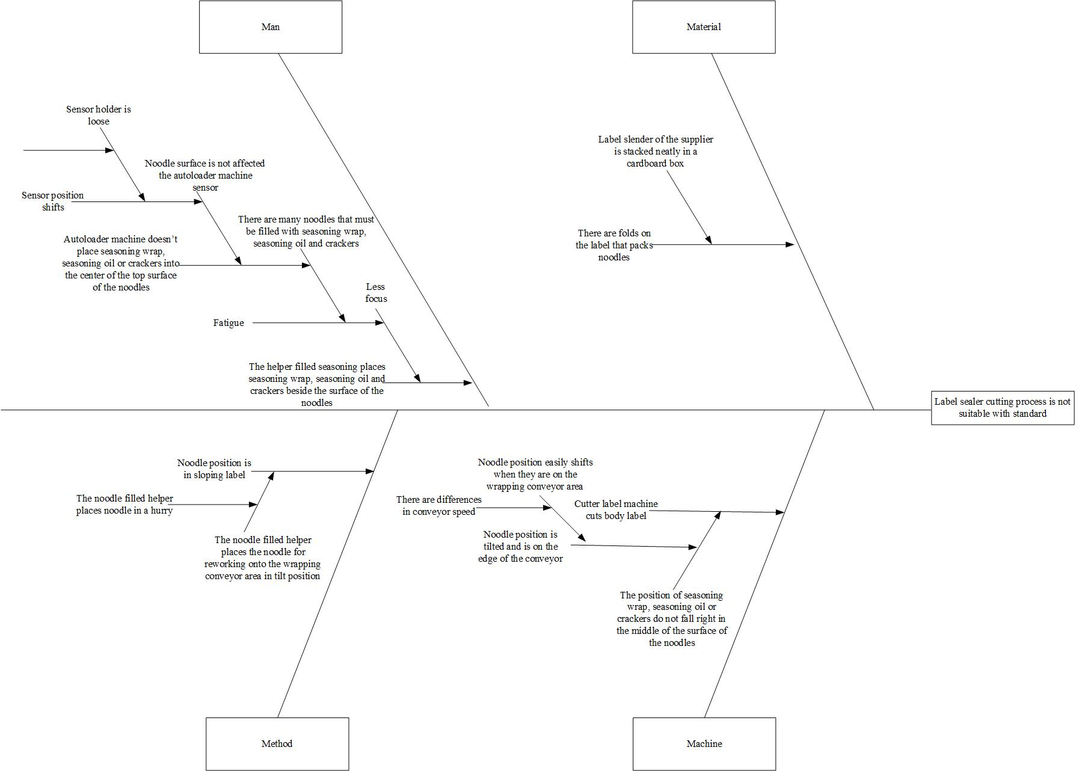
Figure 5 Fishbone Diagram of Label Sealer Cutting Process is not Suitable with Standard

  - Improvement Phase
Improvement recommendations are given to reduce waste due to product defects that have been known through a cause and effect diagram.

Table 11 Value of Risk Priority Number
Failure Type | Work Process | Failure Cause | Failure Effect | S | O | D | RPN | Improve Recommendation
The label sealer cutting process is not suitable with standard | Wrapping noodle with label | Cutter of label machine cuts label body | Rework appears, time is wasted to separate noodle with label that is not suitable with quality standard, waste appears and noodle are broken (the possibility of one potential can appear) | 10 | 9 | 8 | 720 | Closing the distance up between the conveyor and the conveyor table in the wrapping area

In Table 11, it can be seen that the cause of failure of the label machine cutter cuts label body has the highest RPN value, which is equal to 720. The improvement recommendation given to reduce the cause of this failure is to close the distance up between the conveyor and the conveyor table in the wrapping area. The reason for the close up of the conveyor table with the conveyor in the wrapping area is to anticipate the easy shifting of the noodle position when entering the packaging area due to the difference in conveyor speed.

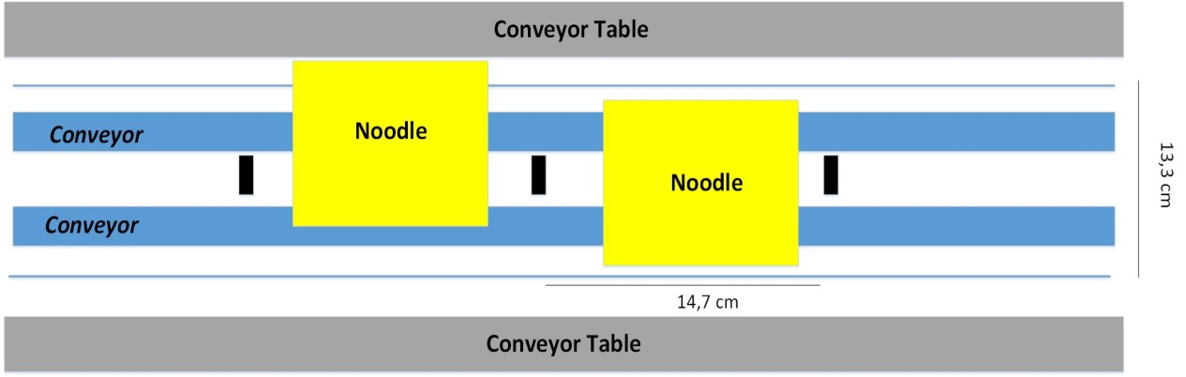
Figure 6 Conveyor Table Distance with Wrapping Area Conveyor in Line 10

Figure 6 shows that the size of noodle is 10 x 9 cm, the noodles are on a conveyor that has a size of 14.7 x 13.3 cm. Based on the picture, there is distance on the left and right of the conveyor with a conveyor table. This distance can make noodles easily shifted because there is no retaining the noodles position when filling the seasoning wrap.

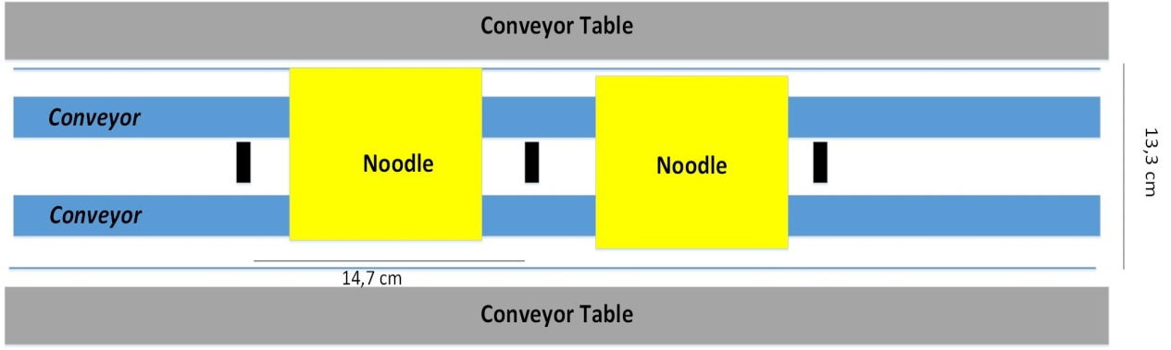
Figure 7 Conveyor Table Distance with Wrapping Area Conveyor Line 10 Recommended

Figure 7 is improvement recommendation given to the company, where the distance between the table and the wrapping conveyor area is narrowed. The purpose of giving this distance is to keep the noodle position straight and not shift to the edge of the conveyor. The position of the noodle which is straight and is in the middle of the conveyor can make a seasoning wrap, seasoning oil and crackers fall right in the middle of the surface of the noodles.

  - Control Phase
The next step is to make control document as form of quality control during the cutting and folding strand noodles, frying noodles, and wrapping noodles with label. The recommendation given to reduce the three types of failure are checking the cutter sharpness on the cutter machine, spraying oil on the fryer retainer chain and checking the position of the sensor on the seasoning and cracker autoloader engine, as well as the seasoning autoloader machine. The control process is carried out every hour, the aim is to reduce waste due to product defects that appear.

- Conclusion
The result of the identification of waste in the line 10 that has been carried out by using WRM and WAQ, obtained the first rank waste, namely waste due to product defects that have a weight of 25.03%. The calculation of the sigma level obtained in the line 10 process for July 2018 is 4.75 sigma. Based on the results of FMEA, the cause of the failure of the cutter of label machine cuts label body obtains the highest RPN value of 720, this describes if this failure is the dominant cause of the appearance of waste due to product defects.

REFERENCES

Gaspersz, V. & Fontana, A. (2017). Lean Six Sigma for Manufacturing and Service Industries. Bogor:Vinchristo Publication.
Grzelczak, A. & Lewandowska, K. W. (2016). Eliminating Muda (Waste) in Lean Management by Working Time Standardization. Arabian Journal of Business and Management Review, 6(3), 1–11.
Gupta, N. (2013). An Application of DMAIC Methodology for Increasing the Yarn Quality in Textile Industry. IOSR Journal of Mechanical and Civil Engineering, 6(1), 50–65.
Hassan, M. K. (2013). Applying Lean Six Sigma for Waste Reduction in a Manufacturing Environment. American Journal of Industrial Engineering, 1(2), 28–35.
Hines, P. & Taylor, D. (2000). Going Lean. Cardiff: Lean Enterprise Research Centre.
Indrawati, S. & Ridwansyah, M. (2015). Manufacturing Continuous Improvement Using Lean Six Sigma : An Iron Ores Industry Case Application. Procedia Manufacturing, 4, 528–534.
Kabir, E., Boby, S. M. M. I. & Lutfi, M. (2013). Productivity Improvement by Using Six-Sigma. International Journal of Engineering and Technology, 3(12), 56–84.
Kaid, H. et al. (2016). Six Sigma DMAIC Phases Application in Y Company: A Case Study. International Journal Collaborative Enterprise, 5(3), 181–197.
Kumar, J., Verma, M. & Dhillon, K. S. (2014). Reduction in defects rate using DMAIC approach- A Case Study. International Journal of Enhanced Research in Science, Technology & Engineering, 3(12), 146–152.
Nandakumar, P. P. M., Anitha, H. S. & Singh, B. P. (2014). Six Sigma Methodology Utilization in Medical Transcription-A DMAIC Process to Identify Six Sigma Projects. International Journal of Scientific Engineering and Technology, 3(5), 574–578.
Neha, S. et al. (2013). Lean Manufacturing Tool and Techniques in Process Industry. International Journal of Scientific Research and Reviews, 2(1), 54–63.
Rekha, R. S., Periyasamy, P. & Nallusamy, S. (2017). Manufacturing Enhancement through Reduction of Cycle Time using Different Lean Techniques. in IOP Conference Series: Materials Science and Engineering, 1–11.
Singh, H. & Lal, E. H. (2016). Application of DMAIC Technique in a Manufacturing Industry for Improving Process Performance - A Case Study. International Journal on Emerging Technologies, 7(2), 36–38.
Sujova, A., Simanova, L. & Marcinekova, K. (2016). Sustainable Process Performance by Application of Six Sigma Concepts: The Research Study of Two Industrial Cases. Sustainability, 8, 1–21.
Supriyanto, H. & Maftuhah, D. I. (2017) A Lean Six- Sigma Manufacturing Process Case Study. International Journal of Mechanical Engineering and Technology, 8(7), 498–509.
Uluskan, M. (2016). A Comprehensive Insight into The Six Sigma DMAIC Toolbox. International Journal of Lean Six Sigma-Emerald Insight, 7(4), 406–429.

