Figure 1: Plane strain model for slabs with three rows of piles

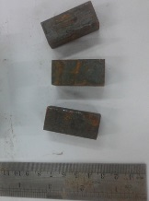
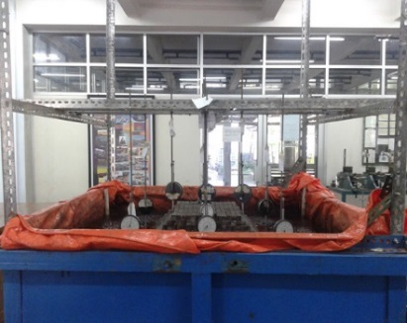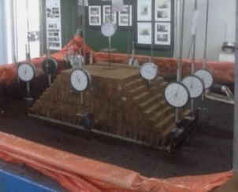

Figure 2: Laboratory small-scale model for embankment load test

Figure 3: Test scheme in the laboratory

Figure 4: The results of pile tensile test on peat soil

Figure 5: The relationship between the deflection of slabs (δ) and the ratio of δ/δ_{o}

Figure 6: The Modulus of subgrade reaction values

Figure 7: The comparison between calculated and observed deflection

(a)
(b)
Figure 8: The settlement in the center of embankment on slabs with 15 cm monolithic piles: (a) The relationship of time and settlement; (b) The relationship between pressure and settlement

Note: L_{p} = Length of monolithic pile, L_{p}’ = Lenght of non-monolithic pile
Figure 9: The relationship between pressure due to embankment and settlement at the center of embankment
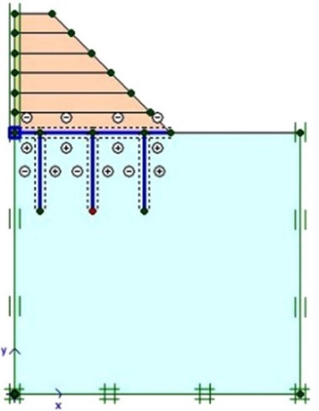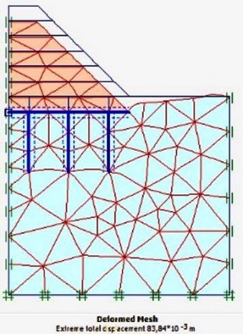
(a) (b)

Figure 10: (a) Input geometry; (b) Total displacement due to embankment on slabs with piles

Figure 11: The comparison of the settlement between observations with FEM

Figure 12: The relationship between time and settlement of slabs without piles

Figure 13: The relationship between time and settlement of slabs with piles

