POWER ENGINEERING: NUCLEAR POWER PLANTS AND RENEWABLE ENERGY SOURCES
Alexander Solovyev,
Lomonosov Moscow State University, 119991, GSP-1, Moscow, Lenin Hills, d. 1, Bldg. 19, Russian Federation
Andrey Pustovgar
Moscow State University of Civil Engineering, Yaroslavskoe shosse, 26, Moscow, 129337, Russia
Aleksey Adamtsevich
Moscow State University of Civil Engineering, Yaroslavskoe shosse, 26, Moscow, 129337, Russia
Liubov Shilova
Moscow State University of Civil Engineering, Yaroslavskoe shosse, 26, Moscow, 129337, Russia
Kirill Degtyarev
Lomonosov Moscow State University, 119991, GSP-1, Moscow, Lenin Hills, d. 1, Bldg. 19, Russian Federation
Dmitry Solovyev
Joint Institute for High Temperatures of the Russian Academy of Sciences, 125412, Moscow, Izhorskaya street, 13/2, Russian Federation

Abstract
The article considers a comparative dynamics of power engineering development based on the use of nuclear energy and renewable energy sources science 1960s. The authors evaluate the parameters of environmental and economic efficiency, risks and prospects of power engineering development based on various types of energy carriers. It is shown that the reduction of the share of nuclear power engineering in the world energy balance cannot be compensated due to renewable energy sources, and it would cause the increase in the use of fossil fuels. The authors come to the conclusion about the necessity of a parallel development of both the renewable energy sources and the nuclear power engineering.
Keywords: environment,nuclear energy, renewable energy sources, power engineering politics

ELEKTROENERGETIKA: NUKLEARNE ELEKTRANE I OBNOVLJENI IZVORI ENERGIJE
Sazetak
Artikal sadrži komparativnu dinamiku elektroenergetike razvoj zasnovan na upotrebi nuklearne energije i obnovljeni izvori energije iz 1960 godine. Autori procjenjuju parametre životne sredine i ekonomsku efikasnost, rizike i perspektivu razvoja elektroenergetike bazirane na različitim tipovima energenata. Pokazalo se da je smanjenje nuklearne energije u svijetu da se energetski balans ne može nadoknadi iz obnovljenih izvora energije, jer bi to izazvalo porast korišćenja fosilnih goriva. Autori su došli do zaključka da je neophodno paralelno razvijati obadva iz obnovljenih izvora energije kao i nuklernu energiju.

Ključne reči: životna sredina, nuklearna energija, obnovljeni izvori energije, politika elektroenergetike

- INTRODUCTION
The purpose of this study is revealing the role of nuclear power plants (NPP) as well as various types renewable energy sources (RES) in the process a non-carbon power engineering structure’s formation. The study also gives a comparative evaluation of the aforesaid role, the attending increase in environmental and economic efficiency, contains the risk analysis concerned and the prospects of diversified power engineering’s development. The article based on statistical and analytic materials, considers the dynamics of development of the world non-carbon power engineering within second half of the XX century and early XXI, the comparative evaluation of trends and special features and the correlation of the nuclear power engineering development with the changes in the environment parameters as well as the environmental efficiency of various types of power engineering. The comparative evaluations of economic efficiency of power engineering are presented; the uncertainties and risks concerning NPP and RES and their influence on the prospects of non-carbon power engineering development are discussed.
- THE DYNAMICS OF DEVELOPMENT OF THE WORLD POWER ENGINEERING ON THE BASIS OF NUCLEAR AND RENEWABLE ENERGY SOURCES.
The share of nuclear energy in the world energy production has grown from 0.2% (6 mln ton, fuel equivalent) in 1965 to 4.4% (574 mln ton, fuel equivalent) in 2014 (Table 1, Fig.1). There were two periods of nuclear power engineering development: the active growth (1965-1990s)and the stagnation (2000s – up to present). The maximum share (6.1% to 6.3%) of nuclear energy in the world energy consumption structure was achieved in 1995 - 2002;since then this share is decreasing. The maximum value of nuclear energy consumption ran up to 635 million ton of fuel equivalent in 2006, later it became less, then stabilized and showed a slight growth in 2012-2014.

Table 1. Dynamics and structure of world energy consumption in 1965-2014 with respect to the energy sources [2]
Energy source | 1965 | 1975 | 1985 | 1995 | 2005 | 2014
Million ton, fuel equivalent
Oil | 1 530 | 2 692 | 2 817 | 3 291 | 3 919 | 4 211
Natural gas | 588 | 1 064 | 1 483 | 1 925 | 2 505 | 3 066
Coal | 1 395 | 1 562 | 2 077 | 2 258 | 3 122 | 3 882
Total fossil fuels | 3 512 | 5 318 | 6 377 | 7 474 | 9 547 | 11 158
Nuclear energy | 6 | 82 | 335 | 526 | 626 | 574
Hydraulic energy | 209 | 324 | 448 | 563 | 661 | 879
Other RES | 1 | 4 | 12 | 37 | 85 | 317
Total | 3 728 | 5 729 | 7 173 | 8 600 | 10 920 | 12 928
Share in the energy consumption structure
Oil | 41,0% | 47,0% | 39,3% | 38,3% | 35,9% | 32,6%
Natural gas | 15,8% | 18,6% | 20,7% | 22,4% | 22,9% | 23,7%
Coal | 37,4% | 27,3% | 29,0% | 26,3% | 28,6% | 30,0%
Total fossil fuels | 94,2% | 92,8% | 88,9% | 86,9% | 87,4% | 86,3%
Nuclear energy | 0,2% | 1,4% | 4,7% | 6,1% | 5,7% | 4,4%
Hydraulic energy | 5,6% | 5,7% | 6,2% | 6,5% | 6,1% | 6,8%
Other RES | 0,0% | 0,1% | 0,2% | 0,4% | 0,8% | 2,5%
Total | 100,0% | 100,0% | 100,0% | 100,0% | 100,0% | 100,0%

Consumption of world primary energy with respect to the energy sources, million ton, fuel equivalent, 1965-2014
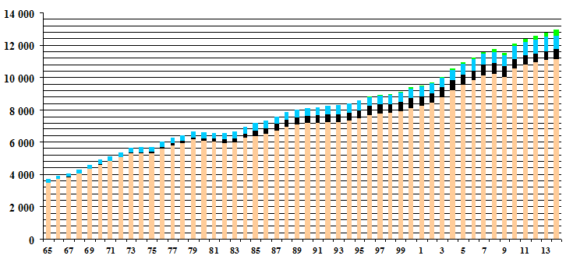
Fossil hydrocarbons
Nuclear energy
Hydraulic energy
Other renewable energy sources

Fig. 1. Dynamics and structure of consumption of the world primary energy, million ton, fuel equivalent, 1965-2014

This dynamic is more distinctly shown in the example of electric energy production (Table 2, Fig.2), the share of which in the world energy production has grown from 31% (9956 TWh, 2253 million ton, fuel equivalent) in 1985 to 41% (23537 TWh, 5326 million ton, fuel equivalent) in 2014.
Table 2.Dynamics and structure of electric energy production in 1980-2014, TWh, with respect to the production sources [11].

Energy sources | 1980 | 1985 | 1990 | 1995 | 2000 | 2005 | 2010 | 2014 [2]
Electric energy production volume, TWh
Fossil fuels | 5 589 | 6 041 | 7 136 | 7 787 | 9 333 | 11 437 | 13 642 | 15 715
Nuclear energy | 684 | 1 426 | 1 909 | 2 210 | 2 450 | 2 625 | 2 630 | 2 537
Hydraulic energy | 1 723 | 1 952 | 2 144 | 2 453 | 2 623 | 2 905 | 3 422 | 3 885
Other RES | 31 | 54 | 135 | 179 | 249 | 391 | 765 | 1 401
Total | 8 018 | 9 460 | 11 304 | 12 608 | 14 627 | 17 330 | 20 437 | 23 537
Share in the production structure,%
Fossil fuels | 69,7% | 63,9% | 63,1% | 61,8% | 63,8% | 66,0% | 66,8% | 66,8%
Nuclear energy | 8,5% | 15,1% | 16,9% | 17,5% | 16,7% | 15,1% | 12,9% | 10,8%
Hydraulic energy | 21,5% | 20,6% | 19,0% | 19,5% | 17,9% | 16,8% | 16,7% | 16,5%
Other RES | 0,4% | 0,6% | 1,2% | 1,4% | 1,7% | 2,3% | 3,7% | 6,0%
Total | 100% | 100% | 100% | 100% | 100% | 100% | 100% | 100%

Shares of various energy carriers in the world production and consumption of electric energy in 1980 – 2014, %
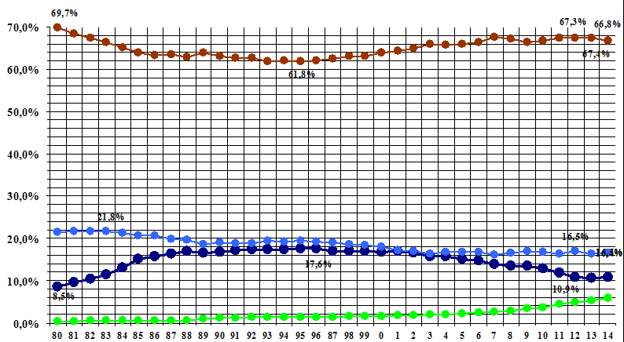
Nuclear energy
Hydraulic energy
Fossil energy sources (coal, oil, gas)
RES (expect hydraulic energy)
Fig.2. Shares of various energy sources in the world production and consumption of electric energy in 1980 – 2014 (1980-2012 [11], 2013-2014 [2])

The maximum share of nuclear power engineering in the world production of electric energy (17.0% - 17.6%) was achieved in 1993 – 1999; later this share decreased (11% in 2012) and stabilized at the level of 10.7% - 10.8% compared to other types of production. The maximum share of nuclear energy coincided with the minimum share of fossil fuels (Table 1). The reduction of the nuclear energy share caused a greater role of fossil energy carriers in the world energy balance. Their share in the world energy consumption grew up to 87.6% by 2007 and became less than 87% after 2012. The share of fossil hydrocarbons in the world production of electric energy returned to about 67% in the second half of 2000s. Partly, the reduction of the nuclear energy share was compensated due to the development of RES power engineering, but to a greater extent, it happened due to the growth of “fossil” power engineering (Table 3), first and foremost, in electric power engineering. Otherwise, the reduction of the share of “fossil” power engineering was mainly caused by the development of nuclear power engineering.
In the whole, the share of fossil hydrocarbons in the world consumption of primary energy decreased from 91.7% (1980) to 86.3% (2014), and the RES share (including hydraulic energy) increased from 5.9% to 9.3%. At the same time, the electric energy production passed ahead of the total energy consumption volume, and this progress was due to either the nuclear power engineering (within the period of its active development) or the fossil hydrocarbons (during the its stagnation period).
Table 3.Dynamics of the shares of various energy carriers in the world energy balance in 1980-2014.

Energy source | 1980 | 1995 | 1980-1995 | 2010 | 1995-2010 | 2014 | 2010-2014 | 1980-2014
In the world consumption of primary energy
Fossil hydrocarbons (coal, oil, gas) | 91,7% | 86,9% | -4,8% | 87,0% | +0,1% | 86,3% | -0,7% | -5,4%
Nuclear energy | 2,4% | 6,1% | +3,7% | 5,2% | -0,9% | 4,4% | -0,8% | +2,2%
Hydraulic energy | 5,8% | 6,5% | +0,7% | 6,5% | +0,0% | 6,8% | +0,3% | +1,0%
Other RES | 0,1% | 0,4% | +0,3% | 1,4% | +1,0% | 2,5% | +0,9% | +2,4%
Total RES | 5,9% | 6,9% | +1,0% | 7,9% | +1,0% | 9,3% | +1,4% | +3,4%
In the world production of electric energy
Fossil hydrocarbons (coal, oil, gas) | 69,7% | 61,8% | -7,9% | 66,8% | +5,0% | 66,8% | +0,0% | -2,9%
Nuclear energy | 8,5% | 17,5% | +9,0% | 12,9% | -4,6% | 10,8% | -2,1% | +2,3%
Hydraulic energy | 21,5% | 19,5% | -2,0% | 16,7% | -2,8% | 16,5% | -0,2% | -5,0%
Other RES | 0,4% | 1,4% | +1,0% | 3,7% | +2,3% | 6,0% | +2,3% | +5,6%
Total RES | 21,9% | 20,9% | -1,0% | 20,4% | -0,5% | 22,5% | +2,1% | +0,6%

The time period from 1980 to 2014 was noted by the following processes: the RES share (including the hydraulic energy) in the world production of electric energy increased only by 0.6% (from 21.9% to 22.5%); herewith the hydraulic energy share appreciably decreased (from 21.5% to 16.5%), and the growth of the other RES compensated the reduction of the hydraulic energy share meanwhile. It should be noted here that during the time period from 1973 to 2012 the RES share in the world energy production structure increased by 1.1% (from 12.4% to 13.5%), and the nuclear energy share increased by 3.9% (from 0.9% to 4.8%).

Table 4. World energy production structure [5]

Energy carrier | 1973 |  | 2012
Energy carrier | Energy production, million ton, oil equivalent | World production share | Energy production, million ton, oil equivalent | World production share
Coal | 1 502 | 24,6% | 3 878 | 29,0%
Oil | 2 815 | 46,1% | 4 198 | 31,4%
Gas | 977 | 16,0% | 2 848 | 21,3%
Total fossil hydrocarbons | 5 294 | 86,7% | 10 924 | 81,7%
Nuclear energy | 55 | 0,9% | 642 | 4,8%
Hydraulic energy | 110 | 1,8% | 321 | 2,4%
Biofuel and garbage | 641 | 10,5% | 1 337 | 10,0%
OtherRES | 6 | 0,1% | 147 | 1,1%
Total RES | 757 | 12,4% | 1 805 | 13,5%
Total | 6 106 | 100,0% | 13 371 | 100,0%

Thus, the factual dynamics of development of the RES power engineering does not conform to common ideals about its rapid growth, and it is the nuclear energy which has the key role in the reduction of the fossil fuel share.
- Environmental efficiency of various power engineering types.
The dynamics of nuclear power engineering development correlates with the changes in environment parameters. In particular, a period of active growth of nuclear power engineering corresponds to a lesser CO₂ emission into the atmosphere (Fig.3).
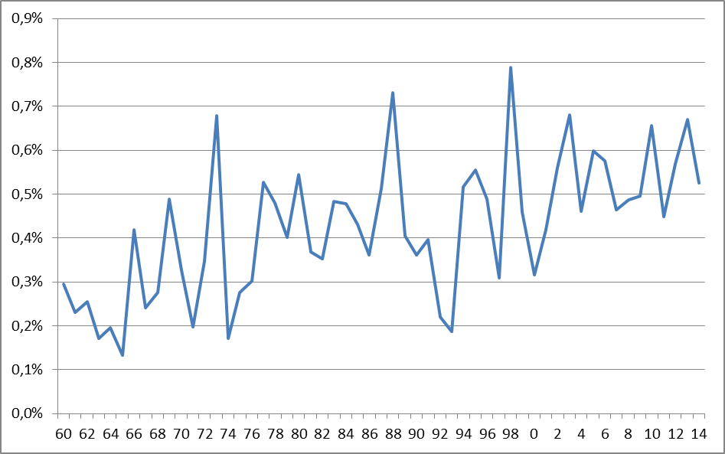
Fig.3. Dynamics of the CO₂ emission into the atmosphere in 1960-2014 [6]

Moreover among the most development countries, France has a lower value of the CO₂ emission (Table 5); the nuclear energy share in the electric energy production in France is very high: more than 70%. Herewith the RES share (including hydraulic energy) in France is about 16%, which is lower than in other development countries (in Germany, the RES share is about 25%).

Table 5. Per capita CO₂ emissions (ton/person*year) in the most developed industrial countries in 2013 [10]
Country | CO_{2,} emission (ton/person*year) (2013)
Australia | 16,9
USA | 16,6
Canada | 15,7
South Korea | 12,7
Russia | 12,6
Japan | 10,7
China | 7,4
EU as the whole | 7,3
Germany | 10,2
Great Britain | 7,5
Italy | 6,4
France | 5,7

In general, the analysis of the whole life cycle of the energy production (from the production of energy carrier and the equipment concerned to the utilization of waste products and power plants themselves) gives the following average emission values [7] for various current energy production types in CO₂ gram-equivalent for 1 kWh of the electric energy produced.
- Heat (coal and gas) power plants – 490-820;
- Bio-mass heat power plants – 230-740;
- Solar battery stations – 41-48;
- Geo-thermal stations – 38;
- Solar concentrators – 27;
- Hydraulic power plants – 24;
- Nuclear power plants – 12;
- Wind generator power plants – 11-12.
The external expenses for the production of 1 kWh may be considered as an integral parameter of environmental and economic efficiency. For the EU-countries, the values of this parameter (in Euro-cent /kWh) in 2003 were the following (according to [14] ):
- Coal – 2-15;
- Oil - 3-11;
- Gas – 1-4;
- Solar battery energy – 0.6;
- Bio-mass energy – 0-5;
- Hydraulic energy – 0-1;
- Nuclear energy – 0.2-0.7;
- Wind energy – 0-0.25.

Thus, the NPP are quite competitive in comparison with the RES power plants; moreover, they are more efficient than all the others (but the wind power plants) with respect to environmental and economic parameters.
As to the economic efficiency of power engineering, the levelized costs of 1 kWh are used as an integral parameter. The levelized costs include the investment component of expenses, the operational and the organizational ones. The total expenses including the expenses for the construction of power plants, the maintance services, the organization and transaction expenses are distributed for the whole life-cycle of the power plant.
The calculation of levelized costs considers the following items: the investments for 1 kW, the coefficient of use of rated power (CURP) of the power plant and the energy production value (kW), the energy carrier costs, the financial coefficients connected with the money costs and the discount rate, the capital costs, etc. In particular, the US Energy Information Administration. Updated Capital Cost Estimates for Utility Scale Electricity Generating Plantsgives the calculated data concerning the levelized costs for the production of electric energy by various power plants types being introduced by 2020 (Table 6) with the following assumptions: time period – 30 years, average capital cost – 6.5%, CURP – see Table 6. With the aforesaid assumptions, the total levelized costs of electric energy production are the following: 72-145 $/MWh (7-15 cent/kWh) for heat power plants, 95 $/MWh for nuclear power plants and 48-240 $/MWh for renewable energy sources.

Table 6. Calculated levelized costs for the production of electric energy ($/MWh, 2013) for various power plant types being introduced in the USA by 2020.

Power plant type | CURP, % | Levelized investments | Permanent operative expenses | Variable operative expenses (including fuel) | Transaction expenses | Total levelized  costs
Heat power plants (coal and gas) | 30-85 | 14,4-97,3 | 1,7-9,8 | 30,7-94,6 | 1,2-3,5 | 72,6-144,4
Nuclear power plants | 90 | 70,1 | 11,8 | 12,2 | 1,1 | 95,2
Geothermal power plants | 92 | 34,1 | 12,3 | 0,0 | 1,4 | 47,8
Bio-mass power plants | 83 | 47,1 | 14,5 | 37,6 | 1,2 | 100,5
Wind power plants (at land and off shore) | 36-38 | 57,7-168,6 | 12,8-22,5 | 0,0 | 3,1-5,8 | 73,6-196,9
Solar power plants (solar battery plants and solar heat plants) | 20-25 | 109,8-191,6 | 11,4-42,1 | 0,0 | 4,1-6,0 | 125,3-239,7
Hydraulic power plants | 54 | 70,7 | 3,9 | 7,0 | 2,0 | 83,5

Thus, the electric energy produced at NPP is quite competitive as well.The RES power plants also approach the price competitiveness level. In recent years there is counter movement – while reducing investment costs to RES is their growth capacity on fossil fuel. The latter fact is connected with the requirements to the productivity of power plants and to their environmental characteristics; in particular, the installation of carbon capture and storage equipment at HPP causes a considerable growth of investment expenses for 1 MW (Table 7). The technological and environmental improvement of gas and coal heat power plants causes the increase of investment and permanent operative expenses by 2 to 3 times. The additional safety measures in the process of construction of nuclear power plants also make the investment expenses higher.

Table 7. Calculated average investment expenses ($/kW) for various power plant types in 2013 [13]
Heat power plants (coal and gas) | 917 - 7 108
Nuclear power plants | 5 530
Bio-mass power plants | 4 114 - 8 188
Wind power plants (at land) | 2 213
Off shore wind power plants | 6 230
Solar (heat and PV) power plants | 4 183 – 5 067
Hydraulic power plants | 2 936

The assumptions on the CURP for wind and solar power plants (US EIA) are rather optimistic, significantly differing in the direction of increase of the actual CURP at the plants. At the same time, we should note the key role of the CURP for the economic and environmental efficiency of power plants. In particular, the CURP for the land wind power plants equals 36% (Table 6) as compared with the CURP for nuclear power plants equal to 90% means that the wind power necessary for the production of the same amount of electric energy is by 90%/36%=2.5 times more than the nuclear power concerned; herewith the investments into the construction of the wind power plants with the same output will be approximately equal: (2213/5530)*2.5=1.
If we take a real CURP for wind power plants (not greater than 25%, i.e. 0.7 of the calculated value and no trend to the increase yet) (Fig.5, Table 8), we see that the power ratio is already equal to 90%/25%=3.6 times; and the construction expenses will be by 44% greater: (2213/5530)*3.6=1.4. In addition to that, there exists a high space capacity of wind power plants as compared with the geographic territory potential [10]. The average density of location of WPP is about 10 MW/km².The construction of a WPP fleet generating 1 GW (it is the power of a small NPP) would require an area of 100 km² (for the CURP equal to 0.7 of the calculated value this area would be equal to 143 km²). Besides that, the answer to the question whether the maintenance period of wind and solar power plants will reach the period of 30 years is not clear yet.
- Uncertainties, risks and prospects of developmentof power engineering
One more argument for the prospects of nuclear power engineering as an environmental and economic alternative to the conventional hydrocarbon power engineering is the uncertainty of the prospects of the RES power engineering. From an environmental point of view, revealed a number of unintended consequences of the RES marked, particularly in the work of the Norwegian researcher [1]. It cannot be excluded that over time renewable energy will be identified new unintended consequences with impact on the development of the RES. We should pay attention to the fact that in recent years admit the growth of new capacity had been marked by a slowdown in energy of the RES. Thus, the production capacity in solar power engineering has grown from 386 MW (1996) to 180396 MW (2014) (by 467 times)[2]), and the annual electric energy production has grown from 695 GWh to 185882 GWh (by 268 times). Over the same period in wind power engineering, the production capacity has grown from 6070 MW to 372961 MW (by 61 times) and the annual electric energy production – from 9184 GWh to 706175 GWh (by 77 times). At the same time, the growth rates for the production capacities and the electric energy production decreased both in solar power engineering and in wind one (Table 8, Fig.4). In solar power engineering, a considerable reduction of the growth rates was fixed after 2011 (72.5% in 2011 and 28.7% in 2014). In wind power engineering, the general trend of reduction of the increase rate started in 2000-2001 and became stronger after 2009 (the increase in the output rate was equal to 31.5% in 2009 and 16.2% in 2014).

Annual increase rates (in % with respect to the previous year) for the power and production output in solar and wind world power engineering
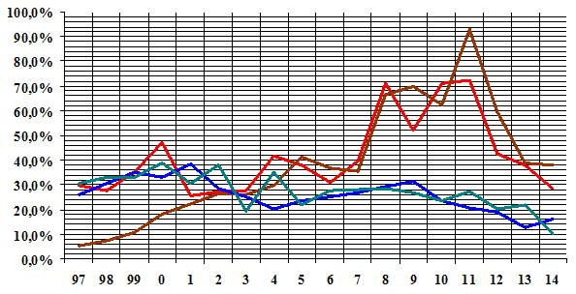
Solar power engineering, power;
Solar power engineering, production output;
Wind power engineering, power;
Wind power engineering, production output.
Fig.4. Dynamics of annual output increase rates in solar and wind world power plants in 1997 – 2014 (according to BP Statistical Review of World Energy, 2015)

On the basis of the aforesaid data on production capacities and production volumes by years, the authors calculated the world average CURP value for the time period from 1997 to 2014. For this calculation, the production output was compared with the average capacity values for both the previous year and the given one with consideration of introduction of new power plants. For instance, for the calculation of the average CURP value of solar world power plants in 1997, we took the arithmetic mean for the capacity values in 1996 (386 MW) and in 1997 (502 MW) equal to 444 MW. Further, we divided the electric energy production output at world solar power plants in 1997 (equal to 732 GWh by 444 MW and obtain the production output of 1649 W for 1 W of the capacity value. The maximum annual output equals the value of 8760 (1 year=8760 hours) and corresponds to the CURP value equal to 100%. The factual CURP is calculated through the division of factual electric energy production value by the maximum possible value, and here it equals 1649/8760=18.8% (the average CURP value for solar power plants in 1997). In this way, the CURPvalues were calculated for solar and wind power plants in 1997 – 2014 (Fig.5).

Dynamics of average CURP values (%) for solar and wind world power plants
in 1997 - 2014
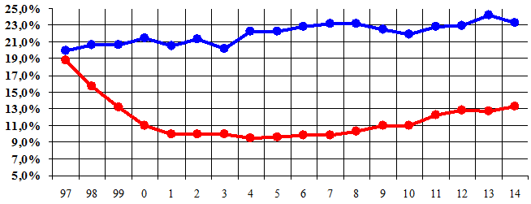

Solar power plants
Wind power plants
Fig. 5. Dynamics of average CURP values for solar and wind world power plants in 1997-2014 (on the basis of the data from BP Statistical Review of World Energy, 2015).

Table 8. Principal parameters of development of solar and wind world power engineering in 1996-2014
Parameters | 1996-2000 | 2001-2005 | 2006-2010 | 2011-2014
Solar power engineering
The capacities introduced by the end of the time period, MW | 1 275 | 5 083 | 41 345 | 180 396
Average annual capacity increase rates for the time period | 35,0% | 32,0% | 52,9% | 45,4%
Annual output for the last year of the time period, GWh | 1 029 | 1 029 | 31 411 | 185 882
Average annual production output increase rates for the time period | 10,4% | 29,2% | 54,3% | 57,5%
Average CURP value for the time period | 14,7% | 9,8% | 10,4% | 12,8%
Wind power engineering
The capacities introduced by the end of the time period, MW | 17 934 | 59 186 | 197 736 | 372 961
Average annual capacity increase rates for the time period | 30,3% | 27,1% | 27,3% | 17,2%
Annual output for the last year of the time period, GWh | 29 481 | 104 306 | 343 364 | 706 175
Average annual production output increase rates for the time period | 29,3% | 29,0% | 26,1% | 19,9%
Average CURP value for the time period | 20,4% | 21,3% | 22,6% | 23,3%

The calculation shows that by the end of the considered time period the CURP of solar power plants decreased from 19% to 13% with the minimum CURP value of 9.5% in 2004then a gradual increase emerged, although the maximum values of the late 90s have not been achieved. The CURP of wind power plants slightly increased from 20% at the end of 1990s to 23% - 25% in recent years.
The calculated CURP values (US Energy Information Administration, Table 6) for solar and wind power plants under construction are, respectively, 20% - 25% and 36% - 38%; these values seem to be set too high.
Thus, there is no reason for considering the curtailment of nuclear power engineering to be compensated by the development of the RES power engineering. More probably, this process will cause the growth of the use of fossil hydrocarbon energy carriers. The opposition of nuclear and renewable power engineering seems to be counter-productive. A more constructive approach is a parallel development of nuclear and renewable power engineering and their mutual complementation.
At present, the current situation shows that for the majority of the countries, electricity generation at nuclear power plants is not more expensive than at pulverized coal thermal power plants and especially gas-oil thermal power plants [5].
Within the next 50 years the mankind will consume energy more, than it was consumed in the whole previous history [3]. Earlier forecasts about the growth of energy consumption and the development of new energy technologies haven't come true: the level of consumption is growing much faster, and renewable sources of "green" do not always allow you to get the required amount of energy at competitive prices. The issue of shortage of fossil energy resources is getting ever more acute. The possibilities of building new hydroelectric power stations are also very limited. Do not forget about the fight against the "greenhouse effect", which imposes restrictions on the burning of oil, gas and coal in thermal power plants (TPP) [10].
The solution to the problem can be the active development of nuclear power, one of the youngest and dynamically developing sectors of the global economy. An increasing number of countries today come to the need to begin to develop a peaceful atom.
It is obvious that the cost of "nuclear" electricity can be very high if it includes a fund for insurance of risks of accidents and health of the population living near NPP, handling of radioactive waste, etc. Expenses which the system of insurance isn't able to cover subsequently become the expenditures of budgets of the affected states, which can be considered as a hidden subsidy of the nuclear industry. Thus, the owners of nuclear facilities do not fully pay their risks and transfer them to society as a whole.
The nuclear power engineering has its own problems: uneconomical use of nuclear fuel in water-moderated reactors [3], ensuring safe operation of NPP equipment and storage of waste nuclear fuel. However, these problems have some technological solutions, in particular, fast reactors and other developments, related to the minimization of the risk of accidents during the operation of power equipment, the creation of a closed-cycle nuclear power engineering using and . In addition to that, the developments in the field of controlled thermonuclear fusion seem to be quite real, and the success in the field will result in the introduction of a powerful ecological energy source which is practically inexhaustible. There are also some particular developments improving the work of nuclear power plants: resource saving systems, improvement of environmental safety of heat-and-mass transfer hydraulic systems [9].

Conclusions and Policy Implications
The analysis of development of nuclear power engineering and renewable one since 1960s shows the key role of nuclear power engineering in the process of formation of a non-carbon trend in power engineering and reduction of negative effects on the environment.
The reduction of the share of fossil hydrocarbon fuels in the process of electric energy production since 1960s as well as a certain reduction of the CO₂ emission rates clearly correlates with the development of nuclear power engineering; the share of other non-carbon energy carriers mostly reduced due to the decrease in the share of hydraulic power engineering. The share of nuclear energy in the world energy balance has reduced since 1990s, and the electric energy production output at nuclear power plants has reduced since 2000s. It was not compensated by the growth of the renewable energy production, and, on the contrary, it caused an increase in the share of fossil hydrocarbons in the world electric energy production. It also correlates with a new increase in the CO₂ emission into the atmosphere.
For all that, there has been a steady decrease in the development of renewable power engineering since 2010s. The increase rates for the electric energy production output at wind and solar power plants are less than the increase rates for the production capacities. This fact points out certain barriers in the development of renewable power engineering, which may be worse in the near future.
A comparative estimate of economic and environmental parameters of nuclear power plants and RES power plants points out a high competitiveness of NPP with respect to the both aforesaid parameters.
The trends in the field and the analysis of environmental and economic parameters show that the nuclear power engineering is a necessary component in the process of transition to a non-carbon power engineering and reduction of environmental risks. A nihilistic attitude to the nuclear power engineering and its opposition to renewable energy sources seem to be unfounded. The analysis of development of world power engineering for the period of 50 to 55 last years as well as the consideration of current trends in the field point out the expediency of development of both renewable and nuclear power engineering, which are mutually complementary.

References
[1] Andersen, O. (2013) Unintended Consequences of Renewable Energy. Problems to be solved, London, 94.
[2] BP Statistical Review of World Energy, (2015), [electronic resource] URL: http://www.bp.com/en/global/corporate/energy-economics/statistical-review-of-world-energy.html
[3] Kostyuk, V.V., Makarov, A.A., (2011) Energy and Geopolitics, Moscow, 396.
[4] External Costs. Research results on socio-environmental damages due to electricity and transport. European Commission URL: http://ec.europa.eu/research/energy/pdf/externe_en.pdf
[5] IEA Key World Energy Statistics, (2014) URL: http://www.iea.org/publications/freepublications/publication/KeyWorld2014.pdf
[6] Mauna Loa Observatory (MLO), URL: http://co2now.org/Current-CO2/CO2-Now/
[7] Schlomer S., Bruckner T., Fulton L., Hertwich E., McKinnon A., Perczyk D., Roy J., Schaeffer R., Sims R., Smith P., Wiser R. (2014) Annex III: Technology-specific cost and performance parameters. In: Climate Change 2014: Mitigation of Climate Change, 1335.
[8] http://www.ipcc.ch/pdf/assessment-report/ar5/wg3/ipcc_wg3_ar5_annex-iii.pdf

[9] Solovyev A., Degtyarev K., Zalikhanov A., Beryozkin M. and Sinyugin O. Innovations in renewable energy – the start-ups of scientific cooperation. In: Russian-Swiss energy seminar Watt d'Or, Russia, Moscow, Lomonosov Moscow State University.
[10] Soloviev A., Degtyarev K., Zalikhanov A. and Chekarev K. (2015) Regional and local geographical potentials of renewable energy sources in Russia Moscow, 716.
[11] Trends in Global CO2 Emissions, 2014 Report, URL: http://edgar.jrc.ec.europa.eu/news_docs/jrc-2014-trends-in-global-co2-emissions-2014-report-93171.pdf
[12] US Energy Information Administration, URL: http://www.eia.gov/cfapps/ipdbproject/iedindex3.cfm?tid=2&pid=2&aid=12&cid=regions,&syid=1980&eyid=2012&unit=BKWH
[13] US Energy Information Administration. Levelized Cost and Levelized Avoided Cost of New Generation Resources in the Annual Energy Outlook 2015 URL: http://www.eia.gov/forecasts/aeo/electricity_generation.cfm
[14] US Energy Information Administration. Updated Capital Cost Estimates for Utility Scale Electricity Generating Plants. [electronic resource] URL: http://www.eia.gov/forecasts/capitalcost/

