Figures (JAES)
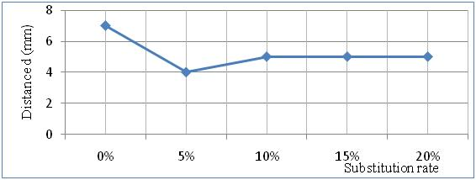
Figure 2: Variation of consistency according to the substitution rate.

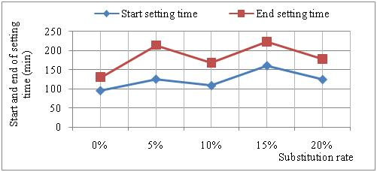
Figure 3: Variation of the start and end of setting time versus the substitution rate.

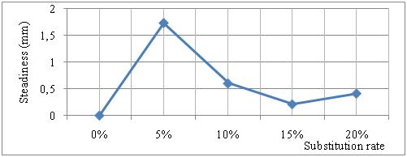
Figure 4: Variation of the steadiness versus the substitution rate

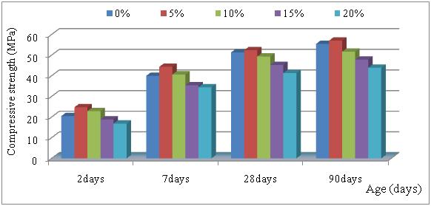
Figure 5: Variation of the compressive strength versus the substitution rate
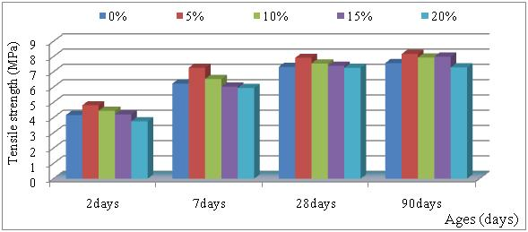
Figure 6: Variation of the tensile strength in flexion versus the substitution rate

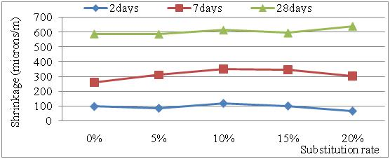
Figure 7: Variation of the shrinkage versus the substitution rate

