"Greening the Blue" – An Example of Institutional Contribution to the Global Culture of Climate Neutrality
Mirjana Devetaković, Milan Radojević
Abstract
Under the title “Greening the Blue”, a range of actions are gathered, promoting the culture of climate neutrality within UN, one of the most important international organizations. All the actions have been structured into following groups: Buildings, Meetings, Procurement, Staff engagement and Travel, reflecting nature of the organization activity. In the focus of this study are predominantly the actions related to buildings of the UN, for which the organization is trying to achieve the carbon neutrality of a significant level.
After presenting a brief history of the “Greening the Blue” idea, dating back to 2007 when the general Secretary of the UN Ban Ki-moon called all UN sectors to “go green” and to become climate neutral, we give an overview of the contents available at the “Greening the Blue” web resource (http://www.greeningtheblue.org/), highlighting the key achievements. The paper continues with a review of a range of documents related to climate neutrality of the UN worldwide building portfolio. A special attention has been paid to a range of institutional policies, guidance and manuals, as well as on the presented cases of the UN climate neutral offices worldwide, particularly the ones functioning in the climates similar to the climate of Serbia.
Considering the twofold targets of the “Greening the Blue”, one to control operational costs and the carbon footprint of this complex, globally distributed organization; and the other to achieve a practical leadership in promoting the idea of climate neutrality, in this study we are highlighting the most useful details that could be learnt from this institutional case and finding out which of the promoted actions could be adopted and applied in our country, and by which particular institutions.
Keywords: climate neutrality, carbon footprint, buildings, UN, climate changes, Serbia

Introduction
“In combating climate change the United Nations should lead by example.”
Ban Ki-moon, United Nations Secretary-General
United Nations (UN) is one of the largest international organizations, with main headquarters in New York and Geneva, and its numerous agencies and departments located worldwide. By the metaphor “Greening the Blue”, United Nations, represented with its characteristic colour as the “blue”, are promoting an institutional orientation towards a sustainable, climatically responsible, green development . This is one of the best recent examples of a clear, easy to understand, effective campaign promotion title, benefiting from the beauty and preciseness of the English language, yet difficult to transpose into other languages.
The idea of climate neutrality and “going green” was promoted in 2007 by UN secretary general Ban Ki-moon, in the occasion of World Environment Day. The “Greening the Blue” initiative has been officially launched in 2010, as a mean of communication among all UN staff, aimed at raising awareness of sustainability issues through the UN system. It highlights what has been achieved, what are the next activities and what are the modes of staff involvement.
“Greening the Blue” is considered the UN response to challenges of becoming more sustainable. It is developed primarily for the UN staff and collaborators, but is also expected to be a guiding example for other institutions and organizations, facing the same challenges.
This study is interested in overall strategies of the UN system in achieving climate neutrality and sustainability, but being realized within the technological research project TR36035: SPATIAL, ENVIRONMENTAL, ENERGY AND SOCIAL ASPECTS OF DEVELOPING SETTLEMENTS AND CLIMATE CHANGE – MUTUAL IMPACTS, it is particularly interested in the strategies focused on reducing emissions from UN building facilities. It is also aim of this study to examine if/how the climate neutrality experiences of one large international organization could be applied on a national level, in the case of Serbia.
In this study we use the content analysis methodology, taking into account the “Greening the Blue” official web site and a range of referenced publications and reports, trying to identify possible analogies with other areas of application, appropriate for our country.

“Greening the Blue” Resources
The “Greening the Blue” initiative is an important example of well orchestrated institutional action, supported by a wide range of excellent, mostly Web based, freely accessible resources. They are all characterized by an attractive graphic design, clearly and explicitly communicating the main idea behind, using the recognizable green colour for all accented details, as well as the blue – the colour of UN.
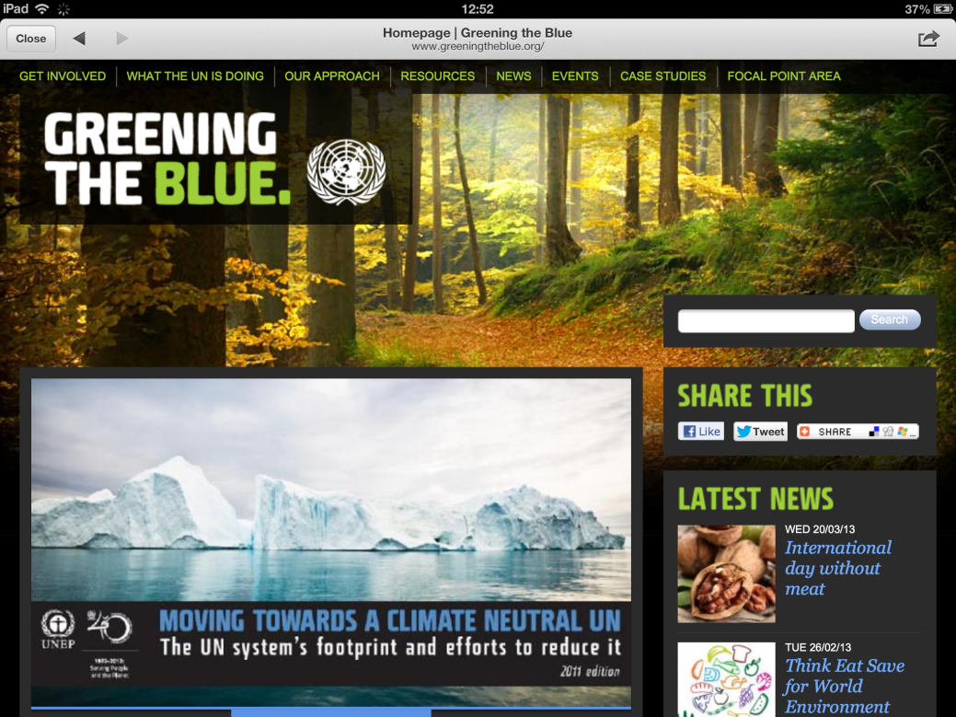
Figure 1 The Greening the Blue Web site home page, http://www.greeningtheblue.org

Greening the Blue – the Web site structure and selected contents
The main Website of the Greening the blue initiative (http://www.greeningtheblue.org) is a dynamic and reach of information resource on the Web, where all the areas are freely accessible.
The main and most informative part of the Web site is its entry page, presenting the latest and the most condensed information on the “Greening the Blue” initiative. The rest of the contents of the Web site has been structured in following sections:
- Get involved
- What the UN is doing
- Our approach
- Resources
- News
- Case studies
- Focal point area
The entry page of the “Greening the Blue” (Figure 1) has a characteristic appearance. It overviews the recent events related to the initiative, as well as the latest tweets from its Tweeter activity. The background of the entire Web site is black, according to the greening idea (the energy saving difference between the dark and light screens). In the central part there’s an image of the title page of the publication “Moving towards a climate neutral UN, the UN system footprint and efforts to reduce it” (edition 2011). In the third edition of this publication, issued in April 2012, the UN gives the highlights of its activities towards sustainability goals, one or two for each month of the year 2011. It proceeds by an overview of institutions making the UN system (about 60) and the brief history of the climate neutrality idea within the UN. After that, there is an inventory of the UN greenhouse gas emissions for the year 2010, with explained methodology of its collecting and calculating, as well as results and data quality discussed. The chart on the Figure 2 gives the 2010 emissions of various UN bodies, calculated in tones of CO₂ equivalent per staff member (per capita). A brief analysis of measured results indicates that, as calculated per capita, the emissions vary, and the differences between various institutions are significant. There’s also a calculation of UN average emission, which is 8.2 tC0₂eq/staff. Such results illustrate the importance and necessity of measuring emissions and compare them between the similar institutions using the standardized methodology.

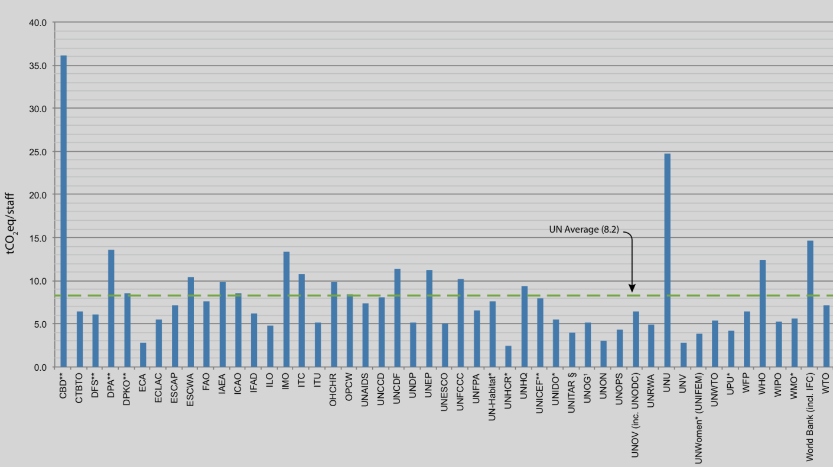
Figure 2 2010 emissions per capita (tonnes CO₂ equivalent), (source Moving towards a climate neutral UN, 2012, pp. 14)
The “Get involved” section is addressed to UN staff calling for pledges on how to behave more sustainable in a daily routines. There’s an interactive part where staff members can create their proposals and share them with others. Part of this section is a 200 pages book (available as booth e-book and pdf document) titled “Kick your habit – a UN guide to climate neutrality”. After introducing the notion of climate neutrality, it explains the basic terms like mitigation, resilience, greenhouse gasses (GHG), emissions, etc. It identifies the key actors, starting from individuals, small and big organizations and countries, proceeding with defining reduction cycle. It stresses the importance and proposes techniques of climate impact measurements, than acting by reducing and offsetting emissions on four identified levels, i.e. individual, organizational, city and country.
The section “What UN is doing” gives an overview of all UN centres, agencies, organizations, etc., explaining their activities and giving indicators of the climate impact (for the year 2010). The example of such indicator for UNESCO is the following:
Total emissions: 26,581 tonnes CO₂ equivalent
Emissions per staff member: 5.0 tonnes CO₂ equivalent
Emissions from air travel: 10,589 tonnes CO₂ equivalent
Air travel as a proportion of total emissions: 40%
Air travel per staff member: 2.0 tonnes CO₂
Building-related emissions: 34 kg CO₂ equivalent per square metre
In the “Our approach” section it is possible to find information on the overall context in which the “Greening the Blue” initiative is taking place. It also explains the importance and impacts of measuring, reducing and offsetting institutional GHG emissions. Linked to this section, there’s another book titled: “A Guide to Greenhouse Gas Emissions Reduction in UN organizations.”
The section “Resources” contains the books, instruction guides and other documents, as well as links to groups, networks and other relevant Web based services. All the resources have been structured as following:
- General publications
- Facilities
- Meetings
- Procurement
- Staff engagement
- Travel
Each of the subsections contains relevant publications, specially developed software, ready-to-use slide presentations, etc., and all of them contain case studies of successfully applied particular concepts.
Although all the sections deserve a careful analysis, later in the text a special attention would be paid to the “Facilities” subsection, explaining what has been done within the UN in domain of buildings used by various agencies worldwide.
In the sections “News”, “Events” and “Case studies”, the series of concise news/events/cases information has been presented in a chronological order, while there’s a functionality that permits to filter the news concerning particular organizations within UN. All the items are also tagged with one of the following tags: buildings, finance, ICT, energy, leadership, meetings, offsets, procurement, staff engagement and travels. This way, all the news/events/cases could be filtered according to the subcategories from the previous section.
The last section of the “Greening the Blue” Website is titled “Focal point”. It presents the Issue Management Group (IMG) on sustainability. This group includes members of majority of UN organizations (known as “focal points”) that have been appointed to coordinate the sustainability management process throughout their respective organizations and to keep methodologies and measures up-to-date and harmonized with the other UN organizations.

Greening the Blue on Facebook and Tweeter
The news and events that have been published on the “Greening the Blue” website, appear as posts on the “Greening the Blue” Facebook profile, being followed by about 4000 people (as on March 2013). This way the popular social media has been used on the best way to promote the campaign. The “Greening the Blue” on the Facebook exists since May 2010 and counts several hundreds of posts, some of which directly corresponding to the information published on the “Greening the Blue” Website, some related to the sustainability within UN more general or less formal.
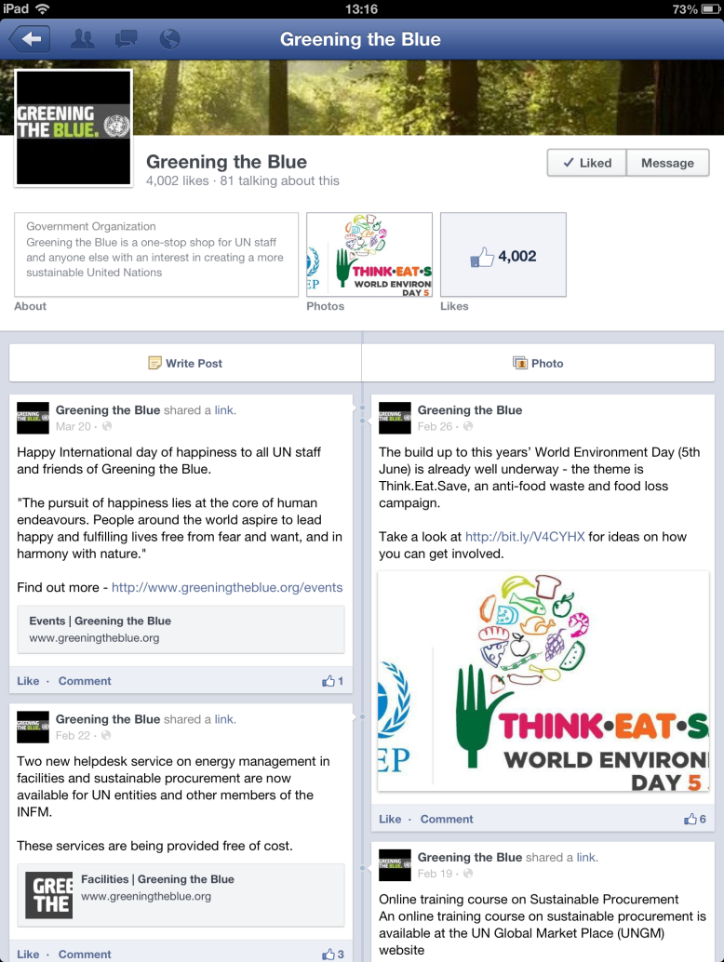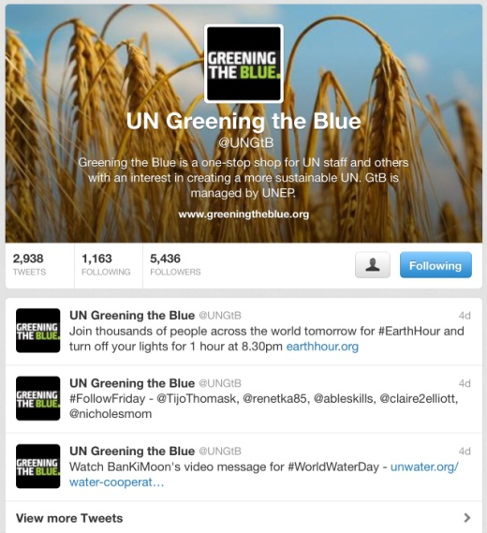
Figure 3 Greening the Blue on Facebook , https://www.facebook.com/GreeningtheBlue, and Tweeter, @UNGtB (March 2013)

Following trends in use of social media, the “Greening the Blue” exists on Tweeter too, counting about 5500 people interested in receiving the related information, and about 3000 tweets since December 2011.

“Greening the Blue” actions
All the actions of the “Greening the Blue” initiative are directed towards reduction of the greenhouse gas emissions within UN (Moving Towards a Climate Neutral UN, 2011). They have been structured in the following five categories:
- Travel
- Facilities
- Meetings
- Procurement
- Staff engagement

Travel
The nature of UN activity and global distribution of agencies are reasons for travel to be the main source of UN carbon emissions. According to the latest reports 80% (894 537 tones CO₂eq) of these emissions come from air travel, while about 20% (225719 tonnes CO₂eq) come from vehicles, and less than 1% (2 187 tones CO₂eq) from public transport.
Similarly as the “think before you print” habit introduced by UN for the offices, they promote the “think before you travel”, pledging on more careful decisions on international, long-distance travels and their real necessity. Reduction of travels is opportunity, not only to reduce GHG emissions, but also to reduce the significant related costs. The notion of “sustainable travel” has been introduced by the UN in 2010 and in 2011 several instruments have been promoted to facilitate the emissions related to travel.
Some tools, in the form of guidelines, are related to procurements of more efficient (but also more expensive vehicles) from the more sustainable suppliers, improving its own culture of sustainability and educating its partners.
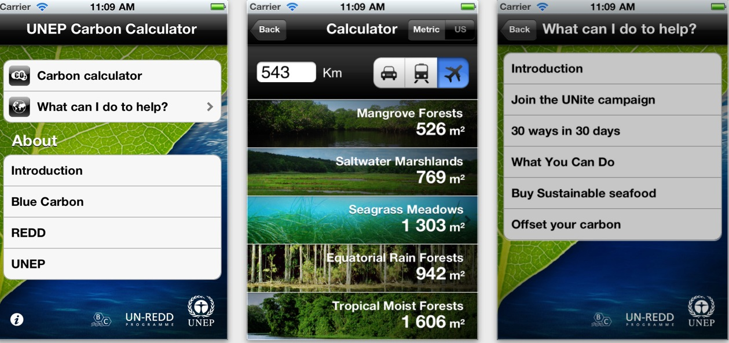
Figure 4 UNEP Carbon Calculator for smart phones, screenshots
Several examples of various software have been developed with aim to either help in raising awareness of general travel impacts and ways of possible offsetting (UNEP Carbon Calculator, Figure 4) or to assist in optimizing decisions while organizing international meetings (ICAO Green Meeting Calculator, Figure 5). The Carbon Calculator developed for UNEP (United Nations Environment Program) calculates the emissions for a given journey and translates the emissions in an equivalent area of particular ecosystem needed to offset it. The application suggests the individual activities that could help in compensation the damage, such as buying sustainable food, participating in the Unite campaign, etc. The application is freely available from December 2011. ICAO Green Meeting Calculator - The Green Meeting calculator is an application developed by the International Civil Aviation Organization. It is aimed at helping in organizing the global meetings in terms of finding optimal destinations for the meeting venues, decreasing the environmental impacts of participants’ travel. The software calculates the CO₂ emissions required for attending meetings on different locations, taking into account position and number of participants. It proposes a range of the optimal locations. The application is available as both desktop and mobile application. The first version of the Calculator appeared in November 2012. The latest version calculates total CO₂ emissions for each of the proposed venues, for the economy and the premium class travels. The solutions are calculated for direct flights and for all other solutions.
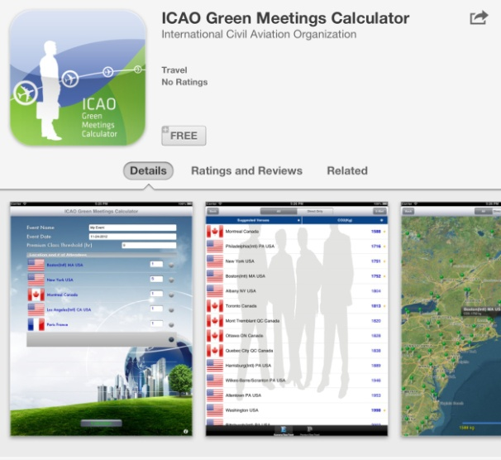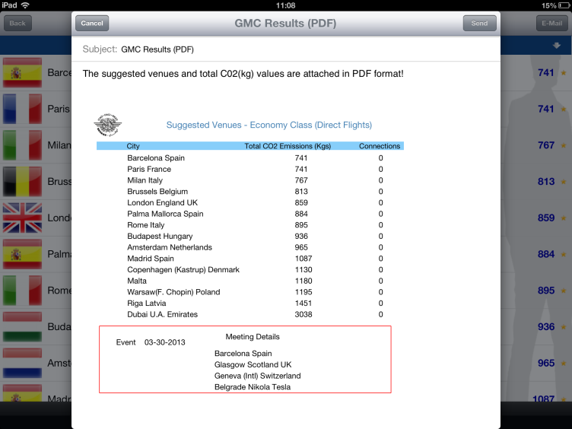
Figure 5 ICAO Green Meeting calculator
As an alternative to unnecessary travels, the UN promotes videoconferencing system, considering it the second best solution after the face to face meetings. Introduction of videoconferencing technology has been tested in some organization wide campaigns, and advantages as well as efficiency limitations have been carefully examined. In some organizations there are estimations that air travels could be reduced by one flight per staff member per year, which is already a contribution to the UN footprint reduction. The technology has been applied on the large global meetings.
Finally, there are initiatives for adopting the habits like cycling to office, or the concepts like distance working, presuming for some staff categories one or two days per week working from home. Of course, this model of working has operational impacts and calls for rethinking working spaces and facilities in general.

Facilities
Facilities are the second largest source of the UN GHG emissions, after the travel (Moving Towards a Climate Neutral UN, 2011). Related to facilities there are assessments of energy efficiency and GHG emissions policy instruments (Assessment of Policy Instruments for Reducing the Greenhouse Gas Emissions, 2007), guidance for facility managers (Energy Efficiency in Buildings, Guidance for Facility Managers, 2008), as well as the related software and case studies.
Among the commitments and actions from the emission reduction strategies for 2011, the following examples have been identified contributing to the reduction from buildings:
- Upgrade heating system
- Air-conditioning off periods
- Air curtains at ground entrance
- Raise building temperature in summer and lower it in winter
- Heavy curtains will keep offices cooler – reducing energy consumption for air conditioning
- Blinds and shades for cooling
- Install light timers and motion detectors
- Install solar panels
- More efficient lighting
- Minimize ceiling lighting in favour of task lighting
The facilities related software includes various carbon footprint calculators. Within the UN there’s also a help desk service on energy management in facilities, providing a broad guidance for queries at the conceptual and practical levels.

Meetings
Related to organizing small, medium and large size sustainable meetings, there are two guidebooks: The Green Meeting Guide (2009) and Sustainable Events guide (2012), referenced within the “Greening the Blue” initiative. A definition of a “green meeting” given in these guidebooks refers to the meeting that minimizes the negative environmental impacts of an event, considering management, venue, accommodation, communication, local transportation issues. Both publications contain very useful instructions and recommendations for organizing meetings, including the checklists helping to estimate the achieved results.

Procurement
The procurement within the UN organizations has been regulated by policies, and several guidelines have been published, as well as an online course aimed at introducing the principles of sustainable procurement mechanisms. The sustainable procurement is defined as a “procurement practice that integrates requirements, specifications and criteria that are compatible and in favour of the protection of the environment, of social progress and in support of economic development, namely by seeking resource efficiency, improving the quality of products and services, and ultimately optimizing the costs”( Buying for a better world, 2011, pp.12).
The procurement guidelines are related, but not limited to:
- Cafeteria, food and kitchen equipment.
- Carbon offsets
- Cleaning products and services
- Furniture
- Freight Forwarding
- Generators and batteries
- ICT equipment
- Lighting
- Stationary
- Vehicles
The online course on sustainable procurement is freely available at: https://www.ungm.org/SpTraining/OnlineTraining/player.html, but the final test is available exclusively to the UN staff members.
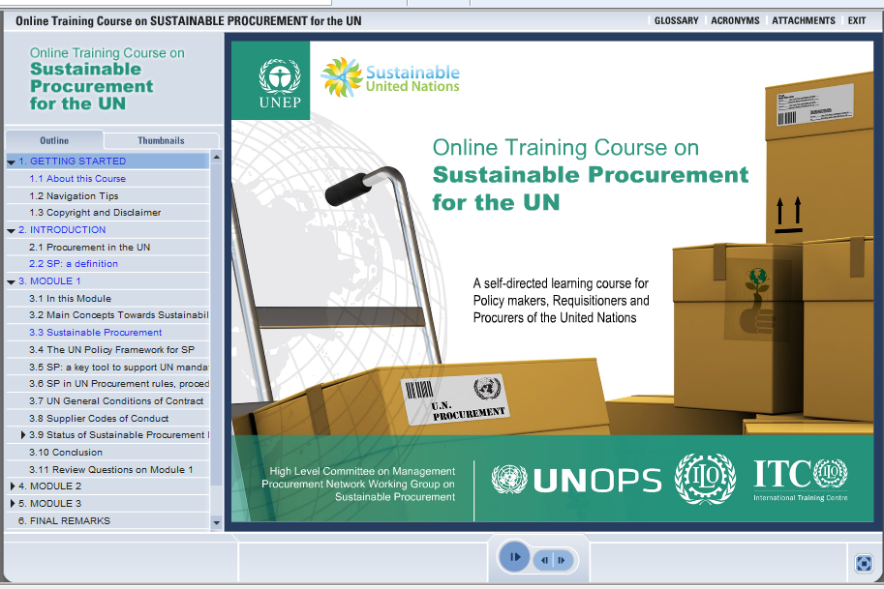
Figure 6 Online Training Course on Sustainable Procurement (https://www.ungm.org/SpTraining/OnlineTraining/player.html)
With an aim to facilitate the communication between the departments in charge for the procurement activities, as well as with the network of suppliers, within the UN exist UN Procurement Division, HLCM Procurement Network and the UN Global Marketplace, a portal bringing together UN procurement staff and the supplier community.
Particularly interesting in this section are examples of the so called offset procurements, i.e. procurements that compensate the emissions that organizations could not reduce other ways.

Staff engagement
The engagement of individual UN staff members has been promoted as an important aspect of the “Greening the Blue” initiative. It has been facilitated by powerful social media, such as Facebook and Twitter, bringing the greening ideas to the staff members on a daily base, and allowing a direct, semi-formal communication, often based on various contests aimed at sharing the information on greening behaviour among the UN staff members worldwide.
The communication of the Greening the Blue initiative is facilitated with a wide range of tools. There are even two cartoon characters – Philip and Norma, specially created for the communication purposes, conveying the key “Greening the Blue” messages in an animation available online.

Selected case studies
From the list of the “Greening the Blue” case studies and success stories, the most interesting for this research are certainly the ones that belong to the category “buildings”. There are ten such cases:
- International Environment House – Geneva
- UN Vienna International Centre (VIC)
- UN’s New York headquarter
- International Fund for Agricultural Development (IFAD) headquarters – Rome
- United Nations Environment Programme’s Regional Office for North America (UNEP RONA), Washington, USA
- The UN’s new energy neutral office – Nairobi
- United Nations Development Program (UNDP) office - New York
- United Nations Development Program (UNDP) office - Bratislava
- International Civil Aviation Organization (ICAO) headquarters in Montreal
- UN’s eco-building – Podgorica
From the listed ten cases, the following three are briefly presented in this study: International Environment House in Geneva, the UN’s new office in Nairobi and UN’s eco-building in Podgorica. While the first two buildings host the United Nations Environment Program offices, so they are expected to serve as representative examples of refurbishment (Geneva) and new building (Nairobi), the last is under construction in Montenegro, being the first building of its kind in the region.

International Environment House – Geneva
The International Environment House was built in late 1990es in Geneva. It hosts the UNEP (United Nations Environment Program) Geneva office, and many other institutions related to environment issues, including several NGOs. By the nature of the activities it hosts, the building is expected to be an example of environment friendly edifice.

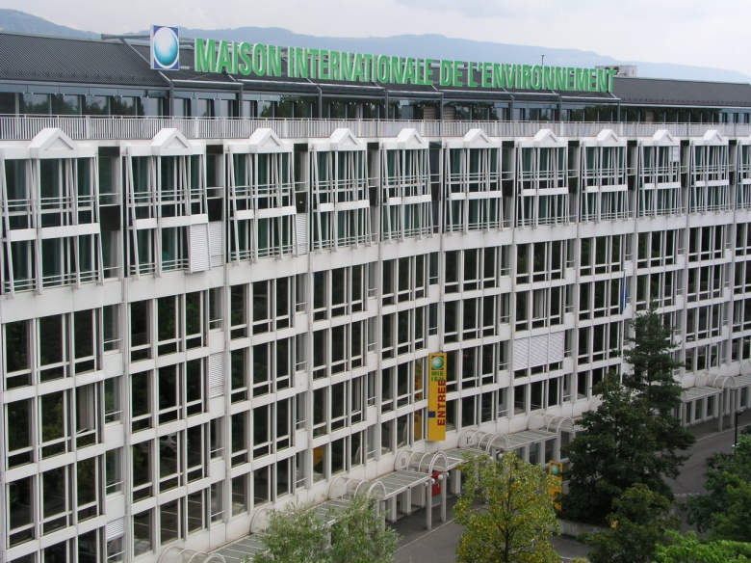
Figure 7 International Environment House, Geneva (source of illustration Geneva Green Guide, pp. VII)
Although sustainable at the time it was designed, it recently needed a USD 3.1 million retrofit, to meet current green standards. With the waste management solved earlier (separation and recycling), the main interventions have been done in reducing energy and water consumptions. The retrofit included:
- New heating, ventilation and air-conditioning systems and improved insulation (58% energy consumption savings)
- Local electricity utility company’s green all-hydroelectricity tariff (reduction of emissions)
- installation of low water consumption taps and toilets (25% water savings)
The investment thus resulted in significant operational cost reductions, as well as in building environmental performance (gaining the MINERGIE certificate – a Swiss standard for building materials and energy efficiency excellence).

The UN’s new energy neutral office – Nairobi
“This is a working building but it is also in many ways a research facility and a sustainable building showcase.” Achim Steiner, Director-General United Nations Office at Nairobi
United Nations Office in Nairobi (UNON) was established in 1996 and hosts two important UN programs headquartered in Nairobi – the United Nations Environment Program (UNEP) and the United Nations Human Settlement Program (UN-Habitat). It also manages offices of another 50 UN agencies located in Kenya.
The new office facility in Nairobi was completed in 2011, using the principles of sustainability, aimed at being a showcase for sub-Saharan Africa, as well as for other developing countries. It has 6,000 square metres of solar panels, energy saving lighting, natural ventilation systems and other green features (water saving, garbage treatment, etc.), and is designed as energy neutral, i.e. ready to generate as much energy as needed for its 1200 occupants during the year. The design process considered the expertise of local architects and engineers, application of local materials, all combined with the highest standards in designing sustainable buildings (Building for the Future, A new United Nations Showcase in Nairobi, 2011).

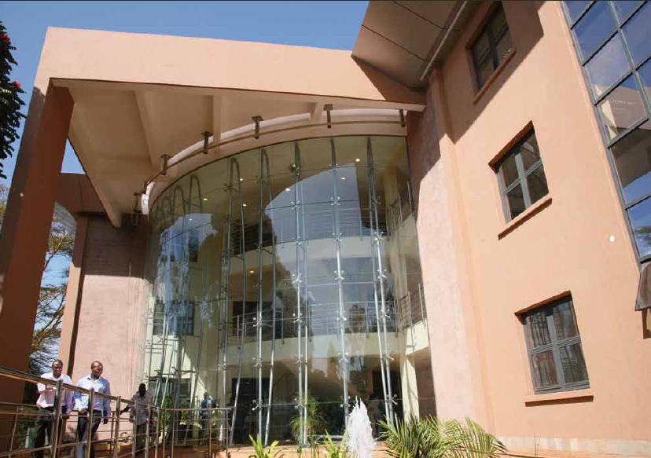
Figure 8 The new UNON office building in Nairobi,
(source of illustration “Building for the Future, a United Nations showcase in Nairobi” 2011, pp. 2)

The idea of constructing a building that will be a showcase and a research facility will be a base for proposing an implementation of greening strategies in selected sectors in Serbia, first of all in domain of university buildings.

UN’s eco-building - Podgorica
The most interesting case for this research is probably the one of UN’s building in Podgorica, for which the government of Montenegro committed the funds in 2003, according to the official efforts in becoming an ecological state.
The so called eco-building has been designed as one of the first of this kind in the region, aimed at hosting the UN headquarters in Podgorica, Montenegro. Financed by the government of Montenegro and the city of Podgorica, the 1400sqm building is under construction. It has been designed by an Austrian team, within the competition organized exclusively for Austrian architectural teams in 2006. It is aimed in being a climate neutral, energy autonomous building, benefiting from the following local conditions:
- A fact that Podgorica has more than 250 sunny days per year, so the solar potential is significant.
- Proximity of the river the water from which has been used for cooling during the summer and heating during the winter time.
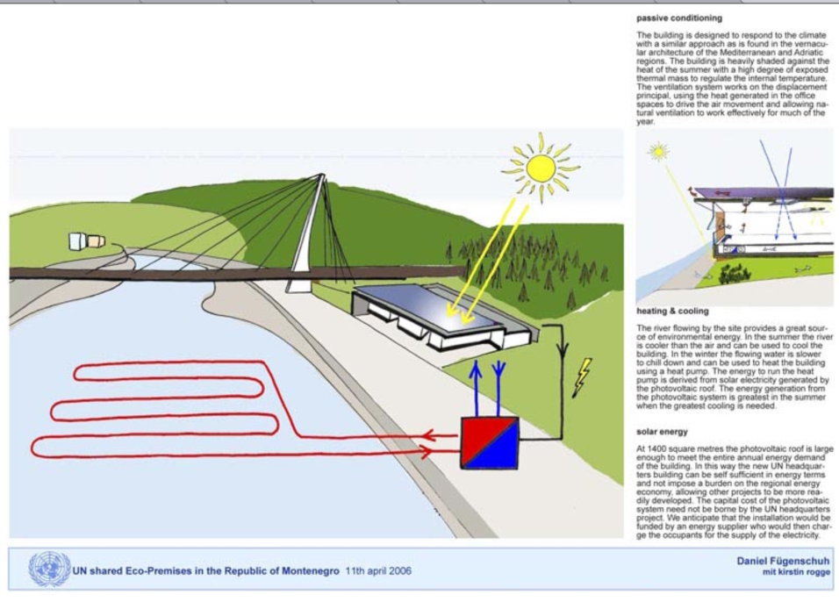
Figure 9 The UN shared eco premises, Podgorica, design by Daniel Fügenschuh
Analyzing the possible lessons to be learnt for Serbia, it is important to highlight the synergetic efforts around this case, where Montenegrin government allocated €3.2 million, city of Podgorica 4000sqm land, Austrian government €900 000 and UN agencies €250 000.
The latest newspaper reports indicate the slight changes of the initial building design and the finalization of the UN eco-building in Podgorica is expected in 2013.

Possible adoption of the “Greening the Blue” experiences in Serbia
Same as the United Nations are seen as a global leader by example in combating climate changes, there are institutions that can play the similar role on national levels.
Serbia is a country with a slight delay in actions related to climate changes issues in general. There are many indicators for such statements, but one of the simplest is the fact that our country, same as many countries in the SEE region [Devetakovic, Radojevic, 2013], has submitted only its first National Communications to the United Nations Framework Convention on Climate Change in 2010 [First National Communication, 2010], about fifteen years after other European countries, and eight years after Croatia. Such situation urges to examine various international experiences and to try to learn as much as possible from successful experiences. It also permits to use the cutting edge technological approaches of localizing and spreading the knowledge.
Learning from the Greening the Blue initiative is intended to be quite accessible since the range of related resources is freely available. It might be task for researchers, various officials and many others involved in climate change related decision and policy making. It is important to understand the aspects of intervention, as well as the impact of quite simple actions when applied organization-wide.
The localization activities are equally important as the learning itself. The advantage of the actions proposed in the Greening the Blue initiative is their applicability in various climate and socio-cultural contexts. It is still necessary to remember that there’s part of organizational culture that all UN agencies share, regardless of their geographic location.
The concept of the Greening the Blue initiative could be adopted by many institutions and organizations, predominantly the ones with a possibility to make centralized strategic decisions and to include these decisions into institutional policies. In the case of Serbia, four areas for possible application have been identified:
- Health sector
- Government
- Municipalities
- University
The common characteristics for all the areas for possible application of similar initiative, is their spatial distribution, large number of staff, and a general need to reduce operational costs. Apart from that, all the sectors are important for Serbian society, so they might serve as a positive example for other sectors like agriculture, industry, tourism, primary education, childcare, custom offices, private sector, housing, etc.
While all the sectors require significant reduction of energy consumption, in the case of health sector the reason for implementing the greening strategy is rather economic and environmental. The government institutions and municipalities on the local level, represent examples of environmentally responsive institutional behaviour for the citizens, and therefore need to promote the green strategies as part of their institutional culture. University however, as educational environment, needs to be a leader in promotion of greening strategies. The university buildings, in which educational processes take place, need to be well maintained, energy efficient, climate resilient and adapted as much as possible, as they strongly influence future professionals and determine their life-long environmental behaviour. The campaigns promoting a greening strategy of entire university and of particular faculties should be part of regular activities at the beginning of each school year. For some students in Serbia, the university could be the only place where they can see and use environmentally responsive sanitary equipment, energy efficient lighting and other equipment (ICT for example), special garbage separation and treatment, recycling methods, and many other systems. The government investments in such strategies at universities might bring an enormous benefit for the society. Greening universities, not only in Serbia but in many developing countries, could be financed partly by governments and partly from international development resources.

Conclusions
“Greening the Blue” is one of the most extensive and the best communicated initiatives towards achieving institutional sustainability in a wide range of aspects, such as facilities, travels, meetings, procurement and staff behaviour. The successful case studies, reported within the “Greening the Blue” Web resources and numerous publications, come from UN offices world-wide approving that sustainable strategy could be realized in every corner of the world. A general approach to various sustainability aspects, documented in guidelines and manuals, increases a possibility of their application in many countries, including the less developed ones, and in other complex organizations. The main ideas of the climate neutrality behind the “Greening the Blue” initiative are oriented towards minimising GHG emissions and general reducing the operational costs.
The strategies that could be adopted in Serbia include first of all adopting the culture of measuring emissions and introducing benchmarking and comparing emission data between similar institutions. The GHG inventory methodology could be directly adopted as it has been developed for international contexts. It also can be examined and slightly modified, according to specific characteristics of the country or particular organization, with aim to get more reliable results. Apart from measuring, the concept that also could be shared is the simple, well structured and easy to understand way of communicating the greening ideas. Finally, there’s a strategy of staff members involvement in spreading the greening ideas, sharing experiences and proposing new activities.
The proposed domains of implementation of some of the sustainable strategies identified within the “Greening the Blue” initiative include Serbian government institutions, municipalities, health sector and university. The government institutions have a structure the most similar to the UN, so the application of the greening concepts can be realised on a same way as within the UN, centrally initiated by the highest authorities. While the health sector is the area that might need the biggest operational cost reductions, the universities are identified as the most important for spreading the greening ideas, acquired by students and later applied within their professional activity in any discipline.

References
Assessment of Policy Instruments for Reducing the Greenhouse Gas Emissions, UNEP - United Nations Environment Programme and Central European University, 2007, http://www.greeningtheblue.org/sites/default/files/AssessmentofPolicyInstruments_0.pdf (accessed November 2013)
Building & Climate Change: Status, Challenges & Opportunities, UNEP - United Nations Environment Programme, 2009, http://www.greeningtheblue.org/sites/default/files/Buildings%20and%20climate%20change_0.pdf, (accessed November 2013)
Building for the Future, A new United Nations Showcase in Nairobi, UNEP - United Nations Environment Programme 2011, http://www.unep.org/gc/gc26/Building-for-the-Future.pdf, (accessed November 2013)
Buying for a better world, A Guide on Sustainable Procurement for the UN System, UNEP, 2011, pp. 12, http://www.greeningtheblue.org/sites/default/files/BFABW_Final_web_1.pdf, (accessed November 2013)
Climate Friendly Buildings and Offices: a Practical Guide, UNEP - United Nations Environment Programme, 2010, http://www.greeningtheblue.org/sites/default/files/climate-friendly-buildings-final_0.pdf (accessed November 2013)
Devetakovic, M.; Radojevic, M.: Knowledge on climate changes in SEE and the Western Balkans, integrated in the Knowledge Base supporting the project TP36035, RESPAG Conference, Belgrade 2013 Conference proceedings, CD Ed.
Energy Efficiency in Buildings, Guidance for Facility Managers, UNEP-Skanska, 2008, http://www.greeningtheblue.org/sites/default/files/energyefficiencyinbuildings_0.pdf (accessed November 2013)
Geneva Green Guide, UNEP United Nations Environment Programme, Geneva 2009, http://www.genevaenvironmentnetwork.org/?q=en/system/files/content/guide-uk_lowres.pdf, (accessed November 2013)
Greening the Blue, Official website, UNEP - United Nations Environment Programme, http://www.greeningtheblue.org/, (accessed November 2013)
Moving Towards a Climate Neutral UN, UNEP - United Nations Environment Programme, 2011, http://www.greeningtheblue.org/sites/default/files/2011CNeutral_UN_final_0.pdf, (accessed November 2013)
Republic Of Serbia, Ministry of Environment and Spatial Planning (2010): Initial National Communication of the Republic of Serbia under the United Nations Framework Convention on Climate Change, http://unfccc.int/resource/docs/natc/srbnc1.pdf (accessed November 2013)
Sustainable Events Guide, UNEP United Nations Environment Program, 2012, http://www.greeningtheblue.org/sites/default/files/Sustainable%20Events%20Guide%20May%2030%202012%20FINAL.pdf, (accessed November 2013)
Sustainable Travel in the United Nations, Sustainable United Nations, UNEP United Nations Environment Program, 2010, http://www.greeningtheblue.org/sites/default/files/sustravel_13.09.10.pdf, (accessed November 2013)
The Green Meeting Guide, UNEP United Nations Environment Program, 2009, http://www.greeningtheblue.org/sites/default/files/GreenMeetingGuide.pdf (accessed November 2013)

In the case of other institutions, particularly in specific countries like Serbia, it might be necessary to examine the UN methodology of measuring emissions and to possibly localize it.
Among the 16 case studies related to travel issues and published on the “Greening the Blue” Web site, one of the most interesting is certainly the one on COP15 (United Nations Climate Change Conference, Copenhagen, December 2009) where 30 000 people participated and another several tens of thousands followed the event via videoconferencing system, in 250 hours of tele-presence meetings. http://www.greeningtheblue.org/case-study/cop15-connecting-world-videoconferencing-network
The Cool Climate Calculator developed at Berkley, CA, http://coolclimate.berkeley.edu/carboncalculator
http://www.minergie.ch/
Završetak zgrade UN-a ove godine, CDM, Jan. 29, 2013, http://www.cdm.me/drustvo/podgorica/zavrsetak-zgrada-un-a-ove-godine
For an overview of initial national communications to the UNFCCC, please check the following page: http://unfccc.int/national_reports/annex_i_natcom/submitted_natcom/items/1395.php. it is important to stress that majority of countries have submitted their fifth communications in 2010.

